|  |
| --- |
| Plymouth Marjon University |
| Critical Reflective Essay |
| *By Kieran Claydon-Smith* |
| **December 2017** |
|  |
|  |

Student Number: 20080310

Word Count: 2720

|  |
| --- |
|  |

**Chapter 1: Introduction**

This essay will critically analyse the physical, social, emotional and cognitive learning aspects of my own personal learning throughout. This will be achieved through reflecting upon a multi-day intensive program supported by Plymouth Marjon University to help myself and others upon this course to attain a recognised professional qualification in the outdoors, otherwise known as a National Governing Body Award (NGB). Specifically, this will be a ‘RYA Level 2 Award in Power boating’, where the Royal Yachting Association (RYA) suggest the individual must be competent to deliver, drive and facilitate a power boat in a variety of techniques whilst suggesting those ‘helming’ a powerboat must be aware of their own limitations including others ‘crewing’ the powerboat (RYA, 2017).

Essentially, this will be driven by ‘photo-elicitation’, where imagery taken upon this course, will ensure an in-depth reflection towards different aspects of my own learning. According to Loeffler (2005) imagery is a contemporary method that helps improve the researchers’ ability to recognise past experiences and further reflect upon it. From which, helps trigger memories and emotions associated within these experiences (Loeffler, 2005; Loeffler, 2004) and ensures that we do not forget these learning experiences on a long-term basis (Schunk, 2012); justifying, the use of photographs amongst this essay.

According to Schunk (2012) learning in its own entity is more diverse and complex than once thought, a conflicting subject amongst a wide majority of researchers. Schunk (2012) further understands the relationship between the processes of learning and how it may influence or be influenced by ‘behaviour’; thus, indicating the previously stated behaviours as aspects of personal learning. Ord & Leather (2011) further determine how the conceptualisation of learning is facilitated by researchers in a contradictory manner by oversimplifying *‘Kolb’s experiential learning model’* (See Appendix D).Hence, the importance of this research associated with my own personal development to relate to experience, and reflect upon my own learning. This essay further provides value to this field of research by; contributing an understanding into the process of learning.

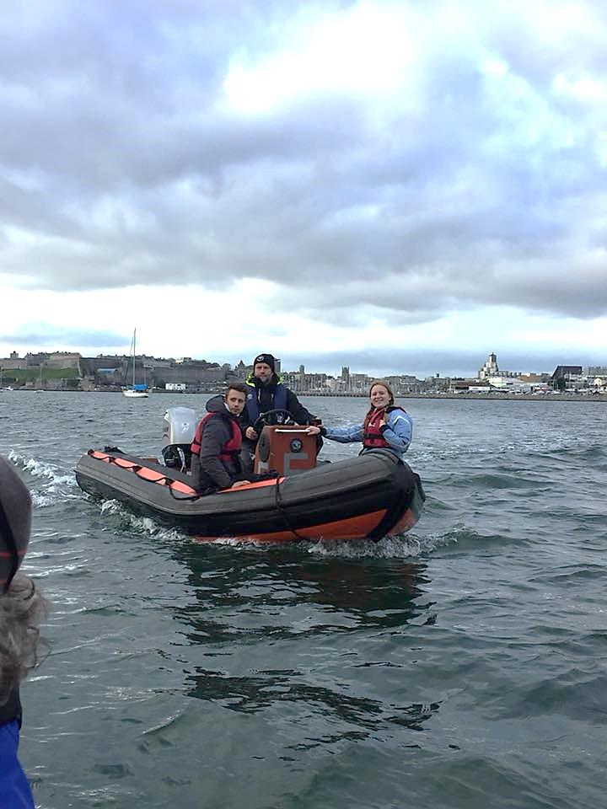**Chapter 2: Implementing programme towards individual learning styles.**

Image 1: *High Speed Manoeuvres on Plymouth Sound.* Nicholls (2017)

*“I knew that I was going to be thrown in the deep end of learning, my course leader values leading and educating forms of practical engagement in the outdoors, his research demonstrates this and so does his mannerisms when involved. I was highly surprised when he took upon a democratic approach; he offered my group of two, to make the choice of how we would like to be taught. Perhaps in the light of simply enjoying power-boating as leisure activity, we would support his ways but in sight of the pressure to attain a professional qualification out of this, we all supported an instructional approach. For myself, I knew that either way the experiences offered on this day would have a positive impact. However, I did find it difficult to comprehend this instructional behaviour from where repeated instructions where at no use to me when I was focused on the task at hand; such as mooring the boat and small manoeuvres but on other hand it helped myself take on high speed manoeuvres more rapidly.”* (Claydon-Smith, 2017)

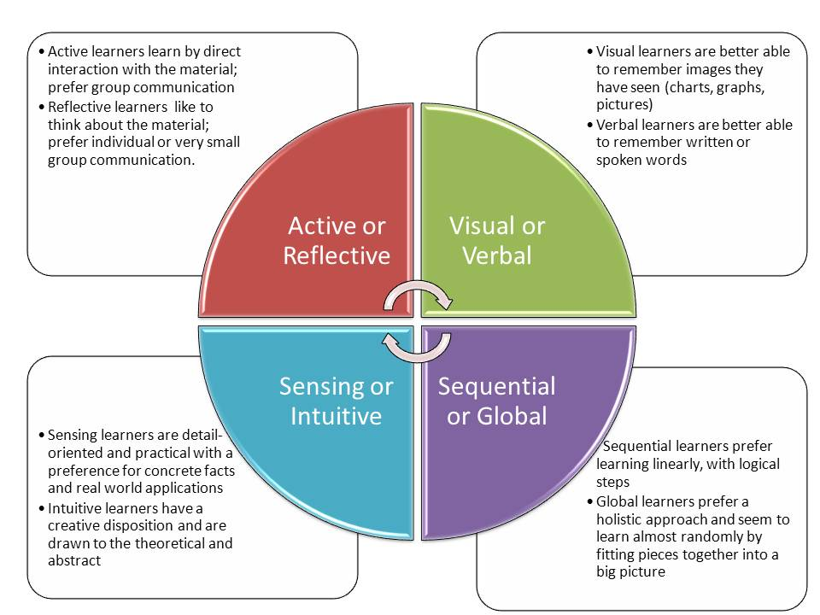According to Ewert & Sibthorp (2014: 92) those who participate in adventurous activities may learn in different ways, every individual learns at differing rates and preferences and therefore, it is common to see some who enjoy using their own initiative to face challenges. On the other hand, there are those who like to be instructed each step of the way, to have demonstrations and to communicate on a constant basis between instructor to participant for perhaps reassurance purposes. These follow on towards an understanding of learning styles (See Figure 2.1).

Figure 2.1: *Description of Felder-Silverman Learning Style Dimensions* (Felder & Silverman, 1988).

The following model provides a unique insight into describing differing learning styles. Drawing from this I can further understand myself as a ‘sequential learner’, where I seek to learn with a constant feed of linear and logical steps in preference to seek instructors rather than educators or educating myself. According to Bruce et al (2017) recent studies suggest learning styles vary upon the environmental setting and situations at hand, perceiving that learning styles change over experiences, suggesting that the individual must follow on the tangent of Kolb’s works whereby the individual must take responsibility of their learning.

Conversely, the model demonstrating differing learning styles lacks in empirical evidence (Ewert & Sibthorp 2014: 93). Where Ewert & Sibthorp (2014) further supports its guidance in the practicality of it; which can be of use for instructors. Suggesting, instructors to curve the adventurous program by means of the participant’s style of learning; bringing upon the perception that my course leader purposefully attempted to instigate the curving of the program to the groups individual dynamic needs, whilst assuming that we would take responsibility of doing so. According to Wagstaff and Attarian (2009) outdoor practitioners naturally follow a flow of responsibility when implementing programs, that specifically aim, towards individual development needs and learning styles (See Figure 2.2).

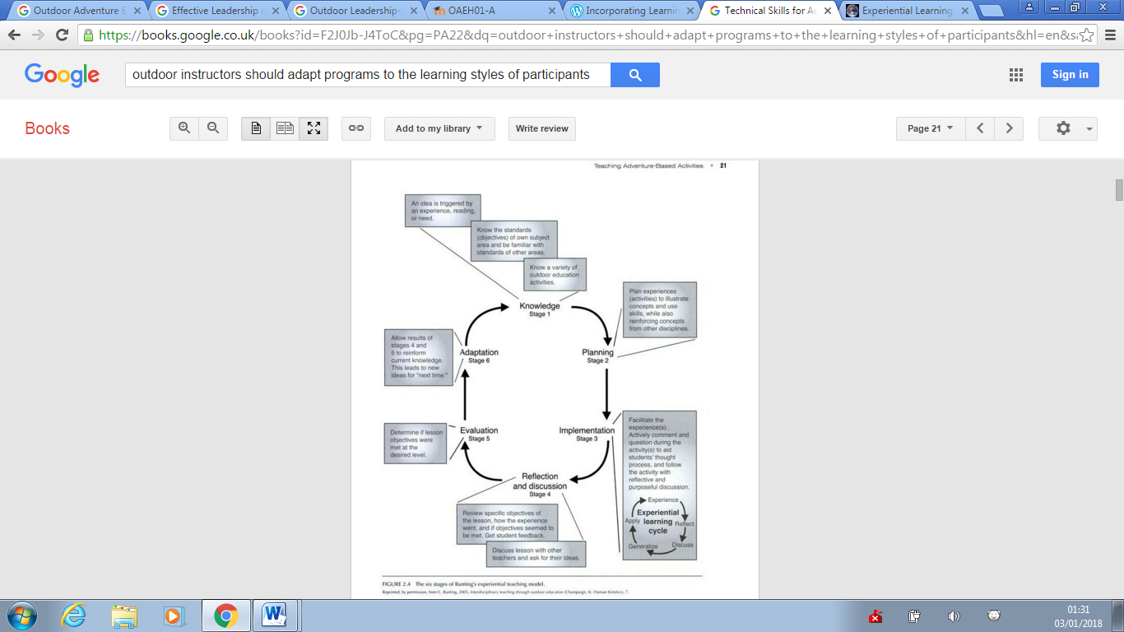

Figure 2.2: *The six stages of Buntings experiential teaching model* (Bunting, 2006: 7, cited in Wagstaff & Attarian, 2009: 21).

This model seeks to describe the experienced instructor process referring closely to a set standard of stages to ensure the quality of the implemented programs suits to the learning needs of participants by: acquiring knowledge, thoroughly planning, implanting experiences, engaging in discussion and reflection with participants, evaluating the session and adapting future sessions (See Appendix A). However, this model critically assumes its positioning with upcoming outdoor practitioners, assuming that those who seek to adapt sessions to learners needs must use this is a guideline and much to the words of Ord and Leather (2011); contemporary models are oversimplified, supporting a critical view point, where myself, would struggle to follow this model within a vocational and adventurous setting.

*“It was clear to me that my course leader was there to improve not only on our technical skills but how we grow as outdoor practitioners; I knew that the qualification at the end of this programme was not that important. Additionally, it was more encouraging that the session would be designed specifically to our own needs but in line with the RYA course specifics.”* (Claydon-Smith, 2017)

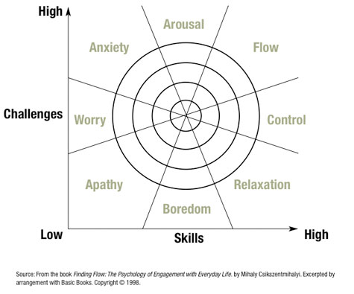According to Ewert & Sibthorp (2014: 93) learners amongst the outdoor adventure education context have complex needs for their learning environment, the combination for challenge and risk dominates the overall engagement of the individual and thus has a lasting impact on the learning outcomes. (See Figure 2.3)

Figure 2.3: *Reconceptualization flow model* (Csikszentmihalyi, 1990. cited in Ewert & Sibthorp, 2014)

The model shows the differing outcomes when the relationship between ‘skill’ and ‘challenge’ are at differing levels.

“*Conversely, power boating for myself was of low challenge where I further felt the want to do something that required more attention and more adrenaline.”* (Claydon-Smith, 2017)

During my engagement with the power boat course, I was able to determine my competency to drive the powerboat easier and therefore I found myself, eager, to up my skill engagement and escape from a position of boredom. From which, justifies my course leader’s responsibility; to further adapt the programme specifically to push towards the ‘flow’ sector of the model. (See Figure 2.3)

In addition, many researchers compare learning styles to ‘multiple intelligences’, a field of research that many confuse learning styles with (Ewert & Sibthorp, 2014). Essentially, multiple intelligences refer to eight factors such as: linguistic, spatial, bodily kinaesthetic, naturalistic, rhythmic, mathematical, interpersonal and finally intrapersonal (Mitchell & Kernodle, 2013) (See Appendix B). According to Bruce et al (2017) the knowledge gained from understanding multiple intelligences can help provide a ‘tool box’ for outdoor practitioners to diversify their sessions. With the ever growing complexities of learning, it is essential for this to be put into practice.

*“Although, I found my views to be rather self-orientated, because I really did want to achieve a level 2 in power boating. I knew that others would find tasks in their own unique way to be difficult perhaps because they learn in a different manner.”* (Claydon-Smith, 2017)

Which highlights a crucial point, I knew that learn in different manner to others but understanding how I learn was a crucial element in socially, physically, emotionally and cognitively. So, it is crucial to determine ones multiple intelligence and not confuse with learning styles. In addition, it was clear that I would forte in mathematical factors but perhaps find weakness in bodily kinaesthetic.

*“It was hard to attain a muscle memory that can control the power boat in different ways, physically. I struggled to, at first, to simply drive in a figure of eight. The accelerator was not compatible to me; where I would either over accelerate to underestimate it.”* (Claydon-Smith, 2017)

Through referring back to the overall understanding of learning, it is clear that throughout the intensive outdoor programme and through further reflecting in addition to acquiring knowledge on the subject; that I have personally cognitively grown, by better understanding my own learning, the way I learn and the responsibilities that I must consider both in the learning or the instructor positioning, that I must continue to personally develop.

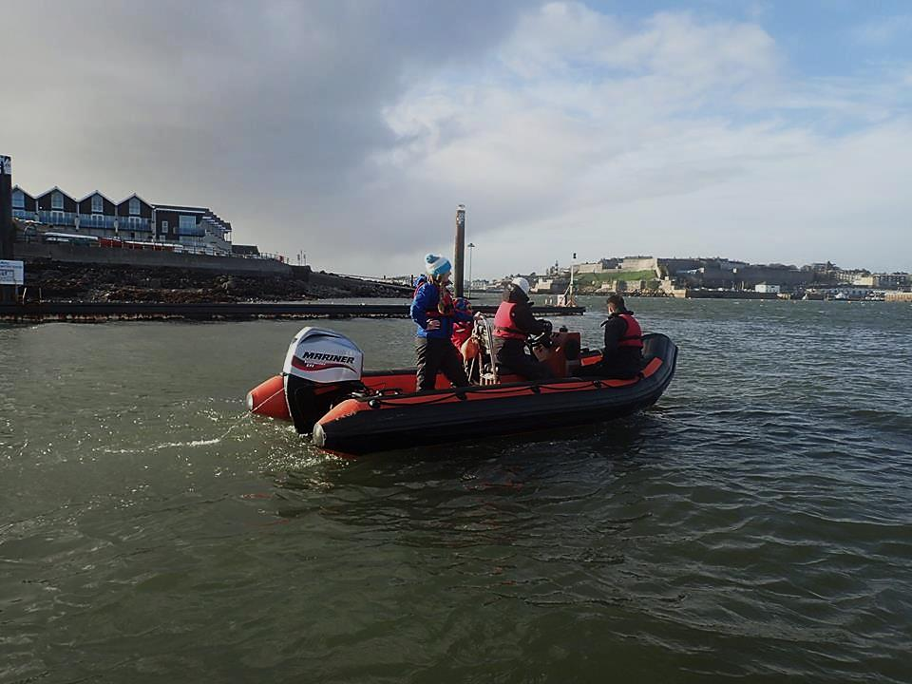**Chapter 3: Environmental contribution to learning.**

Image 2*: Underestimating environmental conditions for power boating near Sutton Harbour.* Leather (2017)

*“It was the end of November, how can I expect to be warm and dry whilst power boating? Of course not, extra layers and a determined attitude seemed to be best and only option to get through this day.”*(Claydon-Smith, 2017)

From my own perspective, the environment plays a crucial part in physical and emotional learning. According to Smith & Knapp (2011: 84) those who find themselves with an opportunity to learn in the outdoors, must embrace the physical environment around them by using a variety of senses to further attribute towards maximal engagement and learning. Crucially, it highlights how a positive approach towards the environment may improve the learning experience. Throughout my experiences, I knew that I would not develop within safe settings and although it was cold, wet and windy, the overall conditions provided an excellent learning opportunity. Conversely, it lacks evidence to support such a claim, and yet provides reason to question further the impact the environment has towards learning behaviours.

*“The conditions were dramatically changing one moment a ray of light would provide warmth and next an overshadowing cloud would bring a shower of cold wet and miserable rain. But I was not held back by the weather, when practicing man over board it provided a physical challenge that positively contributed toward my learning experience, after all smooth seas do not accompany great power-boaters.”* (Claydon-Smith, 2017)

The element of added challenge and skills would further contribute towards physical learning behaviours and refers to the ‘model of optimal arousal’ (See Figure 3.1). Initially, this model theorises on a learner by demonstrating the differing levels of ‘arousal’ that overall determines their performance and learning outcomes (Ewert & Sibthorp, 2014). This relates closely to figure 2.3, but relaxes the instructor capability towards the contribution made towards the learning experience.

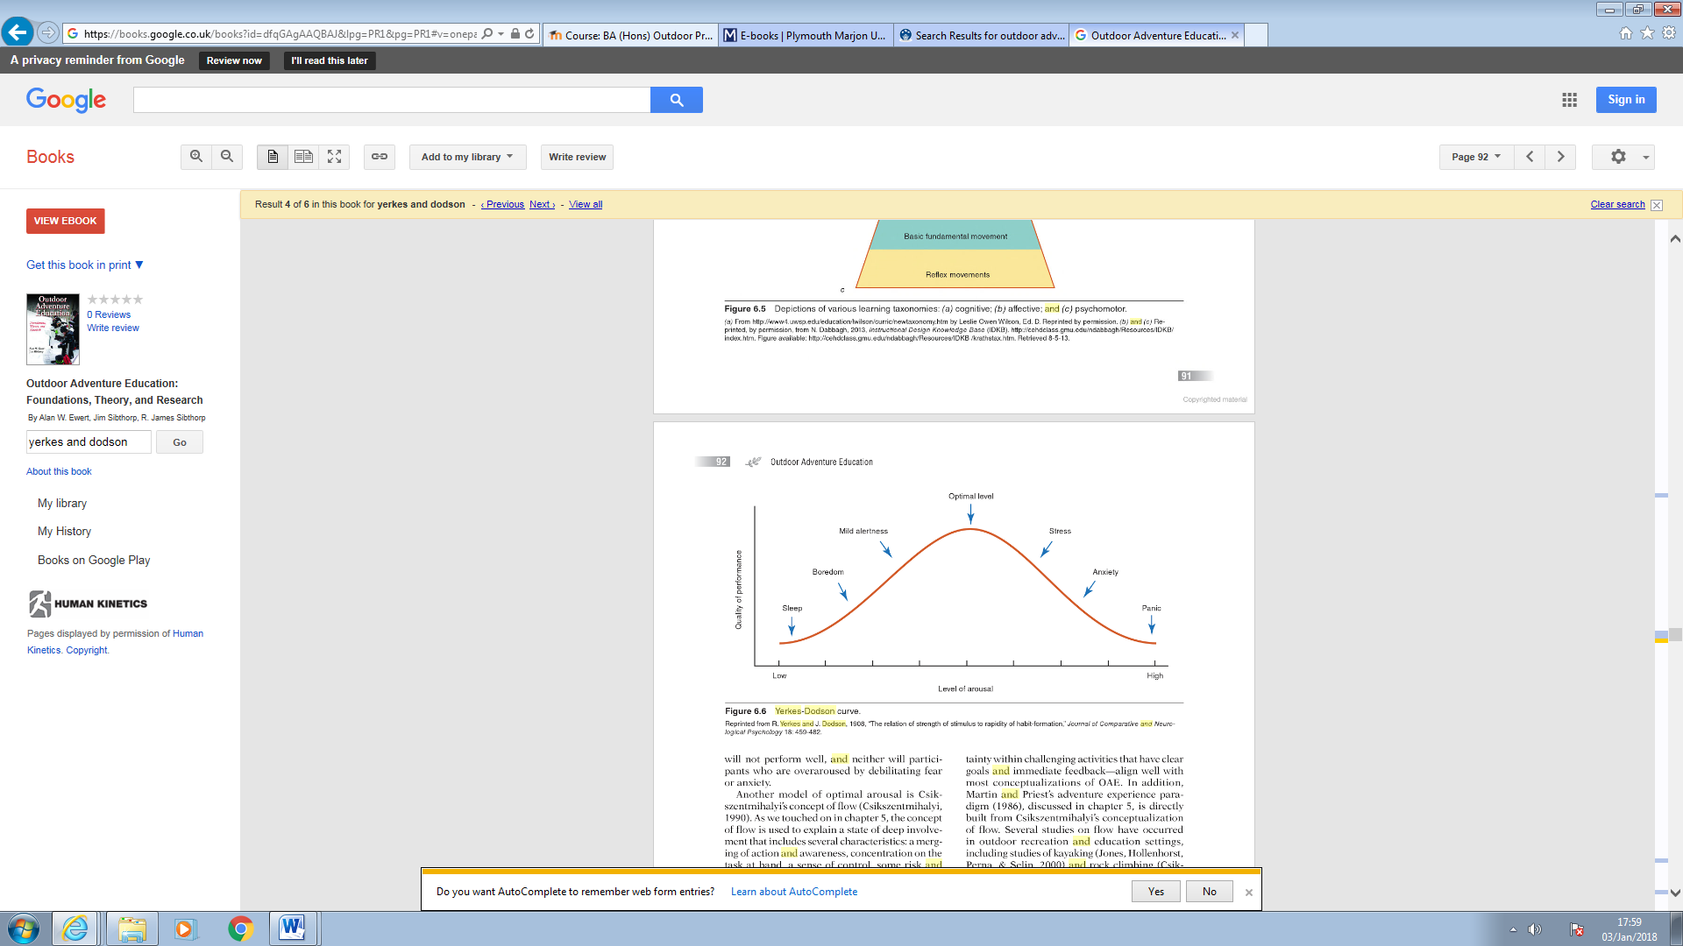

Figure 3.1: *Model of Optimal Arousal* (Yerkes & Dodson, 1908, cited in Ewert & Sibthorp, 2014: 92)

Essentially, this model adapts the original model developed by Yerkes and Dodson in 1908, which demonstrates the simplicity of the model, sectioning three factors included with altered ranges between arousal and performance. Where the arousal increases so does the quality of the learning experience but it also suggests that if the arousal level of the individual reaches a certain level the individual will enter the ‘danger zone’ determining the suffering of performance and neglect towards learning associated (Ewert & Sibthorp, 2014; Corbett, 2013; Reeve, 2009)

*“Is it time to call it a day? I was beginning to feel bored, challenged at first but nothing was stimulating my attention, I was falling back into a state of boredom; I could not help but pay close attention towards the cloud forming over Plymouth and hoped for a storm to occur, the waters were already rough and choppy but by now I want to experience what it feels like to learn in an environment that pushes my limits. Thankfully, we as a group decided to take a trip past Plymouth Sound to experience the waters that were blockaded by the breakwater, I’m excited and anxious at the same time, if it is all too much, then this can go wrong very quickly.”* (Claydon-Smith, 2017)

Crucially, my reflective practice unknowingly provided a practical guideline into the understanding of the model of arousal. Describing how the challenging environment would provide a crucial element towards increasing and decreasing levels of arousal and perhaps anticipated the emotional response to an environment that is too much for me to learn and perform inside of. According to Ewert & Sibthorp (2013) people will naturally seek to face challenging situations based on their previous learning. Leading to a significant argument; where I may have learned from past experiences that are unique to my learning, others may have not had the same opportunities. From where, I may have been eager to reach an optimum level of learning but others may have already reached that level near Sutton harbour.

Critically, this model demonstrates a rather linear, smooth and static guideline into understanding how the contribution of; arousal, physical performance learning and environmental elements that shape outcomes (Corbett, 2013). Corbett (2013) and Bissell (2008) point out that this model does not accompany the complexity of such relationships, and shares beliefs that settings required for learning, is never static but rather unstable. From my own perspective, I could not help but question whether learning is equal in comfortable and uncomfortable situations and how the environment not only contributes towards physical learning behaviours but towards emotional and social learning behaviours.

*“So far, I feel like I have achieved something that may be insignificant to some. But, the element of working towards a level 2 in power boating has had a lasting impact both personally and professionally, where I feel I have developed emotional, social and intellectual skills.”* (Claydon-Smith, 2017)

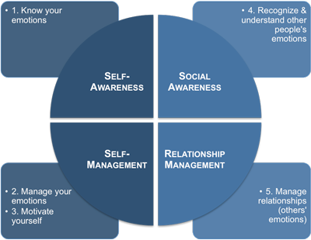Furthermore, the learning achieved through this multi-day intensive programme, has had a significant impact emotionally. According to Mortiboys (2012) emotional development refers highly to ‘emotional intelligence’ or ‘EI’, and assumes; emotional understandings, limitations and responses towards one’s-self and those socially connected around them. Many researchers are conflicted by the process of EI and its developmental learning behaviours, where many researchers believe that EI is multi-dimensional, and relates highly to characteristics associated with experiences. To personality traits that to some degree shape the way one may emotionally respond towards differing environments (Gong et al., 2017). It provides a certain level of confusion associated with research and further supports the reasoning behind Schunk (2012) who suggest learning on all aspects is vaguely understood. However, it is clear that emotional intelligence is a learning behaviour that is influenced through experiences met by adventurous scenarios. Goleman (1995) assisted in providing a framework for their contribution to develop various learning behaviours including emotional intelligence. (See Figure 3.2)

Figure 3.2: *Model of Emotional Intelligence.* (Goleman, 1995, cited in Team FME, 2014)

This model represents four factors: self-awareness, self-management, social awareness and relationship management. This model further recognises that emotional intelligence is a learning behaviour that can have an influence on social environments. According to Priest & Gass (2017) social groups of small quantity within outdoor settings can be influenced by ones emotional intelligence that ultimately is required to solve problems, create an easier social environment and influence the outcome of the activity; which assumes the nature of the model represented. (Figure 3.2)

However, this understanding of emotional intelligence is an area of ‘self-teaching’ through informal adventurous scenarios (Berry & Hodgson, 2011). So, to say that I have developed emotionally could mean that I had a high emotional response to the positive outcomes of the adventurous programme and not further developed my emotional intelligence (Berry & Hodgson, 2011) this is due to the fact that although I was presented with a unique social environment, the programme was intentionally designed to be accomplished through instructional control.

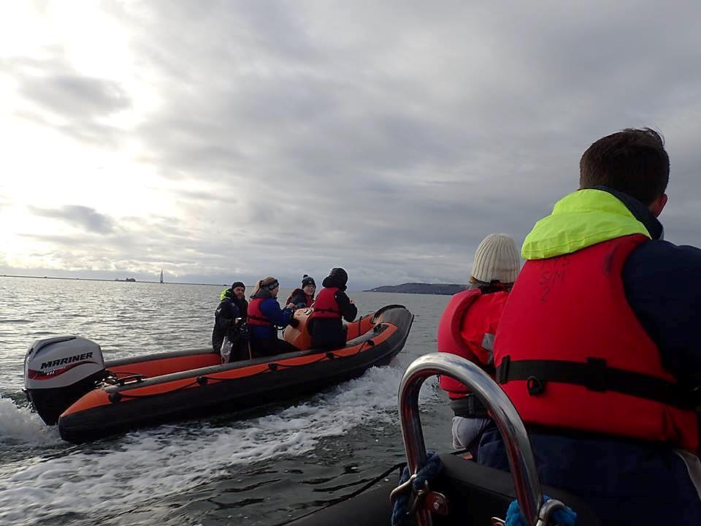**Chapter 4: Group dynamics to individual learning needs**.

Image 3: *Parallel to similar social environments on the Plymouth Sound*. (Nicholls, 2017)

*“My place in this group was isolated outside of power boating. Yet, I felt a part of the group dynamics and a crucial player amongst the group needs and outcomes.”* (Claydon-Smith, 2017)

The individuals’ role socially; understands a group due to ‘surface level attributes’, such as gender and ethnicity. Additionally, isolation from everyday life into adventurous settings see to ‘deep level attributes’, such as values and personality, becoming more influential (Jostad et al., 2015). Conversely, individuals will identify as a group rather than a strengthened independent (Ashworth, 2017). To some extent, practical level involvement in outdoor practice may establish these ‘deep level attributes’ and help ignore ‘surface level attributes’ to build trust within groups. (Chang et al., 2017; Jostad et al., 2015).

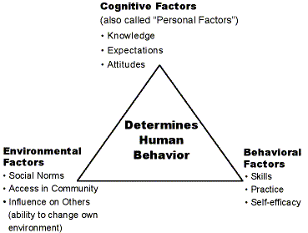My place inside this social environment had shifted on a short term basis, perhaps the isolation from society’s norms had influenced a socio-environment to share, collaborate and experience from; which questions whether this was influenced by the practice or by those within the session. According to Ryan (2012) research associated with understanding social learning behaviours can be better understood by the works of Bandura (1988), who developed the ‘social learning and social cognitive theory (1988)’. (See Figure 4.1)

Figure 4.1: Social learning Theory. (Bandura, 1988, cited in Instructional Design Toolbox, 2017.)

This model demonstrates the relationship between cognitive, environmental and behavioural factors that influence the social learning.

Bandura understood social learning to occur on an observational stand point where individuals interact as a group but continuously observe the social dynamics from where learning occurs by consequences caused by interactions met by others within the group. Kolodziej (2015) understands how this theory understands how individuals duplicate knowledge of group members to solve problems existing with potential activities such as outdoor practice.

*“We had to approach unique features on the Plymouth Sound within 2 metres. That seemed easy but to do so whilst fighting the tide and trying to stay in the same position was difficult. I could see the other group attempt to do the exact same thing only with a different feature, I could see how they drifted off when they approached the feature from different angles, and I used this as a learning point.”* (Claydon-Smith, 2017)

From this we draw upon Banduras social learning theory, where personal learning took place by the means of others mistakes. This was an observational effort to achieve the desired outcome throughout my experience. However, it does not fully comprehend the social positioning of myself within the group, practice and environment.

Another perspective of social learning occurs through the means of social constructivism, the hypothesis that was originally developed by Vygotsky. According to Kiraly (2014), the meaning of social learning is created by each individual. Kiraly (2014) claims that Vygotsky’s theory of social constructivism further illustrates how each individual is not alone when learning; “We learn to communicate, and then to think, by sharing and contrasting perspectives with other members of the communities to which we belong.” (Kiraly, 2014: 34). Demonstrating, how social collaboration can certainly determine the learning outcome through the means of internal and passive forms of communication. Ewert & Sibthorp (2014) determine Vygotsky’s social constructivism theory to be at the forefront of all social theories opposing such works of Paiget’s study of cognitive constructivism where the individual learns internally and separate; away from social collaborative forms of learning.

*“I felt like I was on a different page to others within the group, I found my learning to be very different and separate from the rest.”* (Claydon-Smith, 2017)

Critically, these theories are parallel to each other and are opposing hypothesises that equally occur through experiences. However, throughout the multi-day intensive power boating programme, it is evident that these theories can exist together and thus, supports the argument to theorise upon a hypothesis that conjoins both. This helps provide reasoning into how the learners responsibility to learn (Bruce et al., 2014) where appropriate guidelines should be considered in practice (See table 4.2)



Table 4.2: *How we develop emotional competencies*. (Outward Bound, 2017)

This table developed by Outward Bound (2017) instigates a guideline tool for outdoor practitioners to use and understand throughout all forms of outdoor practice. By means of understanding how emotional, social and personal competencies contribute towards learning outcomes. Thus, provides an understanding into how these learning behaviours can potentially be developed. This presents a meaning to explore differing ways and approaches to use through contemporary outdoor practice. Essentially, it provides evidence that the outdoor adventurous educational community are not blind from this topic and are working towards an optimum level of knowledge associated with this field of research.

*“As an outdoor practitioner or rather outdoor experiencer, I find the urge to do more, understand more and contribute more to the outdoor community. Perhaps, this can be attained through developing new research or exploring unknown areas. A romantic fantasy I know, but it begs the question, will my version of what I know of the outdoors change into something unique? Perhaps, my qualification that I have achieved, maybe irrelevant to others in the future; maybe the outdoors will soon be more about how we connect and build as community rather than conquering mountains and gaining NGBs.”* (Claydon-Smith, 2017)

Which provides a crucial point in this research, if everything is a social construction (Ewert & Sibthorp, 2014) then the idea to find new ways to research areas such as learning behaviours would not seem ludicrous. From a personal perspective, the models and research associated with areas such as social learning may only conclude to un-authentic and over complex theoretical tangents to follow. The idea that we should refer back to the simplistic works of Kolb and Dewey (Ord & Leather, 2011) may seem appropriate but critically negative if we are to discover new ways to better finesse the learning of learning, specifically, in outdoor practice.

**Chapter 5 – Conclusion**

This essay critically analyses the physical, social, emotional and cognitive aspects of my own personal learning during an intensive multi-day professional development skills programme. The reflective practice of this course that specifies in the completion of my RYA level 2 power boating course has provided further engagement into research associated with learning. In addition, reflective practice has been achieved by means of imagery as seen throughout, helping explicit in-depth emotionally journal led accounts of this programme; overall strengthening research associated with this essay. Providing, an enrichment of knowledge to transfer into future professional and personal outdoor settings that I may find myself in. Critical understandings from current literature and commonly functioned models, developed by leading researchers has helped me attain valuable and adequate reasoning to continuously learn about myself, how others learn and how differing learning environments are shaped by various factors that ultimately influence learning outcomes. By doing so, I hope to engage in future outdoor practice with a higher element of anticipated learning requirements that I can progress from. However, this essay contributes towards a fractional level of these factors associated with the broad and underestimated term ‘learning’.

**References:**

Ashworth, D. (2017) Can communitas explain how young people achieve identity development in outdoor adventure in light of contemporary individualised life?. *Journal of Adventure Education and Outdoor Learning*. Vol. 17, No. 3: 216-226.

Bandura, A. (1988) Organizational Application of Social Cognitive Theory. *Australian Journal of Management*. Vol. 13, No. 2: 275-302.

Berry, M. and Hodgson, C. (Eds.) (2011) *Emotional Intelligence: Why It Can Matter More Than IQ*. (1st ed.) Abingdon, Oxon: Routledge.

Bissell, J. (2008) Comfortable Bodies: Sedentary Affects. *Environment and Planning*. Vol. 40, No. 7: 1697-1712.

Bruce, M., Bruenig, M., Wagstaff, M. and Goldenberg, M. (Eds.) (2017) *Outdoor Leadership*. (2nd ed.) Champaign, IL: Human Kinetics.

Bunting, C.J. (Ed.) (2006) *Interdisciplinary through outdoor education*. Champaign, IL: Human Kinetics.

Chang, T., Tucker, A., Norton, C., Gass, M. and Javorski, S. (2017) Cultural issues in adventure programming: applying Hofstede’s five dimensions to assessment and practice. *Journal of Adventure Education and Outdoor Learning*. Vol. 17, No. 3: 1-14.

Claydon-Smith, K. (2018) *Day 1 of Power Boating*. [Online] 05 January 2018. Available from: <http://sites.marjon.ac.uk/kdclaydonsmith/wp-admin/customize.php?url=http%3A%2F%2Fsites.marjon.ac.uk%2Fkdclaydonsmith%2F> [accessed 05 January 2018].

Claydon-Smith, K. (2018) *Day 2 of Power Boating*. [Online] 05 January 2018. Available from: <http://sites.marjon.ac.uk/kdclaydonsmith/wp-admin/customize.php?url=http%3A%2F%2Fsites.marjon.ac.uk%2Fkdclaydonsmith%2F> [accessed 05 January 2018].

Claydon-Smith, K. (2018) *Day 3 of Power Boating*. [Online] 05 January 2018. Available from: <http://sites.marjon.ac.uk/kdclaydonsmith/wp-admin/customize.php?url=http%3A%2F%2Fsites.marjon.ac.uk%2Fkdclaydonsmith%2F> [accessed 05 January 2018].

Corbett, M. (2013) Cold comfort firm: Lean organisation and the empirical mirage of the comfort zone. *Culture and Organization*. Vol. 19, No. 5: 413-429.

Csikzentmihalyi, M. (Ed.) (1990) *Flow: The Psychology of Optimal Experience*. (1st ed.) New York: Harper and Row.

Ewert, A. and Sibthorp, J. (Eds.) (2014) *Outdoor Adventure Education Foundations, Theory, and Research*. (1st ed.) Champaign, IL: Human Kinetics.

Felder, R.M. and Silverman, L.K. (1988) Learning and Teaching Styles in Engineering Education. *Engineering Education*. Vol. 78, No. 7: 674-681.

Goleman, D. (Ed.) (1996) *Emotional Intelligence: Why It Can Matter More Than IQ*. (1st ed.) Soho, London: Bloomsbury.

Gong, X., Fletcher, K. and Paulson, S. (2017) Comfortable Bodies: Sedentary Affects. *Personality and Individual Differences*. Vol. 10, No. 6: 71-76.

Instructional Design Toolbox (2017) *Social Learning Theory (Bandura)*. [Online] Available from: <http://idtoolbox.eseryel.com/social-learning-theory.html> [accessed 13 December 2017].

Jostad, J., Sibthorp, J., Pohja, M. and Gookin, J. (2015) The Adolescent Social Group in Outdoor Adventure Education Social Connections That Matter. *Research in Outdoor Education*. Vol. 13, No. 1: 16-37.

Kiraly, D. (Ed.) (2014) *A Social Constructivist Approach to Translator Education*. (2nd ed.) Abingdon, Oxon: Routledge.

Kolb, D.A. (Ed.) (1984) *Experiential learning: Experience as the source of learning and development*. (1st ed.) Prentice-Hall, NJ: Englewood Cliffs.

Loeffler, T.A. (2004) A picture is worth... capturing meaning and facilitating connections: Using outdoor education students' photographs. *Australian Journal of Outdoor Education.* Vol. 8, No. 2: 56-67.

Loeffler, T.A. (2005) Looking Deeply In: Using Photo-Elicitation to Explore the Meanings of Outdoor Education Experiences. *Journal of Experiential Education*. Vol. 27, No. 3: 343-346.

McLeod, S. (2017) *Kolb - learning styles*. [Online] 11 October 2017. Available from: <https://simplypsychology.org/learning-kolb.html> [accessed 12 December 2017].

Mitchell, M. and Morris, M. (2013) Sport Education and Multiple Intelligences: A Path to Student Success. *Journal for Physical and Sport Educators*. Vol. 26, No. 4: 31-34.

Mortiboys, A. (Ed.) (2012) *Teaching with Emotional Intelligence*. (2nd ed.) Abingdon, Oxon: Routledge.

Ord, J. and Leather, M. (2011) The Substance Beneath the Labels of Experiential Learning: The Importance of John Dewey for Outdoor Educators. *Australian Journal of Outdoor Education*. Vol. 15, No. 1: 1-11.

Outward Bound (2017) *How we develop emotional competencies.* [Online] Available from: <https://www.outwardbound.org.uk/media/293446/how-we-develop-emotional-competencies.pdf> [accessed 14 December 2017].

Priest, S. and Gass, M. (Eds.) (2017) *Effective Leadership in Adventure Programming*. (3rd ed.) Champaign, IL: Human Kinetics.

Reeve, J. (Ed.) (2009) *Understanding motivation and emotion*. (5th ed.) Hoboken, NJ: Wiley.

RYA (2017) *Level 2 Powerboat Handling*. [Online] Available from: <http://www.rya.org.uk/courses-training/courses/powerboat/Pages/level-2.aspx> [accessed 12 December 2017].

Ryan, R. (Ed.) (2012) *Oxford Handbook of Human Motivation*. (1st ed.) Oxford: Oxford University Press.

Schunk , D. (Ed.) (2012) *Learning Theories An Educational Perspective*. (6th ed.) Boston, MA: Pearson Education Inc.

Smith, T. and Knapp, C. (Eds.) (2011) *Sourcebook of Experiential Education Key Thinkers and Their Contributions*. (1st ed.) New York: Routledge.

Team FME (2014) *Understanding Emotional Intelligence*. [Online] Available from: <www.free-management-ebooks.com> [accessed 13 December 2017].

Wagstaff, M. and Attarian, A. (Eds.) (2009) *Technical Skills for Adventure Programming: A Curriculum Guide*. (1st ed.) Champaign, IL: Human Kinetics.

Yerkes, R.M. and Dodson, J.D. (1908) The Relation of Strength of Stimulus to Rapidity of Habit-Formation. *Journal of Comparative Neurology and Psychology*. Vol. 18, No. 5: 459-482.

**Appendices**

**Appendix A: The six stages of Buntings experiential teaching model (Bunting, 2006: 7, cited in Wagstaff & Attarian, 2009: 21).**

*Stage 1 – Knowledge:* An idea is triggered by an experience, reading or need. Know the standards (objectives) of own subject area and be familiar with standards of other areas. Know a variety of outdoor adventurous education activities.

*Stage 2 – Planning:* Plan experiences (activities) to illustrate concepts and useful skills while also reinforcing concepts from other disciplines.

*Stage 3 – Implementation:* Facilitate the experience(s). Actively comment and question during the activity(s) to add to students thought process, and follow the activity with reflective and purposeful/ discussion. (Refer to Appendix D for model shown in Stage 3)

*Stage 4 – Reflection:* Review specific objectives of the lesson, how the experience went and if objectives seemed to be met. Get student feedback. Discuss session with other teachers and ask for ideas.

*Stage 5 – Evaluation:* Determine if the lesson objectives were met at the desired end.

*Stage 6 – Adaptation:* Allow results of stages 4 and 5 to re-inform current knowledge. This leads to new ideas for ‘next time’.

**Appendix B: Multiple Intelligences adapted from Mitchell & Kernodle (2013)**

*Linguistic –* This is an area that specialises in verbal communication and written language. Those with high linguistic intelligence may find reading, telling and writing stories more efficient including the ability to memorise words and names more effectively.

*Spatial -* This is an aspect of intelligence measured by the ability to visualise space, objects and surrounding areas.

*Bodily Kinaesthetic –* An aspect, of intelligence, that measures one’s ability to function high bodily functions in practical and skilful situations. In addition, those with high intelligence in this specific area may find physical exercise, hand to eye co-ordination and the ability to train response more effective.

*Naturalistic –* This is an area of intelligence that is described in the works of Mitchell and Kernodle (2013) but has only recently become relevant in research. This aspect of intelligence refers to one’s ability to recognise patterns, demonstrate eco-environmental knowledge and connect to the natural world more efficiently. Those with high intelligence in this area may find agriculture and biological science more professionally appealing.

*Rhythmic –* This refers to sound and the individuals sensitive towards rhythm, vibrations, tones and melody. This may include those who are able to play musical instruments and compose music vocally and vocationally.

*Mathematical –* This area relates highly to critical thinking, numbers and logical reasoning. Those high in this area may find the subject’s mathematics and physics more relatable.

*Interpersonal –* This relates more fluently with those who are able to work and operate in social settings. This can mean that they thoroughly understand and react effectively to others: moods, feelings and motivations. Those high in this area, may find communicating their debates and discussions more effective in group placed scenarios.

*Intrapersonal –* This aspect of intelligence refers to an individual’s ability to understand their own limitations. Those high in this area may find it easier to comprehend self-reflective practices and anticipate their own emotions in a variety of settings.

**Appendix C: EduBlog (Claydon-Smith, 2018)**



**Appendix D: Kolb’s experiential learning mode (Kolb, 1984: 38, cited in McLeod, 2017)**

