Exercise Rehabilitation Plan
Patient Name:
Date:

Exercise | Mon | Tues | Wed | Thurs | Fri | Sat | Sun
1
2
3
4
5
Lower Back Rehabilitation Sheet
- Use the following table to create a weekly plan

- Use the following table to tick off when you have completed your exercises
 | Mon | Tues | Wed | Thurs | Fri | Sat | Sun
Week 1
Week 2
Week 3
Week 4
Week 5
Week 5

Notes:
______________________________________________________________________________________________________________________________________________________________________________________________________________________________________________________
Prayer Stretch Reps_________ Sets_________
Push chest towards the floor
- Reach as far as possible
- Hold 5-10 seconds
- Repeat 5 times
Twist stretch Reps_________ Sets_________
- Keep shoulders as flat on floor as possible
- Hold for 30seconds

Trunk Rotation Reps_________ Sets_________
- Back flat and feet together
- Rotate both knees together to the side
- Hold for 3 seconds
- Do daily
--------------------------------------------------------------------------------------------------------------------------------------
Knee Tucks Reps_________ Sets_________
- Hands behind back of knees
- bring knees to chest until you feel a stretch
- Keep back relaxed
- Hold 5-10seconds
- Try with 1 leg (see additional image)

Quadruped Reps________ Sets_________
- Slow and controlled
- Can alternate from opposite arm/leg to same side arm/leg
--------------------------------------------------------------------------------------------------------------------------------------
Cat/camel Reps________ Sets_________
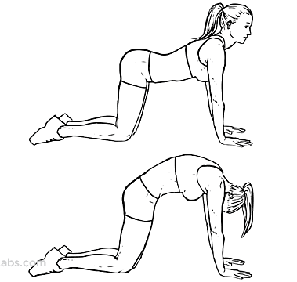
- Maintain straight arms
- Slow and controlled
- Hold each pose for up to 10seconds

__________________________________________________________________________________
Bridge Reps________ Sets_________
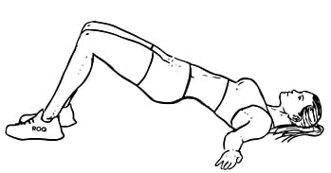
- Keep both shoulders on flat on the floor
- Adjust distance between heels and bottom
- Drive hips up so that your shoulder, hips and knees are inline
- Lift heels for alternative stretch for hamstrings
- Slow and controlled

__________________________________________________________________________________

