Exercise Rehabilitation Plan
Patient Name:
Date:

Exercise | Mon | Tues | Wed | Thurs | Fri | Sat | Sun
1
2
3
4
5
Shoulder Posture Rehabilitation Sheet
- Use the following table to create a weekly plan

- Use the following table to tick off when you have completed your exercises
 | Mon | Tues | Wed | Thurs | Fri | Sat | Sun
Week 1
Week 2
Week 3
Week 4
Week 5
Week 5

Notes:
______________________________________________________________________________________________________________________________________________________________________________________________________________________________________________________
Door Frame Stretch Reps_________ Sets_________
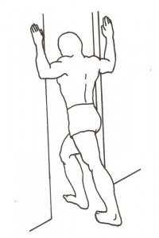
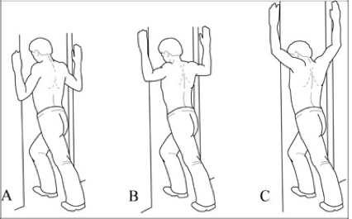
- Hold for 30 secs
- Repeat 3 times
- Alter positioning of arm (see additional image)

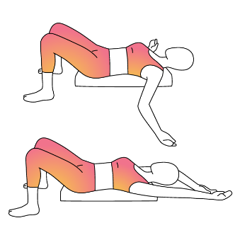
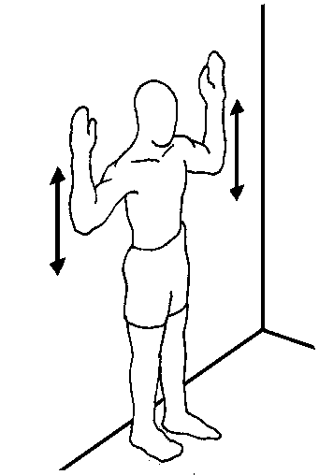
Wall angels Reps_________ Sets_________
- Slow and controlled
- Keep as much of your body in contact with surface
- Can be done on the floor or against wall
- Add bolster or foam roller (see second image)

--------------------------------------------------------------------------------------------------------------------------------------
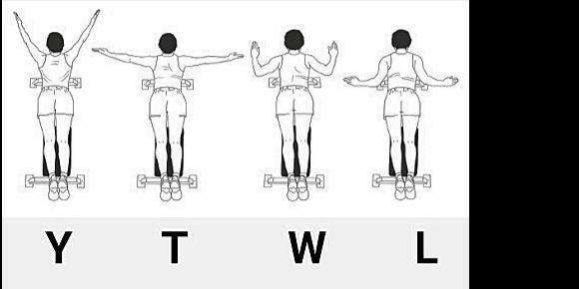
Y, T, W, L exercises Reps_________ Sets_________
- Use exercise ball, bench or bed
- Add weights to add resistance
(dumbbells, filled bottles, tin of beans!)
- Maintain scapular position (squeeze together)
- Slow and controlled
--------------------------------------------------------------------------------------------------------------------------------------
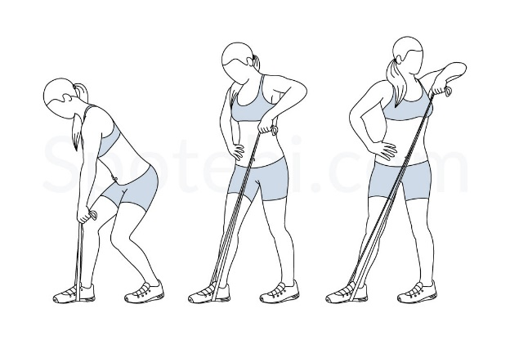
Lawn mower mobility exercise Reps________ Sets_________

- Can be done using a weighted object instead of resistance band
- Slow and controlled

--------------------------------------------------------------------------------------------------------------------------------------
Low row scapular exercises (see variations) Reps________ Sets_________
