Subjective Examination – Sports Therapy Date................................
Client Name...................................................................................... DOB..................................
Address.......................................................................................................................................
Therapist Name.........................................................................................................................
Consent for Assessment and treatment: Yes/No
Medical form completed and attached: Yes/No
Current issue (VAS pain and pain presentation etc): .......................................................................................................................................................................................................................................................................................................
.................................................................................................................................................... .................................................................................................................................................... ....................................................................................................................................................
Relieving Factors:
........................................................................................................................................................................................................................................................................................................
Aggravating factors:
........................................................................................................................................................................................................................................................................................................
Other diagnosis (x-ray/MRI) and treatments performed and rehabilitation assigned:
.................................................................................................................................................... .................................................................................................................................................... ....................................................................................................................................................
Other comments:
........................................................................................................................................................................................................................................................................................................
Objective Examination – Sports Therapy
Clinical impression from subjective: .................................................................................................................................................... ....................................................................................................................................................
Observation (oedema, hematoma, heat, redness, obvious deformities):
.................................................................................................................................................... ....................................................................................................................................................
Palpation (specific area of palpation and pain):
.................................................................................................................................................... .................................................................................................................................................... ....................................................................................................................................................
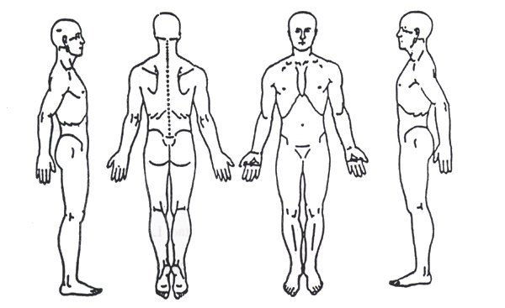
Assessment:
Joint above cleared? (circle) +ve -ve Joint below cleared? (circle) +ve -ve
Joint Movement | Active |  | Passive |  | Resisted (1-5)
 | Left | Right | Left | Right | Left | Right

Special Test | Result (+ve or –ve) | Comments
Treatment performed:
.................................................................................................................................................... .................................................................................................................................................... .................................................................................................................................................... ....................................................................................................................................................
Rehabilitation and/or further programme of exercise assigned to client:
.................................................................................................................................................... .................................................................................................................................................... .................................................................................................................................................... ....................................................................................................................................................
Client Signed...................................................................................Date.....................................
Therapist Signed.............................................................................Date.....................................

