Rationale -
Pupil’s mental health and emotional wellbeing is an essential aspect in respect to children’s perception of the world, as well as their readiness to learn and develop holistically. It Is essential that children are accurately educated and supported with their understanding of emotional wellbeing to overall benefit their development and attainment throughout their education . (Stirling & Emery, 2016)
Importance of books
Bellow you will find three lesson plans that I have designed to focus on two main aspects of emotional wellbeing; concept one: valuing and protecting our environment, concept two: understanding and taking responsibility for our own actions. It is important with the growing concern of pollution upon our planet that children are aware of measures that can reduce their carbon footprint. In addition, it is important that children understanding their actions have consequences and that they are responsible for the consequences that follow their actions.
The entirety of all three learning resources are centred around a well-known Dr Seuss book, The Lorax. particularly, focusing on the impact that the Once-ler has upon the environment and how he takes responsibility for his actions and helps to rebuild what he destroyed (the environment)
Lesson one –
Lesson one begins with group interactive learning, where all pupils and the teacher work together to brainstorm words (their understanding) that correspond with the target word/s (Environment and Responsibility). The reason behind starting the activity with group understanding of the words Environment and Responsibility was because of the significant and importance of these words in relation to the entirety of the lessons and topic. The activity then moves onto a short YouTube clip of the introduction of The Lorax where the Lorax and the Once-ler meet. (ref to Appendices 2.3) The resulting aspect of the lesson closes with character profiles, where pupils will individually provide words that relate to the character they are describing and how they protect or destroy the environment. (Ref to Appendices 2.8 and 2.9, printable worksheets 1.1)
Lesson two –
Commencing lesson two, pupils are asked to watch another short YouTube clip, where pupils are able to gain an insight into the difference and impact the Once-ler had upon the Lorax’s environment. Before pupils individually move onto their worksheet tasks, pupils are to group interact and produce written notes to help support and prompt them during their worksheet tasks. (Ref to slide Appendices 3.3) I chose to include another YouTube clip to provide children with a basis of visualising the impact upon the environment the once-lers actions had, as well as, scaffolding for pupil’s individual worksheet tasks.
Worksheet one, task one – (Refer to Appendices 1.1)
I chose to design a worksheet that allows pupils to both provide written and imagine perceptions and understanding of the impact the Once-ler had upon the Lorax’s environment. Task one provides opportunity for children to expand and use their own individual creativity and imagination. In addition to providing the teacher with their individual understanding and perception.
Worksheet one, task two – (Refer to Appendices 1.1)
Encourages and allows pupils to expand their vocabulary and understanding through effectively using a dictionary/thesaurus to successfully associate words with the corresponding characters.
Learning resource three –
The third and final learning resource commences with pupils identifying and understanding various aspects of protecting the environment e.g. energy saving, recycling and the reasons behind why and how these areas help protect our environment. (Refer to Appendices 2.8) Pupils are able to gain an understanding into different ways of everyday life that contribute to protecting our environment. Extension task for pupils to provide reason why we should protect the trees, using some of the information located in the fact file (refer to Appendices 3.1)
Worksheet resource – (Refer to Appendices 1.2)
Pupils are asked to use their own creativity and design skills to produce a poster identifying aspects to help protect the environment. “How are you going to help the Lorax protect our environment/world”. Pupils can choose which aspect or aspects previously mentioned in slide 13 and/or choose to extend their task by incorporating facts about the importance of protecting trees. (Refer to Appendices 3.1) Pupils to refer to bullet points of what an effective poster should include (Refer to Appendices 3.2)

LESSON TITLE – identifying our understanding of responsibility and the Environment
Lesson number 1
Wellbeing Area/ concept | Activity | Outcome | Materials/Equipment needed
Valuing and respecting people and the environment  Awareness of our responsibility in protecting the environment.  Mental health Concept 2 & 3 | As a group with support from the student teacher (myself) we will take turns to write/brainstorm our ideas around two key words;  - Responsibility  - Environment  Discussion will include what aspects are we responsible for: completing our homework, taking care of our belongings. As well as looking at how we can protect and look after our environment, playground, parks, ocean, forest.  YouTube input clip -  https://www.youtube.com/watch?v=GZ3fgYIUrJU  YouTube clip to refresh and introduce children to Dr Seuss The Lorax.  Slide 5 – Lorax Character Study, focussing on the Lorax’s role in protecting the Environment.  Slide 6- Once-ler character Study focussing on the Lorax’s role in protecting the Environment | “An individual who enjoys good mental health is able to be sincerely interested in other’s welfare. He has friendships that are satisfying and lasting. He is able to feel as a part of a group without being submerged by it. He takes responsibility for his neighbours and his fellow members” (Department For Education, 2018; Reshma, n.d.)  Understanding the impact upon the environment that one person’s actions has upon the environment. | PowerPoint Document  YouTube clip in activity section  Lorax Book  Interactive Whiteboard
KEY VOCABULARY | Environment, Personality, responsibility, positive impact, negative impact, emotions, personal characteristics

Skill Area | Activity | Outcome | Materials
Identifying aspects that affect our environment.  Understanding that our actions have consequences  Ability to express ideas within a group  Group interaction | As a group identify key aspects that are associated with the word “Environment” and “Responsibility”.  Brainstorm and generate a group character study, discussing aspects of their roles, personalities that contribute to protecting or not protecting the environment. | Identifying comprehensive characteristics of the Lorax.  Linking aspects that occur within the fictional story to real life events and impacts. | Power point document  You tube clip  Interactive whiteboard

LESSON TITLE - What impact on the forest does the Once-ler have?
Lesson number 2
Wellbeing Area/ concept | Activity | Outcome | Materials/Equipment needed
Valuing and respecting people and the environment  Awareness of our responsibility in protecting the environment.  Understanding the impact that one person’s actions have upon the environment  Responsibility for your own actions  Mental health Concept 2 & 3 | Watch the you tube clip, showing the impact the Once-ler had upon the environment.  After watching the you tube clip, as a group brainstorm key words that describe the two different environments (before the Once-ler cut down trees and after)  The group brainstorm ideas will help scaffold for the completing the worksheet activity.  (Slide 8)  As individuals complete the task provided upon the worksheets.  Worksheet tasks –  Task 1: Students to draw their own interpretation of the forest before the once-ler chopped down the trees and after the once-ler chopped down the trees.  (In the boxes provided)  Upon the lines provided students are to write their ideas, descriptions and key words to describe the two different environments. (Describing their above drawing and reasons behind their drawing)  Task two: within the two circles provided for the students, they must cut and stick words from the word bank provided and stick them into either the “Lorax circle” or the “Once-ler circle”  The word bank box has additional squares for students to write their own answers and add to the worksheet. | Identifying the Once-ler’s effects upon the environment of which the Lorax protects.  Understanding one’s impact upon the environment | You tube clip -  https://www.youtube.com/watch?v=gV6Y3OwR2n0  Power point learning resource  Interactive whiteboard  Lesson 2 Worksheets (Appendices 1.1)  Colouring pencils  Writing pencils  Images provided on power point (before and after forest images)  Dictionary and Thesaurus (extended aspect of task 2)
KEY VOCABULARY | Impact, interpretation, environment, responsibility, actions, Environment, Personality, responsibility, positive impact, negative impact, emotions, personal characteristics

Skill Area | Activity | Outcome | Materials
Identifying aspects that affect our environment.  Understanding that our actions have consequences  Ability to express ideas within a group  Group interaction  Creativity and imagination  Designing and drawing skills | Firstly, watch the YouTube clip (Appendices 2.3)  As a group brainstorm idea based on the YouTube clip, particularly identifying the impact upon the environment that the Once-ler has. (Slide 8)  As individuals (pupils) complete worksheet 2 task 1 and task 2. | Gathering information from the YouTube clip pupils are to provide a visual and written perspective of their own version of the Once-ler, his actions and the Lorax and his actions.  . | YouTube clip  Power point slide 8  Worksheet (appendices 1.1)  Colouring pencils and/or pens  Writing pencils and rubbers

LESSON TITLE – How are you going to help the Lorax protect your environment/world?
Lesson number 3
Wellbeing Area/ concept | Activity | Outcome | Materials/Equipment needed
Valuing and respecting people and the environment  Awareness of our responsibility in protecting the environment.  Understanding the importance of protecting our environment.  Mental health Concept 2 & 3 | Group discussion on ways to help the Lorax to protect our environment. E.g. recycling, saving energy etc.  Slide 13 group brainstorm of how students are going to help the Lorax protect their environment.  Slide 14 – group brainstorm on what good posters should include. (Title, informative, eye-catching, creative)  Students are then to create their own poster on how they are going to help the Lorax protect their environment  Students choice of either using the poster template provided or creating their own poster from scratch on A4 paper provided. | Understanding the importance of protecting our environment.  Creatively thinking of ways to protect our environment and ways of helping the Lorax protect the forest.  Understanding different measures in their own day to day routines that help reduce impact to the environment; recycling, saving energy, protecting the ocean, protecting the environment. | Learning power point  A4 paper  Colouring pencils  Writing pencils  Poster template (Appendices 1.2)  How we protect the world on a daily basis slide (Appendices 3.6)  What a good poster should include slide (Appendices 3.9)
KEY VOCABULARY | Protect, environment, Help the Lorax, Recycling, energy saving, personal perspective

Skill Area | Activity | Outcome | Materials
Creativity and design | Design an eye-catching poster on how you are going to help the Lorax protect our environment/world. Using the information learnt throughout the three resources, knowledge of the Lorax and how we protect the environment. | Understand different aspects of protecting the environment  Producing a fact/information accurate and eye-catching poster for your audience  . | Paper  Poster template  Fact sheet slide 14  What makes a good poster slide? Slide 15  How we protect our environment slide 14

Department For Education. (2018). Mental health and behaviour in schools. Retrieved from https://www.gov.uk/government/publications/behaviour-and-discipline-in-schools
Reshma, S. (n.d.). Mental Health: Definition, Components and Indicators. Retrieved April 2, 2020, from http://www.psychologydiscussion.net/health/mental-health-definition-components-and-indicators/2068
Stirling, S., & Emery, H. (2016). NCB (2016) - Framework for Emotional Wellbeing & Mental Health (leaders resources), 1–14.

Appendix-

1.1 – Lesson 2 worksheets
What impact on the forest does the Once-ler have?
Task 1 –
In the first box draw what you think the forest looked like before the Once-ler chopped down the trees.
In the second box draw what you think the forest looked like after the once-ler chopped down the trees.
- Before

write key words to describe the environment before the trees were chopped down -

___________________________________________________________________________

___________________________________________________________________________

___________________________________________________________________________

2. After

Write key words describing the environment after the trees were chopped down -
___________________________________________________________________________
___________________________________________________________________________
__________________________________________________________________________

___________________________________________________________________________

Task 2 –
In one circle cut out and stick words that relate to the Lorax’s perspective and feelings.
In the other circle cut out and stick words that relate to the Once-ler’s perspective and feelings.

LORAX

ONCE-LER
Use the word bank below to cut and stick into the boxes you think they match.
Extension – use the blank boxes to think of your own personalities for both characters.
Word Bank –
Happy | Sad | Angry | Protective
Irresponsible | Responsible | Caring | Greedy

1.2 Lesson 3 Worksheet -
How are you going to help the Lorax protect your environment?

___________________________________________________________________________

Tittle:

_____________________________________________________________________________
_____________________________________________________________________________
-

2.3 – Lesson plan two YouTube link
https://www.youtube.com/watch?v=gV6Y3OwR2n0

2.4 – Power point slide 1

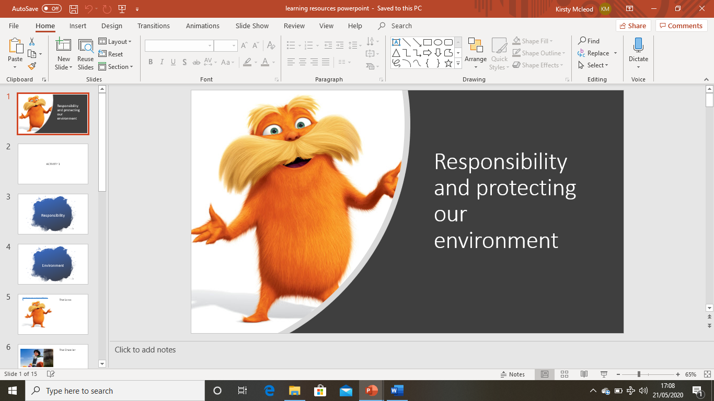

2.5 – Power point slide 2
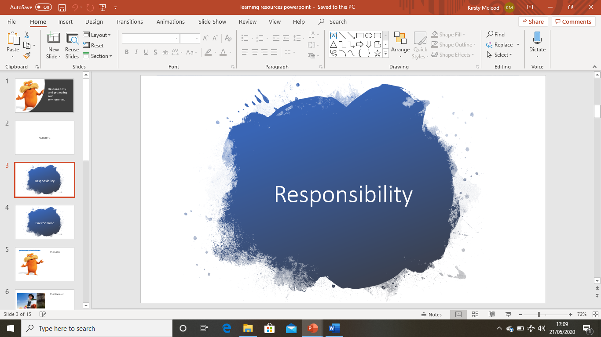

2.6 – power point slide 3 Character Profile 1
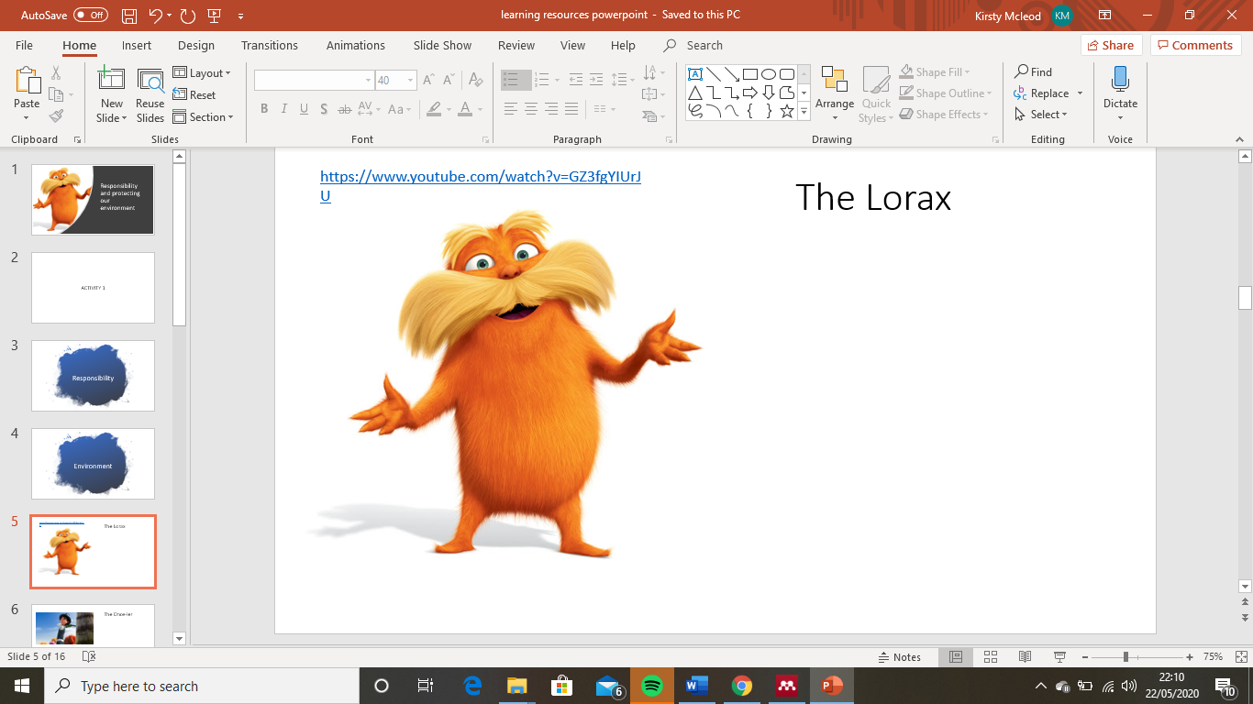

2.7 – power point slide 4 Character profile 2
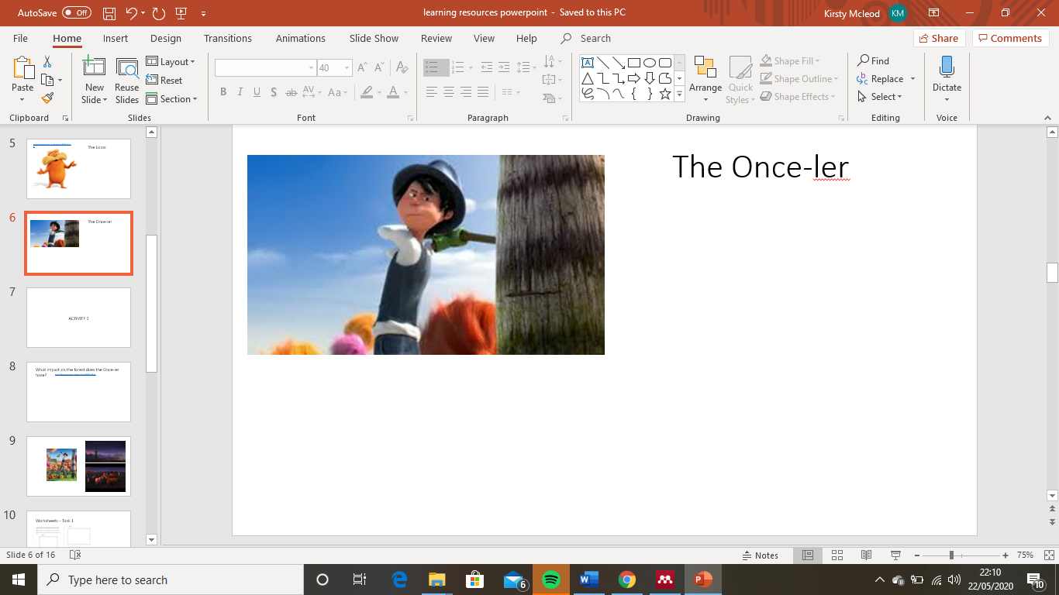

2.8 – power point slide 5 impact on the Environment
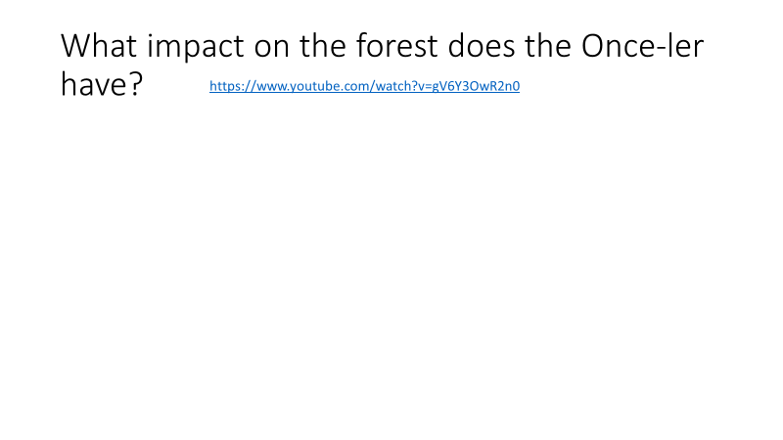

2.9 – power point slide 6 Images showing impact on environment
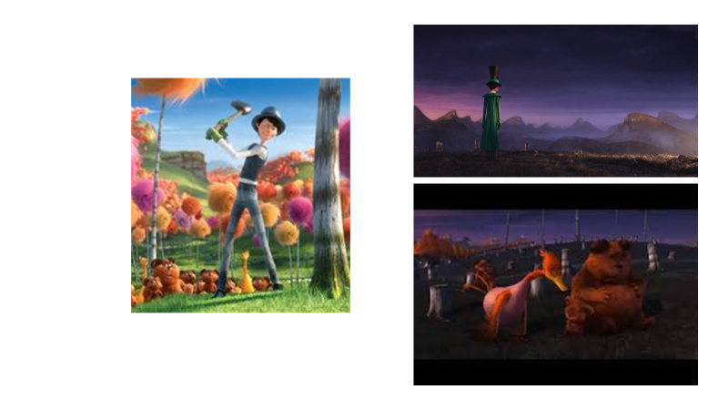

Appendices 3.0 – power point slide 7 How we protect our world
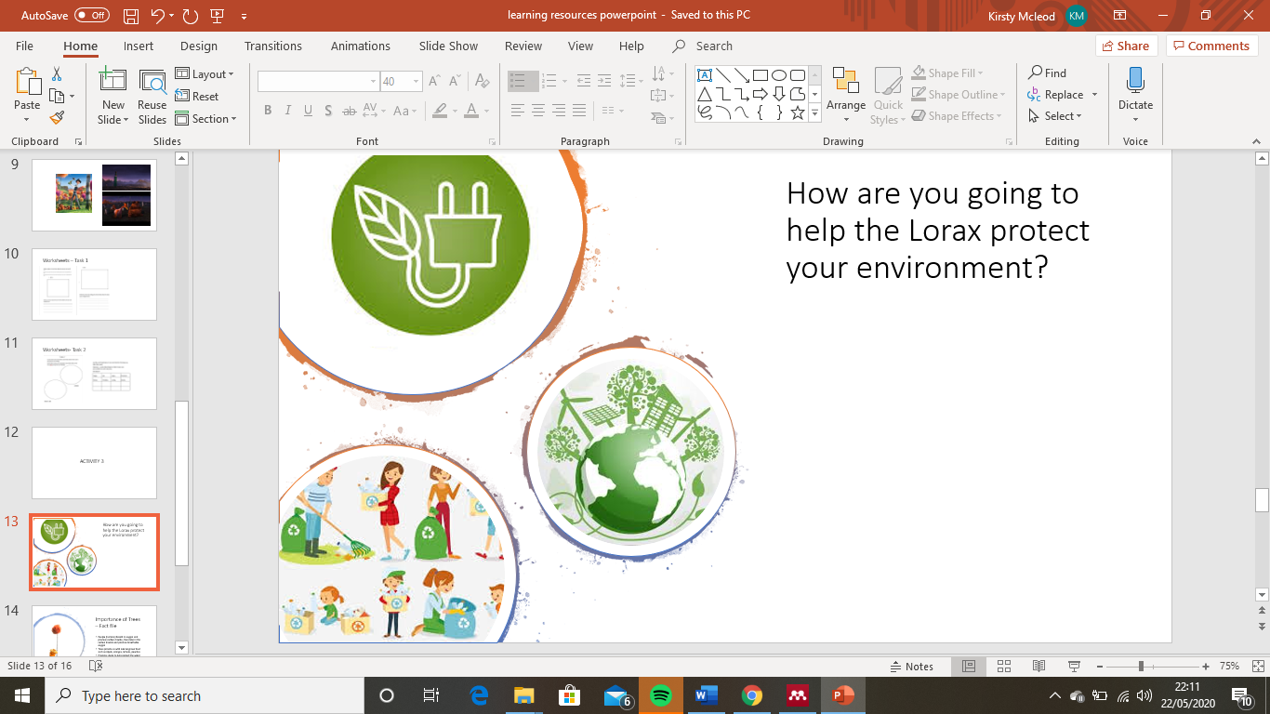

Appendices 3.1 – power point slide 8 fact file
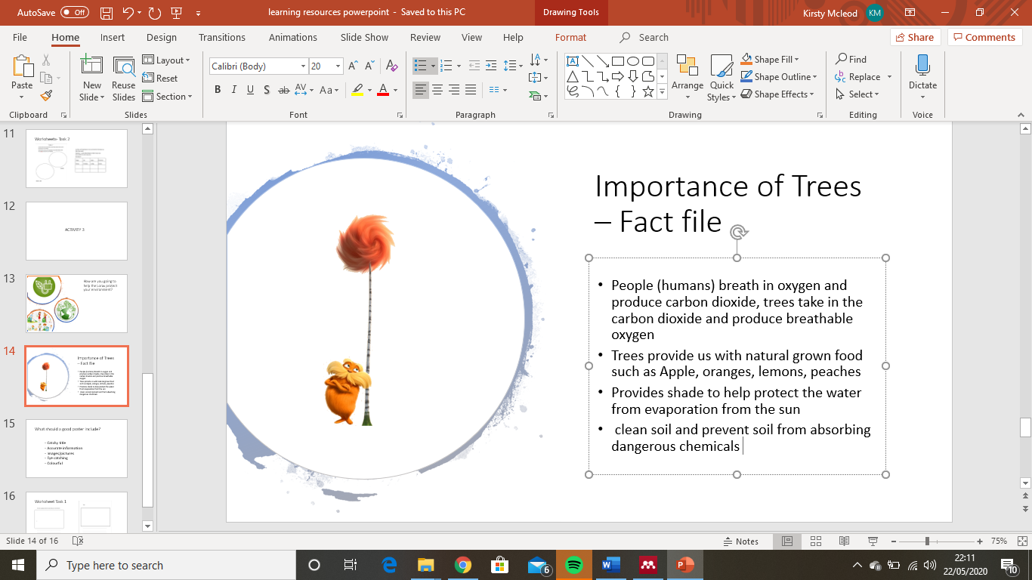

Appendices 3.2 – power point slide 9 what should a good poster include
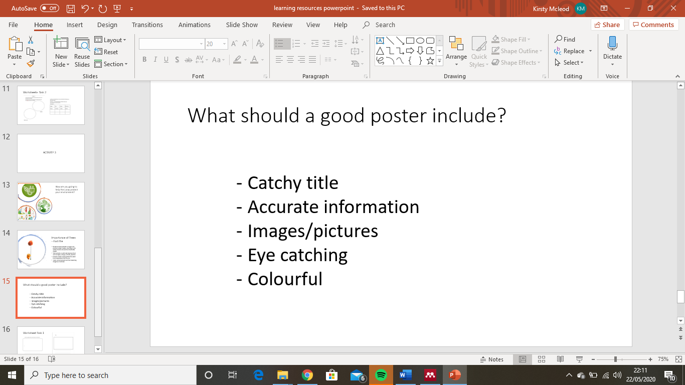

Appendices 3.3 – YouTube Resource https://www.youtube.com/watch?v=GZ3fgYIUrJU

