The University of St Mark & St John
How has lockdown impacted students from Plymouth Marjon University?

Ellie Bright

Research Project submitted in part fulfilment of the requirements for
BA Hons Education with Psychology
2023

Table of Contents
Table of Contents i
List of Figures iii
Statement of Originality iv
Acknowledgements v
Abstract vi
Chapter 1: Introduction 1
1.1 Overall Field 1
1.2 Justification 1
1.3 Aims, Objectives and Scope 2
Chapter 2: Literature Review 3
2.1 Anxiety and the Effects on Gender Differences 3
2.2 Impact on Loneliness in Different Generations 5
2.3 Financial Concerns and Unemployment 6
2.4 NHS Mental Health Service 8
2.5 Remote Learning Effects 9
Chapter 3: Methodology 11
3.1 Type of Research and Sample Size 11
3.2 Data Collection Methods 11
3.3 Data Analysis Methods 12
3.4 Ethical Considerations 13
Chapter 4: Data Analysis 14
4.1 Heightened Anxiety 14
4.2 Social Isolation 16
4.3 Increased Support Services 18
4.4 Financial Hardship 19
Chapter 5: Discussion 21
5.1 Anxiety 21
5.2 Finance 22
5.3 Isolation 23
5.4 Recommendations and Implications 24
Chapter 6: Conclusion 26
Appendices 28
A 28
B 29
C 30
D 31
References 32

List of Figures

Figure 1: Results of heightened anxiety post lockdown 15
Figure 2: Results of change in social life 15
Figure 3: Results showing the change in social life post lockdown 17
Figure 4: personal implications post lockdown 20

Statement of Originality

I confirm that I have fully acknowledged all sources of information and help received and that where such acknowledgment is not made the work is my own.

Signed: Ellie Bright

Dated: 29.04.2023

Acknowledgements
Firstly, I would like to thank my supervisor, Jayne Garcia for her ongoing support throughout my dissertation. I would also like to thank the University of St Johns and St Marks Student wellbeing officers for enabling me to collect data through the process of an interview. I would also like to thank all the University Students who took the time in completing my survey for me to complete my project successfully. Above all, I would like to thank my friends. In particular, a fellow University Graduate, Rosie Bailey, for her continuous support on my dissertation and throughout my degree.

Abstract
During the COVID lockdowns, there were significant changes in lifestyles, finances, jobs security, social isolation, and mental health concerns. The aim of this study was to find out what specific changes occurred because of the COVID lockdowns on Marjon University students. Data was collected through an online Google Forms survey that included a range of questions, investigating a variety of opinions. There is vast current research investigating the effects of COVID lockdowns on finances, mental health, and other factors. However, specific investigation on university students is limited and therefore it makes a significant justification for this research project. The current literature has enabled this project to be linked together with existing research to better understand the hypothesis and data analysed. The qualitative thematic approach has also enabled the research to be closely examined by identifying common themes, topics, ideas and patterns that have come up repeatedly (Caulfield, 2022). Common themes arose in a drastic change in poor mental health, increased social isolation and heightened anxiety across all participants of the project. All participants of the study concluded a negative change in mental health and worries due to the lockdown. Financial implications were also addressed when students expressed their worries due to losing part-time jobs through the furlough scheme and therefore struggling to have a substantial income.

Chapter 1: Introduction

Overall Field
This project will be researching and identifying the effects of Coronavirus (COVID) lockdowns on students at Plymouth Marjon University. COVID has been defined as an extreme health, economic and social emergency and was declared a global pandemic by the World Health Organisation [WHO] in March 2020 (WHO, 2020). COVID is a fast-spreading infectious disease that caused people with underlying medical conditions like cardiovascular disease, diabetes, chronic respiratory disease, or cancer to be at risk of developing a serious illness and a risk to life. As a result of the infectious disease spreading rapidly, the United Kingdom Parliament announced the first national lockdown in March 2020. The national lockdown ordered people to stay at home and citizens were only permitted to leave for essential purposes, such as buying food or for medical reasons. The lockdown and quarantine policies were implemented as a desperate resort to minimise the spread of the disease and to bring it into control. When individuals tested positive for the virus, social contact was restricted completely, and an isolation period of 10 days was enforced. Investigation results show that the median incubation period for COVID is 5.1 days, and can be up to 14 days, resulting in a prolonged period of social restriction (Meo et al. 2020). As the rapid rise in deaths and positive tests continued to increase the last lockdown lasted until July 2021. When the last lockdown approached, the United Kingdom began a phased exit from lockdown (Brown & Kirk-Wade, 2021). Whilst the ongoing limitations occurred with social restrictions and isolation, UK citizens were forced into a state of life constraints, changes in work and home life, and social isolation. The outcome of this caused a huge change in day-to-day lifestyles; causing disturbances to human health, lives, economics, mental health and well-being. This research project will address the changes that occurred over the course of COVID lockdowns, with a specific focus on students from Plymouth Marjon University.

Justification
There are many conflicting views and an overall lack of research on the effects of COVID on university students. This is due to the recent event of COVID and lockdowns. Current research has developed a phenomenon of an overall negative effect of lockdowns on individuals. However, there are gaps that have been highlighted in the literature that have not been addressed and are yet to be understood. Some of these include using links to mental health and wellbeing services and their impact on the pandemic. Using survey questions that are based on university students using well-being services will create validity towards the study delving into factual and evidential knowledge of vindication. Furthermore, a lack of research on the effects of COVID, specifically focusing on university students is yet to be correlated, which has set up the need for the current study and thus justifies the need for this research.

1.3 Aims, Objectives and Scope
The scope of the research aims to identify and evaluate the effect of COVID on university students. The aim is to research the factors that have affected Plymouth Marjon University students, specifically, and to justify the reasoning behind studies and knowledge already gathered such as finance, loneliness, academic problems and mental health difficulties. The intent of the research is to identify the main factors that have occurred as the result of the pandemic and to further support this data with the use of a detailed, in-depth and professional survey. Moreover, the study will be conducted using a survey specifically for university students to meet the aim of the project in identifying the effects of the COVID pandemic. To increase credibility and validity the research project will further undertake the use of a professional survey and supportive research and literature that can help form a hypothesis for the study. For the research to be accurate, the professional survey will be sent to Marjon University students only. This will allow information gathered to specifically target information regarding Marjon students.

In summary, the overall project aim will be achieved by fulfilling the following three objectives:
- Conduct surveys to determine the effects of lockdown on mental health.
- Use survey data to determine factors that caused a change in student mental health.
- Using the literature analysis to determine the reasons for the most popular factors drawn from the survey.

Chapter 2: Literature Review
There is much research regarding how people were affected by COVID in the short and long term. There is a significant amount of research on themes such as heightened anxiety, social isolation and financial worries being caused by COVID. Most research has defined the heightened levels of psychological issues causing long-term life changes in individuals. However, not only has it changed people's well-being, it has also caused a fall in the value of shares, economic unemployment, recession, a decline in the number of people using the hospitality industry and a damaged travel industry (Jones et al., 2021). All these factors may have caused a huge impact on people and their day-to-day life. Furthermore, a considerable amount of research has found that anxiety and depression amplified amid the pandemic. The reasons for this were owing to multiple life factors and the threat of the disease itself (Rettner, 2020). The year 2020 was said to have been the worst pandemic the world had seen in 100 years, which caused more than 75 million cases and 1.6 million deaths worldwide in mid-December. As a result of this, people were left in a state of panic and uncertainty (Bukuluki, 2021). Many people had different experiences with living during the pandemic and these can appear contrarily across contexts, and along different time courses, for individuals, communities, regions, nations and the UK as a whole. Many researchers have studied the most important factors that have affected individuals the most, some of which include anxiety, social isolation and financial worries.

2.1 Anxiety and the Effects on Gender Differences
There was a huge toll taken on people's mental health during COVID. Heightened anxiety was one main outcome of all research; however, the reasons behind heightened anxiety were different between individuals. There were different reasons for the increased anxiety levels shown in different research including fear of disease, social isolation, fear of unemployment, gender, pressures of revenue streams, and the struggle of loneliness and motivation. The National Academies of Sciences & Health and Medicine Division (2020) argued that much emphasis was initially placed on the anxiety levels among the elderly or those with pre-existing health conditions more than any other individual. This was due to the high risk of contracting and/or dying of COVID. Thibaut & van Wijngaarden-Cremers (2020) stated that anxiety was the biggest effect of the pandemic and that young females who had pre-existing mental health conditions were associated with the biggest increase in risk. Their research further developed the idea that COVID had affected women more profoundly than men in several areas, both at the workplace (health and social sector in particular) and at home, with an increase in workload and quarantine measures. In support of this research, the healthcare industry had 70% female employees during the pandemic compared to the 30% of male workers during the pandemic. Some of these jobs include nurses, midwives and community health workers. After this, women during this time were more likely to be exposed to the virus, causing a result of a high level of anxiety. It is important to address that these included full-time qualified workers but, student placements and junior healthcare placements/interns, were still working during this time. Furthermore, Dal Santo et. al., (2022) agree that heightened anxiety levels were much greater during COVID due to a lack of adequate domestic and emotional support services causing heightened anxieties, high levels of depression and even post-traumatic stress disorder [PTSD]. This study concentrated on the exposure and realisation towards women during the pandemic and the outcome that females had a more profound effect on the pandemic. This was due to the greater risk of carrying the virus home from workplaces, causing more time being in contact with others including patients and family members. Furthermore, university students who were still on healthcare placements were not only exposed to the virus but were learning to work in a completely ‘abnormal’ environment as well as having stressors of university stress, worries of contracting the virus and complete restriction to any socialising. Some junior doctors were allowed to move back to family homes but were not allowed any other form of social contact other than work and home. As a result of this, emerging data and reports stipulated that all types of violence, particularly domestic violence and anxiety implications intensified throughout the lockdowns (UN Women, 2021). Moreover, violence against females rapidly increased in the wake of the movement restrictions linked to the pandemic. The support services for women experiencing household violence were hard-hit due to a reduction in prevention, protection efforts and social services (OXFAM, 2023). A lack of support caused women's day-to-day lives to be fulfilled with unexpected encounters that forced daily predisposed anxiety. Bwire (2020) agreed with this study, but also concluded that the epidemiological findings reported across different parts of the world indicated higher mobility and mortality in males than females. In addition, the reason for this was the difference in gender behaviours and lifestyle. For example, higher levels of smoking and drinking among men compared to women. Lastly, as stated previously, women on average across the UK, had a more responsible role during the pandemic. This meant women needed to be more responsible when it came to washing hands, wearing a face covering and following strict guidelines during work.
With all this research considered, it is deemed necessary by the researcher to state that women had a more important role during the pandemic causing higher levels of daily anxiety due to elevated exposure to the virus, a lack of adequate support services to provide underpinning assistance during a hard-working life and home life factors that needed support services. This caused daily stressors and heightened anxieties for females, in particular. On the other hand, males were deemed to be more anxious during and after the pandemic, but with fewer males working in the health and social industries, the daily risk of exposure to the virus was less likely, causing fewer males to experience daily work anxiety. Statistics from Boniol et al. (2019) show that 70% of the health workforce is represented by women. However, this could mean heightened levels of social isolation and loneliness due to prolonged periods of time at home for males.

2.2 Impact on Loneliness in Different Generations
During the global lockdowns, reducing socialising and distancing from others was the most effective measure to slow down the pandemic, whilst a vaccine had not yet been developed (Lampraki et al. 2022). A research study conducted three surveys with 737 participants between the ages of 18-81. The research was conducted over the last quarter of 2020, through one-month intervals. The aim of the study was to draw a conclusion for the development of loneliness and its predictors of social changes. The study concluded that individuals with more close family, friends and friends as confidants had an overall higher number of social interactions. These interactions caused individuals to feel more protected from social and emotional loneliness (Lewis, 2020). However, this study was the broad age category and external factors causing an effect on the reliability of the results. For example, on average the younger generation has a sounder understanding of how technology works and the use of screen devices in comparison to the older generation, who may not even have access to a mobile phone, making them have fewer SOS contacts. Furthermore, elderly individuals were more exposed to loneliness during the pandemic. This was due to the older generations having a higher risk factor of contracting the virus and therefore family contact was limited. With this higher risk, visitors to the elderly were cut off, except for visits from healthcare providers. This caused a significant rise in social isolation in care homes for the elderly as caregivers were sometimes the only form of social connection. Supported evidence from the National Academies of Sciences & Health and Medicine Division (2020) suggested that individuals felt less lonely when they lived with others and had more contact with relatives where emotions could be expressed, the ability to have better sleep quality and more resources to entertain themselves. However, Lewis (2020) argues that more virtual social contact (for example, via video, conferencing, phone, or text messages) during the pandemic was also found to be associated with higher levels of loneliness. This implies that virtual in-person social exchanges may have been better than no exchange, but these still seem to miss aspects that meeting others in person may offer. This contradicts the idea of elderly people experiencing heightened levels of loneliness and therefore suggests that the younger generation was less likely to experience feelings of loneliness compared to the older generation due to the factors of virtual contact and life risk from the virus.

2.3 Financial Concerns and Unemployment
During the lockdowns, many individuals lost jobs and a clear rise in unemployment occurred. Studies have shown that regardless of income, the likelihood of poor mental health is higher if families have experienced a deterioration in their finances. Finch and Eastaugh (2020) state that individuals who were still working or had been furloughed were less likely to report poor mental health than those who had lost their jobs during the lockdown. The study further states that the people who were no longer working after COVID were more likely to report poor mental health and well-being. However, the existing research fails to generate information on individuals who had to work remotely causing a significant change in their ‘normal’ working routine. This is an important aspect as 40% of the UK population changed to remote working during the pandemic. This change in work routines through lockdown resulted in enhanced stress due to less in-person support and having to independently learn new systems online (Figueiredo et al., 2022, p.20-25). However, Clarity Clinic (2022) suggested that a change in work lifestyle can break a routine and people may experience less burnout and have a more positive experience in their day-to-day life. The limitation of this study dismisses the other factors of lifestyle changes including a period of uncertainty in every aspect of life including school closures, financial worries, and a lack of socialisation. Through what is considered ‘normal times’, a change in work lifestyle could break a routine causing less burnout. However, with other external factors affected by COVID, for example, fear of disease and uncertainty, the change in work routine during this time could contribute to an increase in anxieties, fear and job uncertainty for some individuals. Robinson (2021) convincingly contradicts Clarity Clinic’s (2022) study and underpins that workers who had to change their working lifestyles to remote learning displayed significant mental health struggles. He further articulates that most employees working from home had experienced negative mental health impacts, including isolation, loneliness and difficulty getting away from work at the end of the day. He further stated that individuals were worried about losing their job as it took time to switch to a different working environment causing on average a decreased work efficiency. With both studies considered, it is appropriate to suggest that a change in work lifestyle during lockdown added to the heightened anxieties.
Furthermore, unemployment levels dropped throughout 2020 and reached a decrease of 1.77 million in October-December 2020 and continued to fall at the beginning of 2022. Research has accumulated evidence showing a strong and consistent association between unemployment and a range of adverse health outcomes, including all-cause mortality, death from cardiovascular disease and suicide, higher rates of mental distress, substance abuse, depression, and anxiety (Hensher, 2020). This research strongly exemplifies the financial worries that the unemployed were facing during this time, however, it fails to address the mental health of workers specifically within the healthcare industry. Greenberg (2019) agrees that the unemployed struggled drastically with uncertainty in finances and finding a new occupation. However, he also conveys that individuals working in the healthcare industry were at risk of mental health disorders such as post-traumatic stress or depression, and other anxiety disorders. Additionally, they may have been exposed to trauma and/or faced with moral dilemmas relating to challenges in the delivery of high-quality care, possibly due to a lack of experience, or equipment or as a result of low staffing levels. In summary, it is made apparent that the unemployed experienced soaring levels of fear and worry about finances, but workers also faced a high-rise in mental health struggles due to the high demand for work and long hours.

2.4 NHS Mental Health Service
The NHS mental health service was hugely affected by lockdown, by early April 2020 weekly appointments fell by 40% and weekly attendance fell by over 50% compared to previous averages (Secondary Care Analytical Team, NHS Digital, 2021). The lockdown impacted both the demand for and the provision of healthcare. Unemployed and furloughed individuals had a significant rise in mental health problems during lockdown, but it was also clear that the lockdown had also impacted mental healthcare workers (Clark, 2021). Factors such as imposed lockdown measures, knowing colleagues who have been infected, being quarantined, and experiencing stigma because of working in a clinical role, have all been associated with increased psychological distress. A need for greater understanding of the impacts was needed to inform the development of effective interventions to support staff during the outbreak and beyond. Many people forgot about NHS workers' mental health as the direct focus was aligned with patients rather than staff members. During the pandemic, many staff were put under extreme pressure at work whilst also having to balance personal commitments and values, for example, considering their risk of infection to themselves and their family, alongside their duty to care for patients. At times, staff had to isolate themselves from family and friends. Some staff even had to make difficult decisions around the allocation of limited resources (Wilson, 2020). Moreover, during the lockdown, there were reports of inadequate provision of personal protective equipment [PPE] and testing for healthcare staff and unclear infection control policies in some healthcare settings. Not only did the lack of equipment and family isolation cause a rise in mental health issues but other sources of stress were caused by changes in the working environment, with some NHS staff deployed to new roles. The NHS mental health service saw a significant overload in mental health issues during the pandemic. Greaves’ (2022) study concluded that 64% of individuals met the criteria for having a mental health disorder, and 69% of this population reported that their ability to carry out daily tasks was impaired by their mental health. Eventually, people who were experiencing mental health disorders are substantially more likely to have a poorer life quality, function poorly at work and are at increased risk of sickness, absence, or premature departure from their job. Whilst patients were being treated, the mental health of NHS workers may have been side-lined due to the demand for their services, but this caused an increase in employees not being able to attend work having a significant impact on the services.

2.5 Remote Learning Effects
As a result of the national lockdowns, students all over the UK were forced into remote learning. A number of studies have assessed online versus in-person learning during higher education years. Not only were students left with learning how to manage education through technology, they were also having to manage their new learning environment. This change caused many effects on students including technology issues, additional screen time, lack of motivation and a sense of isolation. Besides this, these issues were found to affect academic performance but the change in students' educational lifestyle was hugely impacted. The increased screen time as a cause of remote learning was shown to have some disadvantages for students. For example, recent studies have examined the impact of increased screen time and have found consequences including sleep problems, depression, anxiety and lower academic test results (Mosley, 2020). Moreover, research has also supported that levels of anxiety have increased post-lockdown and a factor influencing this includes the change to remote learning (specifically with University Students). Prolonged periods of time spent in front of a screen can negatively affect an individual's mental and emotional well-being. This is supported by expert researchers suggesting that higher screen time could be connected with a lower one’s ability to read emotions in general (Mosley, 2020). Furthermore, the National Institutes of Health support this finding by concluding that individuals who spent more than seven hours of screen time experienced thinning of the brain cortex, which is related to critical thinking and reasoning (Jernigan et al. 2018). A study by Varadarajan et al., (2021) conducted qualitative research, using a survey with both open and close ended questions, on university students. The project concluded that university closures negatively impacted the overall psychological health of about one-third of the survey respondents. Time management was the aspect of remote learning that caused the highest stress for close to 50% of the students, and interactions with peers and in-person discussions were the aspects of on-campus learning that students missed the most during the remote learning period. To elaborate, during the years 2019-2020 in the depth of lockdowns 37% of university students had symptoms of depression and anxiety and one main factor that was a cause of this was a lack of social interactions with others, which they would otherwise have during usual educational routines. It is also important to note that, that number is statistically higher than the general population of those aged 16-29 which is 22% (Okolicsanyi, 2022). Furthermore, as a result of online learning studies have found that as a result of the lockdowns students' academic levels on average have declined and this may be due to the recent years spent learning remotely. A research study by Joyce et al. (2015) found that students in a traditional lecture format, with twice as much face-to-face instruction, performed better than students who learnt remotely. A limitation of this study, however, is the failure to discuss the participant's ages. This can be a drawback of the study as younger children were more likely to enjoy home learning from primary school. Whereas university students had a lack of socialisation from family living away from home, as well as course friends.
Through an examination of an extensive range of sources, this literature review has explored many aspects of the effects COVID lockdowns had on the population. In particular, it has evaluated the general areas of study and highlighted a lack of research surrounding university students specifically. Common themes arose throughout the wide-spread collection of research, with emphasis on heightened anxiety. However, the research reviewed does not provide an insight to the impact COVID lockdowns had on university students, especially with regard to heightened anxiety, loneliness and financial security. Building on Mosley (2020), Varadarajan et al. (2021) and Okolicsanyi (2022), this research project will assess the most common effects of COVID lockdowns on university students, with foci on heightened anxiety, stress, financial instability and social isolation.

Chapter 3: Methodology

3.1 Type of Research and Sample Size
The survey aimed to gain participants of Marjon University’s opinions on lockdown. The survey was emailed to Marjon University students and an outcome of 10 participants completed the survey in total. The survey provided open-ended questions that provided flexibility for the respondents when answering the questions. The multiple-choice questions were structured to produce easy-to-analyse data and provide mutually exclusive choices. The choice of questions were specifically chosen to avoid any ambiguity and bias. The survey was completed virtually, rather than in person, as it offers participants the ability to feel more at ease and avoid experimenter bias. Furthermore, the virtual research technique allowed the opportunity for many participants to be approached. The researcher had no direct contact with participants. The benefit of this approach is that the researcher is unable to prompt or provide a biased approach to the participants. However, it does mean that participants are unable to ask clarifying questions, if they are not able to comprehend them fully.

3.2 Data Collection Methods
Data was collected through Google Forms, allowing the researcher to discover deep integrations and advanced extensibility regarding the survey (Mauthner et al., 2012). A link was emailed and shared with Plymouth Marjon University Students by the academic staff acting as gatekeepers. The administration software allowed the surveys to be presented in a professional manner and the results collected from the surveys to be kept anonymous. The survey abides by all ethical considerations and includes links for student well-being support services for participants to access as a thought for consideration (British Educational Research Association [BERA], 2018). The survey was conducted at a professional, and accurate standard.
The research project gathered qualitative information through survey data collection methods. The survey collected information on the impacts of COVID lockdowns on students and, the effects on university students at Marjon University. The aim of the survey was to collect an in-depth qualitative research study on students’ feelings on their personal perceptions of changes due to COVID lockdowns. The objective of the survey was to collect as much in-depth information on students’ feelings and perspectives towards the changes that may have occurred as a result of lockdown. To achieve this, survey questions included exploratory questions, multiple choice, and open-ended questions to aid the accessibility of the survey, whilst gathering key information, both on students’ views and experiences as well as contextual information about them. Using a range of question types allowed categories of similarities and differences to occur in the results. It also allowed the data to be collected in a way that achieved a trustworthy set of data (Mauthner et al., 2012).
University students average around the ages of 18-21 (Adams, 2022). However, to ensure reliable and trustworthy results, the survey was only shared with current and former Plymouth Marjon University Students (who were in study during the COVID lockdowns). It was important to involve students who have since left the university as they also experienced and were affected by COVID lockdowns. Their perception of COVID may be different to those who were affected earlier on in their study.
Multiple sources of research information will support the triangulation of sources, which will be made prioritised in my research to increase the credibility and validity of the research findings. Furthermore, this inductive qualitative analysis will take a thematic content analysis approach that will aim to find common patterns across the data set (Braun & Clarke, 2021). The thematic approach will begin with establishing overarching impressions of data and dismissing any approaches of biases. Literature reviews will create links for potential reasonings behind different effects and support the evidence from the surveys.

3.3 Data Analysis Methods
When analysing the cross-sectional survey results, the researcher will use cross-tabulation to filter and refine similar results. Cross-tabulation allows the analysis to draw on precise, impactful insights from the large data set. Moreover, it makes data easier to interpret when analysing potential effects of the results and link similar answers to their cross-tabulation category to answer the reasonings behind the answers (Smith & Albaum, 2005). Research has shown that cross-tabulation reduces the possibility of errors when analysing a large data scale, which allows data to become more trustworthy (Dass, 2010). This will be analysed with up-to-date literature that will provide evidence and back up the reliability of my results. It is important to note that not every student will complete the survey, however, the sample of completed surveys should still represent the more generalised thoughts and feelings of Plymouth Marjon University Students during COVID lockdowns.
Common responses in specific areas, for example, heightened responses in anxieties and weakened social skills post covid will be created as individual chapters and will be closely analysed using evidence and support from relevant literature. Using relevant literature to support the data findings will establish an in-depth understanding and knowledge of the subject field. Furthermore, relevant literature will be important for obtaining an overview of the current knowledge and will provide a sense of framework in which to build an appropriate hypothesis.

3.4 Ethical Considerations
Prior to conducting the survey, the questions were reviewed and granted ethical approval from the Marjon University Ethics Panel (see Appendix A). A form was provided to the participants covering the study aims and objections, and information on data collection and storage. All data collected was stored on a password-locked computer and was deleted upon the completion of this study, in keeping with the 2018 Data Protection Act. The risk of the research project was very low. The participants undertaking the survey were not children, so they were able to assess their own emotions as to whether they felt the need to seek support. The participants were also made aware that they had the right to withdraw their consent and involvement within the study at any time, with no judgements. The survey was also provided with links as to where help and support can be accessed. Furthermore, the study is entirely optional and anonymous, and all data will be kept for research purposes only. This ensures that participants were protected from harm and maintain confidentiality. These ethical considerations align with the British Educational Research Association (BERA, 2018). Lastly, the study was conducted by participants from Marjon University only.

Chapter 4: Data Analysis
The narrative inquiry approach, through form of a questionnaire, formed the results of life histories from students’ experiences of studying higher education during the pandemic. The survey looked at age, gender, and living situation to form the background of the research. These factors may have influenced the behaviours of the participants and were therefore asked during the survey. The survey had 57% female respondents and 43% male respondents with 100% of the participants aged between 18 and 24 (See Appendix B and C). Age was an important determinant as a general demographic indicator as it allowed the research to write off any limitations, including different social barriers, experience and knowledge that may be a reason for the answers given during the survey.
Gender was also an important determinant as it allowed the researcher to analyse the data with a knowledge of the percentage of sex, and therefore consider reasoning behind the data. As highlighted in the Literature Review, men and women had different experiences throughout COVID (Bwire (2020); Dal Santo et. al., (2022); Thibaut & van Wijngaarden-Cremers (2020); UN Women, 2021).
Lastly, the living situation during the pandemic was a huge element as this could have been the main cause for increased loneliness, anxiety, finance or the opposite. 85% of participants were in a student-shared accommodation and 15% of participants were living alone. The survey covered these main characteristics through a thematic analysis approach that helped to develop themes and to emphasize and interpret the patterns of meaning within the qualitative data. On average, there were no obvious anomalies within the data. All research from the participants was raised with similar views and outcomes. This may draw in some questioning for reanalysis and emphasis on a more broaden sample size. However, it has also drawn out a concise set of results that have drawn awareness around the impact of the lockdowns on bad mental health, finances and other factors. Furthermore, the clear set of results has enabled the data to be analysed with a clear articulation of a current problem that needs to be sorted and raised awareness around.

4.1 Heightened Anxiety
Before the survey, there was already a significant amount of research developed on the rise of anxiety post-lockdown. A question asked in the survey was “Do you experience feelings of worry and anxiety more, post-lockdown?” With a 100% answer rate, there was an astonishingly high rate of participants that experienced heightened anxiety post-lockdown. 100% of participants responded with ‘Yes’, which stated all participants saw a change in their anxiety increasing post lockdown.
Figure 1: Results of heightened anxiety post lockdown

The reasoning for this may be due to students needing family support during strange and unpredictable times. Results concluded that 75% of students were living away from home, and therefore may be a result of heightened fear and anxiety. Furthermore, a question stating, ‘Describe how your social life has changed post lockdown?’ had answers of “I get anxious socialising in big groups” and “I hate socialising as I get anxious, before I used to love going out”.

Figure 2: Results of change in social life

These stated answers exhibit the level of honesty conducted by 100% of participants experiencing heightened anxiety and fear. Analysing this data has constructed a significant link between lockdown and anxiety, as earlier research has found.
Moving forward it should be important to recommend and share this information with leaders, and more specifically practitioners, in order for them to adapt and be prepared for current and new students/learners. The initial univariate results have revealed that higher levels of anxiety symptoms, and lower psychological well-being, was associated with social isolation, financial hardship and changes during lockdown. Anxiety and worry symptoms were elevated in all people however, the biggest impact overall came from increased ‘social isolation’. Robb et al. (2020) state that long periods of social isolation, which would have been experienced during lockdown, may have a profound negative effect on mental health conditions, which has been shown in this data. As a result of this, it can help practitioners and researchers to understand why 100% of participants experience anxiety and worry more, post-lockdown. The social isolation effect from lockdown is significantly linked with depression, loneliness and anxiety. Robb et al. (2020) also states that social isolation and loneliness due to lockdown were strongly associated with anxiety, depression and self-harm, and suicide attempts. Furthermore, it is important to address the position of socialising through technology. 98% of individuals classed as ‘Generation Z’ (an individual born between the late 1990s and early 2000s (Dimock, 2019)), own a smartphone. This shows the high percentage of individuals who were able to connect virtually with family/friends or others during lockdown (Georgiev, 2023). The frequency of this, while under social distancing circumstances and its link with anxiety has not yet been investigated outside the current study. However, it can be determined that social connections via technology are in no comparison with face-to-face socialising.

4.2 Social Isolation
Every individual experienced isolation during the pandemic. The result of this isolation caused a domino effect on mental health problems. The rise in mental health issues caused considerably high levels of social isolation even after restrictions were eased. The survey contributed to these factors and drew an outcome of 80% of individuals stating that their social life had changed since the lockdowns.

Figure 3: Results showing the change in social life post lockdown
This 80% can be considered as a negative impact of change due to the outcomes of additional questions asked. Supportive evidence arrives from the alternative question “Describe how your social life has changed post-lockdown”, where an elevated level of answers incorporated assertions of insufficient social life, hating larger groups, augmented nerves and anxieties (see Figure 2). The reasoning behind the high levels of decreased socialising may be a cause of the increased anxiety that was made aware of through a previous question. Evidence has concluded that anxiety plays an important role in social behaviour. For example, highly anxious individuals are more likely to avoid social interactions such as communicating with strangers, which is clearly portrayed in the development of the survey answers (Wu et al., 2013). These results rationalise the elevated level of credibility and honesty from respondents. Furthermore, the survey found that 85% of participants were in shared accommodation with 15% living alone. With these statistics, it would be easy to argue that students who lived alone were at a higher risk of feeling lonely and/or depressed. Living with family, friends or another companion has proven to have had an effect on higher self-esteem, greater empathy, reduced stress, trust, strengthened mental health, and fewer feelings of depression and anxiety (Mental Health Foundation, 2023). However, it should be made aware that the survey does not show the number of students who changed living situations during the pandemic. A further limitation is that the survey does not delve into what connection students had with those they lived with, which will play a huge role in mental health. Some individuals may have experienced higher stress and anxiety levels, domestic abuse, bereavement and unemployment. These factors would have a huge contribution to feelings of isolation, fear, and depression which in the long term, would affect an individual’s future social connections.
Furthermore, social life and mental health in university students are closely connected. University is deemed as a highly sociable environment where individuals build quality friendships. Connections can help to reduce depression and lower stress levels. Research has proven that connecting with others releases hormones, such as oxytocin, that can lower anxiety levels (Abbot, 2021). During the pandemic, this would have been reduced due to a lack of socialising. If students were experiencing this due to a limited social circle, it would have enhanced mental health issues. The survey displays a huge average of students feeling lonely, anxious and feelings of not wanting to socialise post-lockdown (Figure 2). This lack of communication will and has proven to arise anxiety levels as students are left stuck with their own thoughts resulting in an increased risk of mental health problems, and a change in social life (Figure 3). Whilst living situations had a huge effect on mental health online learning also contributed to the social distancing from course friends and lecturers. Being disconnected can lead to loneliness and depression. Whilst the survey results hugely support this, research has found that 32% of graduate students have a major depressive disorder (Abbot, 2021).

4.3 Increased Support Services
During the lockdown, support services such as online resources, were still functional for students and were being pushed as an important aspect for students in order to accumulate support, especially due to the circumstances of isolation. Even if a student is struggling, they don't always reach out for the support available to them. However, the results from the question “Do/have you made use of the student support services at university?”, proved differently. Figure 2 exhibits the implication of student support services needed for individuals. 57.1% of respondents stated “I didn’t before COVID, but now seek support” and 14.3% of respondents declared “I did before covid, and continue to do so”. This demonstrates that over half of the respondents use a form of student support services post-lockdown. The services that Marjon University offer include student funding, counselling, academic advice, and health concerns. The conclusive result that presents a high percentage of respondents using the services presents the findings of students needing support in all areas. This suggests that a high percentage of Marjon students use the services in order to gain support, whether this is financially, academically or mentally. Furthermore, the supporting question ‘What has been the biggest impact for you personally, post lockdown?’ can help to determine the area where students were needing the most support. Out of all responses, 85.7% of the respondents voted for ‘increased social isolation’ and 71.4% of respondents voted for ‘heightened anxiety and fear as well. The less popular vote for ‘financial worries’ came to 14.3%. The reason for this could be due to students receiving maintenance loans which supported them throughout the lockdowns, and a decrease in going out, spending money and paying for transport. It is important to address that while the data shows an increase in symptoms of common mental health conditions, during the first lockdown fewer people were referred to mental health services. During lockdown, the number of referrals decreased by 61% which shows a dramatic change in individuals needing support during this time but being denied the help they were needing.

4.4 Financial Hardship
The survey results showed 62% of individuals agreed that lockdown caused financial hardship for them. A supported research survey revealed that 80% of students were worried about how they will manage financially as a result of the pandemic (Lane, 2021). On average students are seen to be spending money on nights out, getting part-time jobs to support themselves financially, and living off ‘cheap and easy’ meals due to financial instability. The survey has concluded that students are worried about their finances post-lockdown, and this may be down to some major impacts; part-time jobs, furloughing, making students redundant, accommodation rent payments even when students were living at home, increased worries about employability after graduation- with graduate employers being more reluctant to hire with a possible recession, and students still paying full tuition fees adding to the worry about student debt. These factors all stem from the lockdown where restrictions caused a domino effect on factors affecting students' finances. The results from the survey concluded that more students were hesitant to go out and socialise, this may be down to anxiety and fears but also can be put down to financial worries. Supporting evidence has found that the majority of students who were working part-time to supplement their student loan income had a reduction in pay, and 62% of surveyed students held a part-time job where 87% of these individuals had to make adjustments to their job which resulted in a reduction of income, due to being furloughed, made to take unpaid leave, reduction in hours or in some cases, redundancy (Lane, 2021).
Figure 4: personal implications post lockdown

Although the survey showed that only 14% suggested finance was the biggest impact (Figure 4), it may be an underlying factor that students are yet to recognise for a lack of socialising, lack of motivation and heightened anxieties. One response from the survey question ‘Describe how your social life has changed post lockdown’ had a response that stated, ‘I don't really like clubbing- I don't mind parties- but hate going out’. This answer could suggest multiple things, delving deeply it could suggest that the individual doesn't mind parties because it’s financially cheaper compared to clubbing, which could be the determiner. On the other hand, it could be down to heightened anxiety level that comes from the second biggest impact of lockdown according to the survey results (Figure 4). Whilst Figure 4 concludes financial worries to have the smallest impact on students, it is important to note that students may have put this down to other external factors like the global economic crisis and Brexit rather than lockdown.

Chapter 5: Discussion
The research aimed to identify whether the lockdowns affected Marjon University students and if so, how. The discussion below further addresses the findings from the data collection, limitations and links to the Literature Review. It further discusses areas of future research with the goal of understanding long-term mental health effects on students post-lockdown. The discussion has been developed from the data of the research project and the existing literature. Existing Literature has enabled the discussion and data analysis of this study to bring in clarity and focus, broaden the knowledge base within the research area and further contextualise the findings from the study. Furthermore, the data analysis showed common themes that were identified from the data and have further devolved into the reasonings behind this. This data has then developed the discussion by adding links from the Literature Review that have acknowledged previous research projects to better understand the findings. The common themes identified were anxiety, finance, and social isolation. This discussion has further contributed recommendations, and implications of the study that may be valuable for future studies.

5.1 Anxiety
The results interpreted from the study suggest a 100% increase in anxiety as a result of the lockdowns. Changes in this caused participants to state that they use to love big crowds, and going to parties and now anxiety plays a huge part in them where they are too nervous to go out or don't like socialising in big groups at all. External studies support these findings where they have concluded that anxiety was the biggest effect of the pandemic and that young females who had pre-existing mental health conditions were associated with the biggest increase in risk (Mittal & Singh, 2020). While 57% of participants were female and 42% male, every participant indicated an increase in anxiety, a lack of motivation and fear of now being able to socialise. The study did not analyse why this could have been, but the hypothesis of the study was found with a 100% negative change in anxiety. This data conclusion agrees with further research that found a significant number of students reported being occupied with stress and worry related to COVID and that it negatively affected their wellbeing while on-campus, classroom participation, social interactions and in their overall university experience (Rashid et al. 2022). This study supports the research conducted and also suggested that anxiety can be the impact of further isolation, even when individuals are surrounded by others. Age is a huge factor that would have been a determinant of how individuals coped mentally, physically and within their living situation. Moreover, the study showed that 85% of participants lived in student-shared accommodation, which could have been the main determinant as to why there was heightened anxiety. Kharma et al. (2020) revealed that 85% of participants suffered from severe stress and anxiety post-lockdown. The study reported that participants stated that they had feelings of intense fear, which resulted in their fear of the possibility of failing to follow COVID protocols, living away from home, the fear of being exposed to the virus, and the cut off of isolation from family and friends. This supports the findings of the research project conducted and concludes that COVID had a negative effect on anxiety levels due to social restrictions and living situations. However, it should be made aware that this study was conducted in the USA, where restrictions and rules were different in comparison to the UK.

5.2 Finance
Finance was a huge worry during the lockdown. From the survey, Marjon University students were worried about their financial stability during the lockdowns. 62% of participants strongly agreed that lockdown caused financial hardship for them. This concluded that the majority of students had worries regarding their financial status during the lockdown. This above-average theme may have been a result of other factors drawn from the study, including an increase in social isolation, increased anxiety and an increasing lack of academic motivation. With all themes having a negative impact, it may be reasonable to suggest that they all impacted each other. During the pandemic, there were huge worries about financial stability for students where individuals who were working part-time lost their jobs or were forced to work reduced hours, due to the pandemic and lockdown restrictions. Owing to this, individuals were left with insufficient income, leaving individuals anxious and worried: a further factor towards reduced social isolation (Negash et al., 2021). This study does fail to determine whether or not the participants felt their increased anxiety and social isolation were due to financial worries. However, with evidence from multiple studies, it may be necessary to suggest that the implications of increased anxiety and social isolation may be due to financial factors. However, during the lockdowns, there was a pre-crisis in revenue pressure and low profitability, tighter regulation and increasing competition from banks. This may have been a determinant of stress before the lockdown hit, and therefore not an effect of the lockdown itself. Moreover, with 62% of participants stating lockdown has caused financial hardship it will be hard to argue against this, with over half of the participants highlighting it as an impact of COVID lockdowns. Furthermore, a report by the National Union of Students also stated that 80% of students were worried about how they will manage financially now, as a result of the lockdowns (Lane, 2021). This supports the research project in the conclusion that finance was an effect of the lockdown for students. Whilst all students continued their undergraduate studies online, they were still expected to pay full tuition fees and student accommodation, whilst having an overall reduction in income through part-time jobs making students redundant. Furthermore, on top of the national lockdown, the UK also left the European Union: its largest trade and investment partner. According to a study by the Centre for European Reform, the UK economy is 5.5% poorer now than it would have been had it stayed in the EU (Springford, 2022). This contributing factor would have affected all citizens of the UK and, therefore could have been a reason as to why this theme was identified during the project rather than the lockdown having the main effect. Moving forward dissection of the themes and the main determinant should be made. This will address whether the themes were caused by the lockdown or other external determinants like the economic crisis.

5.3 Isolation
Social isolation was a main theme drawn from the research project where 100% of participants stated they had a change in their social life. The impact on student’s lives was all negative where individuals stated they hate socialising in big groups, feel nervous, don't like parties, and have also found their finances to cause them to isolate. Not only was there mention of the social isolation during the pandemic but the continuous impact it has had on isolation post lockdown. A survey conducted by the National Academies of Sciences & Health and Medicine Division (2020), suggested that individuals feeling less lonely occurred when they lived with others and had more contact with relatives where emotions were able to be expressed, the ability to have better sleep quality and more resources to entertain themselves. However, this determined that students living in shared accommodation were still experiencing high levels of isolation with the same amount of academic stress with deadlines, exams and coursework, as well as external stressors; not being able to go home, time away from loved ones and fears of being exposed to the virus. These would have all been determinants of the lockdown impacting students and causing further isolation than already addressed by the government. A further study supports the research project by reporting a high 74% of students stating that lockdown had a negative impact on their mental health due to social isolation (Frampton & Smithies, 2021). A similar study by Leal Filho et al. (2021) found that factors influencing social isolation include health, whether or not the individual is in a close social relationship, educational level, age, family support, and social networks. All of these were at risk during the lockdown or had been changed. It has also been made apparent that individuals felt anxious following lockdown and therefore isolated themselves, even after restrictions had been lifted. Pietrabissa & Simpson (2020) also stated that prolonged isolation during the pandemic can adversely affect physical and emotional health, which was also made evident in the research analysis.

5.4 Recommendations and Implications
This research project has brought together existing research as well as considered data collected from the survey. This has enabled a reliable and trustworthy conclusion to be developed from the data collection. Some limitations recognised from this study have been the ability to link certain survey questions with age and gender. By having this link, it will enable the research to be investigated in more depth and further identify external factors. Future research should expand this study by looking at specifics within the themes generated from this project. This will enable the research to delve deeper into the themes and look at the initial causes, for example, the high level of anxiety caused by the lockdown itself or other external factors. Exploring deeper into these answers will allow further investigation as to what students were anxious about, why they were worried about finances and what was causing them to further isolate themselves. Furthermore, a specific study widening the research target audience should also be done to look at the differences in age groups. This will help to identify and link the most common themes with the age group and why this outcome has been developed. Another area of study would be to compare the effects of COVID lockdowns on university students and non-university students (of a similar age). By conducting this study, it will allow data to conclude whether or not academic studies had a detrimental effect on individuals during the lockdowns. The study has drawn on the importance of mental health and has also raised awareness about the long-term effects of the lockdowns on students. It would therefore recommend that ongoing support be provided for students who were affected by the pandemic. Support needs to be provided in specific target areas, such as financial, wellbeing, academic and socialisation, as highlighted in this research project.
The increased lack of motivation combined with online learning also suggests that students have not studied to the best of their ability and therefore missed out on vital study skills and information regarding their degrees. This should be considered when students are submitting work, due to the mitigating circumstances they have faced. Extra academic provision should be put in place owing to this.

Chapter 6: Conclusion
The research findings have developed an overall conclusion on how the COVID lockdown impacted university students. The findings suggest on average all participants who conducted the study were affected negatively in terms of anxiety levels and social life. With the increase in mental health worries, more and more individuals have been seeking support from services. This increase in anxiety, social isolation and financial worries has contributed to an overall high level of individuals attending support services owing to the lockdown. During the conduction of results, there was a realisation that external factors would have an effect on the answers. For example, students’ living situations, their ages, and financial stability. Learning to include this in the survey meant that any external factors that may be a cause of impact on Plymouth Marjon University Students could be addressed in the analysis. External factors like accommodation, age, and financial stability are all important to address as they could be the reasoning behind the answers given. For example, students living alone and away from their families resulted in a higher risk of heightened anxiety and social isolation. The results of the survey saw a huge one-sided result in students being negatively affected by the lockdown. These results can be seen as reliable due to the correlation with findings from the extensive literature review. Occurring themes of social isolation, academic motivation heightened anxiety and fears were all negatively affected. The biggest impact was an increase in social isolation with 85% of individuals stating this and another 71% of individuals expressing heightened anxiety and fears. While further recommendations have been made in order to keep supporting Plymouth Marjon University Students following the pandemic, it is even more vital following the survey outcome of 57% newly seeking support post-lockdown (See Appendix D).
In summary, the data analysis has concluded that the COVID lockdown drastically affected Marjon University students greatly in areas such as lack of academic motivation, worries about finance, heightened anxiety, and increased social isolation.
To gain ecological validity, future research should be conducted at universities across the UK and if possible, across the world, due to the global nature of the pandemic. In addition, future research should also include investigation into individuals who are not-students and comparing these findings with those who are. By doing this, it will allow the research to identify the impact of COVID lockdowns across the age category and aim to make stronger generalisations.
Furthermore, identifying gender and age specifics in questions will also allow further research to identify whether males or females struggled more and if so, why. Identifying age categories in questions will also be a significant future recommendation. This will allow the research to identify other factors that may impact mental health during the lockdowns. For example, the younger generation may have struggled more than the older generations due to the lack of socialisation with friends. In comparison, the older generation on average may have found this easier. It would also be interesting to investigate whether COVID lockdowns have and will have long lasting effects on areas such as anxiety, financial worries, academic motivation, and social isolation.
Using the data analysed, students from Plymouth Marjon University had negative experiences during the COVID lockdowns and have since suffered adversely. Predictions in further valuable research can be drawn from this study, such as suggesting that this could be a similar outcome for university students throughout the country.
The research project has stipulated findings that are important in recognising the current long-term effects on mental health. These findings have drawn awareness around the importance towards educational settings, particularly universities to acknowledge these effects and implement services, and resources to guide and support students’ wellbeing. The research project benefits Plymouth Marjon University specifically, as recommendations for support can be proposed to enhance student wellbeing post COVID lockdowns.

Appendices

A
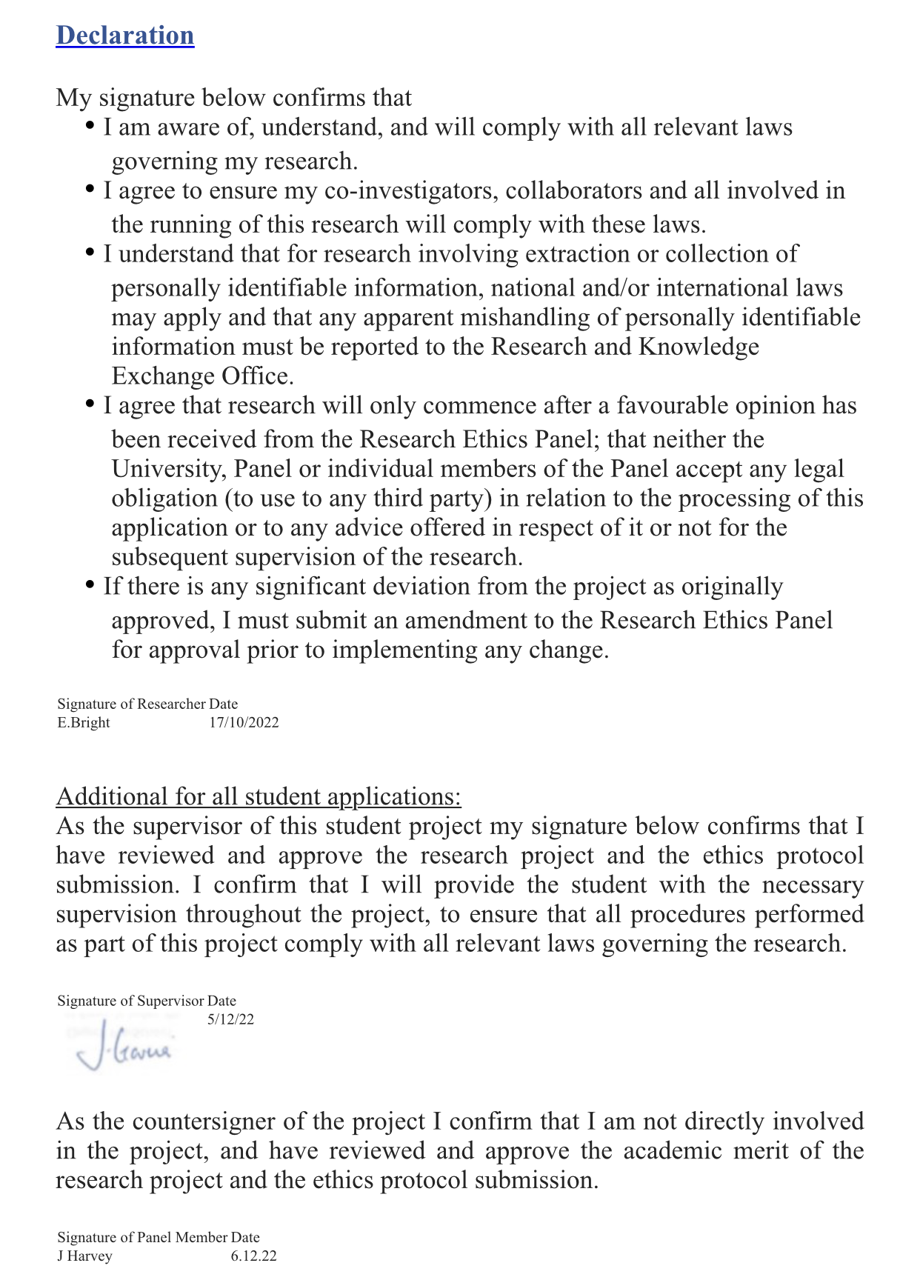

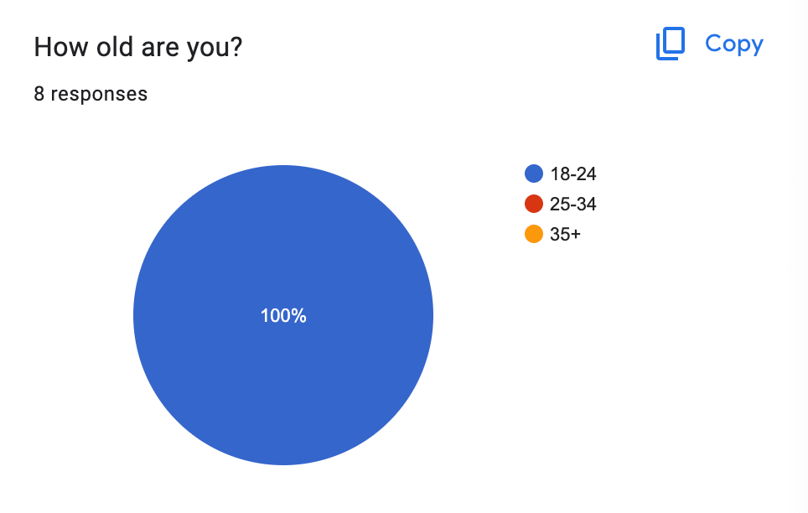
B

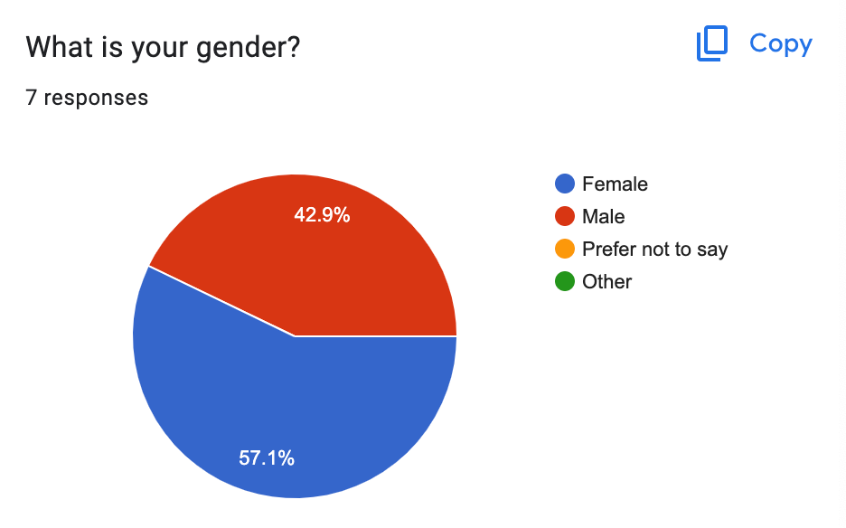
C

D

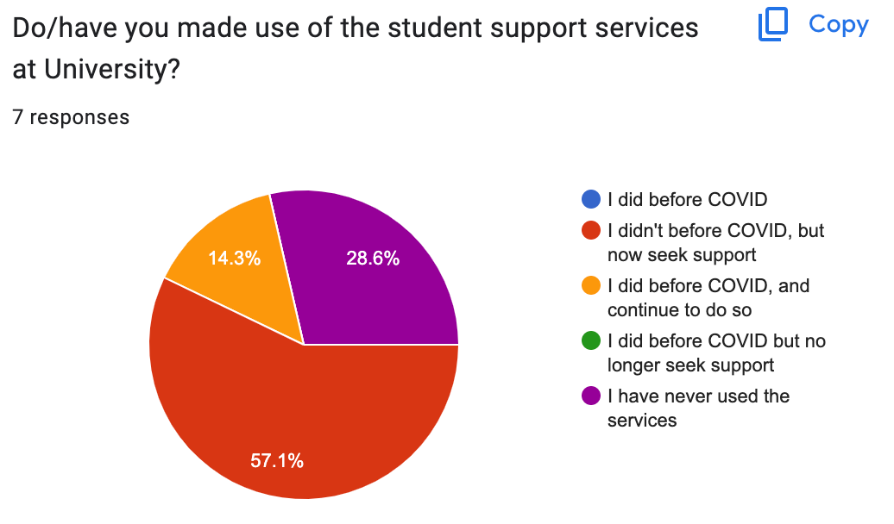

References
Abbot, G. (2021, October 21). How Social Interaction Affects University Students' Mental Health. Psychreg.
https://www.psychreg.org/social-interaction-affects-university-students-mental-health/

Adams, A. (2022). What age do you start and finish university?
https://urbanlocker.co.uk/top-tips/what-age-do-you-start-and-finish-university/#:~:text=Students%20typically%20start%20university%20aged,just%20after%20their%2018th%20birthday.

Boniol, M., McIsaac, M., Xu, L., Diallo, K. & Campbell, J., (2019). Gender equity in the health workforce: Analysis of 104 countries.

Braun, V., & Clarke, V. (2021). Thematic Analysis: A Practical Guide. SAGE Publications.

Brown, J., & Kirk-Wade, E. (2021). Coronavirus: A history of English lockdown laws. House of Commons Library Briefing Paper, (9068).

Bukuluki, P., Mwenyango, H., Kato, F., Kyamulabi, A., & Bagabo, A. (2021). Mental Health Effects of COVID-19. In A. A. Moustafa (Ed.), Mental Health Effects of COVID-19 (69-87). London: Elsevier.
https://doi.org/10.1016/B978-0-12-824289-6.00006-4

Bwire, G. M. (2020). Coronavirus: Why Men are More Vulnerable to Covid-19 Than Women? Sn Comprehensive Clinical Medicine, 2(7), 874-876.
https://doi.org/10.1007/s42399-020-00341-w

Caulfield, J. (2022, May 5). How to Do Thematic Analysis | Guide & Examples. Scribbr.
https://www.scribbr.co.uk/research-methods/thematic-analysis-explained/

Clarity Clinic (2022). The Change Up: How Varying Your Routine Can Improve Brain Function.
https://www.claritychi.com/the-change-up-how-varying-your-routine-can-improve-brain-function/

Clark, H. (2021, November 15). Examining the end of the furlough scheme. The House of Commons Library.
https://commonslibrary.parliament.uk/examining-the-end-of-the-furlough-scheme/

Dal Santo, T., Sun, Y., Wu, Y., He, C., Wang, Y., Jiang, X., ... & Thombs, B. D. (2022). Systematic review of mental health symptom changes by sex or gender in early-COVID-19 compared to pre-pandemic. Scientific Reports, 12(1), 11417.

Dass, M. (2010). Cross‐Tabulation. Wiley International Encyclopedia of Marketing.

Data Protection Act 2018, c. 12.
https://www.legislation.gov.uk/ukpga/2018/12/contents/enacted

Dimock, M. (2019, January 17). Defining generations: Where Millennials end and Generation Z begins. Pew Research Center.
https://www.pewresearch.org/short-reads/2019/01/17/where-millennials-end-and-generation-z-begins/

BERA (2018) Ethical Guidelines for Educational Research, fourth edition (2018). British Educational Research Association.
https://www.bera.ac.uk/publication/ethical-guidelines-for-educational-research-2018

Figueiredo, P. C. N., Tomé, E. L. D. C. S., & Rouco, J. C. D. (Eds.). (2022). Handbook of Research on Challenges for Human Resource Management in the COVID-19 Era. IGI Global.

Finch, D., & Eastaugh, A. (2020). How are changes to employment and finances impacting mental health during lockdown. Health Foundation

Frampton, N., & Smithies, D. (2021). University Mental Health: Life in a Pandemic Listening to higher education communities throughout.

Georgiev, D. (2023, January 5). Gen Z Statistics - What We Know About the New Generation. Review42.
https://review42.com/resources/gen-z-statistics/

Greaves, M. (2022, May 25). How Covid-19 surge impacted mental health of NHS staff. University College London.
https://www.ucl.ac.uk/news/2022/may/how-covid-19-surge-impacted-mental-health-nhs-staff

Greenberg, N. (2019, January 17). Mental health of health-care workers in the COVID-19 era. Nature Reviews Nephrology.
https://www.nature.com/articles/s41581-020-0314-5

Hensher, M. (2020). Covid-19, unemployment, and health: time for deeper solutions? BMJ, 371

Jernigan, T. L., Brown, S. A., & Dowling, G. J. (2018). The adolescent brain cognitive development study. Journal of research on adolescence: the official journal of the Society for Research on Adolescence, 28(1), 154

Jones, L., Palumbo, D., & Brown, D. (2021, January 24). Coronavirus: How the pandemic has changed the world economy. BBC.
https://www.bbc.co.uk/news/business-51706225

Joyce, T., Crockett, S., Jaeger, D. A., Altindag, O., & O'Connell, S. D. (2015). Does classroom time matter?. Economics of Education Review, 46, 64-77.

Kharma, M. Y., Koussa, B., Aldwaik, A., Yaseen, J., Alamari, S., Alras, H., & Almech, M. (2020). Assessment of anxiety and stress among dental students to return to training in dental college in COVID-19 era. European journal of dentistry, 14(S 01), S86-S90.

Lampraki, C., Hoffman, A., Roquet, A., & Jopp, D. S. (2022). Loneliness during COVID-19: Development and influencing factors. PloS one, 17(3), e0265900.

Lane, C. (2021). 80% of UK Students Struggling Financially Due to COVID-19. Top Universities.
https://www.topuniversities.com/student-info/student-finance/80-uk-students-struggling-financially-due-covid-19

Leal Filho, W., Wall, T., Rayman-Bacchus, L., Mifsud, M., Pritchard, D. J., Lovren, V. O., ... & Balogun, A. L. (2021). Impacts of COVID-19 and social isolation on academic staff and students at universities: a cross-sectional study. BMC public health, 21(1), 1-19.

Lewis, K. (2020). COVID-19: Preliminary data on the impact of social distancing on loneliness and mental health. Journal of Psychiatric Practice®, 26(5), 400-404

Mauthner, M., Birch, M., Jessop, J., & Miller, T. (Eds.). (2012). Ethics in Qualitative Research. SAGE Publications.

Mental Health Foundation. (2023). Relationships and community: statistics. https://www.mentalhealth.org.uk/explore-mental-health/statistics/relationships-community-statistics

Meo, S. A., Abukhalaf, A. A., Alomar, A. A., Almutairi, F. J., Usmani, A. M. & Klonoff, D. C., (2020). Impact of lockdown on COVID-19 prevalence and mortality during 2020 pandemic: observational analysis of 27 countries. European Journal of Medical Research. Eur J Med Res 25, 56 (2020)
https://doi.org/10.1186/s40001-020-00456-9

Mosley, A. (2020). The Negative Effects of Screen Time for Adults and Children. Valleywise Health.
https://blog.valleywisehealth.org/negative-effect-of-screen-time-adults-children/

National Academies of Sciences & Health and Medicine Division. (2020). Social Isolation and Loneliness in Older Adults: Opportunities for the Health Care System. National Academies Press.

Negash, S., Kartschmit, N., Mikolajczyk, R. T., Watzke, S., Matos Fialho, P. M., Pischke, C. R., ... & Schmidt-Pokrzywniak, A. (2021). Worsened financial situation during the COVID-19 pandemic was associated with depressive symptomatology among university students in Germany: Results of the COVID-19 international student well-being study. Frontiers in Psychiatry, 2298.

Okolicsanyi, H. (2022). Depression and Anxiety on the Rise Among UK Students. Symplicity.
https://www.symplicity.com/blog/depression-and-anxiety-on-the-rise-among-uk-students

OXFAM, (2023). 5 ways women and girls have been the hardest hit by Covid-19. Oxfam International.
https://www.oxfam.org/en/5-ways-women-and-girls-have-been-hardest-hit-covid-19

Pietrabissa, G., & Simpson, S. G. (2020). Psychological consequences of social isolation during COVID-19 outbreak. Frontiers in psychology, 11, 2201.

Rashid, S., Shaikh, S., Mardini, L., & Saad, F. S. (2022). Back to School: COVID-19 Post-Lockdown Classroom Anxiety. Education Sciences, 12(11), 800.

Rettner, R. (2020, August 14). Depression and anxiety are skyrocketing in young adults amid pandemic. Live Science.
https://www.livescience.com/depression-anxiety-increase-covid-19.html

Robb, C. E., De Jager, C. A., Ahmadi-Abhari, S., Giannakopoulou, P., Udeh-Momoh, C., McKeand, J., ... & Middleton, L. (2020). Associations of social isolation with anxiety and depression during the early COVID-19 pandemic: a survey of older adults in London, UK. Frontiers in psychiatry, 11, 591120.

Robinson, B. (2021). Remote Workers Report Negative Mental Health Impacts, New Study Finds. Forbes.
https://www.forbes.com/sites/bryanrobinson/2021/10/15/remote-workers-report-negative-mental-health-impacts-new-study-finds/?sh=62beaa6674b8

Secondary Care Analytical Team, NHS Digital (2021, September 23). NHS Digital.
https://digital.nhs.uk/data-and-information/publications/statistical/hospital-outpatient-activity/2020-21/covid-19-impact

Smith, S. M., & Albaum, G. S. (2005). Fundamentals of Marketing Research. SAGE Publications.

Springford, J. (2022). Centre for European Reform. The Cost of Brexit to June 2022.
https://www.cer.eu/insights/cost-brexit-june-2022
Thibaut, F., & van Wijngaarden-Cremers, P. J. (2020). Women's mental health in the time of Covid-19 pandemic. Frontiers in global women's health, 1, 588372.

UN Women. (2021). The Shadow Pandemic: Violence against women during COVID-19. UN Women.
https://www.unwomen.org/en/news/in-focus/in-focus-gender-equality-in-covid-19-response/violence-against-women-during-covid-19

Varadarajan, J., Brown, A. M., & Chalkley, R. (2021). Biomedical graduate student experiences during the COVID-19 university closure. PLoS One, 16(9), e0256687.

Wilson, C. (2020, October 5). Mental health impacts of COVID-19 on NHS healthcare staff. POST
https://post.parliament.uk/mental-health-impacts-of-covid-19-on-nhs-healthcare-staff/

World Health Organisation [WHO] (2020). Coronavirus disease (COVID-19). World Health Organization (WHO).
https://www.who.int/health-topics/coronavirus#tab=tab_1

Wu, T., Luo, Y., Broster, L. S., Gu, R., & Luo, Y. J. (2013). The impact of anxiety on social decision-making: Behavioral and electrodermal findings. Social neuroscience, 8(1), 11-21.

