The University of St Mark & St John
An Exploratory Study of Stakeholder Perspectives regarding Screen Time Usage

Katy Kitto

Dissertation submitted in part-fulfilment of the requirements for
BA Hons Education Studies and Psychology
2023

Table of Contents
Table of Contents i
Statement of Originality iii
Acknowledgements iv
Abstract v
Chapter One Introduction 1
Chapter Two Literature Review 2
Chapter Three Methodology 9
3.1 Participants 9
3.2 Research Design and Ethical Considerations 9
3.2.1 Parents/Carers 10
3.2.2 Children 10
3.3 Data Collection 12
Chapter Four Discussion of Results 13
4.1 Quantitative Data 13
4.2 Qualitative Data 14
4.3 Theme One ST Controls 15
4.4 Theme Two Reasons for ST 17
4.4.1 Sub-theme One IT Literacy 18
4.4.2 Sub-theme Two Social Pressure for ST 18
4.4.3 Sub-theme Three Positives of ST 20
4.5 Theme Three Negatives of ST 21
Chapter Five Conclusion 25
References 27
Appendices 37
Appendix A Participant Information Sheet 37
Appendix B Consent Form 42
Appendix C Parents/Carers Letter 43
Appendix D Online Survey 45
Appendix E Research Ethics Application 47
Appendix F Children’s Research Activity 71
Appendix G Coding Process and Mind Maps 72
Appendix H Data Notes Version One 73
Appendix I Data Notes Version Two 76
Appendix J Data Notes Version Three 84

Statement of Originality

I confirm that I have fully acknowledged all sources of information and help received and that where such acknowledgement is not made the work is my own.
Signed:
Dated: 04.05.23

Acknowledgements
Firstly, I would like to thank my supervisor, Jayne Garcia, who has supported me and offered help and advice throughout my three years of university. Any concerns and moments of panic, you have been there to encourage me. I was able to be myself and be completely honest with any concerns I had, and you would always reassure me and help me to move forwards.
I would also like to thank Seth Macdonald, my fiancé, who has truly been there for me every step of the way. Whether you were in the same room or whether you were across the world, 5000 miles away, you offered me endless support and constant reassurance, and you didn’t let me give up. You have made this whole process so much easier. Thank you for all the effort you put in to help me - I am forever grateful for you.
And lastly, I would like to thank my parents, for supporting me throughout everything and your positivity throughout the whole of my degree. Thank you for always being there for me and never giving up on me even when I felt like giving up myself. Your constant reminder of how proud you are of me was the motivation I needed to carry on. I love and are so grateful for you both.

Abstract
This study compares perspectives regarding screen time (ST) between parents/carers and children. A qualitative survey was used to gather the perspectives from parents/carers, and 44 responses were obtained. A separate research activity with a qualitative approach was conducted with young children aged four to eleven, and 33 children participated in this activity. The results of the data analysis highlighted many novel areas regarding ST and technology as a whole. Parents showed concern over the content more so than the ST specifically, while children had a more positive outlook for ST. This study has implications for how schools and society may provoke increased ST and how responsible ST usage should be fostered. Overall, ST was seen to have both positives and negatives, but there were significant knowledge gaps and therefore education and further study into how to effectively manage ST in children is essential.

Chapter One Introduction
Technology is one of the world’s most rapidly growing inventions (Mohajan, 2019). Over five and a half billion people owned a technological device in 2020, with this figure continuously rising (Lin et al., 2022). Technologies are also targeting children (Park et al., 2019), with ninety one percent of children owning a mobile phone by eleven years old in the United Kingdom (OFCOM, 2022). Due to this excessive growth (Pandya & Lodha, 2021), this topic holds high importance in understanding how to manage it effectively to not be overly engrossed by it, but rather for it to be utilised as an assistive tool for life. It is important to recognise that technology presents both benefits and limitations, which will be discussed within this education project. Moreover, ST refers to the amount of time one spends on technological devices per day; this is often calculated on a daily timescale. Due to the rise in technology, ST is also increasing (Domingues-Montanari, 2017). This education project aims to discover both parents’/carers’ and young children’s (aged four to eleven) perspectives to identify the consensus for technologies in order to gather information on how much of the consequences of technology are truly understood, as well as how well these can be navigated by parents/carers. Due to children’s perspectives often being ignored (Dillon, 2021), this research will also consider children’s opinions surrounding ST, as all children have a right to be heard (Koller, 2021). Furthermore, this study also seeks to evaluate the differences between the perspectives of parents/carers and children, considering the potential factors and reasonings of their opinions regarding ST.

Chapter Two Literature Review
There are many definitions of the term ‘screen time’ (ST) (Kaye et al., 2020); however, it predominantly focuses on the “time spent engaging with visual screen-based technologies” (Oswald et al., 2020, p. 3). Technological devices have been rapidly evolving over the past century, resulting in a continuously increasing amount of ST, often being described as ‘excessive’ and ‘addictive’ (Pandya & Lodha, 2021; Lucena et al., 2015; Domingues-Montanari, 2017). This topic of ST is more relevant now than ever before, with young people being labelled as ‘generation z’, referring to those who were born in the technological era. It is also believed that ‘generation z’ individuals have different attitudes and characteristics than those born previously to this time period (Singh & Dangmei, 2016) due to their enhanced connectedness with technology. This literature review will focus on children below the age of eighteen in order to gain a wide and dynamic understanding of ST across childhood as a whole. When considering ST, a variety of mediums will be discussed, including television, computers, and hand-held devices such as mobile phones and tablets. Furthermore, this review will seek the ideas, perspectives and reasonings regarding parents/carers’ judgements of their children’s ST usage, including any uncertainties they have relating to technologies and ST. This literature review will chronologically explore ST, recognising how ST has grown, and will identify any gaps in the research, focusing on children and the development of ‘generation z’.
Alan Turing proposed the idea of the computer in 1945; his first design was known as an ‘automatic computing engine’, which slowly gained popularity in the UK, leading to others creating computers based on Turing’s ideas (Bowen, 2017). Technology developed over time, with notable steps being the first mobile phone in 1983 (Pozniak, 2014), smart watches in 2004 (Singh Chandel et al., 2021), the iPhone in 2007 (Mickalowski et al., 2008) and iPads in 2010 (Wakefield et al., 2018). Televisions were one of the first technologies to be invented for entertainment purposes (Ng, 2012); however, the invention of computers and subsequent ‘smart technology’ such as smart phones or watches have increased ST dramatically due to their portability and multi-use functionalities; for example, work and entertainment (Belal & Shcherbina, 2018). Due to these evolvements, children are now growing up with access to more devices and therefore, ST has become a prominent factor in children’s lives.
Television ST was studied in children under eleven by Christakis et al. (2004), and the results displayed daily averages of ST as over an hour, with twenty two percent of parents being concerned about this. The small number of concerned parents may be suggestive of a lack of knowledge regarding the consequences of ST, especially in relation to the positive outcomes such as television providing a distraction method (Christakis et al., 2004). Many studies from this era predominantly focused on television, as well as general ST effects rather than studying the perspectives of parents or children (Gordon-Larsen & Nelson, 2004; Nemet et al., 2005). Gathering perspectives may help researchers in discovering how much ST information is already known to parents and children, and where there are knowledge deficiencies.
Between 2005-2010, television ST was researched further, as well as the ST of the increasingly popular medium of video games. The research highlighted how using ST to encourage exercise can enhance children’s physical development, including gross motor skills, by utilising software like the ‘Wii’ (Lanningham-Foster et al., 2006; Lanningham-Foster et al., 2009). The Wii is especially beneficial as it allows children to exercise even when they are unable to be outdoors. Alternatively, ST was criticised when being used without sufficient reasoning, with Vandewater et al. (2006) arguing the ineffectiveness that this has on children cognitively and physically. ST can become addictive for children (Domingues-Montanari, 2017) which is unhelpful for many reasons; for example, using devices gratuitously may distract children from cognitively engaging in schoolwork, or prevent physical play or being outdoors (Larson et al., 2018). Consequently, despite some potential benefits, the majority of ST lacks the ability to help children developmentally with cognitive stimulation or physical activity. This suggests that ST may not be developmentally appropriate for children and should only be accessed when they have efficient discipline and time-management skills. This is important as children are growing up with easy access to televisions and video games (Christakis et al., 2004), and thusly, they may spend more time on these as opposed to physical play or connecting with others face-to-face, despite this being important. Therefore, there is a risk that children may struggle with basic interaction skills such as communication due to a potential of limited practice.
ST was also measured in children under two years, with results showing that ninety percent of children aged two and under regularly watched television, which exceeded ST recommendations in like with the American Academy of Pediatrics (Zimmerman et al., 2007). Interestingly, Zimmerman et al. (2007) advised parents to “make educated choices about their children’s media exposure” (Zimmerman et al., 2007, p. 473); however, it may be that there was a lack of information for parents to make educated choices regarding ST for children, due to the rapidly growing popularity of devices.
Moreover, the ‘iPhone’ in 2007 became a global phenomenon, selling nearly four million handsets in six months (Mickalowski et al., 2008). The iPhone catered for many apps to be downloaded, including social media apps. Social media allows individuals to communicate with one another via different programmes on electronic devices, either synchronously or asynchronously (Carr & Hayes, 2015). Due to these features and the portability of the iPhone, their popularity increased, suggesting the beginnings of excessive ST and social media. Vandewater et al. (2006) and Zimmerman et al. (2007) exemplify the early research into the negative consequences of ST. Although, the popularity of smart phones and their ability to be used anywhere meant that this form of ST required more study.
It is suggested that children’s ST correlates with their parents’ ST (Lauricella et al., 2015; Xu et al., 2015); however, there is little insight into the areas in which it correlates. This lack of detail makes applying these findings to real life contexts difficult, further highlighting the necessity for more research. This education project aims to gather children’s and parents’ habits, aiming to better understand how ST may be linked between the two cohorts as well as how restrictions are managed in the child-parent/carer relationship.
Furthermore, many studies have asserted how ST correlates with physical activity (PA); these correlations can be positive; for example, by utilising exercise games (Staiano & Calvert, 2011). This can encourage children to be active and promotes physical wellbeing in a diverting and child-friendly manner. Alternatively, correlations can also be negative (Tandon et al., 2012) through prioritising technologies over PA. Tandon et al. (2012) predominantly focused on children from lower socio-economic environments within their study, with results outlining how children from lower socio-economic environments had increased ST than those from higher socio-economic environments. Due to this, Tandon et al. (2012) suggested that removing some technologies from children from lower socio-economic environments may aid their physical wellbeing.
Hinkley et al. (2012) also asserted how children are overusing ST, and this is likely to continue to increase as children get older. This idea suggests the importance for younger children to be considered, due to the habits than can be created from an early age, which can affect later life. Therefore, this reason exemplifies why this education project focuses on younger children as opposed to older children. Likewise, as technologies are a large part of daily life (Chuencharoen, 2021), it is important that children learn from an early age how to use these effectively. Due to the overuse of children’s ST (Hinkley et al., 2012), it is beneficial to uncover the causes for this, and seek what they enjoy and gain from using devices. In addition, this can help future researchers; for example, through designing a programme which links the child’s interests with more active ST. Active ST refers to the amount of time one spends on devices which is cognitively or physically stimulating, whereas passive ST is absentmindedly being in contact with devices without any cognitive or physical enhancements (Kim et al., 2020). For example, if future research discovers that what children enjoy the most about devices is communicating with peers, a programme could be designed which implements both communication (which would motivate the children through their enjoyment), and active ST (which provides benefits to children’s development) (Lanningham-Foster et al., 2009). For instance, this could be achieved through a fitness game with a multi-player function, which includes communication whilst encouraging exercise, thus exchanging passive ST for active ST. This area of research has been understudied and would have implications to many children as it enables ST to be used in a more appropriate and beneficial manner rather than being removed completely. Removing devices fully may be difficult to attain due to the cruciality of ST for modern life, such as for work and education purposes. Thus, reducing ST as well as enforcing better ST are two viable approaches, and by gaining the opinions of children, this is more easily achieved.
Between 2015 and 2020, most research focused on the negative effects of ST, with many studies asserting that high ST can lead to lower mental and physical health outcomes in children (Hale & Guan, 2015; Liu et al., 2016; Domingues-Montanari, 2017; Lissak, 2018; Madigan et al., 2019). There are also risks relating to children’s safety and a lack of resources for parents for protecting and managing children’s ST (Blum-Ross & Livingstone, 2016). The growing concern regarding ST is apparent here, so it is vital for further research on ST management to be conducted (Webster et al., 2019). This education project will positively contribute to research in this field, seeking parental perspectives which may identify concerns regarding children’s ST and how to manage this; therefore, further implications will be revealed through this research.
Further research on the effects of ST is required, as the results of studies have contradicted each other; for example, Twenge & Campbell (2018) found that using ST appropriately may not have negative consequences on development. The reliability of Twenge & Campbell’s (2018) research is heightened due to the large sample-size and age range of children included in the study, and the variety of ST mediums which were used to gather their results. Despite their findings, many children do not use ST appropriately, with Satici & Uysal (2015) outlining how many children use devices for excessive gaming and social media, which in turn cause addictions. This may have detrimental effects on children’s health and development, and thusly, further research should be conducted on how to ensure appropriate use. This education project aims to discover parents’ views, to gain an understanding of their opinions of their children’s ST and discover what further support is needed to aid ST management. These results can increase awareness of ST implications, provide further knowledge, and reduce any feelings of uncertainty in parents/carers. As children are beginning to access devices from an earlier age (Domingues-Montanari, 2017) and are using electronics more than exercising and being outdoors (Larson et al., 2018; Schmidt et al., 2020), it is important that researchers aim to reduce children’s ST, because activities such as being outdoors are vital for children’s development (Bento & Dias, 2017) and health (Carpenter & Harper, 2015).
The aforementioned studies have highlighted the growing popularity of ST since the early 2000s; however, since 2020, there has been considerable growth with technological devices having greater influence in young people’s lives (Granic et al., 2020). The global coronavirus pandemic initiated more ST than ever before; for example, children aged eight had nearly twelve hours per week of ST pre-pandemic. However, a year later during the pandemic this doubled (McArthur et al., 2021). This was due to devices becoming a necessity within the pandemic, as children were forced to continue their education online (Wiederhold, 2020; Kaya et al., 2022). Consequently, parents struggled to control children’s ST usage due to the requirements of online learning; maintaining relationships; and entertainment purposes (Eyimaya & Irmak, 2021; Lewis et al., 2022). However, parents also used devices for entertainment, which often exceeded the amount that their children used (Konca, 2022); showcasing how parents/carers may not always set a good example for their children in this respect.
Eyimaya & Irmak (2021) and Jeong et al. (2022) concur with the previous studies, asserting a correlation between parents’ and children’s ST, again highlighting how reducing parents ST may symbiotically reduce that of their children. Having a reduced amount of ST is extremely beneficial as it can enhance children’s psychosocial and intellectual abilities (Kaya et al., 2022), and promote health and development (Lissak, 2018; Madigan et al., 2019; Dong et al., 2021). Therefore, if ST is reduced, this can make a huge difference (Moon-Seo & Munsell, 2022), such as reducing the likelihood of overall poorer health, or children developing behavioural issues (Dong et al., 2021). Furthermore, greater concern for children’s ST has developed within more recent years (Granic et al., 2020), due to new technologies being created and the coronavirus lockdown making devices essential (Kaya et al., 2022). Due to this substantial increase in children’s ST, existing research asserts the need to study children’s current daily ST further, to examine if this has reduced again subsequently to the pandemic (McArthur et al., 2021). Despite the abundance of research on this topic, there is a substantial lack of children’s perspectives within this field (Monteiro et al., 2022), with many studies considering the outcomes of ST, such as poorer mental health (Liu et al., 2016) rather than the opinions of a child; and only parents’ and teachers’ views regarding children’s ST (Monteiro et al., 2022). This is an oversight in the research as in order to help reduce or manage ST behaviour in children, there should be knowledge surrounding the reasons behind the child’s perspectives of ST, and all children have a right to advocate their views and to be listened to (Koller, 2021). Therefore, this research aims to collect primary data from children themselves on their ST, to gain a multi-angled view into the parts of devices which are most valuable to them, and how ST can be managed in real life contexts. This may also aid parents’/carers’ ST management for their children.
In the early 2000s there were fewer available devices, and people believed that ST benefited children’s lives through providing distractions and encouraging physical activity (Lanningham-Foster et al., 2009); consequently, ST was of little concern to parents at this time (Christakis et al., 2004). This may have been due to ignorance of ST effects, and not having much research available. An important factor to consider is that most of the research is based externally to the United Kingdom. Although this allows a wider analysis to be undertaken, there should also be research on children’s ST within the United Kingdom due to potential cultural differences; therefore, this education project is beneficial in such respect. Overall, this review clearly outlines the evolvement of ST since the year 2000, with devices originally holding positive labels (Lanningham-Foster et al., 2006), and more recently having researchers arguing the detrimental effects of excessive ST (Kaya et al., 2022). It can also be suggested that ST is now out of control in ‘generation z’ children (Singh & Dangmei, 2016), and that modern Western people could not live in a world without technological devices (Granic et al., 2020). This study aims to contribute to the field by exploring both the perspectives of children and parent/carers regarding ST usage.

Chapter Three Methodology
The research focus for this education project aimed to develop a more in-depth understanding of both parents’/carers’ and children’s positive and negative views towards children’s ST, in order to ascertain how ST can be managed to ensure appropriate usage. Due to the thought-provoking nature of this education project, a phenomenological approach is utilised to base this research upon; this approach considers individuals’ perspectives and experiences of life (Neubauer et al., 2019), thus highlighting its link to the study. Qualitative data is beneficial for this type of research, as participants can delve into as much or as little detail as they believe relevant to each topic. This project also used quantitative methods, which was utilised to gain basic descriptive insights into the cohort of participants.

3.1 Participants
All participants were recruited through the Christian-based organisation ‘KidzKlub’ (KK). However, it is important to recognise that not all participants had a Christian faith, as this can lead to bias (Smith & Noble, 2014); these included both the parents/carers of children and the children themselves. All the children were of primary school age; this was decided because older children are more likely to have their own devices (Rosen et al., 2014), and, therefore, be more independent than younger children. Consequently, the parents/carers may be less knowledgeable regarding their ST; for example, older children may spend less time at home. Also, younger children may be more open with their perspectives, differing to older children who may be more secretive, which improves the reliability and validity of the results (Gordon et al., 2014). An additional benefit was having the use of the KK programme for enlisting participants, with these children being primary school aged. The wealth of participants in this age group in comparison to the lower availability of older children also benefitted the utilisation of primary school aged children.

3.2 Research Design and Ethical Considerations
The present study was concerned with the perspectives of both children and their parents/carers. On two subsequent Friday evening KK events (13th and 20th January 2023), parents/carers were provided with a participant information sheet (appendix A), a consent form (appendix B), a letter including information on a survey to complete through Google Forms (appendix C and D), as well as information regarding a children’s research activity to be conducted on Friday 27th January 2023.
The information was given to parents/carers upon arrival, allowing them to complete it immediately if they wished, and ask any questions without time pressure. The letter included details regarding how to complete the survey, as well as providing a URL and QR code so that participants could complete the survey online. Parents/carers were given this information on two consecutive weeks as a reminder, and to obtain more participants through parents/carers who had not been present the previous week. This three-week window to complete the forms allowed for less time pressure, and allowed parents/carers to complete the survey within their own time, in a non-disruptive way. For the children’s research activity, the children were also asked if they would like to take part, and both parents/carers and children were reminded of the confidentiality and anonymity of their results, as well as their right to withdraw until their responses are submitted. This study was also approved by the Marjon University Ethics Panel (appendix E), and all children who took part had written consent from their parents/carers. All data is being handled securely at the premises and will be permanently discarded after the award of the degree.

3.2.1 Parents/Carers
The survey was accessible through a quick response (QR) code or URL link and contained eleven questions pertaining to qualitative data, as well as descriptive quantitative data, and covered topics relating to their child’s ST. Parents/carers were asked to complete the survey regarding their primary school aged child/children. An online survey was chosen due to the flexibility it allows, with participants being able to complete it at a time which best suits them. It was also kept short to improve response rates when considering participants have young children. Participants were also able to ask questions to the researcher during the KK events; however, no parents/carers did so.

3.2.2 Children
The number of children who attend KK averages thirty to forty each week; however, it sometimes reaches up to one hundred children. The children’s research activity was not a survey but rather was presented as an activity during KK. This accommodated a large collection of data at once, by ensuring the activity was interactive for the children. This involved asking the children their thoughts on the positives and negatives of ST, and enabling them to write these down with pen and paper. This was achieved without prompts to receive a true reflection of their perspectives. The children’s research activity was conducted differently as originally planned. The original idea consisted of all children completing the activity as one large group. However, shortly before KK started, the club changed its arrangements, and the older children were separated from the younger children. This meant the activity needed to be conducted twice, first on the younger group and then on the older group. The children were all told the same information and the activity was conducted in the same way for both groups, to make sure there were no confounding variables through how the researcher conducted the study. Despite this sudden change with arrangements, this change allowed the data between the two age groups to be compared when conducting the analysis and enabled deeper insight into the thought processes of children at different age groups.
The research activity was conducted as follows: firstly, the children’s attention was sought by the researcher through a quick game, to ensure all the children were listening. Then, the children were told the concept of the study, including why the researcher was conducting this and what their responses will be used for. The researcher then proceeded to tell the children how the data would be gathered, which was through using red post-it notes for the children to write their negative perspectives of ST, and green post-it notes for positive ideas. The children could then stick these responses onto a large sheet of paper saying “good” for the positive responses, as well as a large sheet of paper saying “bad” for the negative responses (appendix F). This ensured that the children did not give their responses directly to the researcher, in order to ensure anonymity of the research. It was made clear to the children that there was no obligation to take part, and they were able to withdraw up until the point of sticking their post-it notes onto the paper, due to the anonymity of the activity. The researcher also reminded the children to not write their names on the paper to ensure confidentiality. The activity allowed anonymous responses as the researcher wanted the children’s unencumbered and motivated opinions rather than forced responses. For those who took part, they were told that they did not need to provide both a positive and a negative answer if they were unsure, and that it was acceptable to provide just one. This was said in a simplified way to cater for the younger children who may be less likely to understand. Also, staff members were available for the children when help was required. This was not to provide the children with answers, but rather to help the children with transferring their ideas onto paper. Thirty-six parents/carers in total authorised their children to take part in the activity; however, three children chose not to take part. Some children only provided either a positive or a negative response, as opposed to both. Thus, thirty-three responses from the children were gathered.

3.3 Data Collection
There were fifty responses to the survey containing information on eighty-nine children. Unusable data (for example, one response put the name of their child as opposed to their age) was removed. Despite reminding parents/carers to provide information on primary school aged children, many provided information for all their children, some of whom were not of primary school age; therefore, the responses pertaining to these children were also removed. These mistakes were likely caused due to miscommunication; for example, through parents sharing the survey between one another. Only a verbal reminder of the desired age range for the research was given; however, due to these miscommunications it would have been prudent to repeat this information by explicitly stating these ages on the description of the survey. When there were multiple children with different ages and the parents/carers did not state which child they were discussing, the data was treated as though discussing all the children. Errors on the forms meant the data from that question was also removed unless correctable by the researcher. For example, question four of the survey sought parents/carers’ perspectives of any positive outcomes of ST; however, response numbers thirteen and thirty-nine included negative responses. Similarly, question five asked for negative perspectives, and part of the response from number forty-four was positive. Therefore, these responses were placed into the appropriate category by the researcher. Included within the analysis overall was forty-four parents/carers’ responses, and there were seventy children who the parents/carers provided data for.

Chapter Four Discussion of Results
The quantitative data collected from the parents/carers in this study is not being analysed but rather being utilised to contextualise the results and give a descriptive overview. Thematic Analysis (TA) (Braun & Clarke, 2006; 2021) was used to analyse the qualitative data from both the children and their parents/carers. Due to the exploratory nature of the research, the analysis was inductive, meaning patterns were observed without the necessity to link them to pre-existing theories. This was chosen as the research was interested in uncovering the opinions of both children and parents regarding ST, which to the researcher’s knowledge has not been done in the same study before. The author is adopting more of an essentialist theoretical approach which aligns with the authors views that what people say tends to encapsulate what they mean, especially when dealing with children. This is congruent with the critical ontological and epistemological standpoints that is adopted by the researcher. As the perspectives of adults (parents/carers) are being analysed too, Braun and Clarke’s (2006; 2021) reflexive TA was decided upon, as this allows the researcher to reflect on the deeper meanings behind each statement as well as taking them at face value.

4.1 Quantitative Data
Multiple questions on the survey pertained solely to be descriptive of the context of the analysis. Of the 44 usable responses, 42 children owned their own device, with the average age of the children being 7.1 years. Question six of the survey aimed to gather children’s daily ST, and parents were asked to state whether this was confirmed on the device settings, or an estimation. Two children had ‘unlimited’ ST usage and so were not included in the average. Moreover, many responses did not define whether the ST was confirmed from phone settings. Subsequently, the times given were treated as estimates, leaving a mean average of 1.5 hours a day. This is only a rough estimate from parents/carers who may under or over sell ST, or not be aware of their child’s usage, especially when considering weekends (in which thirteen parents said ST increased). This also only includes time that the parents can observe ST, as those with their own devices could use ST during school without parental knowledge; highlighted by the fact that 33 parents said ST increases after school. The mean age that children received their own device was 5.8 years (one response said different ages for different devices, so the lowest was taken; another response said, “secondary school”, so this was taken as eleven years which is the age that children begin secondary school). The average age that parents/carers said that they will remove restrictions was sixteen; however, nine responses said that they were unsure what age these will be. Many parents said that their children’s restrictions will not be removed, which the researcher used as eighteen years of age and when the child could decide for themselves. It is important to recognise that these findings are estimations based upon opinions from the parents/carers at the time, and these may change.

4.2 Qualitative Data
(Braun & Clarke, 2006; 2021) steps were used throughout the analysis, as a guide to promote enhanced TA, in contrast to following this as a ‘to-do’ list. Firstly, all of the responses were read multiple times to ensure that the researcher was familiarised with the data. As some responses needed removing, this step was crucial for maintaining accuracy while collecting the usable data, and thusly, this process was repeated and checked to ensure this was done without errors. Then, the researcher read through the data multiple times again, while annotating points of interest, which were then developed until the completion of the coding process (appendix G). These codes were collated into mind maps (appendix G continued) as well as organised into chunks of notes (appendix H) to help observe patterns. These notes were then grouped together into common ideas (appendix I). before eventually being refined into preliminary themes (appendix J). These preliminary themes were revisited and refined over multiple sittings, and all data extracts relating to the themes were noted or highlighted on the raw data (appendix F). This eventually led to the solidified themes and their linked data extracts; these data extracts/quotes were reduced down until they represented the data and themes in a meaningful way and could be presented in the final report.
Originally, three themes were generated; the first being ‘ST controls’, the second theme was ‘Reasons for ST’, including sub-theme one of ‘IT literacy’, sub-theme two of ‘Social pressure for ST’, and sub-theme three of ‘Positives of ST’. The third theme was ‘Negatives of ST’. Overall, how and when people use ST ran throughout each of these themes, and subsequently will be discussed throughout the analysis. Each theme will be defined and analysed; moreover, how each theme links to the broader discussion surrounding ST will be detailed.

4.3 Theme One ST Controls
The research was specifically interested in the ST controls that parents/carers or children use. This theme encompasses some of the restrictions utilised as well as the reasons why and where there seem to be apparent gaps. Interestingly, parents seem more concerned with the content rather than the time people spent on screens, focusing on what the child is doing rather than how long they’re on it for. For example, participant 4 stated:
“both children have no time restrictions but all their devices have parental control and no access to internet browsers or YouTube etc”.
This shows how the parent/carer is more concerned regarding content, ensuring that restrictions are in place for anything they view as inappropriate. However, they do not consider how the amount of ST itself may cause deeper affects, such as causing them to stay awake longer through brain stimulation. Moreover, this may mean that parents/carers would allow their children to utilise educational apps without any time limits, as this content is seen as beneficial (Lanningham-Foster et al., 2009). However, allowing their child excessive ST may still negatively impact that child, as despite active ST holding benefits, excessive ST is not useful (Satici & Uysal, 2015). However, some parents also monitored ST as well as the content; participant 2 said:
“… They may only access certain apps … Each app is set to an age-appropriate child profile) … They all get to watch the phone/ tablet on a Saturday morning first thing and for an hour or so after school. Possibly more time is given during the holidays. Devices are also used to access homework apps for school. No social media is permitted or any communication sites … Histories are checked on YouTube Kids and discussions happen if they have watched something we don't think it's appropriate- very rare”.
Although the amount of time is considered in this response, there is greater emphasis on the content; thus, future research to better understand this perspective from a greater number of parents/carers would be useful. It may be that inappropriate content is more tangible or observable; for example, a child on a gambling website in comparison to having poorer quality of sleep due to the blue light of extended ST (de Carvalho, 2021). Also, the consequences of these are different; if the child spends from a parent’s credit card on a casino site, the effects are immediate. However, the impacts of increased ST such as depression or anxiety are more delayed or chronic (Khouja et al., 2019). Future work into the effects of ST specifically may be beneficial as parents are more likely to take steps to protect their children over the content, and it may be that they require more knowledge into the effects of the amount of ST for children.
Most parents/carers said that restrictions will be in place until their children are in their late teenage years. Participant 6 said:
“I won’t be removing parental controls for as long as possible. Certainly not under the age of 16. I may adjust them slightly but will keep over 18 sites blocked until he is of age”.
This may cause children to feel trapped, which, in turn, may cause them to rebel and find ways of hiding their ST activity (Sarwar, 2016). This perception may already be forming, with one child from the older group stating “you can only have so many apps” and one of the younger children stating a negative of ST being “downtime”. These responses demonstrate how children are disdaining of the restrictions they have in place. As children get older, they may require more freedom, and so relaxing restrictions slowly over a longer period may serve greater benefits, helping them to recognise that they are moving towards the digital world without restrictions.
Aside from these two comments from the children, no other children mentioned any comments relating to ST controls, which highlights how children have little concern for ST controls or do not notice them. Participant 23 said:
“i’ve tried to set up parental controls a couple of times but i have given up because i find it too confusing”.
This suggests that some parents do consider the amount of ST to be important as opposed to just ST content. This parent may still reduce the amount of time their child spends on devices, just without the use of apps or downtime settings. Participant 48 echoed this:
“I don't like them spending more than 2hrs a day on their device but most often am too busy to engage them in other activities so they end up spending more time on the device which makes me feel bad about letting them down, although I know they enjoy watching their devices.”
This highlights the benefits of implementing automated ST controls, as the parent/carer does not need to monitor the time, and the settings will always have the controls in place until the parent/carer decides to remove or change them. This parent discussed not having a ST routine in place for their child as hindering their own wellbeing too, which reinforces how implementing ST controls can provide benefits. Educational resources (for example, provided by schools) for parents regarding the risks of excessive ST and how to set up ST controls (as well as parental/content controls) would be beneficial. This is important as it is clear that parents/carers are concerned with the technological safety of their children and there has been a lack of information for parents/carers for many years (Zimmerman et al., 2007; Livingstone & Franklin, 2018).
Due to most parents utilising restrictions for their children’s ST, this theme shows that parents/carers are very aware of the dangers of technology, such as inappropriate content and advertisements. They may lack trust in such devices, potentially due to its rapid evolvements and their struggle to understand how to navigate these. Despite this, many parents/carers recognised that ST can be beneficial, but only if restrictions are in place until the child is mature enough to have these removed, or until they are of age. ST seems to be disregarded in comparison to content as far as restrictions go, although this is also important. The variety of opinions discussed presents issues, as individuals may differ in opinions regarding what content or ST is appropriate, and further demonstrates the lack of unified knowledge over guidelines or the risks of ST. Future research into guidelines for children that could be disseminated to parents at school would be beneficial, and more information on automated ST controls would be useful.

4.4 Theme Two Reasons for ST
This theme encapsulates a variety of reasons - both positive and negative - for why ST is prominent in people’s lives. The differences between the reasons that children and parents provide will also be covered, and how these cohorts manoeuvre ST in everyday life too. These have been split into broad sub-themes but there is some overlap between them; for example, IT literacy aids education and vice versa.

4.4.1 Sub-theme One IT Literacy
A reason for higher ST was due to parents/carers wanting their children to have greater computer literacy skills, believing this to be an important skill in today’s world. For example, participant 2 said, “increased computer literacy, in a world increasingly moving towards online work/life” regarding positive outcomes of ST. This shows acceptance that technology is not only a part of life today, but also it will be prominent in future life. This relates to participant 11’s response: “the better understanding my child has of their devices the better they will get on in later life”. Therefore, parents/carers can understand that devices are useful to increase children’s knowledge of technology, so the more ST they have, the more familiar they will become with technology. Despite this, participant 41 said:
“Use of electronic device help children to keep in touch with latest developments in new electronic devices … excessive usage can lead to addiction so a wise and controlled exposure to electronic devices is helpful.”
Therefore, this parent/carer recognises the importance of devices for aiding technology knowledge; however, remaining within certain limits is important for a child to ensure that addictions do not arise. This suggests the need for a healthy balance of ST, which some parents may require information and assistance on to implement this effectively.

4.4.2 Sub-theme Two Social Pressure for ST
As well as technology being useful for later life, there was also a sense of pressure to have ST regardless of a need or want for it. This came in two main forms: social pressure and the need for technology for schoolwork. Social pressure can often come from the children themselves; participant 14 said: “but everything is so about technology now that you can’t not let them”, which demonstrates how parents/carers can feel obliged to allow their children to use devices. Moreover, participant 13 concurs with this,
“the pressure adults/parents feel to ensure that their child has access to suitable electronic equipment is too much. In addition to this the societies pressures from children into children is too much”.
This suggests that children are also being pressured, as well as adults. Children may feel left out if they do not have devices and for this reason parents feel as though they must allow their children to have devices. For example, participant 6 stated “… if he’s happy – I’m happy …”. There is an important enjoyment element in ST, but if it is coming from a pressure to make their children happy, to fit in, or to have a head start in life, then this feels as though the parents/carers are trapped into doing what society says rather than their own opinions. Participant 5 said,
“… but such is the modern world, they feel left out if they do not have access to devices as all of their friends have devices. And their homework now involves devices which doesn’t sit right with me, as I feel devices should be optional, not mandatory”.
This summarises how parents/carers may feel that they need to give their child access to devices, despite whether they agree or disagree with this, as technology is so ingrained into today’s world. Moreover, this mirrors Chuencharoen’s (2021) assertions as discussed within the literature review, that devices are a large part of today’s society, so are seen as a necessity as opposed to a choice.
A second form of pressure comes from schools, which in many cases have made ST non-optional, highlighted by the aforementioned quote from participant 5. This is even more prominent post coronavirus pandemic with many classes taking place online (Lockee, 2021). Although educational and potentially productive, excessive ST of any kind can have detrimental effects (Satici & Uysal, 2015; Kaya et al., 2022), and schools may be hindering this; for example, participant 10 said, “…electronics are part of school and homework…”. Schools may force higher ST, through compulsory activities such as homework. This is incongruent with what schools should potentially be doing, which is informing individuals of the issues associated with excessive ST. This may cause parents/carers greater difficulty when setting time limits, as they need to ensure that the child will have enough time to complete their homework, with additional time for other ST activity if allowed. This could be more detrimental to less able students as the longer they take for homework, the more ST they may have, and they would also have less downtime on games which parents have noted as important too. Instead of schools enforcing higher ST through homework activities, it may be more beneficial to provide parents with information on how to prevent the risks of ST. For example, schools could set time limits on any devices which are given to children from the school or provide parents with information on how to implement time limits. Furthermore, schools could encourage ‘downtime’ on devices, to prevent these from interfering with children’s sleep, as ST before a child goes to sleep can reduce sleep quality (Fuller et al., 2017), which can contribute to anxiety (Weiner et al., 2015), and poorer performance in school (Stormark et al., 2019). This is a difficult subject and individual differences in intelligence, working styles, and working patterns all influence how ST is consumed by children, and the pressures parents face. Therefore, this shows that more research is needed in this area.

4.4.3 Sub-theme Three Positives of ST
There were positive outcomes of ST that were identified, from an enjoyment and ease perspective as well as it being useful, yet there was also pressure to use it when people did not want to. Parents/carers and children seemed to agree the most within this theme.
Two thirds of the older children identified communication with peers as a positive of ST, showcasing its high value to them. One child from the older group wrote “tiktok, YouTube, games”. Likewise to what was previously stated within the literature review, the increased amount of online relationships may hinder children’s face-to-face interactions, particularly if addictions are forming between children and devices (Żerebecki & Opree, 2022). Participant 35 said, “they are sometimes stuck in the gadgets world … human social skills are dying because of this”, which supports how addictions to technology may decrease in-person communication. Although this is a negative response, it exemplifies the differences between the adults and children, such as how the enjoyment of the games can subtract from the real world, and despite IT literacy improving, there is potential for social skills to decrease (Sharma, 2022).
However, parents did confess to some benefits of ST, which explains why technology is so popular with both adults and children. Participant 4 summed up:
“I find it allows them both to unwind and decompress after school, it also keeps them entertained on car journeys. They also play together on them which is a shared interest of theirs and they get on really well together while playing. Certain games require a level of reading too so it helps them with reading and problem solving”.
As this parent/carer has noted, the use of devices may provide children with an entertainment tool on car journeys, which can be a distraction technique, but using apps that involve reading also aids children in their language development skills, thus using this free time to educate the child. This also relates to some opinions of children from the younger research activity group, expressing how they enjoy the learning aspect of ST. For example, one child wrote “lern [learn] things”, which also reflects the previous response, suggesting that encouraging children’s learning is beneficial. Consequently, using devices for educational purposes may be a preferred learning style for children as opposed to paper format, which further demonstrates the popularity of devices in generation z. Although these findings suggest the positive link between ST and learning, future research would be beneficial to examine this further.
Overall, it can be concluded that there is a need as well as a want for ST within today’s society (generation z), but these also come with pressure and sometimes a necessity which is unwanted. Navigating this is a complicated issue and warrants future work, perhaps involving schools into the research, becoming information hubs for children and parents alike. Children’s responses from the research activity showed a greater focus on what they ‘want’ versus the parents’/carers’ responses emphasising ‘needs’ more. Notably, there were a variety of responses showcasing how technology is catering for many individual differences in many ways - demonstrating one of its great selling points.

4.5 Theme Three Negatives of ST
Throughout the analysis, it was clear that there were many more negative outcomes stated by parents as opposed to positive outcomes. Although children were more bias towards positive outcomes, they did also mention some negatives too. Interestingly, there was little cross over between children and parent/carer opinions regarding the negatives of ST. There were a variety of different types of negative connotations regarding technology as a whole, as well as ST. This theme encompasses these negative views and discusses the differences between parents and children.
Similarly to theme one, many parents/carers discussed the inappropriate ST content more than ST itself when discussing the negatives of ST, with the conversation relating to technology as much as it did to ST specifically. For example, Participant 23 said:
“It can be hard to get her to put the device down sometimes. We don't like some of the videos she wants to watch - some that show extravagant lifestyles or pop videos that have sexual content”.
Here, just like many other quotes discussing advertisements and consumerism, the parent/carer is exemplifying a more subconscious outcome of ST and how it may affect the wider viewpoints of their child. There is also a reference to the addictive behaviour their child displays. It is, however, important to recognise that it is unknown what parents/carers view as ‘inappropriate’. Regardless of what is viewed as inappropriate or not, adverts were highlighted repeatedly as a negative outcome of ST, as well as being difficult to control; Participant 29 asserted “adverts that are inappropriate still come up with age restrictions”. Age restrictions may only filter which advertisements can be seen rather than remove them altogether. Consequently, children are exposed to adverts which may perpetuate any culture or agenda which could unconsciously affect children and parents/carers in a variety of ways, such as consumerism (Yoo, 2008). Participant 23 commented,
“I'd like it if it was easier to set up parental controls and I wish kids devices could be set up completely ad free. I find the constant bombardment of consumer culture which seeks to feed and feed off people's insecurities, one of the most unpleasant things in life”.
This further demonstrates the concern that parents have over advertisements and how increased exposure to these through ST is detrimental for both adults and children. These more latent negative effects differed to the perspectives of the children, who predominantly spoke of the negatives of ST in relation to the limitations of the specific devices. For example, one of the younger children stated, “Sometimes they take long to lowd [load]” while one of the older children stated, “battery runs out”. Only one child mentioned adverts, stating: “I do not like playing games because I hate ads”, and even so, this child may only be opposed to them because they interfere rather than because adverts can infect the way children think (Lapierre et al., 2017). This demonstrates how parents/carers can be protective over children’s ST and notice the risks which children may encounter through using devices. This is crucial as it appears as though children are unaware of these risks, and therefore, are not taking steps to help to reduce ST.
Although prolonged exposure to adverts makes them more powerful (Sutherland, 2020), a more poignant issue that parents raised specifically relating to ST rather than the content was the addictive behaviour it can bring forth. Participant 9 said,
“It’s addictive…especially games and he always wants more. The longer time he spends playing games the more it can affect his behaviour afterwards. We spend less quality time together as a family if too long is spent in devices. It doesn’t give him what he really wants and needs which is human connection and interaction”. This was re-iterated by Participant 4 saying: “…it [ST] sometimes makes him say things like 'I don't want to go for a walk/out' because he wants to stay home and play his games…”
Participant 4 demonstrates how children may prefer to prioritise electronics over PA. This may be due to addictions arising with devices (Liza et al., 2023), resulting in this replacing other activities, such as exercise, despite this providing a range of benefits to children (Crumbley et al., 2020). In this respect, ST may be dangerous through preventing things like PA, which links to obesity (Niemiro et al., 2019), and a multitude of physical (Ruegsegger & Booth, 2018) and emotional issues (Twenge & Campbell, 2018). Therefore, education on the negative and addictive effects of ST should be promoted.
As well as addictive behaviours, aggression was also noted; for example, participant 46 said,
“We have noticed behaviour changes in the youngest as he is more aggressive if he has a long period of time continuously for a few days. After a break from screens he settles down again.”
As highlighted in the literature review, Dong et al. (2021) suggests how reducing ST can prevent behavioural issues, which has been backed up by this parent/carer.
Interestingly, the topic of ‘bullying’ was a strong factor of the children’s responses. As previously noted, ST may provoke children to show aggression, which they may then take out on others through the form of cyber-bullying. As very few adults said about this, it suggests that parents/carers do not know the extent of what children can access on devices. This is exemplified through a participant from the older children’s group mentioning, “you get bullied easily by people you don’t know”, and another child said “you can talk to people you know aren’t near you”. This could be online, or through social media – which also relates to some children’s responses for positive ST effects – including “tiktok” and “snapchat”. The children in this study are not of age to have social media, and therefore suggests that they have accounts which falsify their age, either with their parents/carers permission or without their parents knowing. Despite this, it is important to recognise that the children did not provide much detail and so these responses may just be negative factors which they know exist, not necessarily what they have experienced themselves.
This also shows how parents/carers have a lack of knowledge in areas of devices and they may wish for more education regarding technology and ST. However, children may have more knowledge in technology, due to growing and learning in generation z. Participant 35 showcases this point, saying,
“electronic devices bring information at their figure [finger] tips. I can tell that my 9 year old is far more knowledgeable than what I was at her age”,
which shows how children from generation z are very switched on. Furthermore, a child from the older group wrote as a negative response, “when my dad deleted my progress”, thus showing how parents/carers may find it difficult to circumnavigate devices. Therefore, although parents may restrict devices at home, children may have access to online content elsewhere, such as within school. However, parents/carers may recognise this; participant 36 said “potential to access unfiltered content”. Therefore, some parents may be aware that children have potential to unlock the restrictions and further demonstrates how children may be more IT literate than adults due to the advancements in generation z.
In order to set up effective restrictions and aid children’s ST, more information on how to do so is required, which can help to minimise the risks of children accessing inappropriate content, as well as overusing devices. This shows that despite the many restrictions that parents/carers may have in place for their children, children are growing up in the technological world and they are potentially able to circumnavigate and overcome restrictions. This highlights that more research is needed in this area to help parents and children navigate the effects of ST.

Chapter Five Conclusion
ST is rapidly becoming a prominent factor in generation z, with technologies continuously advancing and gaining popularity (Pandya & Lodha, 2021). This UK-based education project carried out contemporary research in an understudied culture and expanded the knowledge within the field of ST research by including both the views of children and adults. The children’s responses mostly encompassed one-word answers which made it difficult to ascertain the reasonings behind the children’s responses. For example, it was surprising that some children mentioned bullying as a negative on ST, as these are young children who are not of age to have social media, and therefore is more difficult to connect with others. However, not having an explanation alongside this response meant that the researcher was unable to decipher whether this was a negative that the child had experienced or an opposite they knew about, such as being taught about cyber-bullying in school. Although the children’s research activity was an enjoyable research method for the participants, encapsulating sufficient data in a child-friendly manner, future research with follow-up interviews with the children would glean more information and gain a deeper understanding of children’s perspectives. There were fifty responses from the parents/carers’ survey, which meant that twenty-three parents/carers did not allow their children to take part in that activity. This may be due to a variety of factors, such as their child would not be able to attend KK on the date of the research activity, but future research into this could offer more insight into this. It also exemplifies how difficult it could have been to get child participants for follow up interviews, which is compounded as implementing interviews with children introduces a host of logistical and ethical considerations. Another limitation of the study is that KK is a Christian-based club, and, despite many of the attendees being agnostic/atheist, those who do have faith may be more likely to be Christian than other religions, which may have some bias on the results (Smith & Noble, 2014). Also, many parents/carers take their children to KK each week, thus taking the time and effort to facilitate extra-curricular activities, which suggests that they value their children’s health and well-being as important. Therefore, these parents/carers may be more likely to utilise ST controls, to further enhance their children’s wellbeing. Additionally, this may mean that their children’s ST is lower than other children’s ST who may not attend extra-curricular activities. Furthermore, some children’s ST may only involve non-handheld technologies, such as television or video games, and some children may have multiple of their own devices or shared devices; and therefore, this ST can be difficult to measure.
Despite these limitations, the research achieved its aim and has extended the understanding of both parents/carers and children’s views towards children’s ST, including the positive and negative outcomes of these, in order to ascertain how ST can be managed to ensure healthier relationships with it. The results showed that parents/carers recognise that their children are likely to require regular access to devices, for example, for educational purposes. Despite the advantages of technology, the key is to use ST responsibly and with an awareness of its drawbacks to prevent it from hindering children’s health and development. Both children and adults seemed to devalue the negatives of amount of ST specifically, but parents/carers were aware of the content issues of technology. The overarching concept of this education project involved children’s use of ST; however, this may have been over-taken by how general technology is utilised. Although these go alongside each other, future research should focus on each aspect of technology and ST specifically, to encapsulate a more detailed view.
ST overuse can lead to negative mental health conditions (Twenge & Campbell, 2018), as well as poor physical health (Ruegsegger & Booth, 2018), which is linked with obesity (Niemiro et al., 2019). Therefore, ensuring that children are prioritising good habits such as exercise and are using ST appropriately rather than excessively is important for their quality of life. Parents/carers may know less about children’s ST than what they think; for example, many children mentioned social media yet only one parent considered this, suggesting that parents/carers are less concerned about social media. This research contributes to future studies within the field and is therefore important. Also, the findings can be used to promote awareness of the little amount of ST which is truly understood by parents and children. More education on ST should be made available for parents/carers as their predominant concern was the content and addictive nature of technology more so than the ST, which as aforementioned, poses many risks. As this was a limited, small-scale study, future research on how educational information may alter the opinions of parents/carers and children would have many implications for how responsible people are with technology.

References
Belal, A., & Shcherbina, E. (2018). Smart-technology in city planning of post-war cities. IOP Conference Series: Materials Science and Engineering, 365(2), 022043. https://doi.org/10.1088/1757-899X/365/2/022043
Bento, G., & Dias, G. (2017). The importance of outdoor play for young children’s healthy development. Porto Biomedical Journal, 2(5), 157–160. https://doi.org/10.1016/j.pbj.2017.03.003
Blum-Ross, A., & Livingstone, S. (2016). Families and screen time: Current advice and emerging research. Media Policy Project London: Media Policy Project, London School of Economics and Political Science, 1–52. https://eprints.lse.ac.uk/66927/1/Policy Brief 17- Families Screen Time.pdf
Bowen, J. (2017). Alan Turing: Founder of Computer Science. Engineering Trustworthy Software Systems: Second International School, SETSS 2016, 1–15. https://openresearch.lsbu.ac.uk/download/18560e509e011d929dd24cf69cdd7bd360ed72db0d87ec715d842973d5b4cafe/1197990/setss2016.pdf
Braun, V., & Clarke, V. (2006). Using thematic analysis in psychology. Qualitative Research in Psychology, 3(2), 77–101. https://doi.org/10.1191/1478088706qp063oa
Braun, V., & Clarke, V. (2021). Braun, V., & Clarke, V. (2021). One size fits all? What counts as quality practice in (reflexive) thematic analysis?. Qualitative research in psychology, 18(3), 328-352. Qualitative Research in Psychology, 18(3), 328–352. https://doi.org/https://doi.org/10.1080/14780887.2020.1769238
Carpenter, C., & Harper, N. (2015). Health and wellbeing benefits of activities in the outdoors (1st ed.). Routledge International Handbook of Outdoor Studies. https://www.taylorfrancis.com/chapters/edit/10.4324/9781315768465-8/health-wellbeing-benefits-activities-outdoors-cathryn-carpenter-nevin-harper
Carr, C., & Hayes, R. A. (2015). Social media: Defining, developing, and divining. Atlantic Journal of Communication, 23(1), 46–65. https://doi.org/https://doi.org/10.1080/15456870.2015.972282
Christakis, D. A., Ebel, B., Rivara, F., & Zimmerman, F. (2004). Television, video, and computer game usage in children under 11 years of age. The Journal of Pediatrics, 145(5), 652–656. https://doi.org/https://doi.org/10.1016/j.jpeds.2004.06.078
Chuencharoen, J. (2021). How Technology Has Changed Our Daily Life and Traditional Businesses and Education? Available at SSRN 3850486, 3. https://doi.org/http://dx.doi.org/10.2139/ssrn.3850486
Crumbley, C., Ledoux, T., & Johnston, C. (2020). Physical Activity During Early Childhood: The Importance of Parental Modeling. American Journal of Lifestyle Medicine, 14(1), 32–35. https://doi.org/10.1177/1559827619880513
de Carvalho, L. B. C. (2021). Optimizing Behavior Strategies for Sleep. Sleep Medicine and Physical Therapy, 335–344. https://doi.org/https://doi.org/10.1007/978-3-030-85074-6_31
Dillon, J. (2021). ‘Wishes and feelings’: Misunderstandings and missed opportunities for participation in child protection proceedings. Child & Family Social Work, 26(4), 664–676. https://doi.org/https://doi.org/10.1111/cfs.12847
Domingues-Montanari, S. (2017). Clinical and psychological effects of excessive screen time on children. Journal of Paediatrics and Child Health, 53(4), 333–338. https://doi.org/https://doi.org/10.1111/jpc.13462
Dong, H.-Y., Feng, J.-Y., Wang, B., Shan, L., & Jia, F.-Y. (2021). Screen Time and Autism: Current Situation and Risk Factors for Screen Time Among Pre-school Children With ASD. Frontiers in Psychiatry, 12, 675902. https://doi.org/https://doi.org/10.3389/fpsyt.2021.675902
Eyimaya, A. O., & Irmak, A. Y. (2021). Relationship Between Parenting Practices and Children’s Screen Time During the COVID-19 Pandemic in Turkey. Journal of Pediatric Nursing, 56, 24–29. https://doi.org/https://doi.org/10.1016/j.pedn.2020.10.002
Fuller, C., Lehman, E., Hicks, S., & Novick, M. (2017). Bedtime Use of Technology and Associated Sleep Problems in Children. Global Pediatric Health, 4, 1–8. https://doi.org/d0o.i.1o1rg7/71/02.13137377/29343X3719747X3167973762
Gordon-Larsen, P., & Nelson, M. (2004). Longitudinal physical activity and sedentary behavior trends: Adolescence to adulthood. American Journal of Preventive Medicine, 27(4), 277–283. https://doi.org/https://doi.org/10.1016/j.amepre.2004.07.006
Gordon, H., Lyon, T., & Lee, K. (2014). Social and cognitive factors associated with children’s secret-keeping for a parent. Child Development, 85(6), 2374–2388. https://doi.org/10.1111/cdev.12301
Granic, I., Morita, H., & Scholten, H. (2020). Beyond Screen Time: Identity Development in the Digital Age. Psychological Inquiry, 31(3), 195–223. https://doi.org/https://doi.org/10.1080/1047840X.2020.1820214
Hale, L., & Guan, S. (2015). Screen time and sleep among school-aged children and adolescents: A systematic literature review. Sleep Medicine Reviews, 21, 50–58. https://doi.org/https://doi.org/10.1016/j.smrv.2014.07.007
Hinkley, T., Salmon, J., Okely, A., Crawford, D., & Hesketh, K. (2012). Preschoolers’ physical activity, screen time, and compliance with recommendations. Medicine and Science in Sports and Exercise, 44(3), 458–465. https://doi.org/10.1249/mss.0b013e318233763b
Jeong, K.-H., Kim, S., Ryu, J. H., & Lee, S. (2022). A Longitudinal Relationship Between Mother’s Smartphone Addiction to Child’s Smartphone Addiction. International Journal of Mental Health and Addiction, 1–12. https://doi.org/https://doi.org/10.1007/s11469-022-00957-0
Kaya, I., Mutlu-Bayraktar, D., & Inan-Kaya, G. (2022). Digital Media Use of Preschool-Aged Children During the COVID-19 Pandemic: Parent Perspectives. Policies and Procedures for the İmplementation of Safe and Healthy Educational Environments: Post-COVID-19 Perspectives, 182–202. https://doi.org/10.4018/978-1-7998-9297-7.ch011
Kaye, L., Orben, A., Ellis, D., Hunter, S., & Houghton, S. (2020). The Conceptual and Methodological Mayhem of “Screen Time.” Int J Environ Res Public Health, 17(10). https://doi.org/10.3390/ijerph17103661
Khouja, J., Munafò, M., Tilling, K., Wiles, N., Joinson, C., Etchells, P., John, A., Hayes, F., Gage, S., & Cornish, R. (2019). Is screen time associated with anxiety or depression in young people? Results from a UK birth cohort. BMC Public Health, 19(1), 1–11. https://doi.org/https://doi.org/10.1186/s12889-018-6321-9
Kim, S., Favotto, L., Halladay, J., Wang, L., Boyle, M., & Georgiades, K. (2020). Differential associations between passive and active forms of screen time and adolescent mood and anxiety disorders. Social Psychiatry and Psychiatric Epidemiology, 55, 1469–1478. https://doi.org/https://doi.org/10.1007/s00127-020-01833-9
Koller, D. (2021). Right of children to be heard. BMJ Paediatrics Open, 5(1), e001161. https://doi.org/10.1136/bmjpo-2021-001161
Konca, A. S. (2022). Digital Technology Usage of Young Children: Screen Time and Families. Early Childhood Education Journal, 50, 1097–1108. https://doi.org/https://doi.org/10.1007/s10643-021-01245-7
Lanningham-Foster, L., Foster, R., McCrady, S., Jensen, T., Mitre, N., & Levine, J. (2009). Activity-Promoting Video Games and Increased Energy Expenditure. The Journal of Pediatrics, 154(6), 819–823. https://doi.org/https://doi.org/10.1016/j.jpeds.2009.01.009
Lanningham-Foster, L., Jensen, T., Foster, R., Redmond, A., Walker, B., Heinz, D., & Levine, J. (2006). Energy Expenditure of Sedentary Screen Time Compared With Active Screen Time for Children. American Academy of Pediatrics, 118(6), e1831–e1835. https://doi.org/https://doi.org/10.1542/peds.2006-1087
Lapierre, M., Fleming-Milici, F., Rozendaal, E., McAlister, A., & Castonguay, J. (2017). The Effect of Advertising on Children and Adolescents. Pediatrics, 140(2), S152–S156. https://doi.org/10.1542/peds.2016-1758V
Larson, L., Szczytko, R., Bowers, E., Stephens, L., Stevenson, K., & Floyd, M. (2018). Outdoor Time, Screen Time, and Connection to Nature: Troubling Trends Among Rural Youth? Environment and Behaviour, 51(8), 966–991. https://doi.org/https://doi.org/10.1177/0013916518806686
Lauricella, A. R., Wartella, E., & Rideout, V. J. (2015). Young children’s screen time: The complex role of parent and child factors. Journal of Applied Developmental Psychology, 36, 11–17. https://doi.org/https://doi.org/10.1016/j.appdev.2014.12.001
Lewis, K., Howard, S., Verenikina, I., & Kervin, L. (2022). Parent perspectives on young children’s changing digital practices: Insights from Covid-19. Journal of Early Childhood Research, 21(1), 76–90. https://doi.org/https://doi.org/10.1177/1476718X221145486
Lin, W.-T. M., Lin, B.-S. L., Lee, I.-J., & Lee, S.-H. (2022). Development of a Smartphone-Based mHealth Platform for Telerehabilitation. IEEE Transactions on Neural Systems and Rehabilitation Engineering, 30, 2682–2691. https://doi.org/10.1109/TNSRE.2022.3204148
Lissak, G. (2018). Adverse physiological and psychological effects of screen time on children and adolescents: Literature review and case study. Environmental Research, 164, 149–157. https://doi.org/https://doi.org/10.1016/j.envres.2018.01.015
Liu, M., Wu, L., & Yao, S. (2016). Dose–response association of screen time-based sedentary behaviour in children and adolescents and depression: a meta-analysis of observational studies. British Journal of Sports Medicine, 50, 1252–1258. https://doi.org/10.1136/bjsports-2015-095084
Livingstone, S., & Franklin, K. (2018). Families with young children and ‘screen time’ advice. Journal of Health Visiting, 6(9), 434–439. https://core.ac.uk/download/pdf/161929281.pdf
Liza, M. M., Iktidar, M. A., Roy, S., Jallow, M., Chowdhury, S., Tabassum, M. N., & Mahmud, T. (2023). Gadget addiction among school-going children and its association to cognitive function: a cross-sectional survey from Bangladesh. BMJ Paediatrics Open, 7(1). https://bmjpaedsopen.bmj.com/content/7/1/e001759
Lockee, B. (2021). Online education in the post-COVID era. Nature Electronics, 4, 5–6. https://doi.org/https://doi.org/10.1038/s41928-020-00534-0
Lucena, J. M. S. de, Cheng, L. A., Cavalcante, T. L. M., Silva, V. A. da, & Farias Júnior, J. C. de. (2015). Prevalence of excessive screen time and associated factors in adolescents. Revista Paulista de Pediatria, 33(4), 407–414. https://doi.org/https://doi.org/10.1016/j.rpped.2015.04.001
Madigan, S., Browne, D., Racine, N., Mori, C., & Tough, S. (2019). Association Between Screen Time and Children’s Performance on a Developmental Screening Test. JAMA Pediatrics, 173(3), 244–250. https://doi.org/10.1001/jamapediatrics.2018.5056
McArthur, B. A., Racine, N., Browne, D., McDonald, S., Tough, S., & Madigan, S. (2021). Recreational screen time before and during COVID‐19 in school‐aged children. Acta Paediatrica, 110(10), 2805. https://doi.org/10.1111/apa.15966
Mickalowski, K., Michelson, M., & Keltgen, J. (2008). Apple’s iPhone Launch: A Case Study in Effective Marketing. The Business Review, 9(2), 283–288. https://www.augie.edu/sites/default/files/u57/pdf/jaciel_subdocs/iPhone.pdf
Mohajan, H. (2019). The First Industrial Revolution: Creation of a New Global Human Era. Journal of Social Sciences, 5(4), 377–387. https://mpra.ub.uni-muenchen.de/96644/1/MPRA_paper_96644.pdf
Monteiro, R., Fernandes, S., & Rocha, N. (2022). What Do Preschool Teachers and Parents Think about the Influence of Screen-Time Exposure on Children’s Development? Challenges and Opportunities. Education Sciences, 12(1), 52. https://doi.org/https://doi.org/10.3390/educsci12010052
Moon-Seo, S., & Munsell, S. (2022). Play as a Medium for Children’s Learning from Parents’ Perspectives. Educational Research: Theory and Practice, 33(2), 23–31. https://files.eric.ed.gov/fulltext/EJ1352344.pdf
Nemet, D., Barkan, S., Epstein, Y., Friedland, O., Kowen, G., & Eliakim, A. (2005). Short- and Long-Term Beneficial Effects of a Combined Dietary–Behavioral–Physical Activity Intervention for the Treatment of Childhood Obesity. Pediatrics, 115(4), e443–e449. https://doi.org/https://doi.org/10.1542/peds.2004-2172
Neubauer, B., Witkop, C., & Varpio, L. (2019). How phenomenology can help us learn from the experiences of others. Perspectives on Medical Education Volume, 8(2), 90–97. https://doi.org/https://doi.org/10.1007/s40037-019-0509-2
Ng, S. (2012). A Brief History of Entertainment Technologies. Proceedings of the IEEE, 100(Special Centennial Issue), 1386–1390. https://ieeexplore.ieee.org/stamp/stamp.jsp?arnumber=6182692
Niemiro, G., Rewane, A., & Algotar, A. (2019). Exercise and Fitness Effect On Obesity. https://europepmc.org/article/nbk/nbk539893#free-full-text
OFCOM. (2022). Children and parents: media use and attitudes report 2022. https://www.ofcom.org.uk/__data/assets/pdf_file/0024/234609/childrens-media-use-and-attitudes-report-2022.pdf
Oswald, T., Rumbold, A., Kedzior, S., & Moore, V. (2020). Psychological impacts of “screen time” and “green time” for children and adolescents: A systematic scoping review. PLoS ONE, 15(9), 1–52. https://doi.org/https://doi.org/10.1371/journal.pone.0237725
Pandya, A., & Lodha, P. (2021). Social Connectedness, Excessive Screen Time During COVID-19 and Mental Health: A Review of Current Evidence. Frontiers in Human Dynamics, 3, 684137. https://doi.org/https://doi.org/10.3389/fhumd.2021.684137
Park, B., Chang, H., & Park, S. (Steven). (2019). Adoption of digital devices for children education: Korean case. Telematics and Informatics, 38, 247–256. https://doi.org/https://doi.org/10.1016/j.tele.2018.11.002
Pozniak, K. . (2014). The History of Mobile Phones. Components of Scientific and Technological Progress, 20(2), 37. http://moofrnk.com/assets/files/journals/components-of-scientific-and-technological-progress/20/Components 2 (20) 2014.pdf#page=37
Rosen, L., Lim, A. F., Felt, J., Carrier, L. M., Cheever, N. A., Lara-Ruiz, J. M., Mendoza, J., & Rokkum, J. (2014). Media and technology use predicts ill-being among children, preteens and teenagers independent of the negative health impacts of exercise and eating habits. Computers in Human Behavior, 35, 364–375. https://doi.org/https://doi.org/10.1016/j.chb.2014.01.036
Ruegsegger, G., & Booth, F. (2018). Health Benefits of Exercise. Cold Spring Harbor Perspectives in Medicine, 8(7), a029694. https://doi.org/10.1101/cshperspect.a029694
Sarwar, S. (2016). Influence of Parenting Style on Children’s Behaviour. Journal of Education and Educational Development, 3(2), 222–249. https://files.eric.ed.gov/fulltext/EJ1161470.pdf
Satici, S. A., & Uysal, R. (2015). Well-being and problematic Facebook use. Computers in Human Behavior, 49, 185–190. https://doi.org/https://doi.org/10.1016/j.chb.2015.03.005
Schmidt, S., Anedda, B., Burchartz, A., Eichsteller, A., Kolb, S., Nigg, C., Niessner, C., Oriwol, D., Worth, A., & Woll, A. (2020). Physical activity and screen time of children and adolescents before and during the COVID‐19 lockdown in Germany: a natural experiment. Scientific Reports, 10(1), 1–12. https://doi.org/https://doi.org/10.1038/s41598-020-78438-4
Sharma, S. (2022). Social Media Platforms and the Paradigm Shift in Interpersonal Communication. IUP Journal of Soft Skills, 16(1). https://web.p.ebscohost.com/ehost/detail/detail?vid=0&sid=db193541-f7a7-4092-b4a2-65b62a4e69bc%40redis&bdata=JnNpdGU9ZWhvc3QtbGl2ZQ%3D%3D#AN=157157967&db=buh
Singh, A. P., & Dangmei, J. (2016). UNDERSTANDING THE GENERATION Z: THE FUTURE WORKFORCE. South-Asian Journal of Multidisciplinary Studies, 3(3), 1–5. https://www.researchgate.net/publication/305280948_UNDERSTANDING_THE_GENERATION_Z_THE_FUTURE_WORKFORCE
Singh Chandel, R., Sharma, S., Kaur, S., Sehijpal, S., & Kumar, R. (2021). Smart watches: A review of evolution in bio-medical sector. Materials Today: Proceedings, 50. https://doi.org/10.1016/j.matpr.2021.07.460
Smith, J., & Noble, H. (2014). Bias in research. Evidence-Based Nursing, 17(4), 100–101. https://doi.org/http://dx.doi.org/10.1136/eb-2014-101946
Staiano, A., & Calvert, S. (2011). Exergames for Physical Education Courses: Physical, Social, and Cognitive Benefits. Child Development Perspectives, 5(2), 93–98. https://doi.org/https://doi.org/10.1111/j.1750-8606.2011.00162.x
Stormark, K. M., Fosse, H. E., Pallesen, S., & Hysing, M. (2019). The association between sleep problems and academic performance in primary school-aged children: Findings from a Norwegian longitudinal population-based study. PloS One, 14(11), e0224139. https://doi.org/10.1371/journal.pone.0224139
Sutherland, M. (2020). Advertising and the mind of the consumer: what works, what doesn’t and why. Routledge.
Tandon, P., Zhou, C., Sallis, J., Cain, K., Frank, L., & Saelens, B. (2012). Home environment relationships with children’s physical activity, sedentary time, and screen time by socioeconomic status. International Journal of Behavioral Nutrition and Physical Activity, 9(88), 1–9. https://doi.org/https://doi.org/10.1186/1479-5868-9-88
Twenge, J., & Campbell, K. (2018). Associations between screen time and lower psychological well-being among children and adolescents: Evidence from a population-based study. Preventitive Medicine Reports, 12, 271–283. https://doi.org/10.1016/j.pmedr.2018.10.003
Vandewater, E., Bickham, D., & Lee, J. (2006). Time Well Spent? Relating Television Use to Children’s Free-Time Activities. American Academy of Pediatrics, 117(2), 473–479. https://doi.org/https://doi.org/10.1542/peds.2005-0812
Wakefield, J., Frawley, J., Tyler, J., & Dyson, L. (2018). The impact of an iPad-supported annotation and sharing technology on university students’ learning. Computers & Education, 122, 243–259. https://doi.org/https://doi.org/10.1016/j.compedu.2018.03.013
Webster, K., Martin, C., & Staiano, A. (2019). Fundamental motor skills, screen-time, and physical activity in preschoolers. Journal of Sport and Health Science, 8(2), 114–121. https://doi.org/https://doi.org/10.1016/j.jshs.2018.11.006
Weiner, C., Elkins, M., Pincus, D., & Comer, J. (2015). Anxiety Sensitivity and Sleep-Related Problems in Anxious Youth. Journal of Anxiety Disorders, 32, 66–72. https://doi.org/10.1016/j.janxdis.2015.03.009
Wiederhold, B. (2020). Children’s Screen Time During the COVID-19 Pandemic: Boundaries and Etiquette. Cyberpsychology, Behavior, and Social Networking, 23(6), 359–360. https://doi.org/https://doi.org/10.1089/cyber.2020.29185.bkw
Xu, H., Wen, L. M., & Rissel, C. (2015). Associations of Parental Influences with Physical Activity and Screen Time among Young Children: A Systematic Review. Journal of Obesity, 2015, 23. https://doi.org/https://doi.org/10.1155/2015/546925
Yoo, C. (2008). Unconscious processing of Web advertising: Effects on implicit memory, attitude toward the brand, and consideration set. Journal of Interactive Marketing, 22(2), 2–18. https://doi.org/10.1002/dir.20110
Żerebecki, B., & Opree, S. (2022). The direct and indirect effects of social technology use on children’s life satisfaction. International Journal of Child-Computer Interaction, 34, 100538. https://doi.org/https://doi.org/10.1016/j.ijcci.2022.100538
Zimmerman, F., Christakis, D. A., & Meltzoff, A. (2007). Television and DVD/Video Viewing in Children Younger Than 2 Years. Arch Pediatr Adolesc Med, 161(5), 473–479. https://doi.org/10.1001/archpedi.161.5.473

Appendices

Appendix A Participant Information Sheet

Participant Information Sheet
Children’s screen time: a comparative study of children’s and parents’ perspectives

Name of Researcher: Katy Kitto
The researcher for this project is Katy Kitto, a Plymouth Marjon University student in year three of the BA (Hons) Education Studies and Psychology. This project will be exploring the differences between children’s and parents’ perspectives of children’s screen time. This will be investigated through two separate methods, one with children and one with parents/carers. This project may encourage participants to consider how much time they spend on electronic devices, or how much time they allow their children to spend on devices if they have not considered this before. As technology is constantly advancing, children may be using such technology from an early age and thusly it may be beneficial to promote awareness for this and ensure that participants acknowledge and consider the effects it may have. The children’s research activity will take place during ‘Kidzklub’, and this will occur in the form of a large group craft. The children will have about five minutes to write or draw their thoughts, opinions, and ideas of screen time. For the parents, a QR code will be sent out on a letter which, when scanned with a phone camera, will provide a link to an online survey, as well as a URL link being provided if participants prefer. Here, the parents will have two weeks to fill out the survey, or they may complete this on Friday 13th January at Kidzklub, when arriving with their children, if this is more convenient. This is voluntary and all responses will be anonymous.
What is the purpose of the study?
This research aims to explore the differences between children’s and parent’s logic regarding screen time. It will be conducted to promote more awareness of the effects of screen time, so that people may have a greater understanding of the consequences which screen time may have. As older children above twelve are of secondary school age, it is more likely that they will have their own devices due to safety reasons and having more independence than younger children. Therefore, the rationale as to why this research is being conducted on children under twelve years is due to the potential lack of awareness of negative consequences regarding screen time they may have. Furthermore, as younger children depend on adults more than older children, younger children may be given technologies as a distraction tool, and so may spend more time on screens. Similarly, this study will involve parents’ perspectives of screen time due to the reasonings as to why they allow or do not allow their children to use devices. In order to conduct this study, the children’s activity will be implemented into ‘Kidzklub’ which will happen on Friday 27th January 2023. Also, the parents will be given their letter with the link to the online survey on Friday 13th January 2023, where the parents will then have a two-week window to complete this and submit it. This survey will be available for all parents of Kidzklub children, and all of the Kidzklub children themselves (if given consent by parents).

Why have I been invited?
Children
The children that have been invited to participate in the study are the children who attend Kidzklub. Due to this research requiring children under twelve years, this means that all children who attend the club are within this age limit. Furthermore, due to the leadership position that I hold within the club, this will allow me to easily implement the craft activity into the programme for Friday 27th January 2023, where I will gain the data for children’s perspectives.

Parents/Carers
The parents/carers of the children in Kidzklub have been invited to participate due to the practicality of being able to complete the consent form and survey at the club, or they can be handed this letter at the club and then take it home to complete. The parents/carers are also able to ask me questions directly, as I will be present when providing them with the documents. Moreover, the survey being handed out to the parents at Kidzklub holds less risks, as it is certain that these are legitimate parents/carers. If I uploaded a link to the survey on social media (for example), there is a risk that it may not be parents who will complete the survey.

Do I have to take part?
Children
There is no obligation for the children to take part in the study, despite whether or not their parents/carers have allowed this via the consent form. The children whose parents/carers have agreed to them taking part will be informed before the activity starts that it is voluntary. The children who have not had consent to take part will be doing a group game whilst the other children involved partake within the study. Therefore, both groups of children will be prevented from feeling left out as both activities will be engaging. Children will give age appropriate consent to take part in the activity and can opt not to join in should they wish to.

Parents/carers
All participants who have been invited to take part in the research have the right to decline the offer or withdraw at any stage of the study up until they have submitted the survey. This is entirely voluntary and there is no obligation to take part. A consent form will be given to the parents/carers on behalf of their child’s/children’s participation in their activity, then, if the children also consent, they will be able to take part.

What will happen to me if I take part?
Participation allows participants to have a voice and communicate their ideas (Sinclair, 2004).
Children
The participants will be informed of what the study is, why it is happening and what the information they provide is being used for. When the children have this initial information and understand the basis of the experiment, they will then be asked to split into their teams (they are already on a team) and one will go to the sheet of paper saying “bad”, while the other team goes to the sheet of paper saying “good”. They will then be allowed a short amount of time to write or draw their ideas on their post-it note, and stick it to the large sheet of paper, before alternating with the other team. This data will be locked away when the activity is completed and then stored on the secure network drive at the University of St Mark & St John when it is being analysed. This data will then be discarded a few months later, after the final write up and submission of the dissertation and award of the degree.

Parents/carers
The participants will be provided with a letter which clearly explains what the survey will be used for and why this is necessary for them. The survey includes ten questions with both open and closed ended questions and will only take a few minutes to complete. These responses will be kept for a few months until the data has been analysed and the results have been written up, before being discarded after the award of the degree.

Expenses and payments
The only payments within the study will be post-it notes and a new box of black biro’s for the children’s activity. As the parents/carers will complete the survey online, there will be no expenses involved. There will be no costs incurred by the participants, nor will any incentives be given.

What will I have to do?
Children
The children will be informed about the study and will have the study clearly explained to them. After the parents/carers have given consent to them taking part in the study, the children will be asked if they want to take part. If the children are willing, they will be asked to gather around a piece of paper in their usual teams. One team will first give their opinions of the negatives of screen time, whilst the other team will give their opinions of the benefits that screen time may have. After a few minutes, the two teams will stick these post-it notes onto the large sheet of paper before they switch sides where they will then write/draw about the alternative. The club will then resume, and all of the children will come back together.

Parents/carers
Along with the letter that the parents will be given will also be a consent form for their children, where they can give consent to the children taking part in a similar study. The parents will be asked to complete a short survey, and the letter will clearly explain what this is for and why they are being asked. This letter will also provide a URL link and a QR code, which can be scanned with a camera app on a phone to access the survey. This letter will be handed out to the parents when they arrive with their children at the club on Friday 13th January 2023. The parents will then have two weeks to submit this survey, by Friday 27th January 2023.

What are the advantages of taking part?
For the children and parents/carers, it allows all participants to consider the effects of using their devices, and may encourage them to consider things that they have not thought about before. For example, the survey questions parents on how long their children’s daily screen time usage is. If they discover this to be a lot, they may ensure their children spend more time playing and learning as opposed to playing games on their devices (for example). Therefore, this study may be very eye-opening and challenging.

As the parents/carers survey is completely anonymous, it allows them to be honest in stating their opinions.
What are the possible disadvantages and risks of taking part?
Within the children’s study, the children are writing or drawing their opinions of screen time. However, they are only able to do this if their parents/carers give consent for them to take part. Therefore, if only a few parents/carers give consent to their children taking part, there may be the risk of having a small sample size, which may lack anonymity. However, all responses will be confidential and will be securely locked away with only the researcher being able to access the data. All data will be stored on the secure network drive at the University of St Mark & St John.

Unlike the adults whose responses are automatically made anonymous, the children may be afraid to suggest their true feelings towards screen time. Some children may be too young to consider the consequences, and therefore may result in copying from peers. Therefore, the responses given may not be truthful and an accurate representation of young children’s perspectives of screen time. However, the children will be reminded that they do not write their names, and they are all given the same pen to prevent me from knowing who has written what.

Although this study may encourage participants to ensure that devices are being used less and instead be more active on a daily basis, it is also quite normal for parents/carers to have concerns about the amount of time their children spend using devices. If you would like to access further information to support you and your children, the following link may be helpful. Https://kidshealth.org/en/parents/net-safety.html

Will my taking part in the study be kept confidential?
Whilst researchers will protect the confidentiality and anonymity of all participants and their data at all times, there are risks to anonymity with limited numbers of individuals taking part. For example, there may be only a small sample size of the children’s study due to this requiring parental consent. Also, the data from all of the participants may be looked at by authorised persons from the university of St Mark and St John to ensure that the study is being conducted in the correct way, however, all researchers and authorised persons will aim to keep all data confidential. All data will be stored on the secure network drive at the University of St Mark & St John, therefore, this ensures that nobody apart from the authorised persons will have access to the participants’ data. Following the submission of this project all datasets will be disposed of securely.
What will happen if I don’t want to carry on with the study?
The children are only able to partake in the study if they have parental consent for this. After the consent has been gained, these children will be asked if they would like to take part in the research. The children have until they have finished their writings or drawing on the paper to withdraw from the study, however, after they have done this, they will not be able to remove what they have done due to the anonymity. Similarly, the parents/carers can withdraw from the study up until they have submitted the survey. After the survey has been submitted, they will be unable to remove their responses and withdraw due to each response being submitted anonymously, thus being unidentifiable.

What if there is a problem?
If participants have any problems, worries, or concerns regarding this research, they are able to contact me, the researcher, to discuss this. These contact details can be found at the end of the participant information sheet. Moreover, if the participants wish to discuss their rights as a research participant, or wish to make a complaint, they can contact the Research Ethics Panel at ethicspanel@marjon.ac.uk

What will happen to the results of the research study?
The results of the study will be used to contribute to the award of my BA Education Studies and Psychology degree. It will also contribute to the knowledge in the field and my own personal development. Furthermore, there is scope for some exceptional projects to be published in a journal, which is a potential option.
Thank you for taking the time to read the information sheet. If you decide to participate you will be given a copy of the information sheet to keep and your consent will be sought.

Contact details of researcher:
Katy Kitto
Plymouth Marjon University,
Derriford Road,
Plymouth,
PL6 8BH,
20103710@marjon.ac.uk,
07877527448.

Appendix B Consent Form
Plymouth Christian Centre
Embankment Road
Cattedown
Plymouth
PL4 9HP

Telephone: (01752) 661019

CONSENT FORM – to hand back in by Friday 27th January 2023

I give consent for my child / children
………………………………………………………………………………………

………………………………………………………………………………………

to take part in the screen time activity on
Friday 27th January 2023.

I understand that further information regarding the nature of the research project and how participant confidentiality will be facilitated is available from the ‘Participant Information Sheet’. Further information and guidelines to promote children’s online safety can be found at https://kidshealth.org/en/parents/net-safety.html

Signed …………………………….…………………………………………….

Appendix C Parents/Carers Letter
Plymouth Christian Centre
Embankment Road
Cattedown
Plymouth
PL4 9HP

Telephone: (01752) 661019

Dear Parents/Carers

My name is Katy Kitto, and I am one of the leaders at Kidzklub. I am currently in my final year at Plymouth Marjon University studying on the BA (Hons) Education Studies and Psychology degree programme. For my Honours level project I am required to conduct an independent research study, you may have heard of this as a dissertation.

I have decided to base this research on the perspectives around children’s screen time. I will be comparing children’s views of their screen time with parents’ views of children’s screen time.

During one of the Kidzklub sessions, the children will write or draw their opinions regarding their use of electronic devices, both pros and cons. This activity will take up to five minutes and will take place on Friday 27th January 2023 during Kidzklub. This is intended to be a fun activity and will not detract from their usually fun enjoyment of the evening.

If this is something that you are happy for your child / children to take part in, please fill out the consent form and hand it back to a Kidzklub worker by Friday 27th January 2023. For you, as the parents, I would be so grateful if you could fill out this quick survey, which will only take a few minutes and will be a huge help for me! You can do this by opening the camera app on your phone and scanning the QR code below, which will give you a direct link to the survey. Alternatively, you can type in the URL link (shown below) into your browser. The responses that both the children and you provide will be completely anonymous. For further information, please read the participant information sheet. Thank you for taking the time to do this, it is greatly appreciated!

Kind regards

Katy Kitto

https://docs.google.com/forms/d/e/1FAIpQLSeVp9dlXSoKGY1BruEBSgdSFM_4MROMaZH2SL1Sa4NYCR0sDQ/viewform?usp=sf_link

Appendix D Online Survey
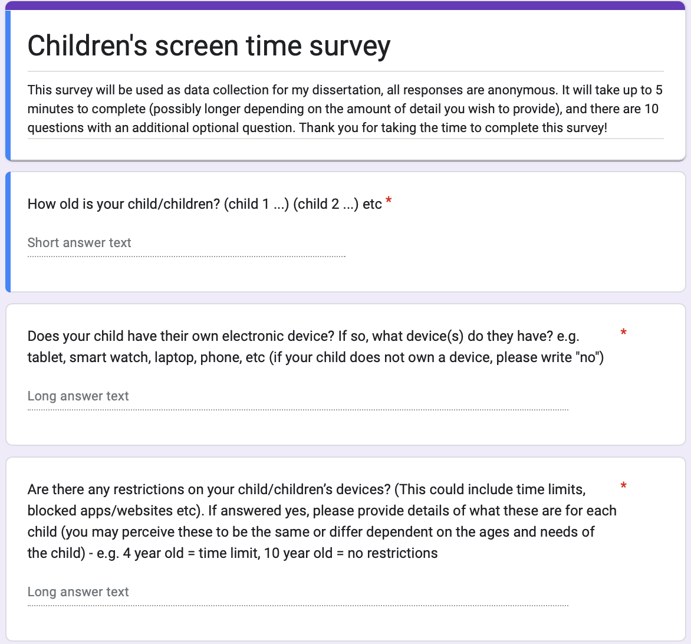
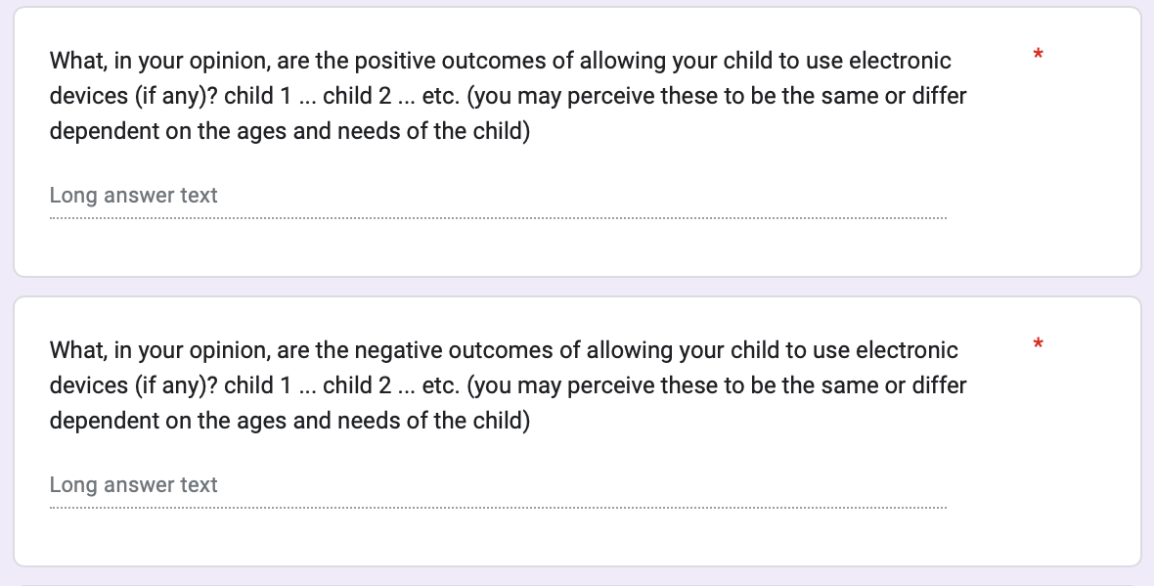
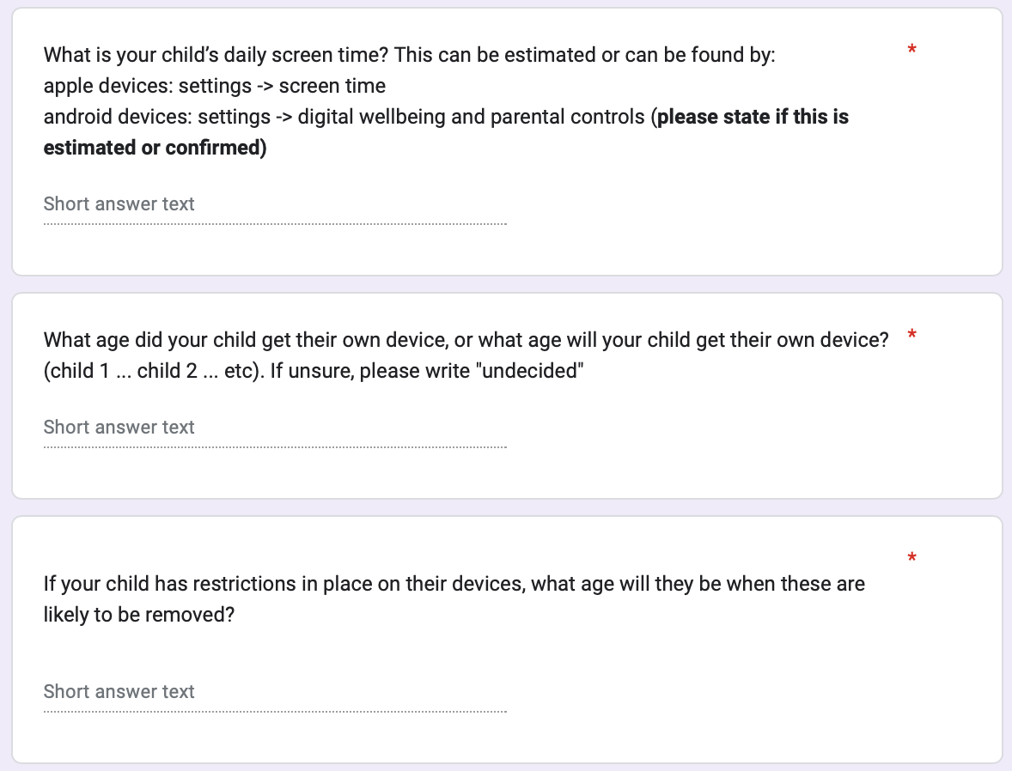
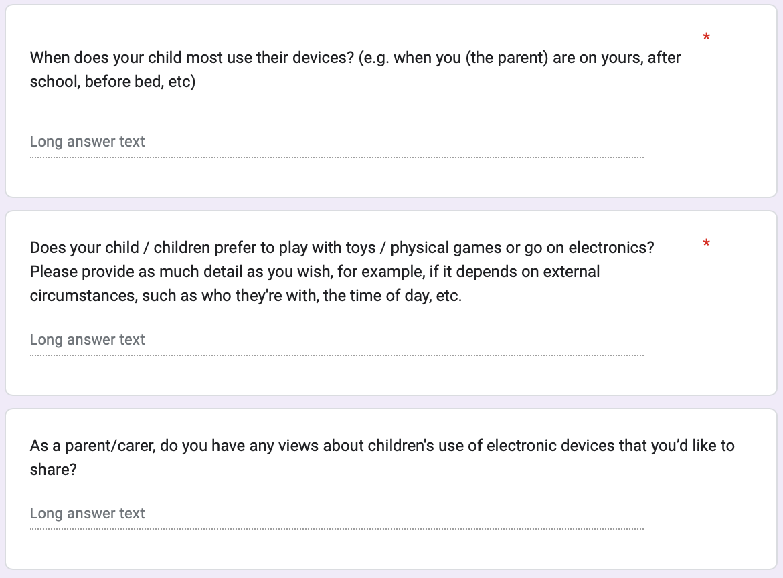

Appendix E Research Ethics Application

Research Ethics Application

PREHP1 / PRUHP1
Education Project

Researcher Information
Student Name | Katy Kitto
Supervisor Name | Jayne Garcia
Proposed Title of Research Project
Children’s screen time: a comparative study of children’s and parents’/carer’s perspectives
Please note that no data collection can take place until ethical approval has been granted.

Rationale
Please provide a brief rationale for the context for your proposed research, including your planned methodology, with links to supporting literature (approx. 250 words).
For my honours project I will conduct a comparative study, exploring how children perceive using screen time for themselves versus how parents/carers perceive children’s screen time usage. The reason for this is because screen time is gaining popularity (Sultana et al., 2021), and there are many positive and negative effects of this (Kumar Agarwai & Lu, 2019). Subsequently, I am interested to examine the difference between children and parents/carers perspectives on these consequences, for example if children see more benefits to screen time than the parents/carers. It also may be important to challenge the parents/carers thoughts on their children’s screen time usage, and allow them to consider whether their children are using screen time to an appropriate amount, and whether this is a beneficial use of time. Technology is prominent in most people’s lives, and most families own one or more forms of digital devices (Pruchno, 2019). Therefore, this research is likely to benefit most families due to the relatability it holds. This research involves primary school aged children, ages four to eleven. The reason for this is because older children are more independent than younger children, therefore devices such as mobile phones may be viewed as a necessity due to the greater independence they have (Crawford et al., 2017). Therefore, most primary school aged children, who still mostly rely on their parents/carers (National Research Council, 2015), may not have their own electronic device. Furthermore, the children and parents/carers who will take part in this research are from a local children’s club, in the city of Plymouth, which involves around thirty to forty children attending. For the parents/carers, a letter will be handed out to all the parents/carers explaining the research and the survey, with a QR code on the letter which, when scanned with a camera app on a mobile phone, will provide a link to the survey. As well as the QR code, a full URL link will be written, which participants can type into their browser to access the survey. This caters for participants’ different preferences, whilst ensuring that all responses are kept anonymous. Moreover, phenomenological research will be used for this project, as this explores individuals’ views (Lester, 1999), which is what this research aims to do.
Research Ethical Considerations
1 | Does the research involve human participants and/or their personal data? | Human Participants | ☒ Yes |  | ☐ No
2 | Does the research involve your own students as participants?  e.g. Children or adults at a setting at which you work or volunteer | Researchers Students | ☒ Yes |  | ☐ No
3 | Does the research involve participants who are unable to give informed consent, considered to be vulnerable, or lack capacity?  e.g. If you require clarification on this, please speak to your supervisor. | Informed Consent | ☒ Yes |  | ☐ No
4 | Will the research require the co-operation of a gatekeeper for initial access to the groups/individuals to be recruited?  e.g. for access to children at school, or to members of a particular organisation | Gatekeeper | ☐ Yes |  | ☒ No
5 | Will the research involve access to records of personal or confidential information concerning identifiable individuals, either living or recently deceased? | Records &  Confidential Information | ☐ Yes |  | ☒ No
6 | Will the research involve the use of administrative data or secure data?  e.g. child records held by a school or college, medical records | Admin / Secure Data | ☐ Yes |  | ☒ No
7 | Will the deception of participants (including covert observation in non-public places) be necessary at any time? | Deception | ☐ Yes |  | ☒ No
8 | Will the research involve discussion of sensitive topics?  e.g. sexual activity, drug use, political behaviour, ethnicity and, potentially, elite interviews, including PREVENT | Sensitive Topics | ☐ Yes |  | ☒ No
9 | Will the research involve members of the public in a research capacity, helping to shape methodology and/or to collect data?  e.g. participatory research with schools | Participatory Research | ☐ Yes |  | ☒ No
10 | Will the research involve visual or vocal methods where participants or other individuals may be identifiable in the audio or visual data used or generated?  Please discuss with supervisor if unsure about this | Audio / Visual  Recordings | ☐ Yes |  | ☒ No
11 | Is the research likely to involve or result in participants experiencing pain or more than mild discomfort?  e.g. Through repeated activity at a sporting event | Pain or Discomfort | ☐ Yes |  | ☒ No
12 | Could the research induce psychological stress or anxiety or cause harm or negative consequences? (Both research participants and their living relatives should be considered) | Stress or Anxiety | ☐ Yes |  | ☒ No
13 | Will the research involve prolonged or repetitive testing of participants?  e.g. Through repeated activity at a sporting event, or class-based activity | Repetitive Testing | ☐ Yes |  | ☒ No
14 | Will data collection involve e-mail, social media, and/or instant messaging services in data collection?  (i.e. individuals can be identified through this method) | Identifiable  Digital Collection | ☐ Yes |  | ☒ No
15 | Will the research place the safety of the researcher(s) at risk? | Researcher Safety | ☐ Yes |  | ☒ No
16 | Will any data collection be undertaken outside of the UK? | Overseas Research | ☐ Yes |  | ☒ No
17 | Will the research or its dissemination involve data sharing of confidential information, or the re-use of previously collected data? | Data sharing or prior data use | ☐ Yes |  | ☒ No
If you answered YES to ANY question, please complete
Research Project Further Information below.
If you answered NO to ALL questions, please complete the Declaration on the final page.
Research Project Further Information
Research Methods
Describe where data will be collected. (Be as detailed as possible)

The data for this research will be collected from a local children’s club called “Kidzklub” in Plymouth which is for children aged four to eleven. This club occurs every Friday evening for an hour during school term-time, and is ran through the organisation Plymouth Christian Centre. The research will be conducted here due to my voluntary leadership position within this organisation; therefore, I am able to gain the information and perceptions from the children easily through conducting my own activity. The children’s data will be collected during the club on Friday 27th January 2023, and the parents/carers data will be collected through an online survey which they will be informed about through a letter which they will be handed when arriving at the club. This gives the parents/carers chance to ask any questions they may have, and will not be rushed if they wish to complete this at the club. This will be handed out on Friday 13th January 2023.

While children and parents/carers are invited to participate, this is a voluntary activity. Age-appropriate consent from children participants will be sought by explaining the project and process, and inviting them to take part. Parents/carers have the option to complete the survey or not.
Describe how data will be collected. (Please indicate all research methods, in stages as appropriate)

Primary research will be conducted within this project. In order to gain the perspectives from the children, I will conduct an activity and implement this into the programme during the club. This will be achieved through having two large pieces of paper at either side of the room, one saying “good” and the other saying “bad”. The simplicity of these words allow for children of all different ages to be catered for, including young children. The paper will also have smiley/sad faces, to reiterate to the children which piece of paper is for positive impacts, and which is for negative impacts. The children will then be given two post-it notes, one in red and one in green, where they will write negatives of screen time on the red post-it notes, and positives of screen time on green post-it notes. This demonstrates how the children will be asked in a more interactive manner, as opposed to a more formal approach such as a survey, as this is likely to lose the children’s’ attention. Also, the use of post-it notes prevents children from copying one another as easily as they could if they were all writing on the same sheet of paper. Furthermore, the different colours of the post-it notes may aid children’s abilities in remembering the aim of the task. Furthermore, this interactive method also ensures that the responses will be anonymous, due to emphasising that the children do not need to write their names, and all ideas are being written in the same colour and style pen.

Subsequently, a survey will be conducted to gather the parents/carers perspectives of the topic. This will involve ten questions which aims to discover how much screen time parents/carers allow for their children, and the reasonings behind this. To receive this information, a letter will be written for the parents/carers of the children, which will explain the research and will provide a QR code on the letter which, when scanned through a mobile phone camera, will be a link to an online survey, which the parents/carers can then complete (a full URL link will also be provided for participants to type into their browser to access the survey). This ensures that the data collected will be anonymous, simple to access, and the ten questions highlight how the survey will be quick. A laptop belonging to the club will be open with the survey on, so that parents/carers may complete the survey when their children enter the club. This may suit the needs of some families better, as there will not be the risk of parents forgetting to complete the survey. Additionally, this allows parents/carers to ask any questions while completing the survey at the club.
Describe how data will be analysed.

Thematic analysis will be used to analyse the data (Braun & Clarke, 2006). Firstly, the separate data from the children and the parents/carers will be read, transcribed, and any main themes will be identified. After this, the data will be coded using key words from the data which acknowledge a specific idea. Then, the data will be re-read and separated into different themes. After categorising the different themes, this will finally be checked through to ensure validity, and a final write up of the analysis will be produced (Chawla & Wood, 2021).

Research Participants
Describe the participants to be recruited. Give as much detail as possible.

All participants will be recruited through my voluntary workplace which is a children’s club called “kidzklub”. This is due to the variety of ages that the club includes, covering all primary school ages. As my research will focus on young children’s views of screen time, the children within the club will be the appropriate ages to conduct this research on. Furthermore, as I hold a leadership position at this club, it enables me to easily carry out the research in an interactive, fun way, through integrating it into the programme. Subsequently, when the parents/carers arrive with their children, they can be given a letter which explains what the research intends to do. The letter will also include a QR code, which links to a survey on screen time for the parents/carers to complete, as well as a URL link which can be typed up into a browser to access the survey. Therefore, this enables a quick and efficient process.

How do you intend to maintain the confidentiality and anonymity of your participants?

Confidentiality and anonymity will be maintained within this project. For the children, they will be writing their answers on a large sheet of paper, and will not include their names. Therefore, due to the large amount of children all writing on the same piece of paper, I will be unaware of which child has written what. Also, a new packet of black biros will be provided to the children, to further promote anonymity.
Moreover, I will hand out a letter to all parents/carers at the beginning of the club. The letter will explain the research process, along with a QR code / URL link for themselves which to access the online survey. They will also be handed a consent form which will ask them to write their children’s names and provide their signature if they consent to their children taking part in the research. The survey for the parents/carers of the children will be created on Google forms which automatically makes all responses anonymous. I will be asking all parents/carers to complete the survey, as opposed to a specific selection of parents/carers, as this further ensures confidentiality.
Does the proposed research involve extraction or collection of personally identifiable information about the participant from existing databases or records?

☐Yes ☒No
If YES, please explain how consent from the individuals or authorisation from the data custodian will be obtained.

Does the proposed research involve participants who have a pre-existing relationship with any of the researchers?

☒Yes ☐No
If YES, please explain the relationship and how power differentials (actual or perceived) will be managed.

I have been volunteering in the children’s club since January 2015, therefore, I have seen many of the children grow through the club, and have developed relationships with them and their families. However, this does not influence the research, as the children will be encouraged to write their opinions, and will be reminded that there are no right or wrong answers, and they are not being tested.

Consent Process
Describe the process that will be used to obtain informed consent and explain how consent will be recorded.

The parents/carers of the children will be handed a participant information letter explaining the research and what I intend to do. This will explain how the research will be conducted with the children, and whether the parents/carers agree to this or not. There will be a section where the parents/carers can tick a box to say whether they agree or disagree, and they are required to provide their signature. If they agree, they can then write their child’s/children’s full names, so that when I conduct the activity with the children, I will know which children are able to take part, whilst the children who were not given consent will be doing a separate activity.

Also on this letter will be a section asking the parents/carers to complete an online survey. The letter will explain what the survey is for, and why the research is necessary. The letter will state that there is no obligation to complete this survey, however, it is useful for the research. The parents/carers will be reminded that they are able to start the survey, but then not complete it if they feel uncomfortable answering questions on this topic. Furthermore, parents/carers will be reminded that all responses are anonymous so they can provide as much detail as they wish to. Additionally, they will be reminded that the research conforms to the University of St Mark & St John’s ethical processes.
Please describe procedures for participants withdrawing from the study.

For the children’s study, this will take place in the form of a craft activity, in which each child will write or draw their responses on a post-it note which they will then al stick onto a large piece of paper. I will explain to the children that it is their choice whether they wish to participate, and they are not being forced to do so. However, I will also make it clear that once they have written or drawn on the paper and it has been handed in, they will not be able to withdraw their responses, as the responses are all anonymous. Similarly, when gaining the parents/carers data, a letter will be handed out along with the QR code providing a link to the survey. This letter will explain that it is the individuals’ choice as to whether they decide to partake within the survey. However, it will also be made clear that after they have submitted the survey, they cannot withdraw their responses due to each survey being anonymous.

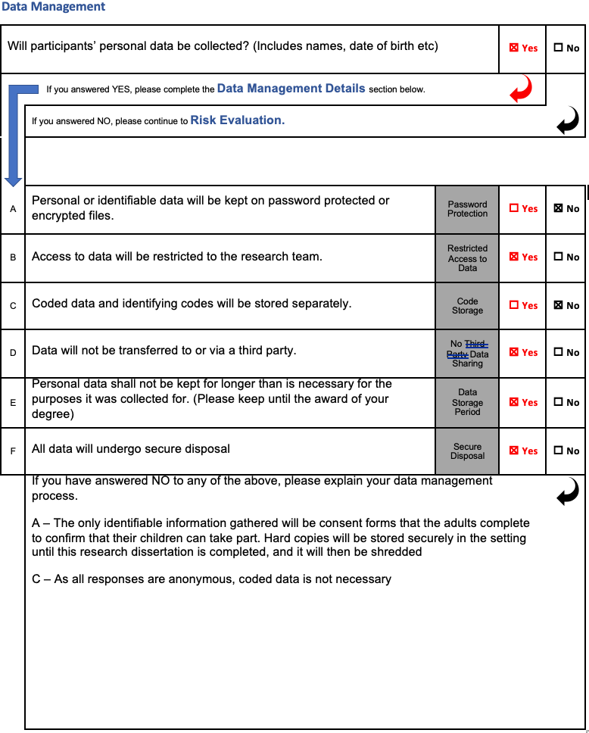
Risk Evaluation
This section is essential to the ethical approval process and must be completed in detail
Please indicate the risk level for the project by checking the intersecting box:

Participant Vulnerability |  | Research Risk
 |  | Low | Medium | High
 | Low | ☒ | ☐ | ☐
 | Medium | ☐ | ☐ | ☐
 | High | ☐ | ☐ | ☐

If the risk level for your project is GREEN or YELLOW, please justify your chosen level of Research Risk and Participant Vulnerability. (Refer to BERA / EECERA Guidelines)

Identified Risk | Ways you will seek to minimise the risk
e.g. Research involves my own students as participants? | Equalise power differentials – I will explain my process clearly to participants, answer any questions they have fully. I will ensure I give clear participant information and seek clear informed consent from participants and / or their parents or carers.
Research involves own students as participants | In line with the EECERA guidelines, I will ensure that the research I conduct is fair and honest, and ensure it is not biased (Bertram et al., 2016). Each participant will be provided with full information on the research, so that all participants are fully aware of the procedures and what will happen with the data that they provide
Data will not be stored on a password protected computer | Part of the research will be conducted in paper form, as the children will write their responses on a large sheet of paper during the club. However, this will be securely locked away in a cabinet, and all responses will then be transcribed and securely locked away on a password protected file on a computer. This is in line with the BERA guidelines. (British Educational Research Association, 2018)

Please note that RED level risk is appropriate only at postgraduate level.
If the risk level for your project is GREEN, or YELLOW, please proceed to Declaration.

Bertram, T., Formosinho, J., Gray, C., Pascal, C., & Whalley, M. (2016). EECERA ethical code for early childhood researchers. European Early Childhood Education Research Journal, 24(1), iii-xiii.

Submission Checklist

Please use this list to ensure that your submission is supported by all appropriate supporting information.

I have attached all research tools (i.e. questionnaires or interview guides) | ☒ Yes | ☐ No | ☐ Not  Applicable
I have attached any participant information sheets | ☒ Yes | ☐ No | ☐ Not  Applicable
I have attached any Consent forms | ☒ Yes | ☐ No | ☐ Not  Applicable

Declaration

My signature below confirms that
- I am aware of, understand, and will comply with all relevant laws governing my research.
- I agree to ensure my co-investigators, collaborators and all involved in the running of this research will comply with these laws.
- I understand that for research involving extraction or collection of personally identifiable information, national and/or international laws may apply and that any apparent mishandling of personally identifiable information must be reported to the Research and Knowledge Exchange Office.
- I agree that research will only commence after a favourable opinion has been received from the Research Ethics Panel; that neither the University, Panel or individual members of the Panel accept any legal obligation (to use to any third party) in relation to the processing of this application or to any advice offered in respect of it or not for the subsequent supervision of the research.
- If there is any significant deviation from the project as originally approved, I must submit an amendment to the Research Ethics Panel for approval prior to implementing any change.

Signature of Researcher  Katy Kitto | Date  05.12.22

Additional for all student applications:
As the supervisor of this student project my signature below confirms that I have reviewed and approve the research project and the ethics protocol submission. I confirm that I will provide the student with the necessary supervision throughout the project, to ensure that all procedures performed as part of this project comply with all relevant laws governing the research.

Signature of Supervisor | Date

As the counter-signer of the project I confirm that I am not directly involved in the project, and have reviewed and approve the academic merit of the research project and the ethics protocol submission.

Signature of Panel Member | Date

Reference list:

Braun, V., & Clarke, V. (2006). Using thematic analysis in psychology. Qualitative Research in Psychology, 3(2), 77–101. https://doi.org/10.1191/1478088706qp063oa
British Educational Research Association. (2018). Ethical Guidelines for Educational Research, fourth edition. https://www.bera.ac.uk/publication/ethical-guidelines-for-educational-research-2018-online
Chawla, T., & Wood, J. (2021). Environmental Resilience of Bottom of the Pyramid Strategies Toward Single-Use Plastics: A Recipe From an Emerging Economy. Economic Effects of Natural Disasters. https://www.sciencedirect.com/topics/social-sciences/thematic-analysis
Crawford, S. B., Bennetts, S. K., Hackworth, N. J., Green, J., Graesser, H., Cooklin, A. R., Matthews, J., Strazdins, L., Zubrick, S. R., D’Esposito, F., & Nicholson, J. M. (2017). Worries, ‘weirdos’, neighborhoods and knowing people: a qualitative study with children and parents regarding children’s independent mobility. Health & Place, 45, 131–139. https://doi.org/https://doi.org/10.1016/j.healthplace.2017.03.005
Kumar Agarwai, N., & Lu, W. (2019). Proceedings of the Association for Information Science and Technology. Asis&t, 56(1), 594–596. https://doi.org/https://doi.org/10.1002/pra2.100
Lester, S. (1999). An introduction to phenomenological research.
National Research Council. (2015). Transforming the Workforce for Children Birth Through Age 8: A Unifying Foundation. https://doi.org/10.17226/19401
Pruchno, R. (2019). Technology and Aging: An Evolving Partnership. The Gerontologist, 59(1), 1–5. https://doi.org/https://doi.org/10.1093/geront/gny153
Sultana, A., Tasnim, S., Hossain, M. M., Bhattacharya, S., & Purohit, N. (2021). Digital screen time during the COVID-19 pandemic: a public health concern [version 1; peer review: 1 approved, 1 approved with reservations]. F1000Research, 10(81). https://doi.org/https://doi.org/10.12688/f1000research.50880.1

Consent form

Embankment Road
Cattedown
Plymouth
PL4 9HP

Telephone: (01752) 661019

Dear Parents/Carers

My name is Katy Kitto, and I am one of the leaders at Kidzklub. I am currently in my final year at Plymouth Marjon University studying on the BA (Hons) Education Studies and Psychology degree programme. For my Honours level project I am required to conduct an independent research study, you may have heard of this as a dissertation.

I have decided to base this research on the perspectives around children’s screen time. I will be comparing children’s views of their screen time with parents’ views of children’s screen time.

During one of the Kidzklub sessions, the children will write or draw their opinions regarding their use of electronic devices, both pros and cons. This activity will take up to five minutes and will take place on Friday 27th January 2023 during Kidzklub. This is intended to be a fun activity and will not detract from their usually fun enjoyment of the evening.

If this is something that you are happy for your child / children to take part in, please fill out the consent form and hand it back to a Kidzklub worker by Friday 27th January 2023. For you, as the parents, I would be so grateful if you could fill out this quick survey, which will only take a few minutes and will be a huge help for me! You can do this by opening the camera app on your phone and scanning the QR code below, which will give you a direct link to the survey. Alternatively, you can type in the URL link (shown below) into your browser. The responses that both the children and you provide will be completely anonymous. For further information, please read the participant information sheet. Thank you for taking the time to do this, it is greatly appreciated!

Kind regards

Katy Kitto
CHILDREN ACTIVITY – this is an example of what the activity will look like. The two pieces of paper will be A1 size to ensure that it will hold many post-it notes.

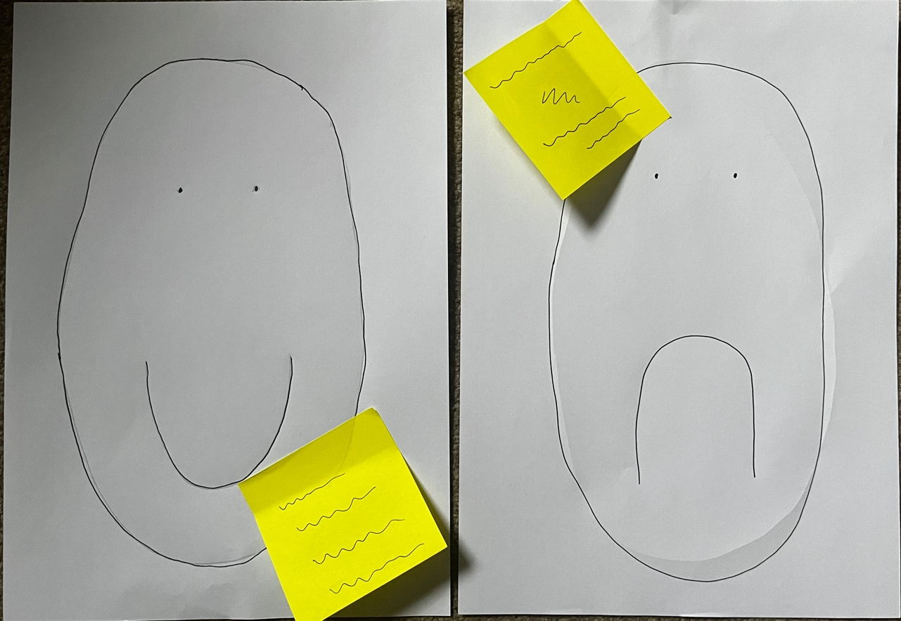

Parents survey questions:

- How old is your child / children? Child 1… child 2…. Child 3…..
- Do they have their own electronic device, if so, what device(s) do they have? E.g. tablet, smart watch, laptop, phone etc ……….
- Are there any restrictions on your child/children’s devices? (This could include time limits, blocked apps/websites etc). if answered yes, please provide details of what these are – child 1…. Child 2…. Child 3….. (you may perceive these to be the same or differ dependent on the ages and needs of the child)
- What, in your opinion, are the positive outcomes of allowing your child to use electronic devices (if any)? Child 1….. child 2….. child 3….. (you may perceive these to be the same or differ dependent on the ages and needs of the child)
- What, in your opinion, are the negative outcomes of allowing your child to use electronic devices (if any)? Child 1….. child 2….. child 3….. (you may perceive these to be the same or differ dependent on the ages and needs of the child)
- What is your child’s daily screen time? This can be estimated or can be found by going to settings -> screen time on apple or settings -> digital wellbeing and parental controls on androids (tick confirmed / estimated boxes)
- What age did your child get their own device, or what age will your child get their own device? Child 1….. child 2….. child 3…….
- If your child has restrictions in place on their devices, what age will they be when these are likely to be removed?
- When does your child most use their devices? (e.g. when you (the parent) are on yours, after school, before bed, etc)
- Does your child / children prefer to play with toys / physical games or go on electronics? (make this more open-ended, e.g. when they’re home etc?)
- As a parent/carer, do you have any views about young people’s use of electronic devices that you’d like to share? (optional)

Participant Information Sheet
Children’s screen time: a comparative study of children’s and parents’ perspectives
Name of Researchers: Katy Kitto
The researcher for this project is Katy Kitto, a Plymouth Marjon University student in year three of the BA (Hons) Education Studies and Psychology. This project will be exploring the differences between children’s and parents’ perspectives of children’s screen time. This will be investigated through two separate methods, one with children and one with parents/carers. This project may encourage participants to consider how much time they spend on electronic devices, or how much time they allow their children to spend on devices if they have not considered this before. As technology is constantly advancing, children may be using such technology from an early age and thusly it may be beneficial to promote awareness for this and ensure that participants acknowledge and consider the effects it may have. The children’s research activity will take place during ‘Kidzklub’, and this will occur in the form of a large group craft. The children will have about five minutes to write or draw their thoughts, opinions, and ideas of screen time. For the parents, a QR code will be sent out on a letter which, when scanned with a phone camera, will provide a link to an online survey, as well as a URL link being provided if participants prefer. Here, the parents will have two weeks to fill out the survey, or they may complete this on Friday 13th January at Kidzklub, when arriving with their children, if this is more convenient. This is voluntary and all responses will be anonymous.
What is the purpose of the study?
This research aims to explore the differences between children’s and parent’s logic regarding screen time. It will be conducted to promote more awareness of the effects of screen time, so that people may have a greater understanding of the consequences which screen time may have. As older children above twelve are of secondary school age, it is more likely that they will have their own devices due to safety reasons and having more independence than younger children. Therefore, the rationale as to why this research is being conducted on children under twelve years is due to the potential lack of awareness of negative consequences regarding screen time they may have. Furthermore, as younger children depend on adults more than older children, younger children may be given technologies as a distraction tool, and so may spend more time on screens. Similarly, this study will involve parents’ perspectives of screen time due to the reasonings as to why they allow or do not allow their children to use devices. In order to conduct this study, the children’s activity will be implemented into ‘Kidzklub’ which will happen on Friday 27th January 2023. Also, the parents will be given their letter with the link to the online survey on Friday 13th January 2023, where the parents will then have a two-week window to complete this and submit it. This survey will be available for all parents of Kidzklub children, and all of the Kidzklub children themselves (if given consent by parents).

Why have I been invited?
Children
The children that have been invited to participate in the study are the children who attend Kidzklub. Due to this research requiring children under twelve years, this means that all children who attend the club are within this age limit. Furthermore, due to the leadership position that I hold within the club, this will allow me to easily implement the craft activity into the programme for Friday 27th January 2023, where I will gain the data for children’s perspectives.

Parents/Carers
The parents/carers of the children in Kidzklub have been invited to participate due to the practicality of being able to complete the consent form and survey at the club, or they can be handed this letter at the club and then take it home to complete. The parents/carers are also able to ask me questions directly, as I will be present when providing them with the documents. Moreover, the survey being handed out to the parents at Kidzklub holds less risks, as it is certain that these are legitimate parents/carers. If I uploaded a link to the survey on social media (for example), there is a risk that it may not be parents who will complete the survey.

Do I have to take part?
Children
There is no obligation for the children to take part in the study, despite whether or not their parents/carers have allowed this via the consent form. The children whose parents/carers have agreed to them taking part will be informed before the activity starts that it is voluntary. The children who have not had consent to take part will be doing a group game whilst the other children involved partake within the study. Therefore, both groups of children will be prevented from feeling left out as both activities will be engaging. Children will give age appropriate consent to take part in the activity and can opt not to join in should they wish to.

Parents/carers
All participants who have been invited to take part in the research have the right to decline the offer or withdraw at any stage of the study up until they have submitted the survey. This is entirely voluntary and there is no obligation to take part. A consent form will be given to the parents/carers on behalf of their child’s/children’s participation in their activity, then, if the children also consent, they will be able to take part.

What will happen to me if I take part?
Participation allows participants to have a voice and communicate their ideas (Sinclair, 2004).
Children
The participants will be informed of what the study is, why it is happening and what the information they provide is being used for. When the children have this initial information and understand the basis of the experiment, they will then be asked to split into their teams (they are already on a team) and one will go to the sheet of paper saying “bad”, while the other team goes to the sheet of paper saying “good”. They will then be allowed a short amount of time to write or draw their ideas on their post-it note, and stick it to the large sheet of paper, before alternating with the other team. This data will be locked away when the activity is completed and then stored on the secure network drive at the University of St Mark & St John when it is being analysed. This data will then be discarded a few months later, after the final write up and submission of the dissertation and award of the degree.

Parents/carers
The participants will be provided with a letter which clearly explains what the survey will be used for and why this is necessary for them. The survey includes ten questions with both open and closed ended questions and will only take a few minutes to complete. These responses will be kept for a few months until the data has been analysed and the results have been written up, before being discarded after the award of the degree.

Sinclair, R. (2004). Participation in practice: Making it meaningful, effective and sustainable. Children & society, 18(2), 106-118.
Chicago

Expenses and payments
The only payments within the study will be post-it notes and a new box of black biro’s for the children’s activity. As the parents/carers will complete the survey online, there will be no expenses involved. There will be no costs incurred by the participants, nor will any incentives be given.

What will I have to do?
Children
The children will be informed about the study and will have the study clearly explained to them. After the parents/carers have given consent to them taking part in the study, the children will be asked if they want to take part. If the children are willing, they will be asked to gather around a piece of paper in their usual teams. One team will first give their opinions of the negatives of screen time, whilst the other team will give their opinions of the benefits that screen time may have. After a few minutes, the two teams will stick these post-it notes onto the large sheet of paper before they switch sides where they will then write/draw about the alternative. The club will then resume, and all of the children will come back together.

Parents/carers
Along with the letter that the parents will be given will also be a consent form for their children, where they can give consent to the children taking part in a similar study. The parents will be asked to complete a short survey, and the letter will clearly explain what this is for and why they are being asked. This letter will also provide a URL link and a QR code, which can be scanned with a camera app on a phone to access the survey. This letter will be handed out to the parents when they arrive with their children at the club on Friday 13th January 2023. The parents will then have two weeks to submit this survey, by Friday 27th January 2023.

What are the advantages of taking part?
For the children and parents/carers, it allows all participants to consider the effects of using their devices, and may encourage them to consider things that they have not thought about before. For example, the survey questions parents on how long their children’s daily screen time usage is. If they discover this to be a lot, they may ensure their children spend more time playing and learning as opposed to playing games on their devices (for example). Therefore, this study may be very eye-opening and challenging.

As the parents/carers survey is completely anonymous, it allows them to be honest in stating their opinions.
What are the possible disadvantages and risks of taking part?
Within the children’s study, the children are writing or drawing their opinions of screen time. However, they are only able to do this if their parents/carers give consent for them to take part. Therefore, if only a few parents/carers give consent to their children taking part, there may be the risk of having a small sample size, which may lack anonymity. However, all responses will be confidential and will be securely locked away with only the researcher being able to access the data. All data will be stored on the secure network drive at the University of St Mark & St John.

Unlike the adults whose responses are automatically made anonymous, the children may be afraid to suggest their true feelings towards screen time. Some children may be too young to consider the consequences, and therefore may result in copying from peers. Therefore, the responses given may not be truthful and an accurate representation of young children’s perspectives of screen time. However, the children will be reminded that they do not write their names, and they are all given the same pen to prevent me from knowing who has written what.

Although this study may encourage participants to ensure that devices are being used less and instead be more active on a daily basis, it is also quite normal for parents/carers to have concerns about the amount of time their children spend using devices. If you would like to access further information to support you and your children, the following link may be helpful. Https://kidshealth.org/en/parents/net-safety.html

Will my taking part in the study be kept confidential?
Whilst researchers will protect the confidentiality and anonymity of all participants and their data at all times, there are risks to anonymity with limited numbers of individuals taking part. For example, there may be only a small sample size of the children’s study due to this requiring parental consent. Also, the data from all of the participants may be looked at by authorised persons from the university of St Mark and St John to ensure that the study is being conducted in the correct way, however, all researchers and authorised persons will aim to keep all data confidential. All data will be stored on the secure network drive at the University of St Mark & St John, therefore, this ensures that nobody apart from the authorised persons will have access to the participants’ data. Following the submission of this project all datasets will be disposed of securely.

What will happen if I don’t want to carry on with the study?
The children are only able to partake in the study if they have parental consent for this. After the consent has been gained, these children will be asked if they would like to take part in the research. The children have until they have finished their writings or drawing on the paper to withdraw from the study, however, after they have done this, they will not be able to remove what they have done due to the anonymity. Similarly, the parents/carers can withdraw from the study up until they have submitted the survey. After the survey has been submitted, they will be unable to remove their responses and withdraw due to each response being submitted anonymously, thus being unidentifiable.

What if there is a problem?
If participants have any problems, worries, or concerns regarding this research, they are able to contact me, the researcher, to discuss this. These contact details can be found at the end of the participant information sheet. Moreover, if the participants wish to discuss their rights as a research participant, or wish to make a complaint, they can contact the Research Ethics Panel at ethicspanel@marjon.ac.uk

What will happen to the results of the research study?
The results of the study will be used to contribute to the award of my BA Education Studies and Psychology degree. It will also contribute to the knowledge in the field and my own personal development. Furthermore, there is scope for some exceptional projects to be published in a journal, which is a potential option.
Thank you for taking the time to read the information sheet. If you decide to participate you will be given a copy of the information sheet to keep and your consent will be sought.

Contact details of researcher:
Katy Kitto
Plymouth Marjon Unversity,
Derriford Road,
Plymouth,
PL6 8BH,
20103710@marjon.ac.uk,
07877527448.

Appendix F Children’s Research Activity
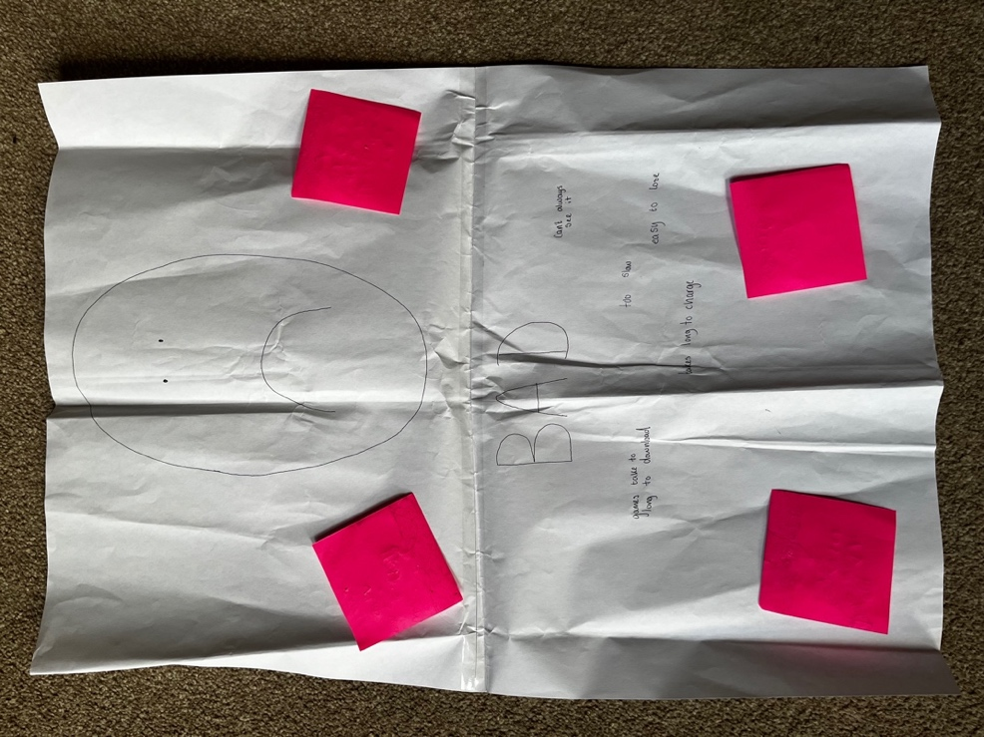
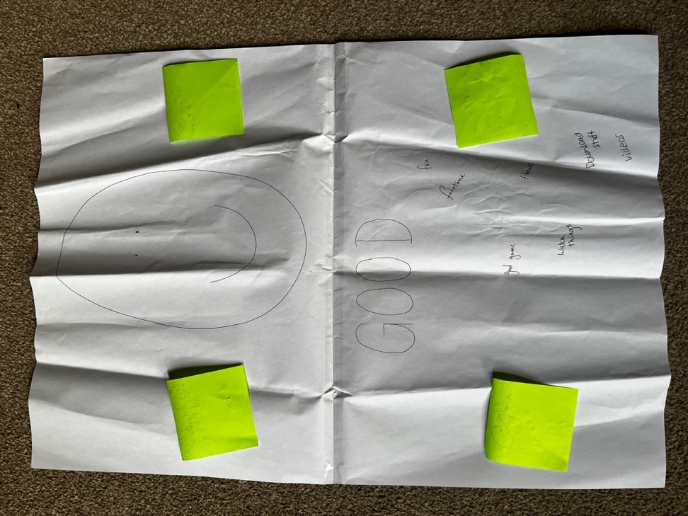

Appendix G Coding Process and Mind Maps

Files emailed to Jayne Garcia 04.05.23

Appendix H Data Notes Version One

Children
Younger kids’ activity: 19 good (including 1 random drawing), 23 bad
Older kids’ activity: 9 good, 10 bad
33 responses altogether – 27 good, 33 bad
3 kids chose not to take part
(27 parents’ consent forms received – including permission for 36 kids as some had multiple children)
Parents
50 survey responses – so 23 parents decided to answer the survey themselves but did not give permission for their children to take part in the activity – why could this be?
sheet 3 notes:
potential themes: time-limits, parental controls / monitored by parents, age restrictions
interesting things to talk about:
- one parent/carer let their child play on games so it improves their confidence with I.T skills – most parents said about restrictions, this parent/carer restricts the phone to just games but this is because they want them to improve with learning (maybe get a reference saying how games help with cognition or something?)
- “i’ve tried to set up parental controls a couple of times but i have given up because i find it too confusing.” - I could talk about this and ways of how to make it less confusing as future research etc, parents need to be educated more so they can understand how to control technology
sheet 4 notes:
potential themes: education / enhanced knowledge, gaming, distraction tool
interesting things to talk about:
- A few talked about computer literacy skills, parents see their children knowing lots about technology as a good thing – one parent said “the better understanding my child has of their devices the better they will get on in later life” another said “increased computer literacy, in a world increasingly moving towards online work/life” – parents recognise that technology is constantly evolving and we will no longer live in a world without technology – maybe they have accepted that their kids need to know about technology
- “if he’s happy – I’m happy” – parents enjoy their children being happy?
- “I can tell that my 9 year old is far more knowledgeable than what I was at her age” – technology is making children more advanced for their age? – loads of responses about educational benefits such as with numbers
- One response mentioned about the child using devices for things like the online dictionary – why cant they just use a regular dictionary? – this may be more accurate as there are loads of online dictionaries and some are proper and others are not – maybe the parent/carer is unaware of these risks?
- Linking to a distraction tool: all kids positive responses link to this - older kids positive response: “you get entertainment” – this is potentially why it is so easy for parents/carers to give devices when kids are ‘playing up’ – but the more they go on devices the worse the behaviour gets, and vice versa – it’s a lose lose
sheet 5 notes:

potential themes: inappropriate content, poor-behaviour, addictive, not-present
interesting things to talk about:
- “too many bad games and videos even on kids google”, another parent/carer said “potential to access unfiltered content” and another “slight increase in safeguarding risk despite multiple layers of protection” “adverts that are inappropriate still come up with age restrictions” – may be more responses like these? – are they actually inappropriate or are parents just being over-sensitive? How can these ads be stopped? Do children need to see things like this to get used to it – it’s a part of our culture now and we cant protect them from seeing stuff forever – the earlier they see stuff the more used to it they will be?
- Many responses such as “they are sometimes stuck in the gadget’s world. No interaction with adults and their colleagues. Human social skills are dying because of this” – how to get kids to stick to recommended time limits to prevent this from happening?
- “but everything is so about technology now that you can’t not let them” – parents may feel obliged and like they’ve given up and accepting that technologies are a huge part of life

sheet 9 notes:
potential themes: ?
interesting things to talk about:
- Majority said after school & weekends
- Some parents said to wind down – maybe they’re unaware that technology is likely to cause them to stay awake for longer due to blue light etc? (reference this?) – one younger child said as a negative response “downtime”
- Few said car journeys
- One said when they are on theirs
- One lets only their older child use before bed
- Some said before dinner – maybe to distract them while they wait?
- One also said that their child uses it while they wait for the other child in a club (response 49)
sheet 10 notes:
potential themes:
interesting things to talk about:
- A few said about the weather – in winter playing on electronics more & preferring to go outdoors when weather is good (responses 5 & 6)
- Many said that their child would prefer to use electronics, but parents prevent this from happening – maybe parents want their children to enjoy their childhood playing physically like they did when they were kids? (Response 23 relates their children playing to their own childhood experiences)
- Children enjoy playing together, when they can’t, they prefer electronics – a few responses said this
- Some parents put their own preferences and did not mention the child’s – maybe they misread the question or do not consider the child’s preferences so are unsure? – maybe they think they know best so do not give them the option, as they might hear from others that screen time is bad

sheet 11 notes:
potential themes: low ST is good, necessity in schools, pressure, needs supervision / monitoring – this links with low ST?
interesting things to talk about:
- Many parents say that devices are needed in schools, such as using apps to complete homework
- Many recognised that we live in a world of technology – they know that their children need to adapt to this way of living else they may fall behind
- Quotes relating to this:
- “But such is the modern world, they feel left out if they do not have access to devices as all of their friends have devices. And their homework now involves devices which doesn’t sit right with me, as I feel devices should be optional, not mandatory.”
- “electronics are part of school and homework.”
- “Times are changing. Children need to adapt and I think it’s important that we help them and learn with them”
- “I believe the school curriculum is putting too much pressure on children’s to have access to devices. Apps such as spelling shed, tt rock stars etc are now used as a way of children completing homework but is promoting screen time”
- “No rush to get them however we live in a world of technology so don't want them to get left behind.”
- “it's also part of our children's future to be aware of this technology”
- “Use of electronic device help children to keep in touch with latest developments in new electronic devices … Excessive usage can lead to addiction so a wise and controlled exposure to electronic devices is helpful.”
- “I try to avoid using my electric devise in front of them. But there is peer pressure to have a phone or Xbox etc.” – pressure from schools but also pressure from others – they may try and not use their device infront of their children to not promote screens
- “I'd like it if it was easier to set up parental controls and I wish kids devices could be set up completely ad free. I find the constant bombardment of consumer culture which seeks to feed and feed off people's insecurities, one of the most unpleasant things in life” – relates to previous responses where parents have said they get confused (check this is not the same parent saying this again) – many responses have shown that ads are inappropriate, annoying, and one response said that their child gets carried away (implying that they click on them sometimes?)
- “I don't like them spending more than 2hrs aday on their device but most often am too busy to engage them in other activities so they end up spending more time on the device which makes me feel bad am letting them down, although I know they enjoy watching their devices,” – when they let their child use screens for longer, it can cause parents to feel guilty.
Overall: most parents have said that they use restrictions, and ST is good IF restrictions are used, they seem quite protective over children’s content / inappropriate ads – most parents defo aren’t oblivious to the risks of technology. Maybe parents are over protective? And they also get confused with technology, and want to put further restrictions in place but don’t know how – more info regarding children’s ST would be useful so they know how to manage it properly

Appendix I Data Notes Version Two

Children
Younger kids’ activity: 19 good (including 1 random drawing), 23 bad
Older kids’ activity: 9 good, 10 bad
33 responses altogether – 27 good, 33 bad
3 kids chose not to take part
(27 parents’ consent forms received – including permission for 36 kids as some had multiple children)
Parents
50 survey responses – so 23 parents decided to answer the survey themselves but did not give permission for their children to take part in the activity – why could this be?
sheet 3 notes:
potential themes: time-limits, parental controls / monitored by parents, age restrictions
interesting things to talk about:
- one parent/carer let their child play on games so it improves their confidence with I.T skills – most parents said about restrictions, this parent/carer restricts the phone to just games but this is because they want them to improve with learning (maybe get a reference saying how games help with cognition or something?)
- “i’ve tried to set up parental controls a couple of times but i have given up because i find it too confusing.” - I could talk about this and ways of how to make it less confusing as future research etc, parents need to be educated more so they can understand how to control technology

sheet 4 notes:
potential themes: education / enhanced knowledge, gaming, distraction tool
interesting things to talk about:
- A few talked about computer literacy skills, parents see their children knowing lots about technology as a good thing – one parent said “the better understanding my child has of their devices the better they will get on in later life” another said “increased computer literacy, in a world increasingly moving towards online work/life” – parents recognise that technology is constantly evolving and we will no longer live in a world without technology – maybe they have accepted that their kids need to know about technology
- “if he’s happy – I’m happy” – parents enjoy their children being happy?
- “I can tell that my 9 year old is far more knowledgeable than what I was at her age” – technology is making children more advanced for their age? – loads of responses about educational benefits such as with numbers
- One response mentioned about the child using devices for things like the online dictionary – why cant they just use a regular dictionary? – this may be more accurate as there are loads of online dictionaries and some are proper and others are not – maybe the parent/carer is unaware of these risks?
- Linking to a distraction tool: all kids positive responses link to this - older kids positive response: “you get entertainment” – this is potentially why it is so easy for parents/carers to give devices when kids are ‘playing up’ – but the more they go on devices the worse the behaviour gets, and vice versa – it’s a lose lose

sheet 5 notes:
potential themes: inappropriate content, poor-behaviour, addictive, not-present
interesting things to talk about:
- “too many bad games and videos even on kids google”, another parent/carer said “potential to access unfiltered content” and another “slight increase in safeguarding risk despite multiple layers of protection” “adverts that are inappropriate still come up with age restrictions” – may be more responses like these? – are they actually inappropriate or are parents just being over-sensitive? How can these ads be stopped? Do children need to see things like this to get used to it – it’s a part of our culture now and we cant protect them from seeing stuff forever – the earlier they see stuff the more used to it they will be?
- Many responses such as “they are sometimes stuck in the gadget’s world. No interaction with adults and their colleagues. Human social skills are dying because of this” – how to get kids to stick to recommended time limits to prevent this from happening?
- “but everything is so about technology now that you can’t not let them” – parents may feel obliged and like they’ve given up and accepting that technologies are a huge part of life
sheet 9 notes:
potential themes: ?
interesting things to talk about:
- Majority said after school & weekends
- Some parents said to wind down – maybe they’re unaware that technology is likely to cause them to stay awake for longer due to blue light etc? (reference this?) – one younger child said as a negative response “downtime”
- Few said car journeys
- One said when they are on theirs
- One lets only their older child use before bed
- Some said before dinner – maybe to distract them while they wait?
- One also said that their child uses it while they wait for the other child in a club (response 49)
sheet 10 notes:
potential themes:
interesting things to talk about:
- A few said about the weather – in winter playing on electronics more & preferring to go outdoors when weather is good (responses 5 & 6)
- Many said that their child would prefer to use electronics, but parents prevent this from happening – maybe parents want their children to enjoy their childhood playing physically like they did when they were kids? (Response 23 relates their children playing to their own childhood experiences)
- Children enjoy playing together, when they can’t, they prefer electronics – a few responses said this
- Some parents put their own preferences and did not mention the child’s – maybe they misread the question or do not consider the child’s preferences so are unsure? – maybe they think they know best so do not give them the option, as they might hear from others that screen time is bad
sheet 11 notes:
potential themes: low ST is good, necessity in schools, pressure, needs supervision / monitoring – this links with low ST?
interesting things to talk about:
- Many parents say that devices are needed in schools, such as using apps to complete homework
- Many recognised that we live in a world of technology – they know that their children need to adapt to this way of living else they may fall behind
- Quotes relating to this:
- “But such is the modern world, they feel left out if they do not have access to devices as all of their friends have devices. And their homework now involves devices which doesn’t sit right with me, as I feel devices should be optional, not mandatory.”
- “electronics are part of school and homework.”
- “Times are changing. Children need to adapt and I think it’s important that we help them and learn with them”
- “I believe the school curriculum is putting too much pressure on children’s to have access to devices. Apps such as spelling shed, tt rock stars etc are now used as a way of children completing homework but is promoting screen time”
- “No rush to get them however we live in a world of technology so don't want them to get left behind.”
- “it's also part of our children's future to be aware of this technology”
- “Use of electronic device help children to keep in touch with latest developments in new electronic devices … Excessive usage can lead to addiction so a wise and controlled exposure to electronic devices is helpful.”
- “I try to avoid using my electric devise in front of them. But there is peer pressure to have a phone or Xbox etc.” – pressure from schools but also pressure from others – they may try and not use their device infront of their children to not promote screens
- “I'd like it if it was easier to set up parental controls and I wish kids devices could be set up completely ad free. I find the constant bombardment of consumer culture which seeks to feed and feed off people's insecurities, one of the most unpleasant things in life” – relates to previous responses where parents have said they get confused (check this is not the same parent saying this again) – many responses have shown that ads are inappropriate, annoying, and one response said that their child gets carried away (implying that they click on them sometimes?)
- “I don't like them spending more than 2hrs aday on their device but most often am too busy to engage them in other activities so they end up spending more time on the device which makes me feel bad am letting them down, although I know they enjoy watching their devices,” – when they let their child use screens for longer, it can cause parents to feel guilty.

Overall: most parents have said that they use restrictions, and ST is good IF restrictions are used, they seem quite protective over children’s content / inappropriate ads – most parents defo aren’t oblivious to the risks of technology. Maybe parents are over protective? And they also get confused with technology, and want to put further restrictions in place but don’t know how – more info regarding children’s ST would be useful so they know how to manage it properly
Using parental controls to prevent child from seeing inappropriate content
sheet 3
“i’ve tried to set up parental controls a couple of times but i have given up because i find it too confusing.” - I could talk about this and ways of how to make it less confusing as future research etc, parents need to be educated more so they can understand how to control technology
sheet 5
- “too many bad games and videos even on kids google”, another parent/carer said “potential to access unfiltered content” and another “slight increase in safeguarding risk despite multiple layers of protection” “adverts that are inappropriate still come up with age restrictions” – may be more responses like these? – are they actually inappropriate or are parents just being over-sensitive? How can these ads be stopped? Do children need to see things like this to get used to it – it’s a part of our culture now and we cant protect them from seeing stuff forever – the earlier they see stuff the more used to it they will be?
- Younger child negative response “I do not like playing games because I hate ads” – this is only child out of many that have mentioned about ads, however, ads clearly has a negative impact on them as its stopped them playing games
Sheet 11
- “I'd like it if it was easier to set up parental controls and I wish kids devices could be set up completely ad free. I find the constant bombardment of consumer culture which seeks to feed and feed off people's insecurities, one of the most unpleasant things in life” – relates to previous responses where parents have said they get confused (check this is not the same parent saying this again) – many responses have shown that ads are inappropriate, annoying, and one response said that their child gets carried away (implying that they click on them sometimes?)
Overall: most parents have said that they use restrictions, and ST is good IF restrictions are used, they seem quite protective over children’s content / inappropriate ads – most parents defo aren’t oblivious to the risks of technology. Maybe parents are over protective? And they also get confused with technology, and want to put further restrictions in place but don’t know how – more info regarding children’s ST would be useful so they know how to manage it properly

Older kids response – “when my dad deleted my progress” – maybe the game was making the child to have bad behaviour so the parent tried to delete?
Parents/carers want their children to be I.T iterate in this technological world

Sheet 3:
- one parent/carer let their child play on games so it improves their confidence with I.T skills – most parents said about restrictions, this parent/carer restricts the phone to just games but this is because they want them to improve with learning (maybe get a reference saying how games help with cognition or something?)
Sheet 4:
- A few talked about computer literacy skills, parents see their children knowing lots about technology as a good thing – one parent said “the better understanding my child has of their devices the better they will get on in later life” another said “increased computer literacy, in a world increasingly moving towards online work/life” – parents recognise that technology is constantly evolving and we will no longer live in a world without technology – maybe they have accepted that their kids need to know about technology
- “I can tell that my 9 year old is far more knowledgeable than what I was at her age” – technology is making children more advanced for their age? – loads of responses about educational benefits such as with numbers
Sheet 11:
- “Times are changing. Children need to adapt and I think it’s important that we help them and learn with them”
- “Use of electronic device help children to keep in touch with latest developments in new electronic devices … Excessive usage can lead to addiction so a wise and controlled exposure to electronic devices is helpful.”

- Linking to previous one – parents/carers dislike the growing of technology but have accepted that this is the new way of living
Sheet 4:
- “if he’s happy – I’m happy” – parents enjoy their children being happy?
Sheet 5:
- “but everything is so about technology now that you can’t not let them” – parents may feel obliged and like they’ve given up and accepting that technologies are a huge part of life
Sheet 11:
- Many parents say that devices are needed in schools, such as using apps to complete homework
- Many recognised that we live in a world of technology – they know that their children need to adapt to this way of living else they may fall behind
- “But such is the modern world, they feel left out if they do not have access to devices as all of their friends have devices. And their homework now involves devices which doesn’t sit right with me, as I feel devices should be optional, not mandatory.”
- “Times are changing. Children need to adapt and I think it’s important that we help them and learn with them”
- “electronics are part of school and homework.”
- “No rush to get them however we live in a world of technology so don't want them to get left behind.”
- “it's also part of our children's future to be aware of this technology”
Confused about how to manage their children’s technology effectively
Sheet 3:
- “i’ve tried to set up parental controls a couple of times but i have given up because i find it too confusing.” - I could talk about this and ways of how to make it less confusing as future research etc, parents need to be educated more so they can understand how to control technology
Sheet 11:
- “I'd like it if it was easier to set up parental controls and I wish kids devices could be set up completely ad free. I find the constant bombardment of consumer culture which seeks to feed and feed off people's insecurities, one of the most unpleasant things in life” – relates to previous responses where parents have said they get confused (check this is not the same parent saying this again) – many responses have shown that ads are inappropriate, annoying, and one response said that their child gets carried away (implying that they click on them sometimes?)
(no children from the older group said about not being able to work it, shows how technology is advancing through gen z)
Older child negative response: “when my dad deleted my progress” – maybe caused my parent confusion?
Parents disliking technology
Sheet 5:
- “too many bad games and videos even on kids google”, another parent/carer said “potential to access unfiltered content” and another “slight increase in safeguarding risk despite multiple layers of protection” “adverts that are inappropriate still come up with age restrictions” – may be more responses like these? – are they actually inappropriate or are parents just being over-sensitive? How can these ads be stopped? Do children need to see things like this to get used to it – it’s a part of our culture now and we cant protect them from seeing stuff forever – the earlier they see stuff the more used to it they will be?
- Many responses such as “they are sometimes stuck in the gadget’s world. No interaction with adults and their colleagues. Human social skills are dying because of this” – how to get kids to stick to recommended time limits to prevent this from happening?
Sheet 11:
- “But such is the modern world, they feel left out if they do not have access to devices as all of their friends have devices. And their homework now involves devices which doesn’t sit right with me, as I feel devices should be optional, not mandatory.”
- “I believe the school curriculum is putting too much pressure on children’s to have access to devices. Apps such as spelling shed, tt rock stars etc are now used as a way of children completing homework but is promoting screen time”
- “I'd like it if it was easier to set up parental controls and I wish kids devices could be set up completely ad free. I find the constant bombardment of consumer culture which seeks to feed and feed off people's insecurities, one of the most unpleasant things in life” – relates to previous responses where parents have said they get confused (check this is not the same parent saying this again) – many responses have shown that ads are inappropriate, annoying, and one response said that their child gets carried away (implying that they click on them sometimes?)
- “I don't like them spending more than 2hrs aday on their device but most often am too busy to engage them in other activities so they end up spending more time on the device which makes me feel bad am letting them down, although I know they enjoy watching their devices,” – when they let their child use screens for longer, it can cause parents to feel guilty.

Linking to previous one – Parents/carers putting their dislike for technology over their children’s preferences for technology
Sheet 10:
- Many said that their child would prefer to use electronics, but parents prevent this from happening – maybe parents want their children to enjoy their childhood playing physically like they did when they were kids? (response 23 relates their children playing to their own childhood experiences)
- Some parents put their own preferences and did not mention the child’s – maybe they misread the question or do not consider the child’s preferences so are unsure? – maybe they think they know best so do not give them the option, as they might hear from others that screen time is bad
Parents/carers feel pressure to maintain low ST for children
Sheet 11:
- “I try to avoid using my electric devise in front of them. But there is peer pressure to have a phone or Xbox etc.” – pressure from schools but also pressure from others – they may try and not use their device infront of their children to not promote screens
- “I don't like them spending more than 2hrs aday on their device but most often am too busy to engage them in other activities so they end up spending more time on the device which makes me feel bad am letting them down, although I know they enjoy watching their devices,” – when they let their child use screens for longer, it can cause parents to feel guilty.
- Older children’s negative responses “you can only have so many apps”
When children most use devices
Sheet 9:
- Majority said after school & weekends
- Some parents said to wind down – maybe they’re unaware that technology is likely to cause them to stay awake for longer due to blue light etc? (Reference this?) – a child from the older group said “eyes kinda hurt” as a negative response, may not be the most useful thing to wind down, especially before bed because of blue light etc – one younger child on negative responses said “draining your brain”
- Few said car journeys
- One said when they are on theirs
- One lets only their older child use before bed
- Some said before dinner – maybe to distract them while they wait?
- One also said that their child uses it while they wait for the other child in a club (response 49)
Other
Sheet 4:
- One response mentioned about the child using devices for things like the online dictionary – why can’t they just use a regular dictionary? – this may be more accurate as there are loads of online dictionaries and some are proper and others are not – maybe the parent/carer is unaware of these risks?
Sheet 10:
- A few said about the weather – in winter playing on electronics more & preferring to go outdoors when weather is good (responses 5 & 6)
- Children enjoy playing together, when they can’t, they prefer electronics – a few responses said this
- Older children from negative response sheet said: “you get bullied” (X2 responses), “get abused”, “you get bullied easily by people you don’t know” and “people say mean stuff” – so out of 10 responses 40% mentioned bullying – yet no parents/carers mentioned about being cyber bullied, maybe children do not tell their parents about cyber bullying or parents think that they cant be bullied if they do not allow their children to use social media, maybe they are unaware of the risks that games can have where they can connect with others
Children are addicted
Older kids – negative
“it has a certain amount of battery”, “battery runs out”
“you can only have so many apps”
“when I’m out of wifi”
“when my dad deleted my progress”
“addictive”
“no dater (data), no wifi”
“nothing”
Kids want more than what they’ve got, they see having break as a negative thing rather than a positive
Younger kids – negative
“sometimes they take long to lowd (load)”
“”it lagged” (children become impatient? – links to behaviour)
“when the internet is slow”
“it easily turns your games off”
“when the charger break”
“glitching”
“its slow”
“it runs out of battry (battery)”
“not connectin” (connecting)

Appendix J Data Notes Version Three
Not sure where to put yet…

— put throughout e.g in IT literacy can say about how blue light effects sleep so kids doing school takss online is fine but doing them before bed isn’t great either.

When children most use devices
Sheet 9:
· Majority said after school & weekends
· Some parents said to wind down – maybe they’re unaware that technology is likely to cause them to stay awake for longer due to blue light etc? (Reference this?) – a child from the older group said “eyes kinda hurt” as a negative response, may not be the most useful thing to wind down, especially before bed because of blue light etc – one younger child on negative responses said “draining your brain”
· Few said car journeys
· One said when they are on theirs
· One lets only their older child use before bed
· Some said before dinner – maybe to distract them while they wait?
- One also said that their child uses it while they wait for the other child in a club (response 49)

— lots can be put in here as some really useful things like the club one, but also some are not great —a re parents just doing what is easy. What should be a useful tool is being used as a crutch

Sheet 10:
· A few said about the weather – in winter playing on electronics more & preferring to go outdoors when weather is good (responses 5 & 6)
· Children enjoy playing together, when they can’t, they prefer electronics – a few responses said this

Sheet 4:
· “I can tell that my 9 year old is far more knowledgeable than what I was at her age” – technology is making children more advanced for their age? – loads of responses about educational benefits such as with numbers

Theme one — ST controls
This theme relates to how parents restrict or control their Childs ST.

sheet 3
“i’ve tried to set up parental controls a couple of times but i have given up because i find it too confusing.” - I could talk about this and ways of how to make it less confusing as future research etc, parents need to be educated more so they can understand how to control technology

sheet 5
· “too many bad games and videos even on kids google”, another parent/carer said “potential to access unfiltered content” and another “slight increase in safeguarding risk despite multiple layers of protection” “adverts that are inappropriate still come up with age restrictions” – may be more responses like these? – are they actually inappropriate or are parents just being over-sensitive? How can these ads be stopped? Do children need to see things like this to get used to it – it’s a part of our culture now and we cant protect them from seeing stuff forever – the earlier they see stuff the more used to it they will be?
· Younger child negative response “I do not like playing games because I hate ads” – this is only child out of many that have mentioned about ads, however, ads clearly has a negative impact on them as its stopped them playing games

Sheet 11
· “I'd like it if it was easier to set up parental controls and I wish kids devices could be set up completely ad free. I find the constant bombardment of consumer culture which seeks to feed and feed off people's insecurities, one of the most unpleasant things in life” – relates to previous responses where parents have said they get confused (check this is not the same parent saying this again) – many responses have shown that ads are inappropriate, annoying, and one response said that their child gets carried away (implying that they click on them sometimes?)

Overall: most parents have said that they use restrictions, and ST is good IF restrictions are used, they seem quite protective over children’s content / inappropriate ads – most parents defo aren’t oblivious to the risks of technology. Maybe parents are over protective? And they also get confused with technology, and want to put further restrictions in place but don’t know how – more info regarding children’s ST would be useful so they know how to manage it properly

Older kids response – “when my dad deleted my progress” – maybe the game was making the child to have bad behaviour so the parent tried to delete?

Sheet 10:
· Many said that their child would prefer to use electronics, but parents prevent this from happening – maybe parents want their children to enjoy their childhood playing physically like they did when they were kids? (response 23 relates their children playing to their own childhood experiences)

(no children from the older group said about not being able to work it, shows how technology is advancing through gen z)

Older child negative response: “when my dad deleted my progress” – maybe caused by parent confusion / aimed to reduce ST?

Theme two — Reasons for higher ST.
— theme shows things as not necessarily good or bad but an acceptance that ST is important and part our world, and parents are often confused as to how to maneuver this.
— links to both parent and child perspectives and the timing of ST/when they use screens.

Sub theme 1 — IT literacy.
- this is important for later life but also for school too.

Sheet 3:
· one parent/carer let their child play on games so it improves their confidence with I.T skills – most parents said about restrictions, this parent/carer restricts the phone to just games but this is because they want them to improve with learning (maybe get a reference saying how games help with cognition or something?)

Sheet 4:
· A few talked about computer literacy skills, parents see their children knowing lots about technology as a good thing – one parent said “the better understanding my child has of their devices the better they will get on in later life” another said “increased computer literacy, in a world increasingly moving towards online work/life” – parents recognise that technology is constantly evolving and we will no longer live in a world without technology – maybe they have accepted that their kids need to know about technology

Sheet 11:
· “Times are changing. Children need to adapt and I think it’s important that we help them and learn with them”
· “Use of electronic device help children to keep in touch with latest developments in new electronic devices … Excessive usage can lead to addiction so a wise and controlled exposure to electronic devices is helpful.”

Sheet 11:
· Many parents say that devices are needed in schools, such as using apps to complete homework
· Many recognised that we live in a world of technology – they know that their children need to adapt to this way of living else they may fall behind

Sheet 11:
· “electronics are part of school and homework.”
· “No rush to get them however we live in a world of technology so don't want them to get left behind.”
· “it's also part of our children's future to be aware of this technology”
— ca discuss how schools could set limits on devices given by the schools and these could include time limits for the evening, or the brightness etc.. - as there are loads of consequences — could look at//link in research about having screen too close etc.. — maybe do this throughout? As can say how people seem unaware of many o the consequences. E.g how lack of sleep is linked with anxiety etc.. and poorer performance in schools — get reference for this but should be easy to find — and then say how devices before bed are bad for sleep etc..

Sheet 4:
· One response mentioned about the child using devices for things like the online dictionary – why can’t they just use a regular dictionary? – this may be more accurate as there are loads of online dictionaries and some are proper and others are not – maybe the parent/carer is unaware of these risks?
— could talk about how little changes could help e.g having a paper dictionary — but the key theme here seems to be ease - its easier for parents to stick someone on a screen.

Sub theme 2 — Social pressure for ST.
- this relates to how parents may want to keep their child happy, or how it may be easier to use devices, or how technology is normalised and kids may feel left out.

Sheet 4:
· “if he’s happy – I’m happy” – parents enjoy their children being happy?

Sheet 5:
· “but everything is so about technology now that you can’t not let them” – parents may feel obliged and like they’ve given up and accepting that technologies are a huge part of life

Sheet 11:
· “But such is the modern world, they feel left out if they do not have access to devices as all of their friends have devices. And their homework now involves devices which doesn’t sit right with me, as I feel devices should be optional, not mandatory.”

Sheet 11:
· “I try to avoid using my electric devise in front of them. But there is peer pressure to have a phone or Xbox etc.” – pressure from schools but also pressure from others – they may try and not use their device infront of their children to not promote screens
· “I don't like them spending more than 2hrs aday on their device but most often am too busy to engage them in other activities so they end up spending more time on the device which makes me feel bad am letting them down, although I know they enjoy watching their devices,” – when they let their child use screens for longer, it can cause parents to feel guilty.
· Older children’s negative responses “you can only have so many apps”

Sub-sub theme 2: positives of ST

This links to social pressure for ST, as ST can also aid children’s development and parents may not want their children to be “left out”, so they feel pressured due to the benefits

Older children’s positive responses included: social media (this is controversial as this also comes with many negatives), entertainment, communication, gaming, long-distance communication, reliability (codes)
· 6 out of 9 (75%??) older children mentioned either social media or communicating with friends as a positive for ST – some parents also mentioned about communication with others as a positive aspect – however, children may not know the dangers especially as one kid said “you can talk to people that you know arent near you” – maybe schools should implement more internet safety lessons?
· Children spoke about entertainment such as youtibe, games, etc but these are also positive (as many parents said) and these may be how addictions / bad behaviour starts – child may also begin to rely on devices for entertainment rather than quality time with family / friends etc – may also lose in person communication skills (like what some parents mentioned)
· “i can watch stuff” – some parents said about inappropriate content being watched which they do not like – or maybe theyre finding a way to get past restrictions such as knowing passcodes etc and parents are unaware?
· Children saying about communication may prefer speaking to people more online than in person? Maybe the parent who said something like “social skills are dying because of this” has a point? If children become addicted to devices, they may find it the easier option to connect via tech rather than in person

Younger children’s positive responses included: gaming, social media, communication, learning, entertainment, (watching tv), ads, photos, fun/happy (codes)
· Some younger children said they like to learn things, this was similar to some parents’ responses about using ST for educational purposes – no children wrote learning things as a negative response so online learning may be popular for children and they may prefer this learning style
· Gaming and videos were probably the most popular responses – but also said on negatives so could be both, youtube seemed very popular – many parents mentioned their concerns about their children’s content that they watch
· Some mentioned social media, parents said that they were very restrictive yet some children have access to social media while being underage?

Most younger kids said about videos & games whereas communication seemed to be more popular with older kids

Theme 3 — Negatives of ST
This is both from parents and the children’s perspectives too.
There were not many similarities between the — discuss reasons for this too.
Discuss differences in knowledge surrounding the negatives of ST
Children are more addicted/consumer driven compared to parents - look into reasons surrounding this

Whilst the data was being familiarised/coded, it was clear that there were many more negative outcomes which were stated by parents as opposed to positive outcomes.

Sheet 5:
· “too many bad games and videos even on kids google”, another parent/carer said “potential to access unfiltered content” and another “slight increase in safeguarding risk despite multiple layers of protection” “adverts that are inappropriate still come up with age restrictions” – may be more responses like these? – are they actually inappropriate or are parents just being over-sensitive? How can these ads be stopped? Do children need to see things like this to get used to it – it’s a part of our culture now and we cant protect them from seeing stuff forever – the earlier they see stuff the more used to it they will be?
· Many responses such as “they are sometimes stuck in the gadget’s world. No interaction with adults and their colleagues. Human social skills are dying because of this” – how to get kids to stick to recommended time limits to prevent this from happening?

Sheet 11:
· “But such is the modern world, they feel left out if they do not have access to devices as all of their friends have devices. And their homework now involves devices which doesn’t sit right with me, as I feel devices should be optional, not mandatory.”
· “I believe the school curriculum is putting too much pressure on children’s to have access to devices. Apps such as spelling shed, tt rock stars etc are now used as a way of children completing homework but is promoting screen time”
· “I'd like it if it was easier to set up parental controls and I wish kids devices could be set up completely ad free. I find the constant bombardment of consumer culture which seeks to feed and feed off people's insecurities, one of the most unpleasant things in life” – relates to previous responses where parents have said they get confused (check this is not the same parent saying this again) – many responses have shown that ads are inappropriate, annoying, and one response said that their child gets carried away (implying that they click on them sometimes?)
· “I don't like them spending more than 2hrs aday on their device but most often am too busy to engage them in other activities so they end up spending more time on the device which makes me feel bad am letting them down, although I know they enjoy watching their devices,” – when they let their child use screens for longer, it can cause parents to feel guilty.

Children
Children are addicted —-
Older kids – negative
“it has a certain amount of battery”, “battery runs out”
“you can only have so many apps”
“when I’m out of wifi”
“when my dad deleted my progress”
“addictive”
“no dater (data), no wifi”
“nothing”

Kids want more than what they’ve got, they see having break as a negative thing rather than a positive
· Children said about bullying and one child said “you get bullied easily by people you dont know” – finding a way to connect with strangers? E.g. online games / social media? Or this could just be what theyve heard but not actually experienced themselves - “you get bullied” (X2 responses), “get abused”, “you get bullied easily by people you don’t know” and “people say mean stuff” – so out of 10 responses 40% mentioned bullying – yet no parents/carers mentioned about being cyber bullied, maybe children do not tell their parents about cyber bullying or parents think that they cant be bullied if they do not allow their children to use social media, maybe they are unaware of the risks that games can have where they can connect with others
· One child said that there is a lack of apps available but this may be due to parents’ restrictions
· One child said “nothing” so they may need to be more educated on technology?

Younger kids – negative
“sometimes they take long to lowd (load)”
“”it lagged” (children become impatient? – links to behaviour)
“when the internet is slow”
“it easily turns your games off”
“when the charger break”
“glitching”
“its slow”
“it runs out of battry (battery)”
“not connectin” (connecting)
· Many said about videos – you get “square eyes” – this phrase seems uncommon and 2 kids said about it so they may have copied eachother? – 5 children said games / videos or “square eyes” were bad which was surprising for young kids – what is it about these that they dont like? Maybe they are told that they are bad by adults?
· Lagging / taking long to load / glitching / being slow / not working etc – their devices may be old / hand me downs from parents so not working at full speed – shows that parents wouldn’t buy their child a new device but don’t mind them having an old one to play on maybe? – but in turn this may create higher ST, waiting for devices to load etc
· One child said about it being distracting – they may use their device to procrastinate? Some parents said that they can have their devices after homework is complete so maybe this is beneficial so children wont feel guilty that their devices are distracting them from doing important things first
· Games and videos etc turn off - most parents have restrictions for their children in place but no children mentioned restrictions, which suggests they do not realise they have restrictions in place – therefore they may be confused when videos and things stop working – maybe more communication is needed between children and parents/carers so they can understand why they have them in place and why theyre important etc
· Some children may have a lack of restrictions in place e.g. “got bad things on them” and “people sometimes hack your account” and “danger” etc – maybe parents need to utilize restrictions more
· Many said about wifi / battery which was very different than parents negative answers which were concerned for children’s safety and what technology is doing to their brains etc – it more just seems like kids ge frustrated when it doesn’t work properly and this may be why parents find that their children get moody and addicted because they don’t spend quality time on their game as it just doesn’t work proper. Maybe better to have a certain amount of time to have a “tech fix” and then they can come off and feel better, rather than having an hours worth (for example) of a half-working device where they didn’t real get anywhere – or – maybe parents do not allow internet access

The kids mostly wrote one word / one sentence answers so was hard to get a lot of insightful detail from it, the older children gave more info than you younger ones

Lack of detail from younger children – e.g. two examples from older responses – one negative one positive – positive: you get to talk to people that you know aren’t near you”, they could mean strangers which comes with lots of risks, or they could mean long distance family / friends, but they do not state this. Negative example: “you get bullied” this may mean that the child may have encountered cyber bullying, which means they would need to have some form of online gaming / social media where they can connect with others – also may be underage to do this – or it may just mean that they have heard that cyberbullying can happen, but it has never happened to them

Many children said about being bullied, one said “you get bullied easily by people you don’t know” – how is this happening when parents are talking about how restrictive they are with their kids’ devices? Are children managing to hide it from their parents? Are parents oblivious? Or are children not talking about themselves, they could just be saying what they have heard

Some of the positive things that the children wrote could also be negative, e.g. entertainment, videos, ‘tiktok’ etc can be negative

Lots of kids wrote videos for negatives? 1- they may have mixed up positive / negative responses but unlikely as they were told many times throughout and also had staff available if they didn’t understand / needed help. 2 – possibly ads that get in the way which was mentioned by the parents and one of the children. 3- if restrictions go off the videos may stop playing and children do not understand why.

Quantitative stuff
· Sheet 2 – response 23 said their child has a phone without SIM card – shows phone is being used not for communication – probably just for games / videos
· Sheet 6 – many said that ST was higher at weekends – maybe weekdays are seen as time to focus on school and work hard and weekend is a break and to relax etc so get rewarded after the week (as parents also mentioned in the survey that devices are good to use as rewards)
· Sheet 7 – some said that devices are only necessary when old enough (e.g. secondary school for safety reasons / when mentally ready), one said that they were pressured to get one from school but they did not want their child to have one
· Sheet 8 – many parents do not want to get rid of restrictions for a long time – lots said they will be altered rather than changed

