Edublogs: Creating a class & invite link quick guide
Edublogs have enabled a new process for students joining an Edublog class. Fortunately the process is much simpler than previously.
Follow this quick guide to learn how to create your site/class and invitation link.

Creating a site (needed to be able to create a class)
- Login to Edublogs (via LearningSpace or www.sites.marjon.ac.uk )
- Click on ‘Get a Blog’

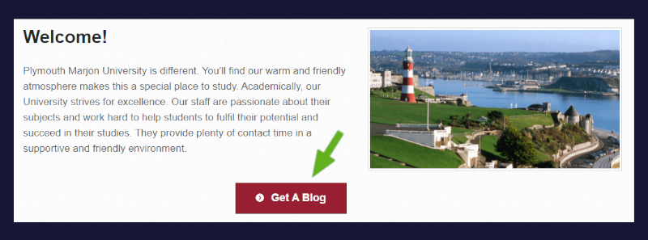
- Enter a site name (lower case no spaces) For example: Module name+Year > Enter a site title (not case sensitive)

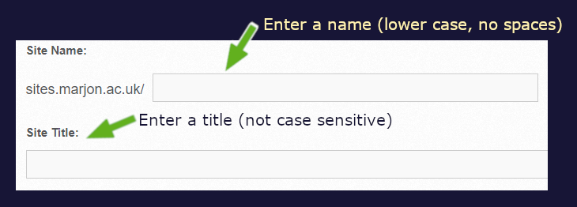
- Set the privacy for your student blogs
- Click into a template screenshot (any will do, not important as this is just a shell to enable a class)
- Scroll down the page and click on the ‘Create Site’ button
You will be take to a success message once your site is created.
- Click on the linking text to be taken into your dashboard

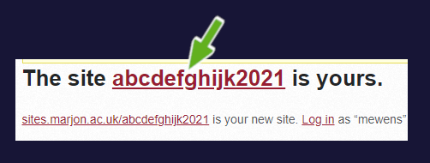

Creating your class & invitation link
- Hover your mouse over ‘My Class’ and select ‘Create a Class’
- Check the box ‘This is a class blog’

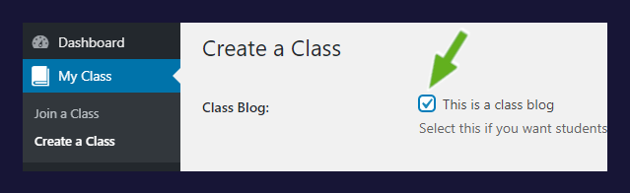
- Leave the default setting as they are, but tick the box in the ‘Teachers’ section > Click on ‘Save’

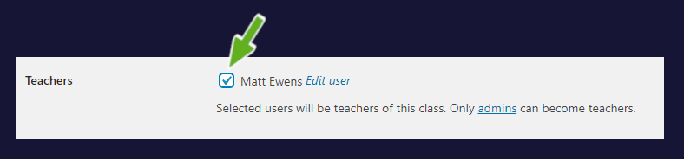

Inviting students to your new class
- To invite your students to join the class click on the ‘invite students’ link

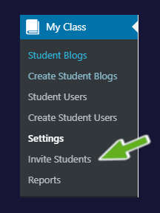
- Enter an invite code > Change the ‘Site Creation’ to ‘Force users to create a site in process’ > Click on ‘Add New Invite Code’

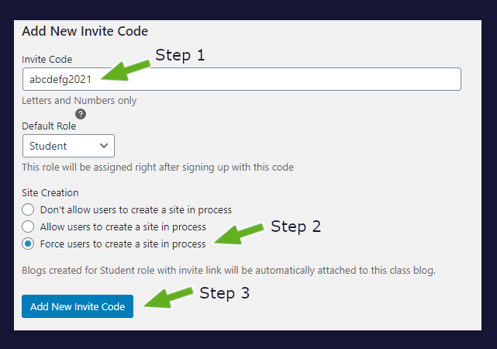
- Your new invite link will be created > Copy the link and email it over to your students

Students’ perspective
When students click on the invite link, it will take them to a page like the below screenshot (they will firstly need to login to Edublogs using their Marjon credentials– they will need to visit: www.sites.marjon.ac.uk ) – all students need to do is then enter their site title and name, then ‘Create site’
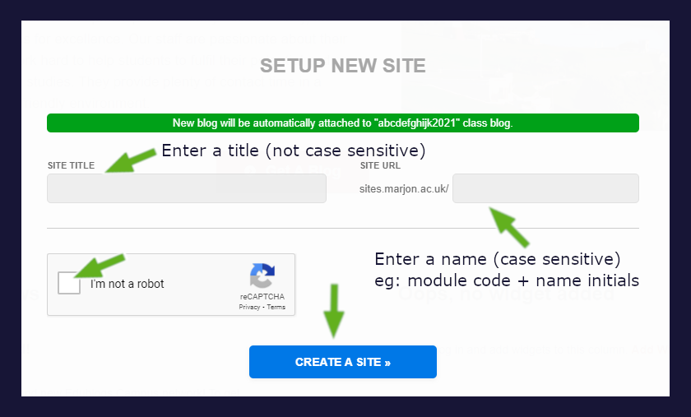
Once the student has entered the required details, they simply click on the ‘Create a site’ button and they will be taken into their site dashboard in Edublogs.
Their site will automatically be added to your class.

