H5P Interative Book Guide
This guide has been created to help you learn the basics of how to create an interactive H5P book.

Getting started
- Login to Canvas via: https://marjon.instructure.com/
- Head to the course where you want to add your H5P interactive book (Go to Dashboard)

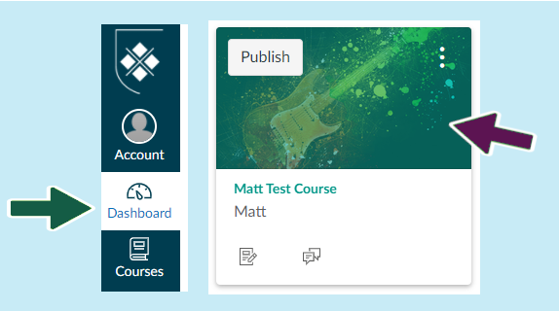
- Select ‘Course Content’

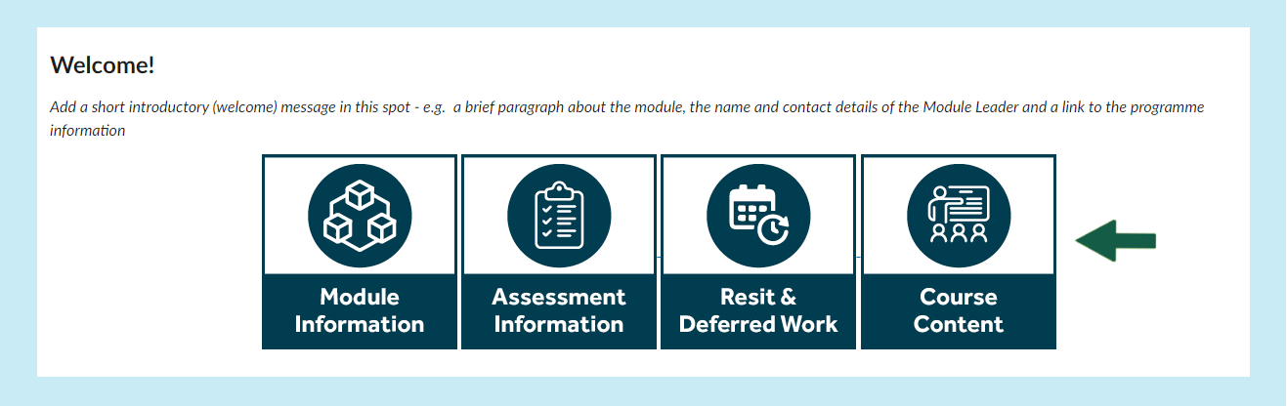
- Look to the right-hand side of the course content tab and click on the plus button +

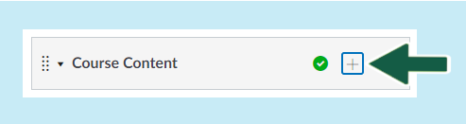

- Next select the ‘Add’ tab to reveal more options and we’d recommend you use the page option

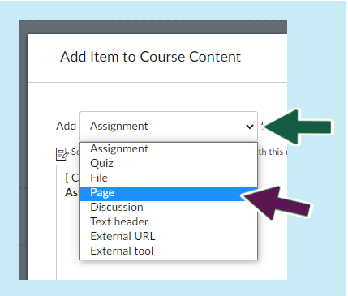
- Next select ‘Create page’ and then enter a name for the page, then click on ‘Add item’

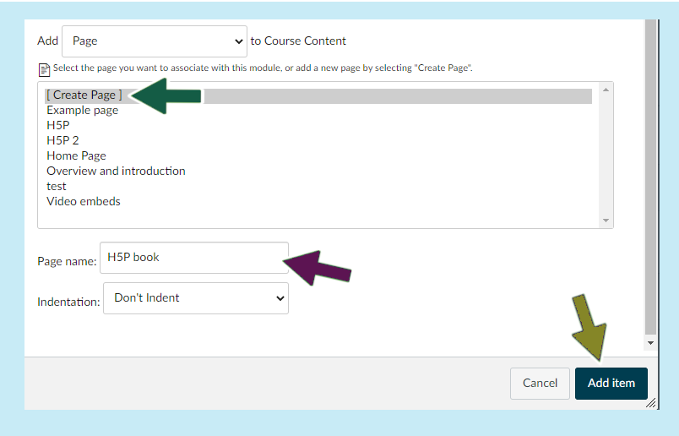
- The new page should appear as part of the course content section

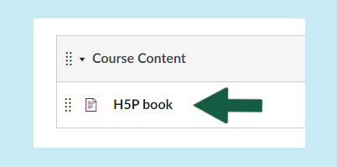
- Click on the new page to access it then click on the edit button (top right-hand side of the page)
- Click on the ‘Apps’ icon as indicated below
- Select ‘Interactive Content – H5P’

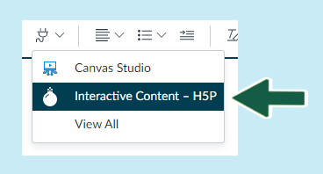
- Select ‘Add Content’

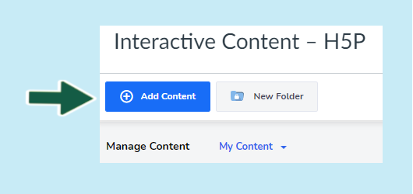
- Click anywhere on the ‘Interactive Book’ section to activate

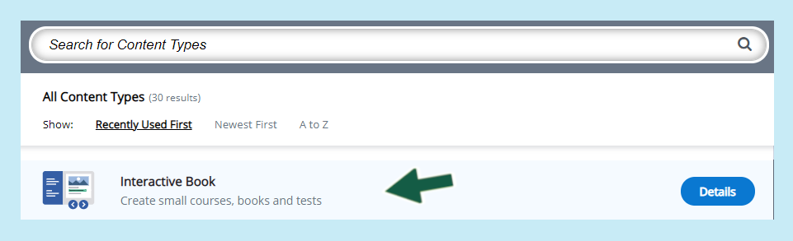
The next tutorial will cover how to start creating your H5P book.

