H5P Interative Book Guide
This guide has been created to help you learn the basics of how to create an interactive H5P book.

Creating a cover page
- Before we create interactive elements, you’ll probably want to create a cover page. This is an attractive landing page that your students will see before entering the activity. (If you feel this is not relevant skip to the third tutorial ‘creating pages’)
- Enter a relevant title for your book then check the box for ‘Enable book cover’

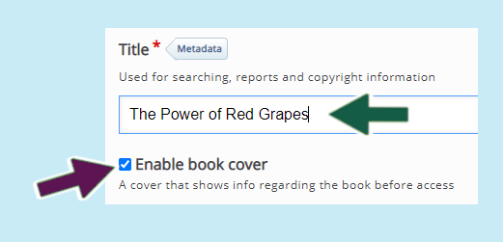
- Enter introductory text to describe what the book is for

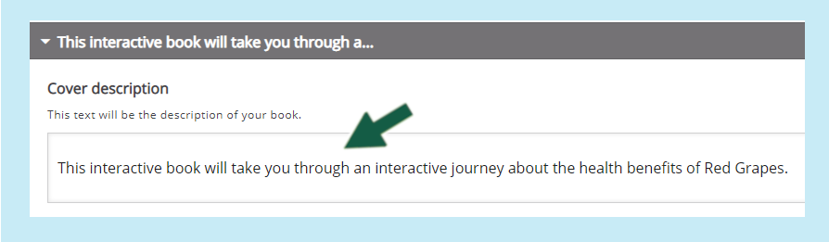
- Click on the ‘Add’ button to include a suitable image (for copyright free images please use www.pixabay.com)

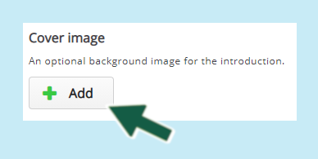
- Please enter ‘ALT’ text in the box provided as this helps screenreader users identify the image

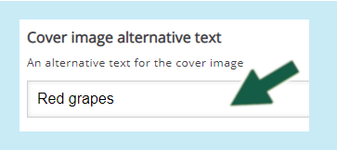
- Click on ‘Save’ to save your progress and proceed to the next tutorial on creating pages

