H5P Interative Book Guide
This guide has been created to help you learn the basics of how to create an interactive H5P book.

Creating pages
- To start we recommend that you create some introductory text to outline what your users can expect from the interactive book. You can also add media like videos and images to this section
- Enter a title and using the drop-down menu select ‘Text’

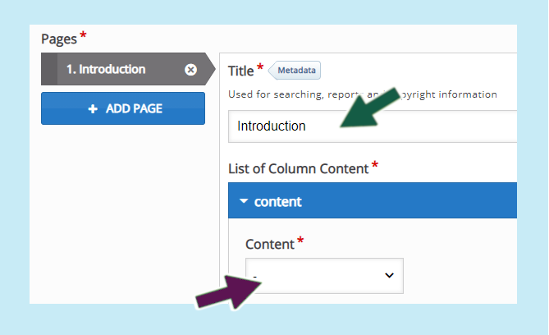
- Once the text box has loaded, click into the space and type in your text. Note if you wish to add a link as highlighted by light green arrow click and select the text and the click on the anchor icon as indicted by the red arrow)

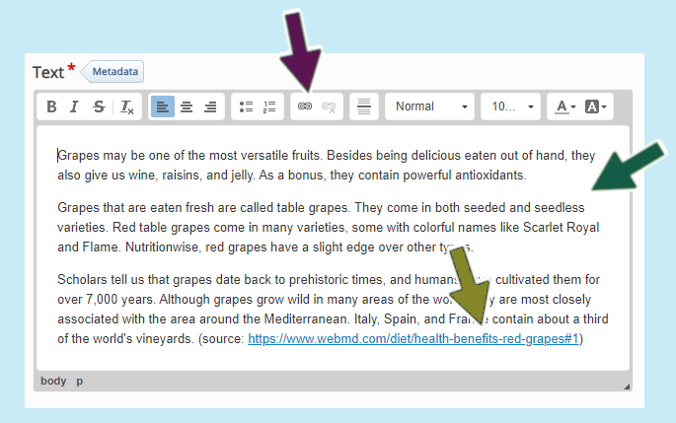

Tip:
You can collapse any section by clicking on the arrow on the tab as below

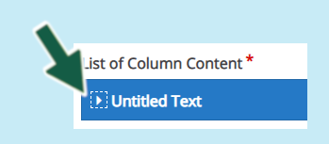
- The next part is to add your pages. You may wish to have 2-4 pages of information, videos or other content before creating your quizzing or the interactive elements. We will assume that you may wish to create 2-4 pages of content. The following will demonstrate a couple of different ways of creating informative content

Image hotspots
Image hotspots are a great way to convey information related to an image or images. They work by providing a visual trigger for your students on the image, when clicked this then displays either text, images or video content.
- On the left-hand side of the H5P editor, select ‘ADD PAGE’

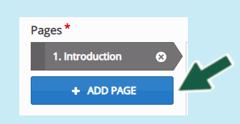
- Enter a suitable title > then select ‘Image Hotspots’ from the Content drop-down list

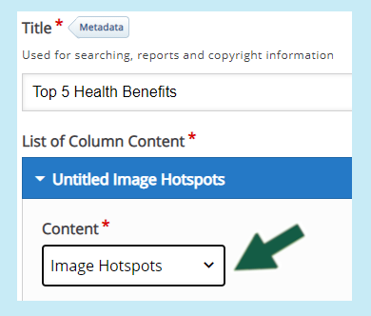
- You will now need to add a suitable image (www.pixabay.com) – in the example we have selected a bunch of grapes and each hotspot will identify different positive attributes
(remember to always include assistive ALT text for images)

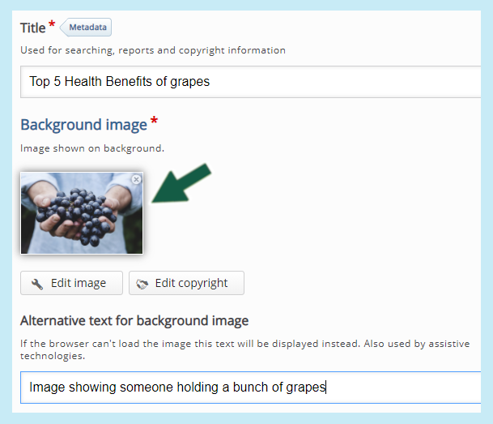
- Next select the type of icon used for the hotspot and colour

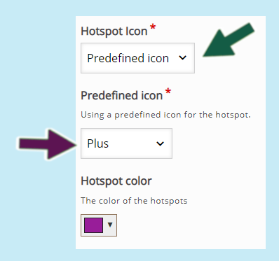
This is an example of what the above settings will look like:

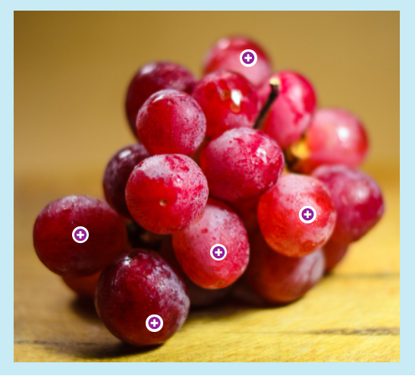
- Next select the hotspot location on the image by simply clicking into the image preview

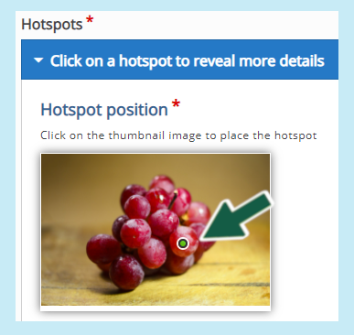
- Enter ‘Header text’ this will appear if the student hovers their mouse over the hotspot. (you may wish to have text such as the below) – the box for ‘Cover entire background image’ will cover the entire image background with the hotspot text.

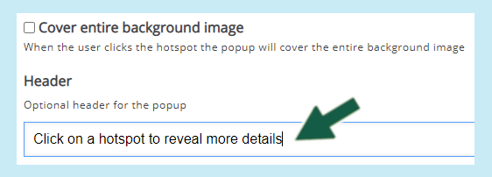
- Next you will need to select the type of pop-up content you wish to have display when your student clicks on the first hotspot – this is either text, image or video. (we will create one of each)
- Select ‘Text’ from the drop-down list and click into the text box and enter your text

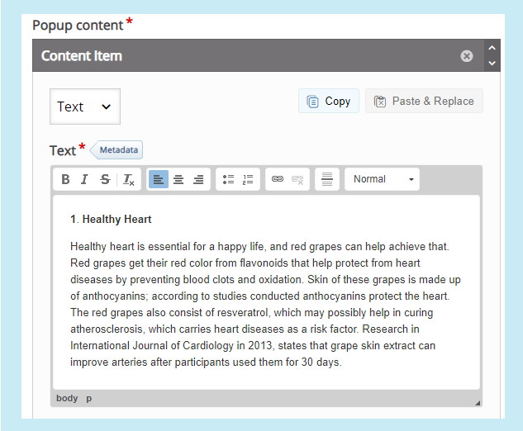
(note, it is possible to add multiple popup items by selecting ‘Add item’ although too many many become cluttered or confusing)
- Click on ‘Add hotspot’ and click into the image to select the next hotspot location > Copy and paste the previous header text if you wish > Select the video content item
- Enter a title and then select your video source, if this is from YouTube for example, copy the URL link and paste it in and press ‘Insert’

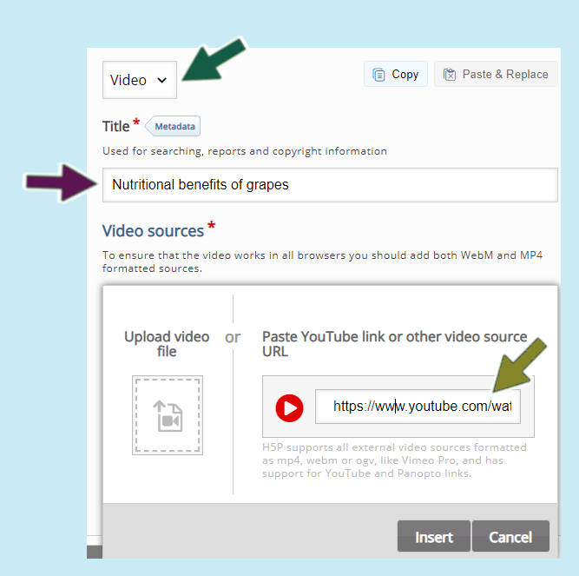
- Next click ‘ADD HOTSPOT’ and select the location for the final hotspot on the image
- Enter header text as before if you wish
- Click on ‘ADD’ to add your image
- Enter ALT text and include hover text if you wish to display text when your students move their mouse over the image

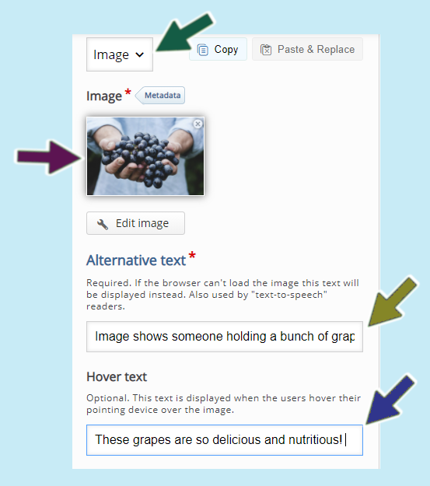
- Select ‘Save’ (note further details on the settings will be covered at later tutorials)
- Now press on the ‘Insert’ green button to add the H5P to your page and then click on ‘Save’ at the bottom of your Canvas page

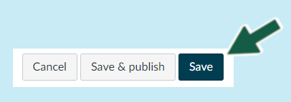
- Click on ‘Read’ and view your work so far, visit page 2 and see what your image hotspot content looks like
- Now select ‘Edit’ to go back into the H5P editor as we’ll be adding more pages to your interactive book

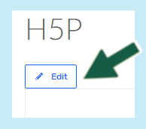

Image slider
- Add a new page (from the left-hand side)
- Enter a title and then select the ‘image slider’ from the available drop-down content options

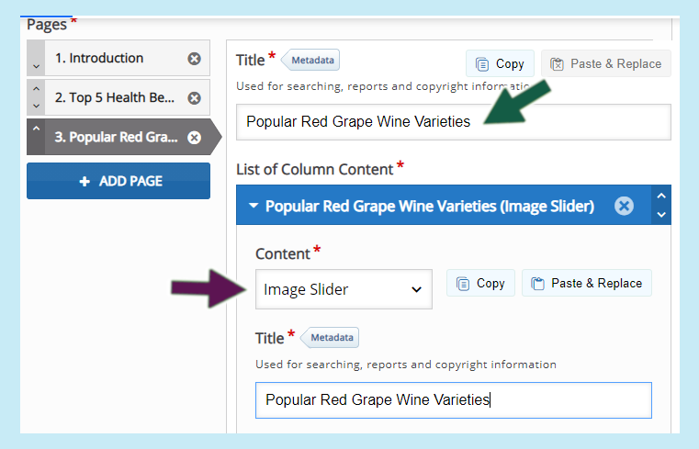
- Enter a title > Click ‘Add image’ (select from your computer)
- Add ALT text and hover text if you wish

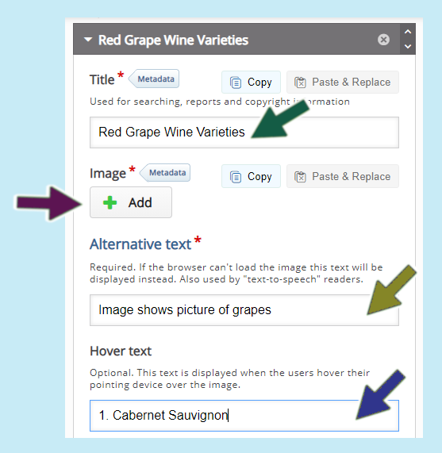
- Select ‘Add item’ then repeat the above steps from 3. You can add as many images as you wish
Note: It is possible to combine text and image galleries, watch out for more advanced tutorials for this.
- Save your work

