H5P Interative Book Guide
This guide has been created to help you learn the basics of how to create an interactive H5P book.

Creating quizzes – Multiple Choice
In H5P you have a access to all kinds of activities and quizzing content options for your book (see here: https://h5p.org/documentation/for-authors/tutorials) – we will focus on 4 basic types of quizzing content for this basic guide to get you started.
- Add a new page to your book by selecting + ADD PAGE from the left-hand side

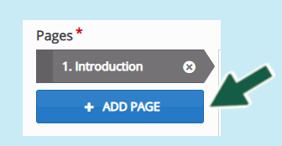
- Enter a suitable title > then select ‘Multiple Choice’ from the Content drop-down list

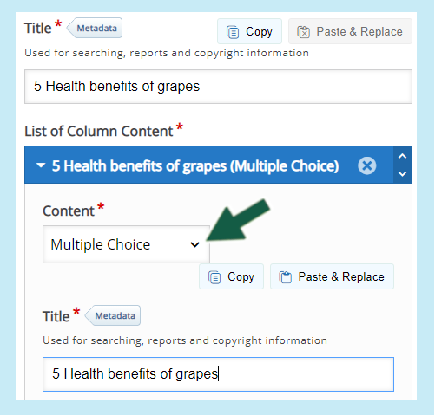
- Scroll down and then type your question into the question box (note if you wish you can open the ‘Media’ drop-down and add an image or video which will appear before the question)

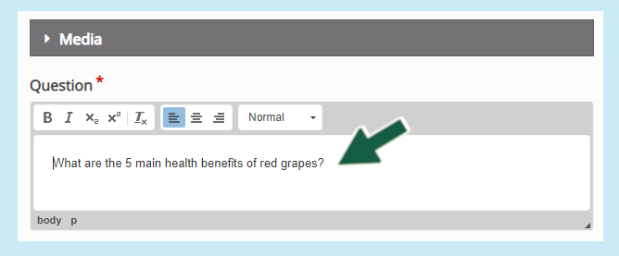
- Next are the available answers entitled ‘Available options’ – enter the first answer and check the box if you want this to be a correct response.

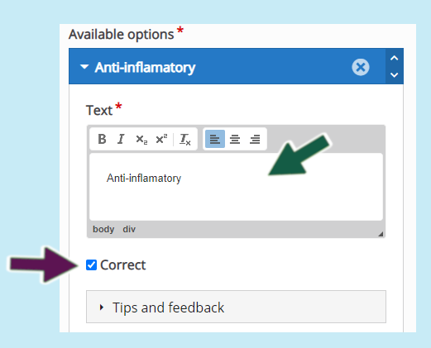
- If you wish to add specific feedback for each answer, you can by opening up the ‘Tips and Feedback’ drop-down. The tip text will show an ‘I’ icon that the student can click on to reveal a clue. The ‘Message displayed if answer is selected’ is the message shown if the student selects the correct answer

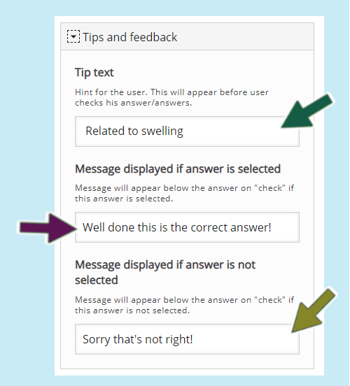
- Scroll down and repeat steps 3-5 to add the next answer. If you need more answer options click on the ‘ADD OPTION’ button

Overall Feedback (can be assigned to each question)
The overall feedback area will enable you to add specific feedback for a score range. This will display feedback for your students. For example if the student scores between 0% - 25% they will receive the following message ‘Try and read the previous content to learn more.’
Note: At the end of the completed course or book, students will be able to submit all their answerss. (Each correct question receives 1 point and you can view reports for each student to see the percentage of correct answers)
- Open up the ‘Overall Feedback’ tab then click on the ‘ADD RANGE’ button to create a new range and enter the range you want. (note: once you have completed your range, you can select ‘Distribute evenly’ if you want the scores to be automatically distributed)

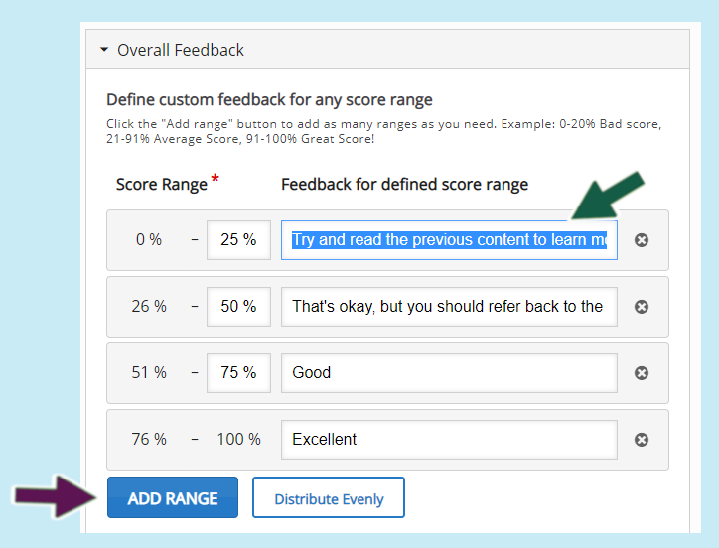
See below for a live version of above:

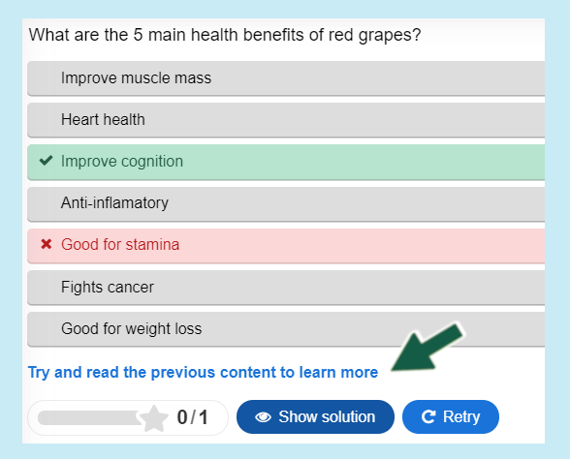

Behavioural Settings
This section will enable you to determine whether you want to give your students the options to try again, or show solution. The following settings are the most commonly used:

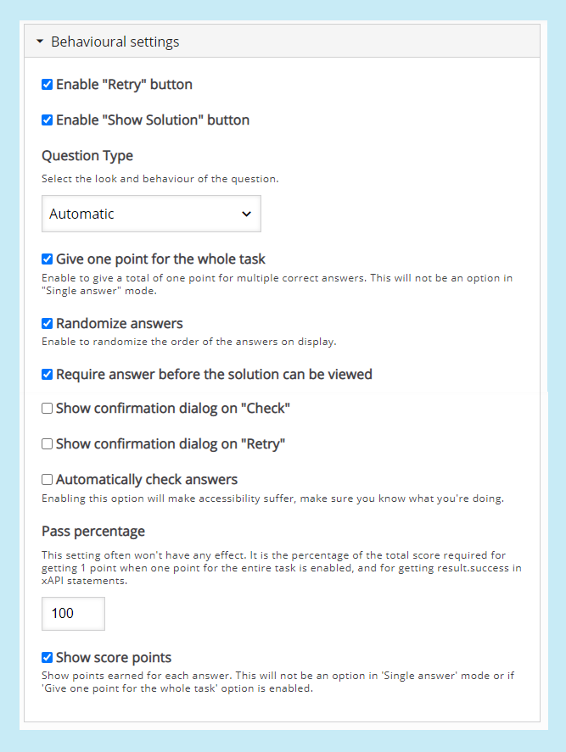
Note: the above overall feedback and behavioural settings can be applied for each question
At the end of the questions, you should see another ‘Behavioural settings’ tab – this determines whether you want to display a table of contents, progress indicator and display summary. (note, display summary must be enabled if you want your students to be able to submit their responses)

