H5P Interative Book Guide
This guide has been created to help you learn the basics of how to create an interactive H5P book.

Creating quizzes – Fill in the blanks
In H5P you have a access to all kinds of activities and quizzing content options for your book (see here: https://h5p.org/documentation/for-authors/tutorials) – we will focus on 4 basic types of quizzing content for this basic guide to get you started.
- Add a new page to your book by selecting + ADD PAGE from the left-hand side

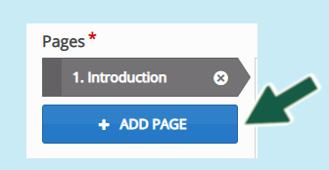
- Enter a suitable title > then select ‘Fill in the blanks’ from the Content drop-down list

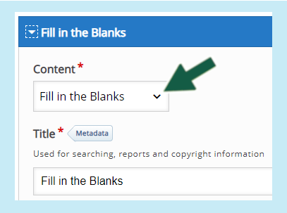
- Enter a task description to explain what your students will need to do, for example: ‘fill in the missing words’
- Then in the text box enter the text and the correct answer is housed within a starting and ending star for example ‘*7,000 years*’ – see the below screenshot

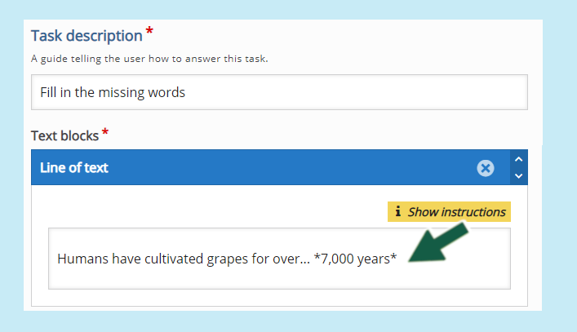

Overall Feedback (can be assigned to each question)
The overall feedback area will enable you to add specific feedback for a score range. This will display feedback for your students. For example if the student scores between 0% - 25% they will receive the following message ‘Try and read the previous content to learn more.’
Note: At the end of the completed course or book, students will be able to submit all their answerss. (Each correct question receives 1 point and you can view reports for each student to see the percentage of correct answers)
- Open up the ‘Overall Feedback’ tab then click on the ‘ADD RANGE’ button to create a new range and enter the range you want. (note: once you have completed your range, you can select ‘Distribute evenly’ if you want the scores to be automatically distributed)

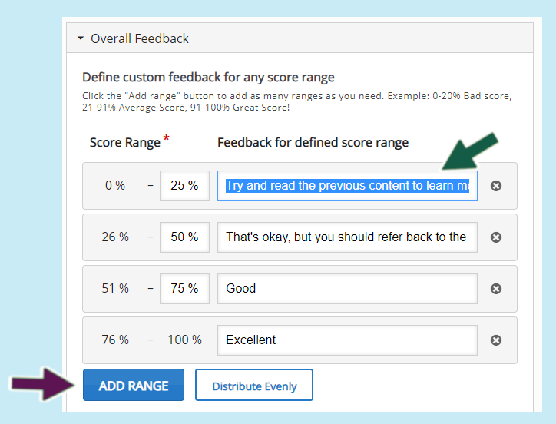

Behavioural Settings
This section will enable you to determine whether you want to give your students the options to try again, or show solution. The following settings are the most commonly used:

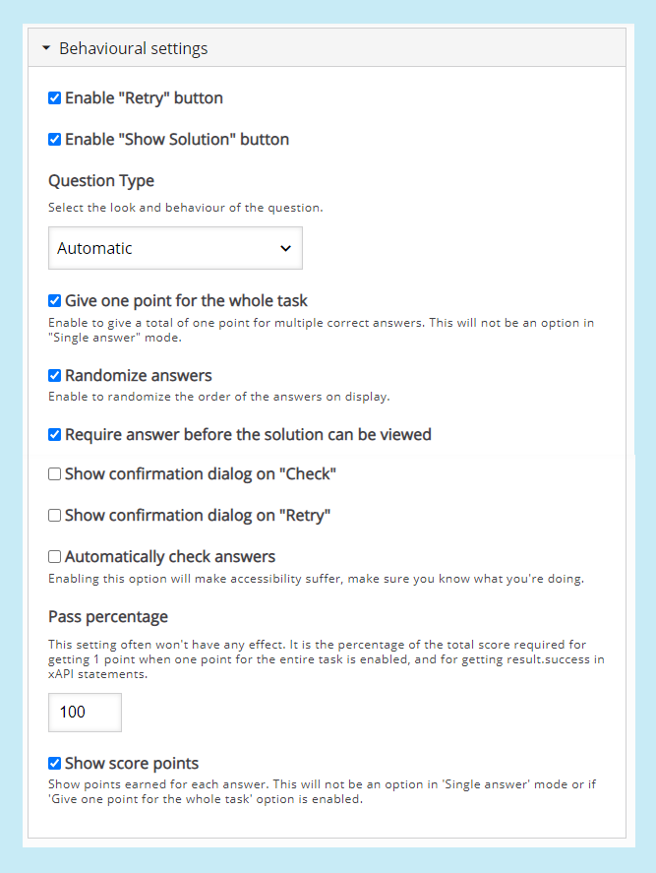
Note: the above overall feedback and behavioural settings can be applied for each question
At the end of the questions, you should see another ‘Behavioural settings’ tab – this determines whether you want to display a table of contents, progress indicator and display summary. (note, display summary must be enabled if you want your students to be able to submit their responses)

