H5P Interative Book Guide
This guide has been created to help you learn the basics of how to create an interactive H5P book.

Publishing & Reporting
When you are ready to publish your H5P book, you’ll need to click on the publish button as below:
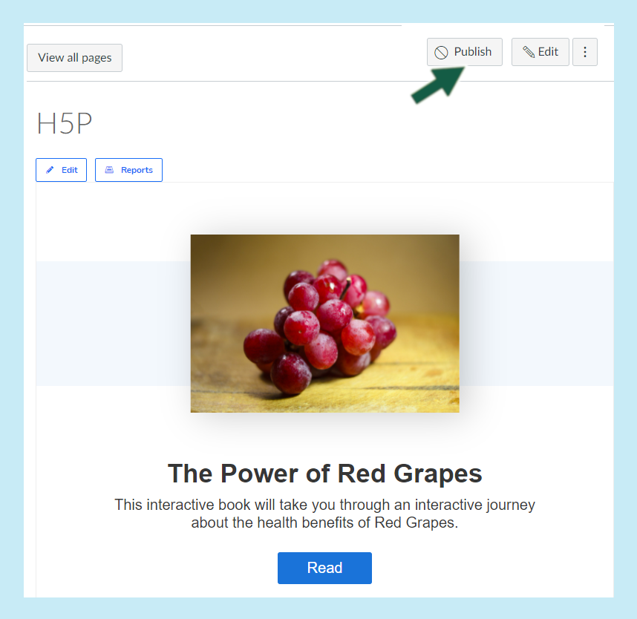
Note this is also available when viewing your course content, if you have setup your H5P into this space as below:

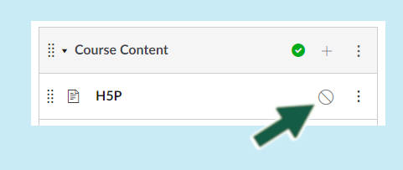

Reporting
Basic reporting is available, just click on ‘Reports’ to view the individual student responses.

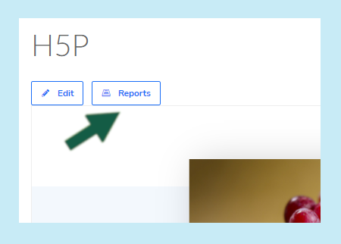
If you click into the student account, you should see additional details.

