Edublogs: Advanced menus – footer menus
In Edublogs you can create different menus for different purposes. This guide will show you how to create a footer menu on your website/blog. (This does depend on whether you have the available footer area within the widgets section of your blogsite.)
- Go to ‘Appearance’ > Customise
- Click on the ‘Widgets’ area
- What you’re looking for is a ‘bottom’ or ‘footer’ area (if there isn’t one, then you can’t have a footer menu, sorry!)
- If you have located a footer menu then head back out of the customiser and go to ‘Appearance’ > ‘Menus’
- Click on the ‘create a new menu’ link
- Call the menu ‘Footer’
- You can now select any Pages, Posts or custom links – then ‘Add To Menu’

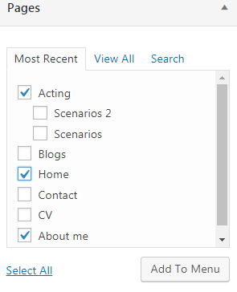
- Save your new menu
- Go to ‘Appearance’ > ‘Customise’ > Find the widgets area and the footer or bottom widget area
- Click on ‘Add a Widget’ > Select the ‘Navigation Menu’ widget

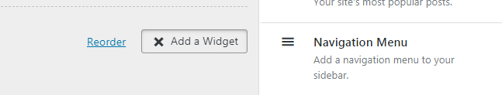
- Enter a name, something creative like ‘Menu’
- Select your new footer menu using the drop-down list and click on ‘Done’

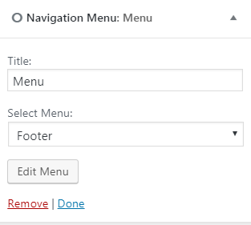
You should now have a new footer menu at the bottom of your blogsite – you may wish to just include the most important pages/posts in this menu

