How to login & create an account
- Visit the Edublogs home page, by either going through LearningSpace or visiting the link: http://sites.marjon.ac.uk
- Click on ‘login’ (either top left or right of the page)
- Click on the blue button labelled ‘Use Marjon ID’
- Enter your standard username and password and click on ‘Login’

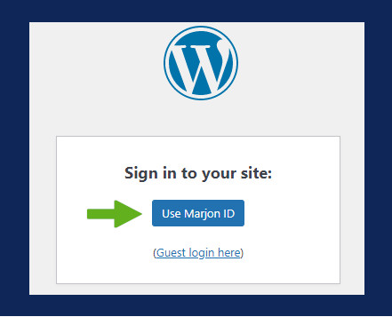
If you need to create a new blog, rather than login to your dashboard, go to the Edublogs home page – then click on ‘Get a Blog’. You’ll need to go through the login process and then you’ll have the option to create a new blog.
You can also create a new blog once logged in to your dashboard by clicking on ‘My Sites’ directly and then clicking on ‘Add New’.
Note: For module Edublogs, your tutor will send you a joining link to create your blog
If you are unable to login, please contact a member of the Digital Innovation Team: digitalinnovation@marjon.ac.uk

