Edublogs: Using the CSS plugin to edit element styles
CSS stands for cascading style sheets and their purpose for every website is to create a consistent set of rules for different elements within a website. This includes things like heading sizes and the colour of text throughout the entire site. It’s a way of assigning styles without having to manually update every facet of a website. The easiest way to describer this is imagine that you have created thirty pages of content for your website/blogsite and assigning a font size for all the paragraph text on every page. It would take a long time. CSS assigns a set style or in this example font size for all paragraph text throughout all pages.
You can edit the CSS on your blog, if for example you wanted to make something different or change something that’s not available to change in the customiser. For example, in the tutorial I show how to add a drop-shadow for the header text by editing the CSS for that particular element.
This part of the advanced guide is about as advanced as it gets, so keep in mind that this isn’t a simple fix – I would highly recommend you investigating further resources on ‘what is CSS’ and ‘how does CSS work’ via watching YouTube clips.
https://www.youtube.com/watch?v=s7ONvIgOWdM
There are some useful resources of the W3 schools site, so take a look at the below links:
https://www.w3schools.com/css/css_intro.asp - introduction
https://www.w3schools.com/cssref/ - CSS properties
Follow the guidance below to start with changing basic CSS elements on your blog site.
- Go to ‘Plugins’ > Search for ‘CSS’ > ‘Install Custom CSS plugin
- Open your live site up > right-click on the header text on your site (that’s the biggest text, showing the title of your site, as below)

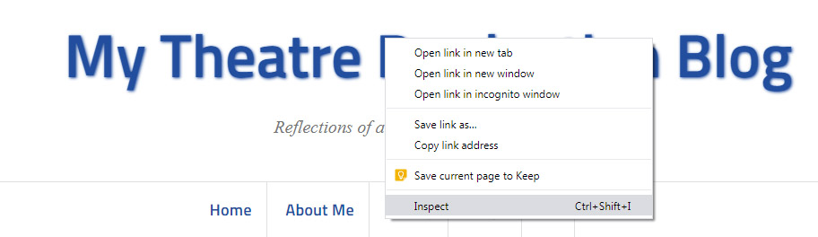
- Click on ‘Inspect’
At this point the window will pop open a panel on the right-hand side of the screen with lots of scary code, don’t worry too much
- You’ll need to expand the box to open up a further panel, hover your mouse over the edge of the new window and the live site window as shown in the screenshot below and click and drag it left until a new window opens up on the right-hand side of the screen

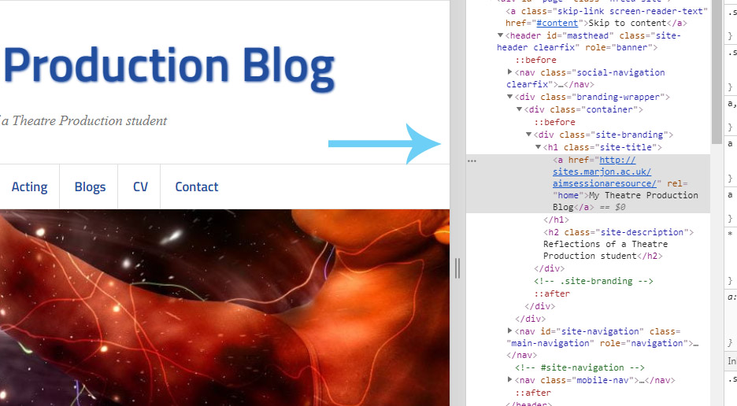
The below screenshot shows the desired view:

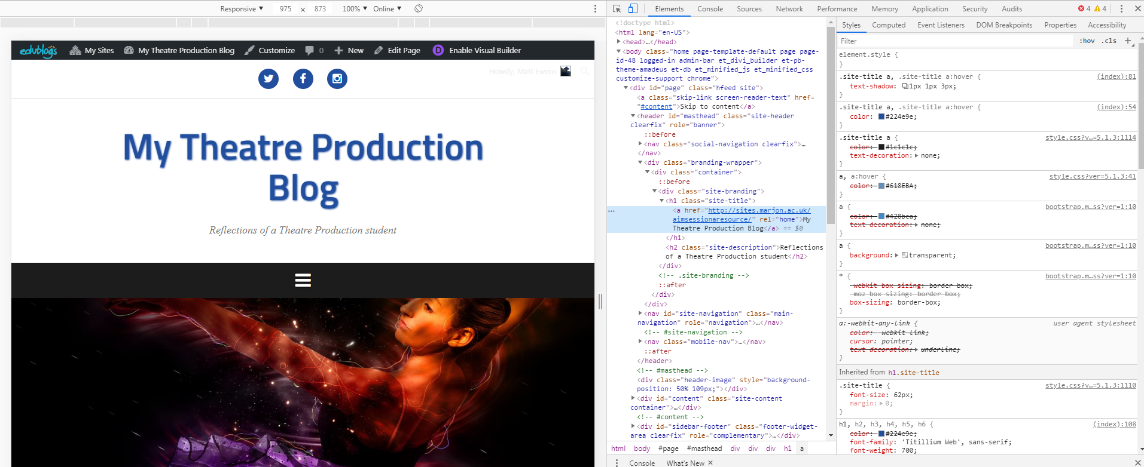
- Right click on the header text again and select ‘inspect’
- Look on the right-hand window and the very top row should contain the code for the header text – in my example using the Amadeus template this is called ‘.site-title a, .site-title a:hover {
- Click underneath the bracket ‘{‘
- Then start typing slowly ‘text-shadow’ > Click on the ‘text-shadow’ element and press the return key on your keyboard
- Next type the following ‘1px 1px 3px – then press return (make sure there’s a space between each part – 1p…..1px……3px
- Congratulations, if you’ve done this currently you should now see a shadow underneath your header text
- Click after the ‘}’ and drag over the code snippet, this will look something like:

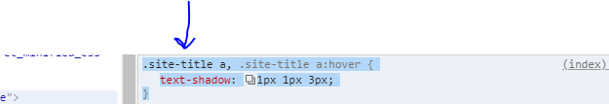
- Copy the snippet by right-clicking on the highlighted code and selecting ‘copy’
- Head back into the editor and go to ‘Appearance’ > ‘Custom Css’
- Paste in the copied code and click on ‘Save CSS’
- Head back to the live site and close down the inspector by clicking on the ‘x’ in the top right-hand corner (the cross underneath the one at the very top)
- Refresh the page > hopefully you’ll have a shadow under your text header! If you don’t like that, you can always head back into the custom CSS plugin and delete the code snippet and Save
- How to change the rollover text colour on your navigation buttons using CSS
- Go back to your live site and this time right-click on one of your navigation links, for example ‘about me’
- Click on ‘inspect’
- We now need to click on the ‘:hov’ link to enable the hover over state to appear in the code (look at the screenshot)

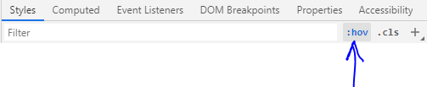
- Click on this will expand more options > then you need to click the box for ‘hover’

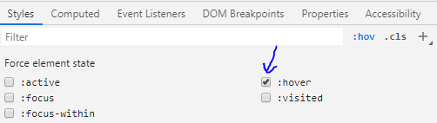
- You’ll need to now locate the main navigation code – for the Amadeus template this is called: .main-navigation a:hover {
- There will most likely be a colour underneath that will look like this:

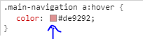
- Click on the coloured box, then select a suitable rollover colour
- When you are happy select the code snippet and copy it
- Head back to the editor and the custom CSS plugin area in Appearance
- Paste in the new code and ‘Save’
- Visit the live site and close the inspector down and refresh the page
Hopefully that’s given you an idea about some of the most basic CSS editing. You can do much more! Sometimes it’s not easy to find the right code, so experiment and learn!
Good luck!

