Connected Learning

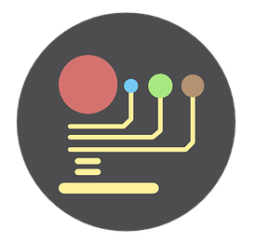

Definition:
Learning may be in formal or informal university learning spaces, and also therefore supports those unable to access the university; the key being that not all students are in the same location. There is frequently the use of technological means to connect individuals and groups and may take advantage of both formal learning rooms as well as social/informal learning spaces.

