Edublogs: Adding social media links
Some templates will allow you to add attractive social media icons at the top of your blog site. If you have a template like Amadeus that accepts social menus, then follow the steps below: (note: if you don’t have this option, then try adding a social media widget instead)
- Go to ‘Appearance’ > ‘menus’
- Create a new menu and call it ‘social menu’
- Click on the ‘Custom links’ tab on the left-hand side of the page
- Note: you will need to have a social account url link at this point – if you don’t – but would like to see how it works copy this text: https://twitter.com/SirPatStew and paste it into the URL field in the custom links tab
- In the Link Text box type in Sir Patrick Stewart
- Click on Add To Menu
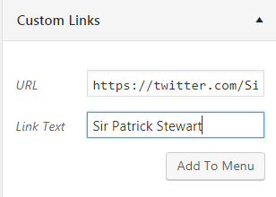
- The new social link is now part of your menu – try experimenting by adding a Facebook page link and an Instagram link follow the same steps as above. (replace twitter feeds and text)
- Then check the box for ‘Social’ and click on ‘Save Menu’
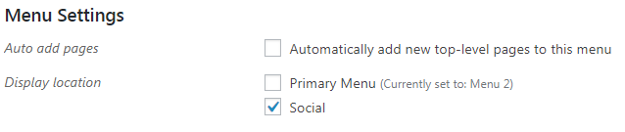
- Visit your live site and review the changes (the links should be at the top as in the below example)

