Edublogs: Adding widgets to your blog
Widgets are additional bolt-on elements that you can add to your blog and often appear on the right-hand side of a blog and can look like the below example:
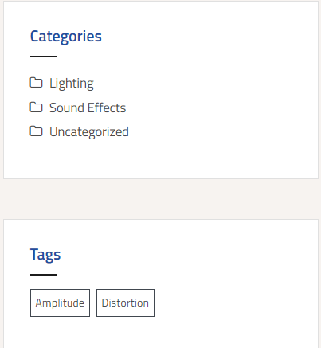
If you’d like to update your widgets or add new ones, follow the below steps:
- Go to ‘Appearance’ > ‘Customise’
- Depending on the template you use, there should be a ‘Widgets’ tab – click on this
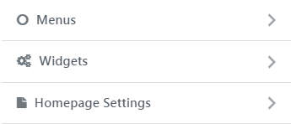
- The most common widget area is called ‘Sidebar’ – you may have different widget areas depending on the template you used. The Amadeus template has x4 widget areas. If you have a sidebar widget area, click on this – if you don’t have a sidebar widget area, but if the tab is called something else, click on it anyway – as per the below example:
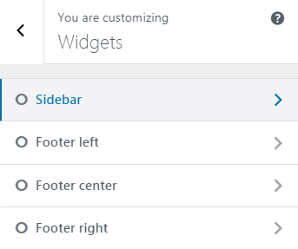
- Once inside the widget area, by default you will probably see a number of widgets already added, such as: ‘categories, archives, recent comments, recent posts & meta’
- You may wish to remove a number of these, such as ‘Meta, archives & recent comments’ (you may wish to keep recent comments if you are expecting comments on your blog)
- If you do want to remove a widget click on the down arrow on the widget and select ‘delete’
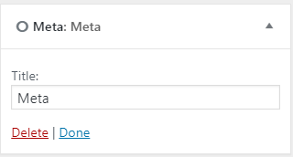
- Once you have cleaned up your widgets, try adding the following widgets: ‘search, gallery’
- When you’ve added the search widget remember to add in the title ‘Search’ (same for the image gallery, add a title)

