Edublogs: Changing the template
To change the template follow the below instructions:
- Go to ‘Appearance’ > ‘Themes’
- In the top left-hand corner, you’ll see the currently selected template – see screenshot below as an example:
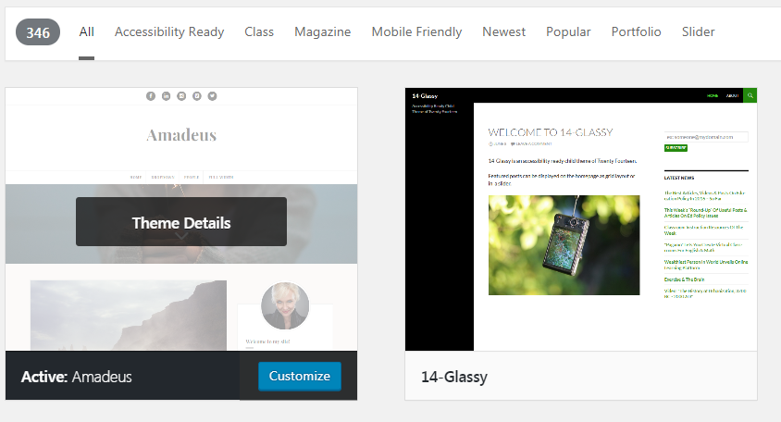
- Hover your mouse over another template and click on ‘Live Preview’
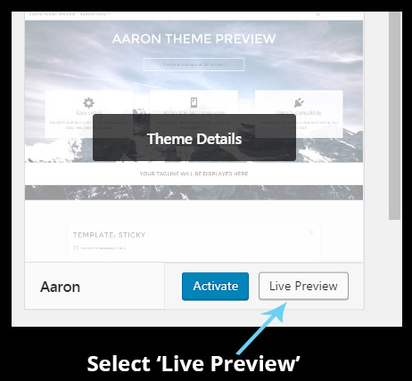
- This will load up a preview within a ‘customiser’ area – you now have two options
- If you like the template, select ‘Activate & Publish’ if you don’t like it, click on the ‘X’ to return to the templates area
