Edublogs: Customising your blog
You can customise how your blog looks by accessing the customiser.
- Go to ‘Appearance’ > ‘Customize’
- Depending on the template that you are using, you’ll have different options and customisations available
- The Amadeus theme used in this example has more available options than some of the other templates
- Most of these are quite self-explanatory – but here is a brief explanation of the tools in the Amadeus theme
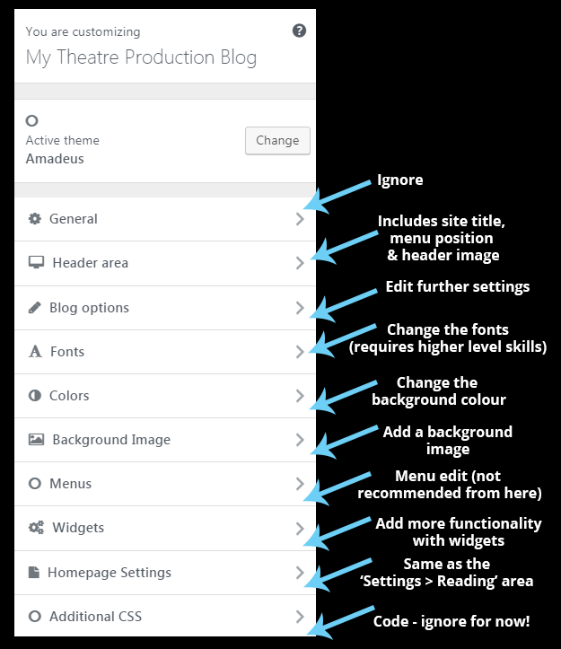
If you’re happy with any changes you make in the customiser, click on ‘Publish’

