Edublogs: Editing pages & posts: Add images, videos & upload files
Once you have created a page, for example ‘About me’ – you’ll need to add content to that page.
- Head into an empty page
- Click into the empty box and start typing!
Use this space to talk about yourself in the context of the blog and think about the following aspects:
- Why have you started a blog?
- What do you hope the achieve from the blog?
- What are your interests in relation to the blog?
- What will the theme or focus of the blog be?
- What are your aims and goals related to the blog and the subjects you are talking about?
- Be personable – so write in a way that reflects your personality

Things not to include:
- Try not to waffle on about unrelated things and write too much text as people’s eye will get tired more quickly reading from a screen
- Limit the use of bad language and text-speak or use of abbreviations
- Separate lengthy text into easily viewable paragraphs & use text formatting if needed to make the text clear to read
Adding images
- Click the mouse at the point where you’d like the image to be
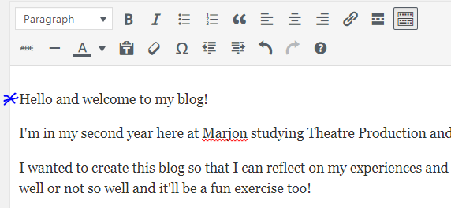
- Click on ‘Add Media’
- Upload your image by click on the ‘Upload Files’ tab
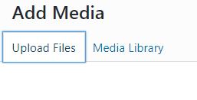
- Click on ‘Select Files’ > Find your image > ‘Open’
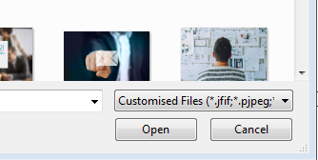
- When the image has been uploaded, look on the right-hand side of the screen
- Enter a suitable title for your image (you can leave the caption blank, this is only used if you want to add text underneath the image – this can be useful for citing images, referencing or adding ex. Text)
- ALT text should always be added to all images before adding to your pages/posts. ALT text enables visitors that have sight problems or disabilities to hear what is on their screen if they are using a screen reader. A screen reader will voice whatever is entered as the ALT text – for example ‘this is an image showing Plymouth Hoe’
- The description is just for your own reference, you can leave this blank if you like
- Set the alignment to ‘right’
- Set the size to either ‘Medium’ or ‘Large/Full size’
- Click on ‘Insert Into Page’
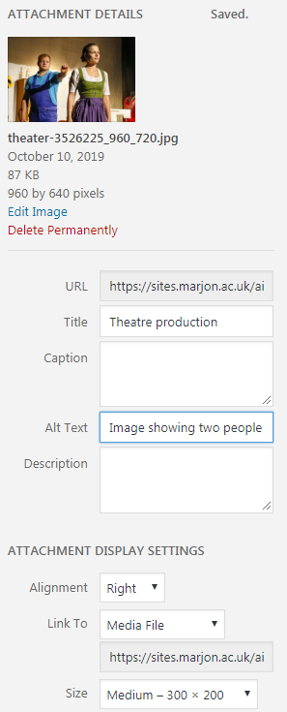
- Your image should be showing to the right-hand side of your text
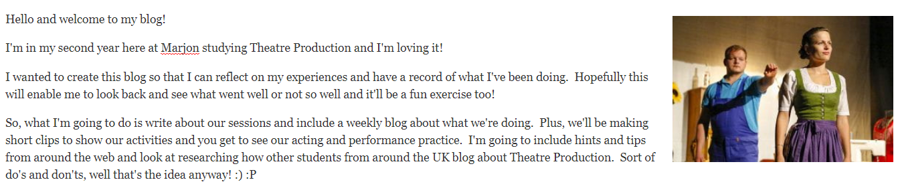
- At this point, please ensure you have ‘Updated’ your page and you are using Google Chrome browser
- Click on the newly added image, you should see a small toolbar appear above the image (check out the key to see what the icons mean below)
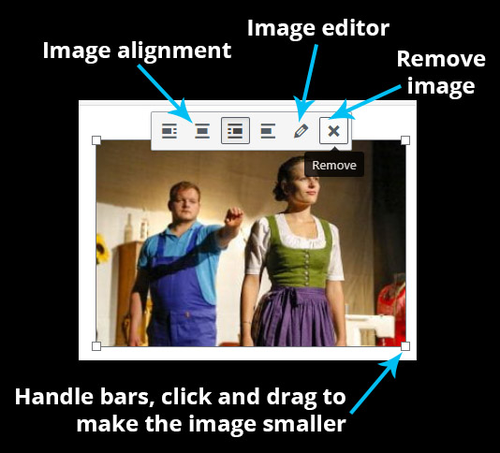
- Practice changing the alignment
TIP: Never expand an image beyond the size you first inserted – this will make the image pixelate and it won’t look good. If you need to make the image bigger, click the pencil and then change the size. Then you can always grab the handle bars and lower the size this way.
BIG TIP: Please never use any image that is not yours, please don’t just search on Google for an image – the image is likely to be protected by copyright law and you may be in breach of the law if you use it.
Visit: www.pixabay.com – this site contains copyright free and attribution free images for you to use (watch the premium images usually at the top as these are paid for)

Adding video
You can add video two different ways, one via a direct upload and the other is by embedding.
To embed video content from YouTube or Vimeo, you simply need to find the video you want and copy the URL into the page.
- Visit www.youtube.com > find an appropriate video
- Copy the url for the video, as in the below example
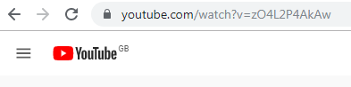
- Go back to the Edublogs page editor and paste into the page where you want the video to be
- Update your page and visit the live site by hovering your mouse over the house icon
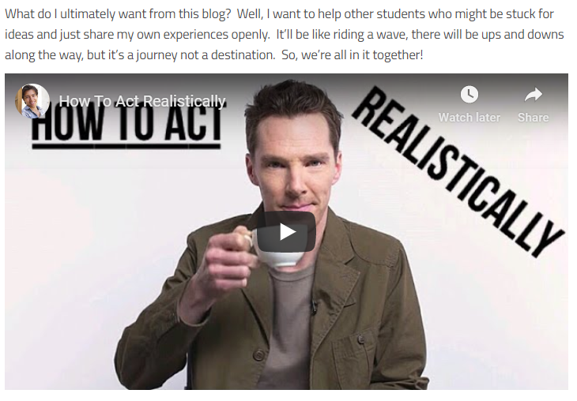
Adding your own videos
- To add your own videos place the cursor in the editor where you want the video and click on ‘Add Media’
- Click on the ‘Upload Files’ tab > ‘Select Files’ – pick your video (this must be lower than 50mb) > Open video
- Insert into page
TIP: If your video file is too big, you can download and use a free program called Handbrake to lower the file size. Check out this link to find out more: http://sites.marjon.ac.uk/elearninghelp/2019/03/22/handbrake-how-to-lower-the-file-size-of-videos/
Uploading files
To upload a file to your page, follow the steps below:
- Place the cursor in the page where you want the file download to appear for your visitors
- Click on ‘Add Media’
- Select the file from your computer after clicking on ‘Upload Files’
- Click on ‘Open and make sure there is a relevant title on the right-hand side of the page before clicking the ‘Insert Into Page’ button
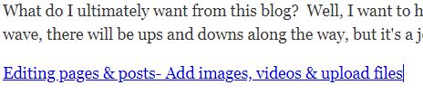
Styling your text & using the formatting tools
You can use a variety of tools when styling the text to make it stand out more, this guide will help you to do so.
Adding larger titles on your page
- In the page you are working on, go the top of the editor and highlight the text or enter title text as in the below example
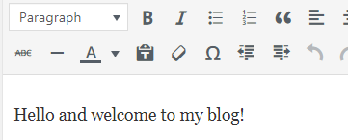
- Click and drag the mouse over the text to highlight it and then click on the above box ‘Paragraph’
- Select ‘Heading 2’ > the text should increase in size as below
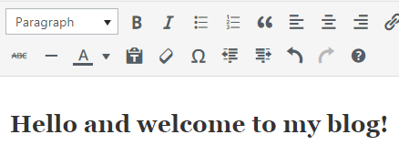
- We’ll now add a bit of colour to the title
- If the toolbar is toggled closed, click on the following icon to open up more options
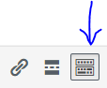
- Highlight the title text again > Click on the ‘A’ icon and select a different colour
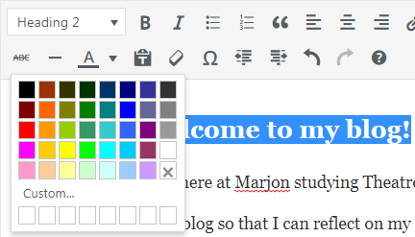
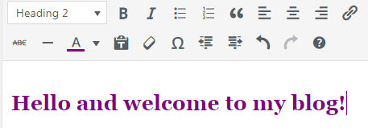
Making text bold or italic
- Highlight some text > click on the ‘B’ icon
- Highlight some text > click on the ‘I’ icon – this should look similar to the below image
Adding numbered and bulleted lists
- Click into an empty space in the editor > click on the bulleted list icon
- Enter text, then press the return key on your keyboard to enter another list item
- When you have added three items, press the return key again to exit the bulleted list
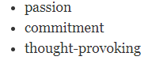
You can add a numbered list in exactly the same way as a bulleted list by selected the numbered list icon:
Adding an attractive quote
You can add a visually appearing quote, which looks good by using the blockquote tool
- Find an empty space in the page > click on the blockquote icon:
- Enter some text, something like the below image
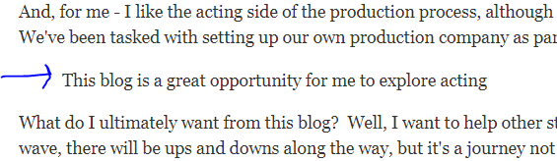
- Note: the above shows indented text, on some templates it will be more viewable in the editor
- Update the page and visit the live site
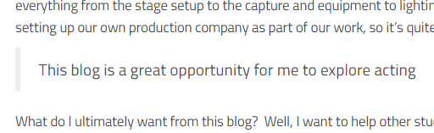
TIP: If you visit your ‘Posts’ – try adding a new post and you can apply all the above to the post in the same way. Have a go at adding content to a new post and publish it. How does it look, what could you do to improve the look of the post?
Why not visit an example ‘About Me’ page to get some ideas: http://sites.marjon.ac.uk/aimsessionaresource/about-me/
Useful keys:
