Edublogs: How to create a new blog site
Once you have logged in and selected ‘Get a blog’ you’ll need to enter in the details of your new blog.
- Enter a site name (this must be all lower case and no spaces)
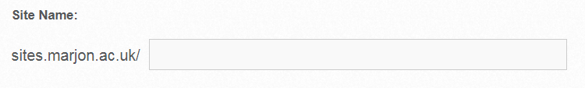
Note that the site name is the url address, for example like www.google.co.uk (the recommended format if you are creating a site for your module is the use the module code followed by your name initials, for example: prud03me (prud03 = module code – me = name initials)
- Next enter the site title, this can be changed later if you like. Enter a meaningful title, if it is for a module – enter the name of the module, for example: Health & Wellbeing M.E (notice the name initials after the title – this helps us to identify your blog if there are any technical issues)
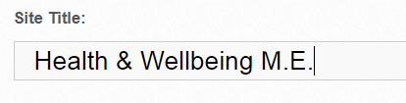
- For the privacy, if you are required to join a class if your blog is for your module assessment, then please skip the privacy as this is controlled from within the class by your lecturer. If you are creating a blog for yourself and it’s not part of a class, please select an appropriate privacy setting (you can change this later if you wish)
- Next, select a template by click on it (note that you can change the template later – this is recommended)
- Scroll down the page until you see the ‘Create Site’ red button. Click on this
- You should then click on the red hyperlink for your site title (example screenshot below)
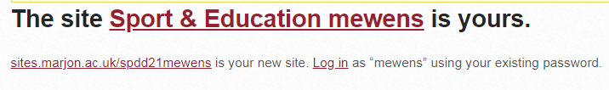
- Your site will then process and setup – please keep the window open during this process
- You will then be taken to your dashboard for your new site

