Edublogs: Joining a class
If you are required to join a class as part of your studies, then you will need to follow the guidance below. (always check the assessment criteria on LearningSpace)
Classes enable your tutor to be able to access your blog and they are created to provide your tutor with the means to access all student blogs in one place. The privacy of your blog that is part of a class is determined by the class settings. (if you have any concerns always contact your tutor)
In order to join a class you will need the class name (ask you tutor if in doubt)
- Login to LearningSpace and find the site you need to add to the class (under My Sites)
- Go to ‘My Class’ > ‘Join a Class’
- In the search box type in the class name – this must be exactly and without any spaces
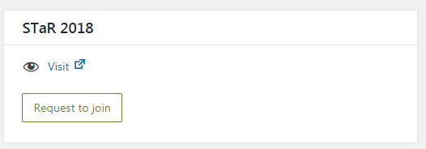
- If you entered the name correctly, you’ll see a request button > Click on this
- When you blog request has been approved by your tutor you should receive an email

