Edublogs: Organising your sites
If you have created a number of sites or have created sites throughout your course and don’t need to see old sites from your ‘My Sites’ list, you can hide these. You may have also been required to subscribe to your other blogs as part of group work and if you no longer need to see other people’s blogs once those group activities have ended – you may also want to hide those sites as well.
To hide any old sites from the My Sites list, follow these instructions:
- Once logged into Edublogs click directly onto ‘My Sites’
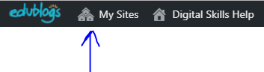
- This will take you to all the sites you have either created or subscribed onto
- Find any old sites and check the box ‘Hide this blog in Admin Bar’
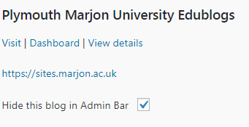
- Click on ‘Save Changes’

