# Edublogs: How to work effectively

Once you have logged in to Edublogs and created your first blog, you should follow this guidance to help you to work more effectively.

1. Hover your mouse cursor over the icon of a singular house
2. On the ‘visit site’ option, right-click on the mouse and select ‘Open link in new tab’

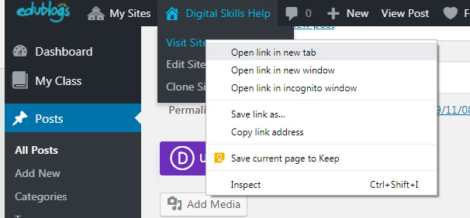

By doing this you can switch between the editor or the dashboard for your blog and the live site.

Another useful tip:

If you are visiting the live site, you can return to the editor by clicking on the icon that looks like a speedometer.

