Edublogs: How to change the header image and use the randomiser
You should always use a header image on your blog site, unless the template you opt for utilises a background image instead.
The header image usually sites at the top of a website, but it can also appear on the right or left-hand side of the blog as well.
Check out the below examples to see what this looks like:
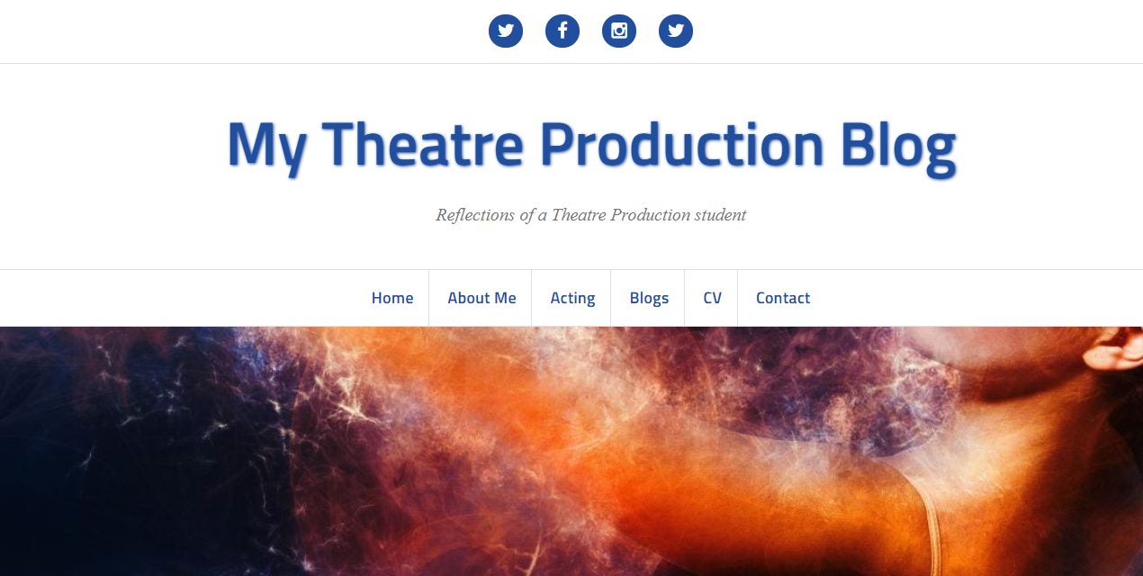
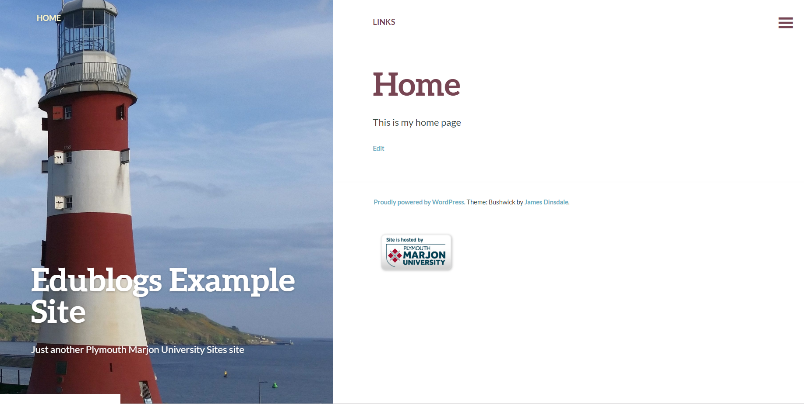
To edit the header image follow the below steps:
- Go to ‘Appearance’ > ‘Customise’
- Click on the header tab (in template like Amadeus, this is via ‘header area > header image)
- You should see a default image, the one that comes with the template.
- Click on ‘Hide image’
- Click on ‘Add new image’
- Find your image by uploading it from your computer (note: please don’t use Google search to find images, go to www.pixabay.com )
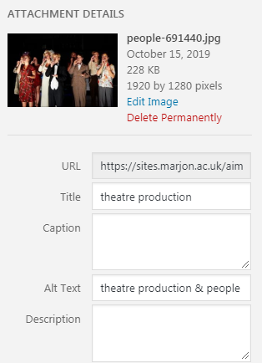
- Click on ‘Select and Crop’
- Move the crop position accordingly and click on ‘Crop image’ (or if it’s okay, just ‘Skip Cropping’
- Your image will now appear in the header area on your site
- Publish the site

Using the randomiser
The randomiser will enabled you to add a suite of different images, which will randomly display every time a visitor to your blog visits a different page
- Add two more images to your header area by repeating the above steps from step 5
- Now click on the link ‘Randomize uploaded headers’
- Publish
- Visit the live site and test visiting different pages
