Edublogs: Using the Divi builder
[You may like to refer to a real example of the below task on the following link: http://sites.marjon.ac.uk/aimsessionaresource/about-me/]
The Divi builder is a plugin that will enable you to have more control over your page layout. It also provides a number of additional modules that you can add to improve the look and functionality of your pages.
Follow the below guidance to install and start using the Divi builder:
- Go to ‘Plugins’ > search for ‘Divi’ > Activate plugin
- Go to one of your pages, or create a test page to practice
- If you don’t have any content in the page, if it’s a new page – add some text and ‘Publish or Update’
- Click on the purple button to activate the Divi builder on the page
If you had content on the page, you may be concerned as it appears to disappear, this is not the case, don’t worry!
To help you to understand the Divi Builder layout, I have put together a key on the next page – so please return to the key as a useful reference point to help you to understand the functions before continuing with this guide.
The below key will look a little different to yours as it contains additional modules.

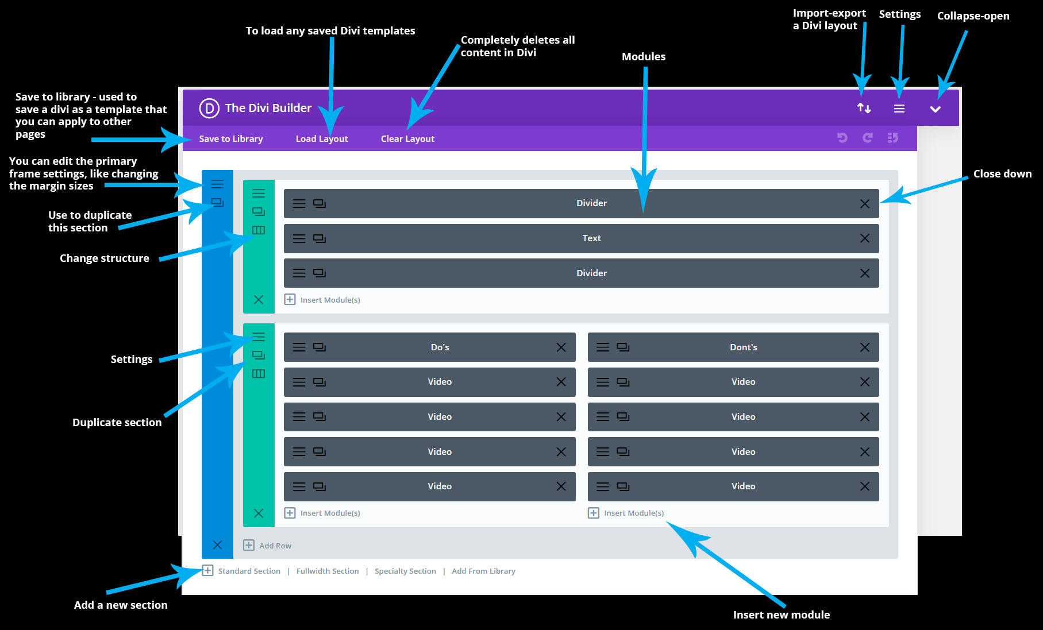
- The content if you had any, will be placed into a single text row as shown in the screenshot below:
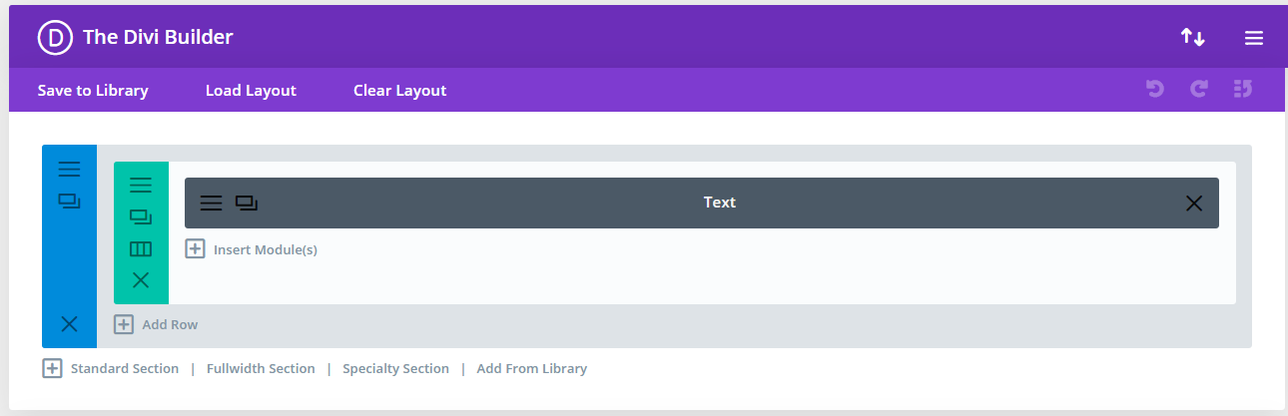
- To access any content you had click on the hamburger menu module settings icon on the row, as shown in the screenshot below
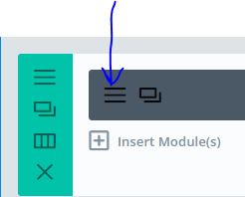
- You should recognise a more familiar editor and your content should appear
- Scroll down the page until you get to the ‘Admin label’ > Rename the label ‘Introduction’ and click on ‘Save & Exit’
- Now click on the ‘+ Insert Module(s) link underneath the text module
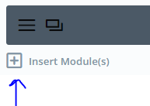

- Find the ‘Divider’ module and click on it
- Click straight on ‘Save & Exit’
- Your new divider module should appear below the ‘Text’ module – hover your mouse over the new module until the cursor changes to crosshairs > Click and hold down the left-mouse button and drag the module above the text module and release the mouse button
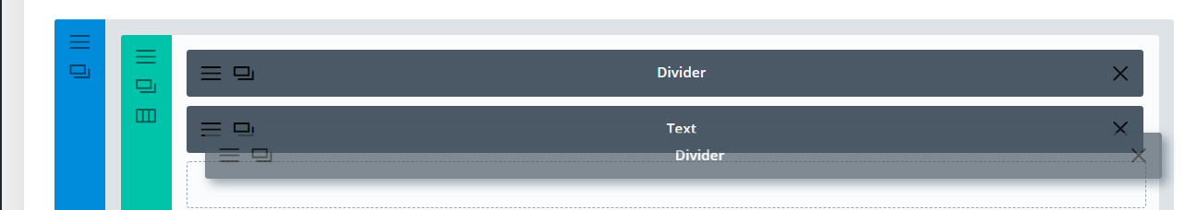
- Update the page & view your live site to take a look at the changes
- One thing you may notice on the live site is that there is a big gap in between the title of the page and the new divider line you added, so we’ll correct that now
- Click on the row hamburger settings menu (the green bar) as shown in the below screenshot
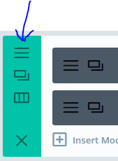
- Next, click on the ‘Design’ tab, then scroll down the page until you find the ‘Spacing’ section
- Insert in both the ‘Top’ and ‘Bottom’ boxes for ‘Custom Margin and Custom Padding’ the value of ‘0’
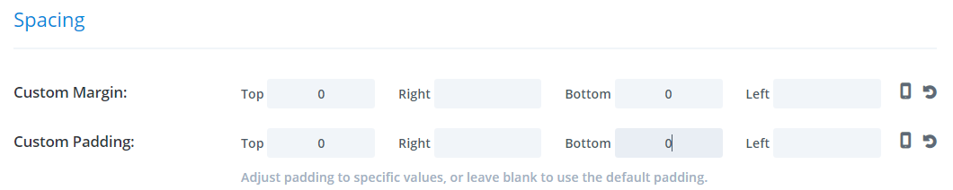
- Click on ‘Save & Exit’ then Update your page
- Now repeat steps 15 – 18, except do this from the blue section settings menu as below
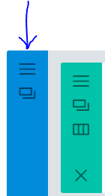
- View your live site (the big gap should now be reduced considerably)
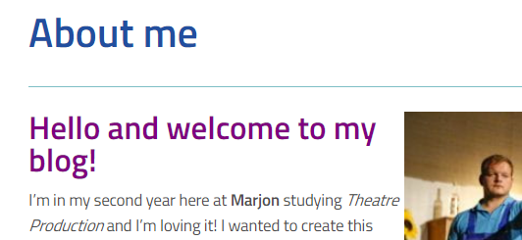

Adding a two-column video module set
The great thing about the Divi builder, is that you can add different columns to your pages by inserting new rows.
- Click on the ‘+ Add Row’ link and select the ½ and ½ layout
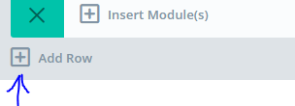
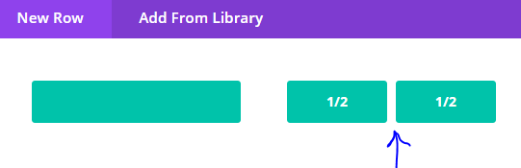
- You should now see two ‘+ Insert Module(s)’ areas within a new row as below
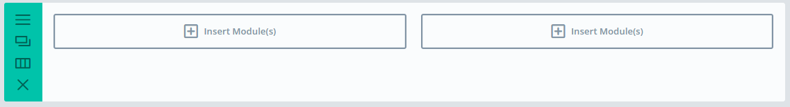
- Click on the left-hand ‘+Insert Module(s)’ empty area and select ‘Video’
- Open a new tab in your browser and find a relevant YouTube clip – then copy the URL for that video (or click on ‘share’ and copy the URL from there)
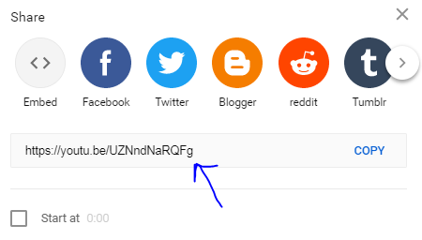
- Head back to the ‘Video Module Settings’ in Edublogs (from step 3)
- Paste into the ‘Video MP4/URL:’ box the copied YouTube URL > ‘Save & Exit’
- Update your page and visit your live site to view the changes
- You will have noticed that the video appears straight after the text on the page, so let’s add another divider and another two-column text box
- Go back into the editor for the page you are working on > Add a new row
- Click on a single row layout
- We can now clone one of the modules already created (this helps saves lots of time for more complicated modules and designs you create)
- On the above ‘Divider’ module click on the clone icon then drag the cloned divider into the new single row you created
- Now drag the single row above your video row
- Once you’ve done the above your Divi builder should look a bit like the below screenshot
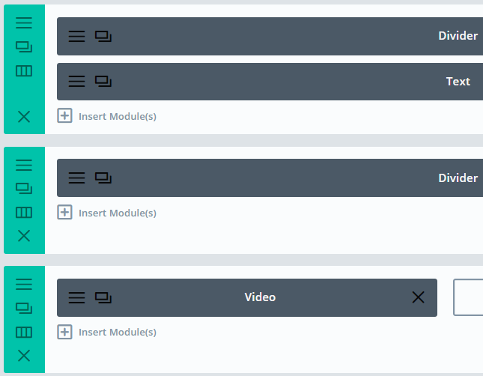
- Update the page and view your live site
- If there’s too much space between the divider and the video, head into the divider settings – go to the design tab and check the spacing (try putting a value of ‘0’ in the ‘Bottom’ boxes, plus you might want around 5px in the Top boxes if your video looks like the below screenshot)
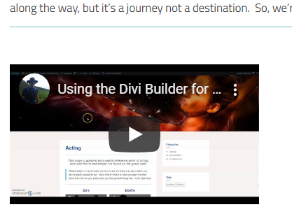
- You may also need to go into the Row settings for the video and add a value of ‘0’ into the spacing for Top as well
- For the purposes of this exercise, we’ll clone the video and then drag the clone into the other empty column
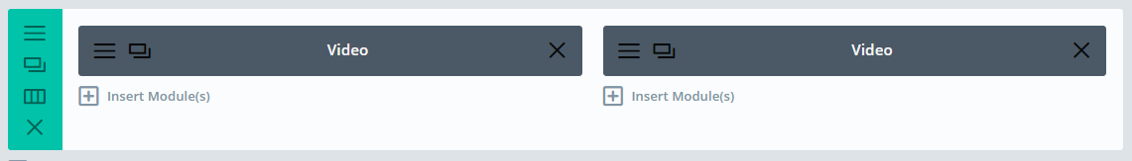
- Now working in the video row, click on the ‘+Insert Module(s)’ link and this time pick a text module
- In the empty box type in ‘Video 1’ and centre the text and make it a heading 3, by highlighting the text and clicking on the ‘Paragraph’ drop-down box
- Save & Exit’
- Drag the new text module above the first video
- Clone the new text box > drag the cloned text box over to the top of the right-hand box above the video module
- Edit the cloned text box > Change the text to say ‘Video 2’ and ‘Save & Exit’
- Update the page and view the live site
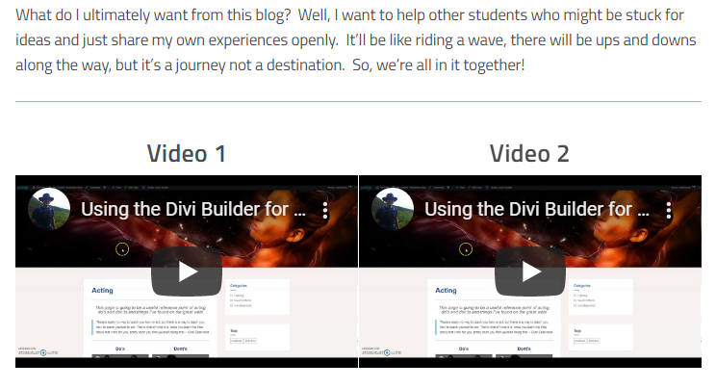
We’ll pause at this point to check if your Divi builder looks the same as mine – the below screenshot shows what your Divi should look like:
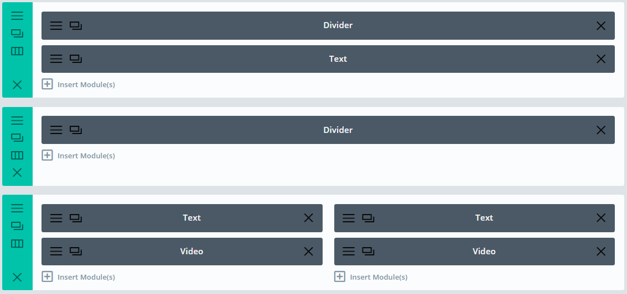
The above modules are only a small selection of modules available in the Divi builder, so experiment with them and look out for further guidance on how to create visually appealing call to action links and more.

