Important considerations when setting up a meeting or session in Teams
When creating a new meeting/session in Teams, there are a number of important considerations you should be aware of. One is how you can set presenting rights for the meeting/session and the other is recording.

How to setup presenting access for a meeting or session
- Select the time for the meeting in the calendar
- Title the meeting and invite any recipients who need be on the meeting
- Save the meeting as you normally would
- Go back into the meeting invite and select Meeting Options:

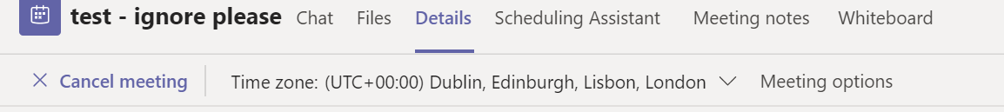
- You should then select who can present.
Leaving this to Everyone or People in my organization will allow any participant the following permissions: Record, Screen share, Document share, mute other participants
Setting to Specific people will allow you to choose who has the permissions above.
Setting to Only me will limit those permissions to yourself. Attendees can then participate in the call via voice, video, chat and view any shared content.
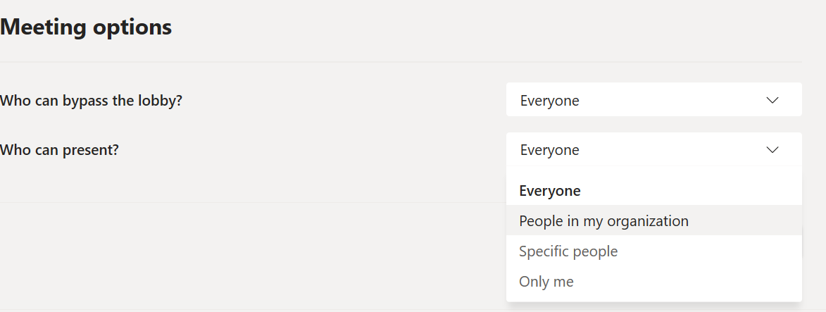
Once you join the meeting or session as the organiser you are able to “promote” attendees to Presenter once in the meeting if required.
- From within the meeting, click to show the participants
- Click the … next to the person you want to be able to present and select the option Make a presenter (note you may need to select ‘make attendee first’)
- To change a person from presenter to attendee, select the option Make an attendee:

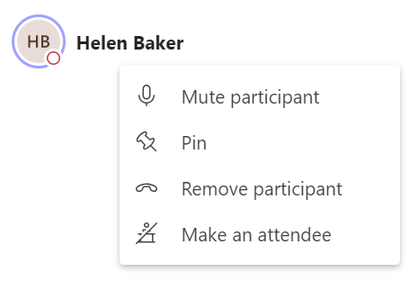

Recording meetings/sessions
If you do need to record a meeting or presentation, please take note of the following:
- Please ensure that you always stop the recording BEFORE you hang up the meeting/session
- You can do this by selecting the … icon and selecting ‘stop recording’

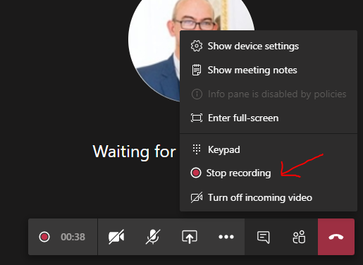
- You can then end the meeting/session by clicking on the red telephone button
- Please ask your attendees to ensure that they have also hung up the call as well once the meeting/session has ended
- Any recording that you made will then appear in the chat area. The video capture will take time to process, when it has it will be available to watch

