Edublogs guide Groups ENTER MOD CODE
Menu (please follow the instructions in this guide, bold tasks we recommend you follow these – especially if you are new to Edublogs)
Please ensure that you complete Task 1 and 2
Task 1. Logging in | Pg: 2
Task 2. Creating a new site, creating your group & joining the class | 3-6
Dashboard key | Pg. 7
What is a page, what is a post | Pg. 8
Working effectively | Pg. 9
Task 3. Creating pages | Pg: 10
Editor key | Pg.11
Adding media, videos, links, customising, configuring and changing the template | Pg.12-17
Further support | Pg: 17

Task 1: Logging in
- Go to www.moodle.marjon.ac.uk (LearningSpace) – please do not go to Google and search for Edublogs as this will present the Edublogs.org website, which we have no management over.
On the home page, you should see a number of different areas, one is Edublogs, click on this:
- You will now be taken to the main Edublogs login page for Plymouth Marjon University. Click on ‘Login’

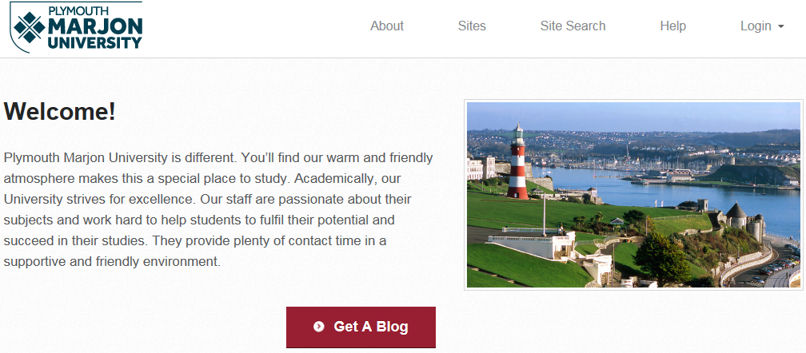

You will be taken to the Login area - this is where you need to click on the blue button.
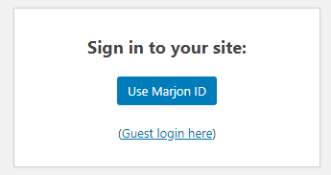
- Then simply enter your standard Marjon username and password to access Edublogs.

Creating a new site, creating your group & joining the class
For this module, you will need to create a new site and join the class

Task 2: Creating a new site
- If you have logged in and the screen looks like this:
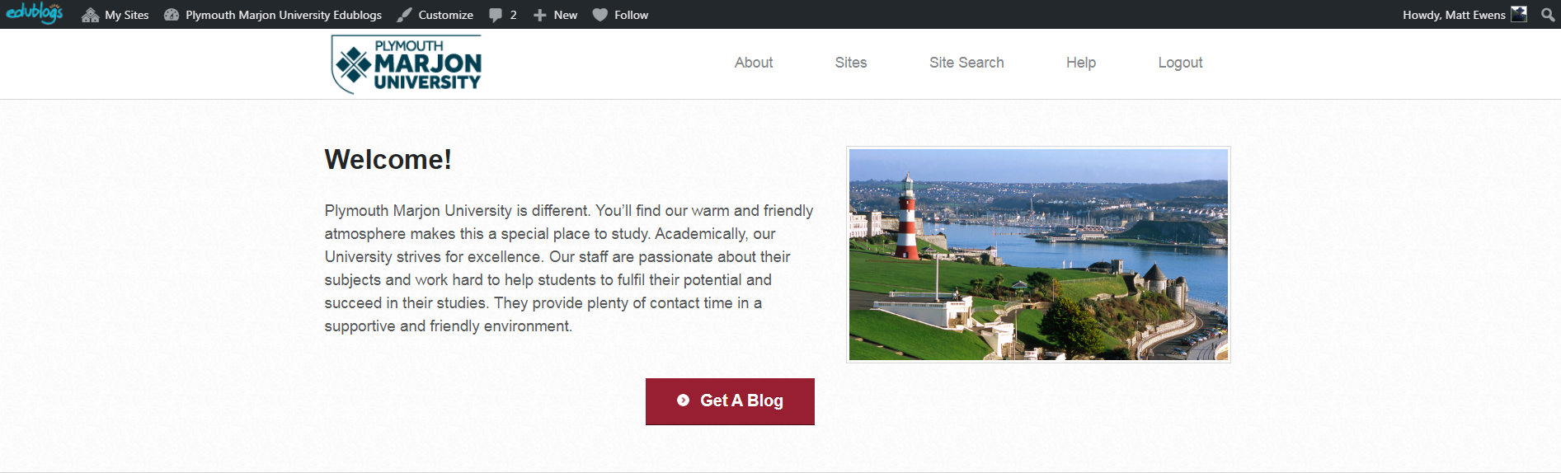
- You should click on ‘Get a Blog’
- If you have logged in and the screen looks like this:
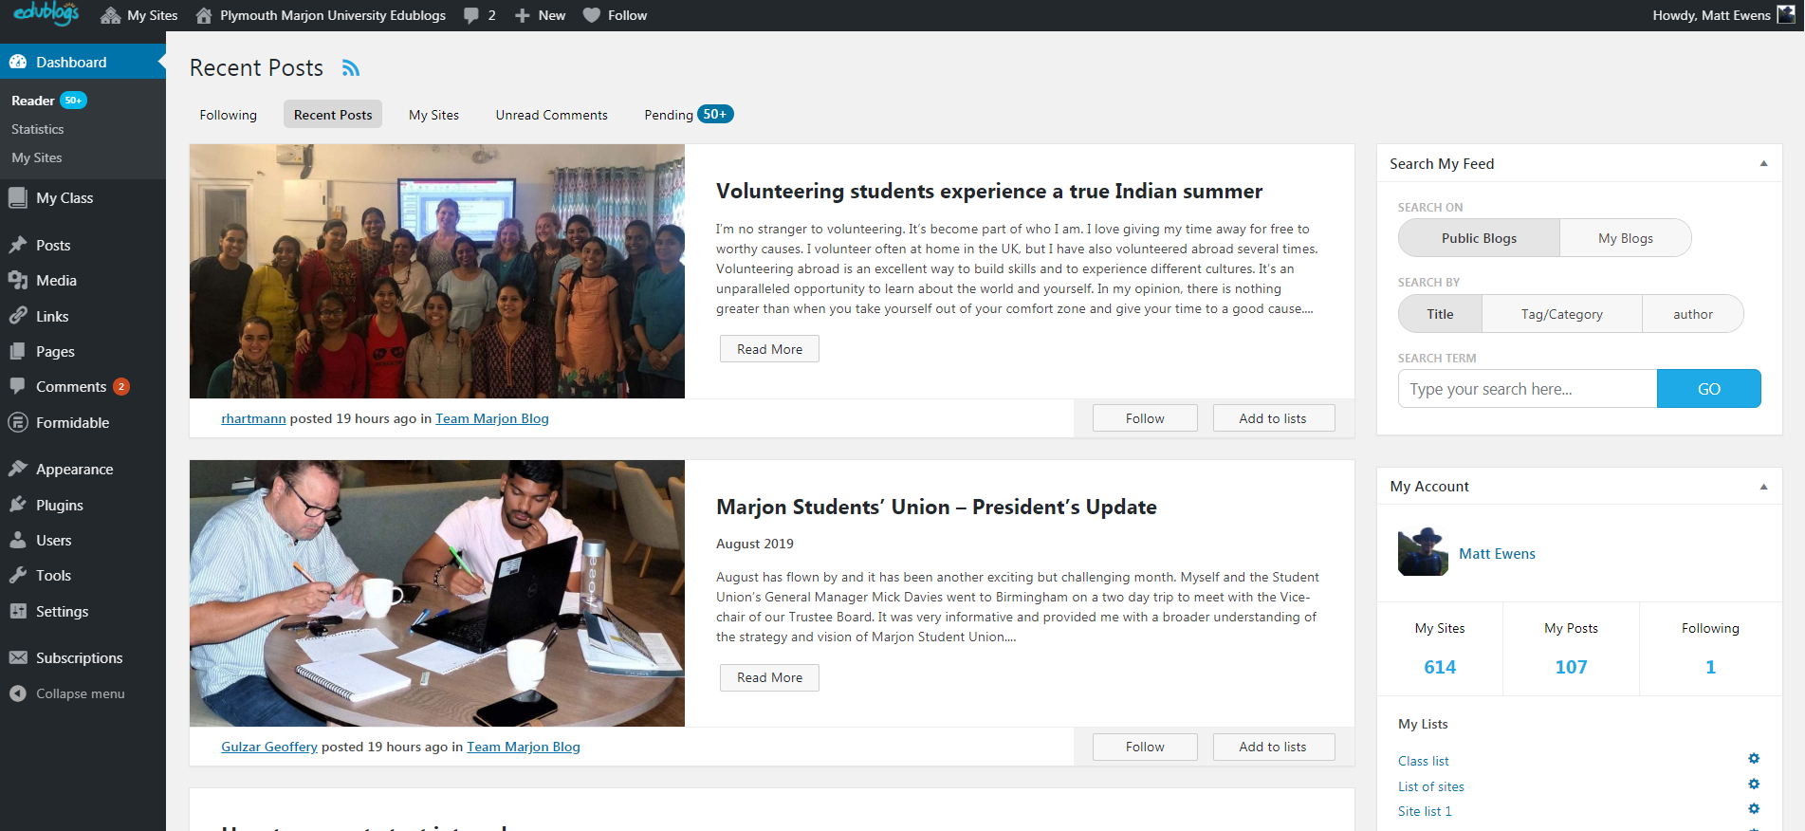
- You should click on ‘My Sites’ > Then click on ‘Add New’ (you will be redirected to the site-creation page)
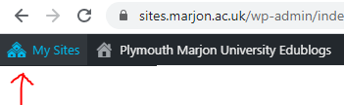
- For your site name, enter LOWER case with no spaces in the following format: first letter of your first name, followed by your surname and the module code, for example: mewensscnd03
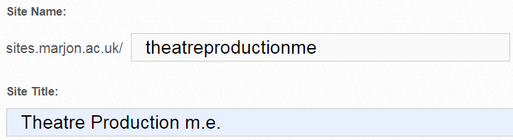

Above is just an example
- Next enter a site title, this is not case sensitive – call it something like: Thematic Learning m.e. (Subject + your name initials)
- Ignore the privacy as this is controlled by the class once you join it
- Then scroll down and select any template (note you can change the template later, to one of over 300!)

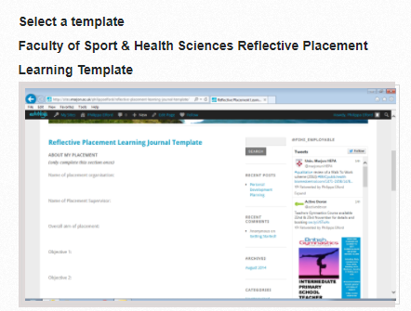
- Once you have selected a template, scroll to the bottom and click on ‘Create a Site’
- Once your site has processed, click the top site title link (your title in red text would be what you entered for the site title)
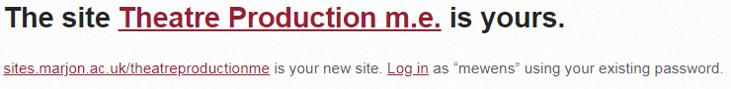
Above is just an example
- You will then be taken to your dashboard for your new site

Creating your group
You will be working in pairs on your Edublog, so chose who will create the blog. The other pairing partner will be added into the blog as a co-creator/editor.
Note: You only require 1 blog, the other person will be added later as a user. You will edit the same blog together.

(if you have never logged into Edublogs before, the second pairing partner will need to firstly login to activate their account before they can be added to the site)
- Go to ‘Users’ > Add existing user

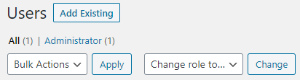
- Enter your partner’s email address, as below and click on the drop-down box and select the role ‘Administrator’ > Then click on ‘Add existing user’

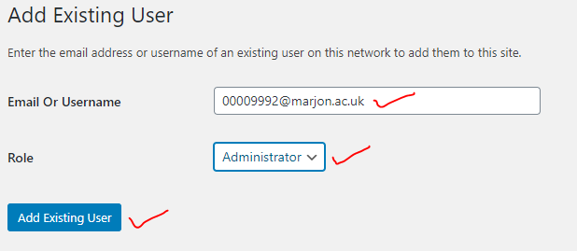
- Your pairing partner can now login to a different computer if they wish and the site will appear in their ‘My sites’ area as below

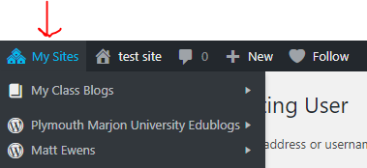

Joining the class
You will need to now join the class once you have subscribed to each group member’s blog, so follow the below steps:
- Hover your mouse over ‘My Class’
- Select ‘Join a Class’

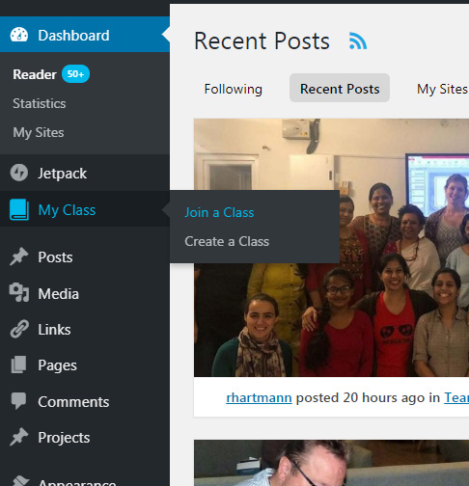
- In the search box type in the following exactly: ENTERCODEHERE & search
- Click on ‘request to join’

Edublogs and the dashboard
Once you have joined the class, you should refer to the below key for the next tasks on page 10, which will remind you about what the different areas mean if you have used Edublogs before – or if you are new to Edublogs, take a moment to review the below key before continuing.
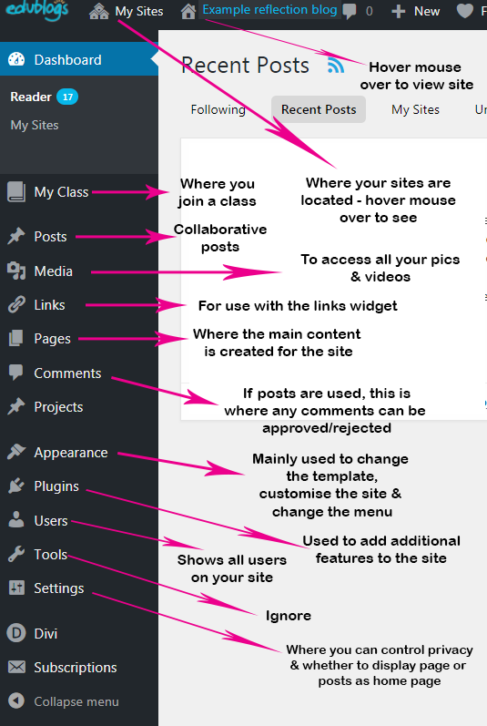

What are pages, what are posts?
(refer to this section if you are new to Edublogs or to refresh your memory about what pages/posts are)
To begin with we will explain the differences between pages and posts. (note you won’t need to use POSTS for your blog)
- Pages are static, so if you imagine most websites, they have ‘home, about us, contact us, etc’ these are static pages and won’t change much over time. Pages are non-collaborative, meaning that other people can’t leave comments on them or have any kind of engagement in them.
- Posts are collaborative and other people can leave comments on them and engage with the content, so most blogs are setup so that the home page will display the most recent posts. This is a convenient option for most students as any new post will automatically appear on the home page once published.
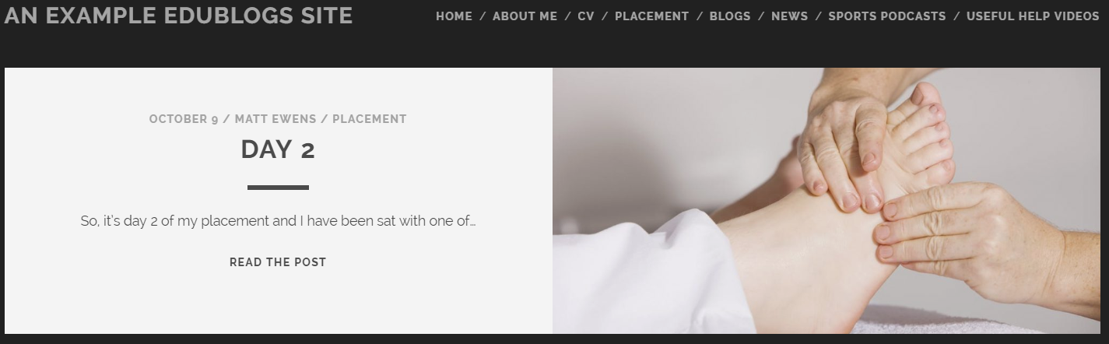The above screenshot shows a site that has recent posts set to display on the home page.

Working effectively (optional task)
To help you work in the editor and see your blog, it’s good practice to open your live site in a new browser tab. Hover your mouse over the icon of a house at the top of the page and right-click on ‘view site’ then select ‘open link in new tab’
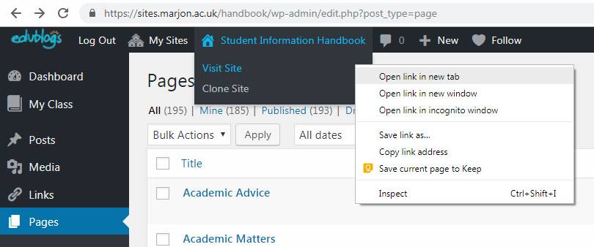
Example screenshot shows where you can open your site in a new tab
You can now switch between the live site in the browser and the editor
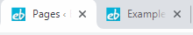

Task 3: Creating pages
We’ll now start creating and editing content in your new blog!
- Look in the pages area. Click into the ‘About me’ page
- Start typing in the editor box! Talk about yourselves, achievements, goals, or your course and the focus of this blog as a starting point. (follow the assessment criteria provided by your tutor or look on your module pages for information on what content is required for your blog) > to save content click on ‘Update’

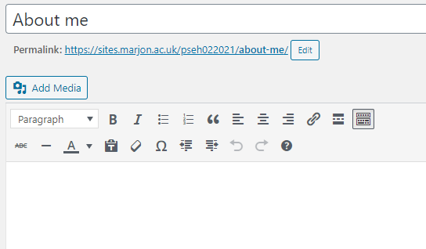
- When you have added some text, why not have a go at adding media, such as images (see sections on adding media, videos, links to learn about adding further content later in your own time)
Note: all the pages and structure is created in the day or weekly format template. There is some example content, such as in the ‘overview’ page and week 1: lesson 1, day 1: lesson 1 pages. You should use these to get ideas on content and edit the content with your own content.

If you wish to add to the menu structure, you’ll need to create new pages and then visit ‘Appearance’ > Menus
You can add any new pages from the left-hand side into your menu. Then simply drag and drop the page where you want it to go in the menu. Then save the menu

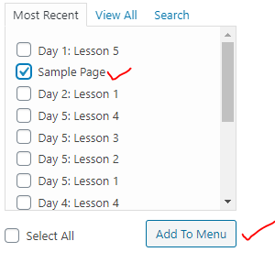
For more help, video tutorials and guides head to the Starter guide

Editor key (refer to this as a reference point)
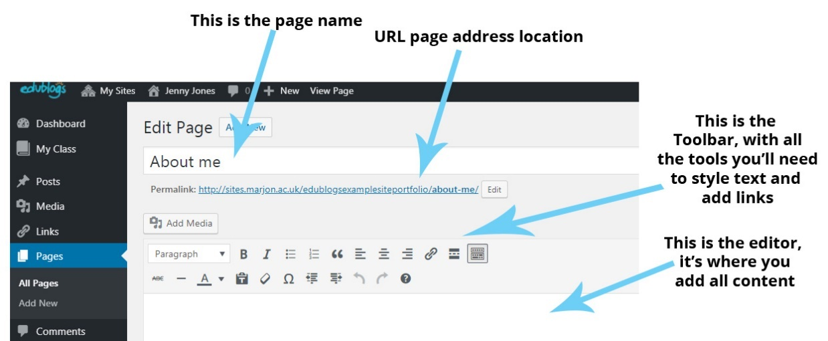
Take some time to review the below editor toolbar key, which will be a good reference point when you come to start adding content to your blog
Editor key

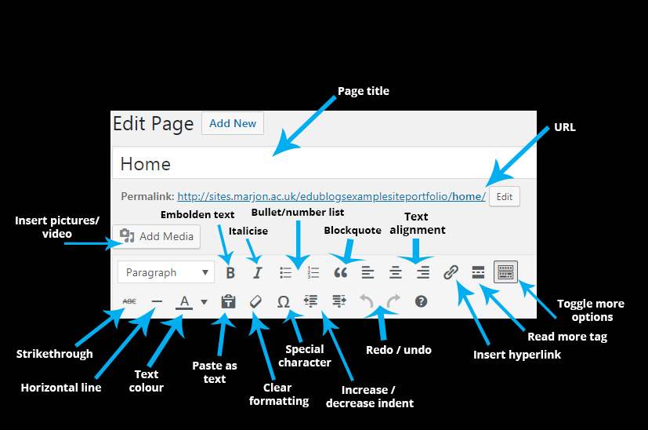
Paste as text: This means you can copy any text from the web or a document without the formatting
Blockquote: This will add a decorative quotation mark, used if you are referencing speech or making an important point

Adding media
- Click before any text where you’d like your image
- Click on ‘Add Media’ > upload your media
- When you click on an image, it will appear on the left of your screen and you’ll notice that on the right-hand side of the screen there are boxes, some may be populated with text already. Take a look at the below diagram which shows what these boxes mean:
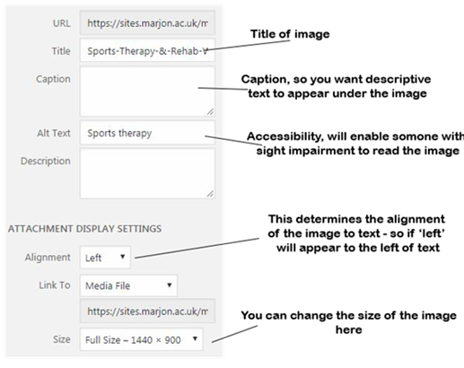
- Set the alignment to whatever you like and select the size and then ‘Insert into Post’
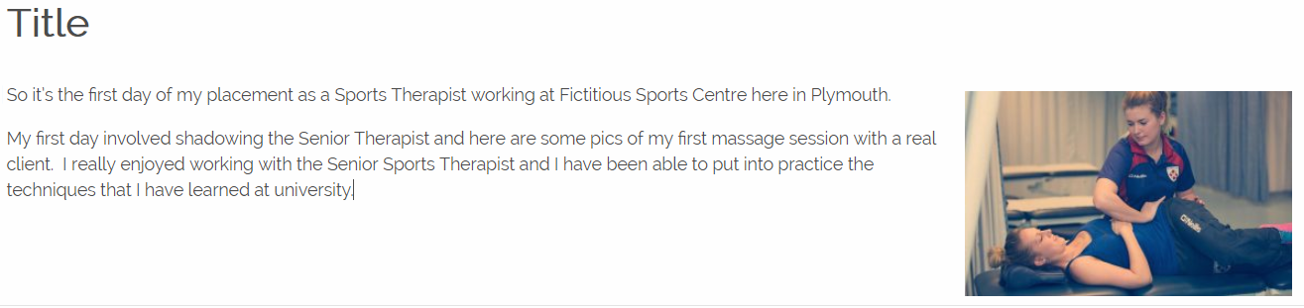
Example of an image inserted into the post
- You can edit any image that you have added to the post just by clicking on it.
- So if you prefer the alignment to be to the left, you can click on the top options bar to do this.

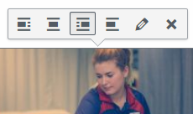
- The pencil tool will enable you to change things like the size and captions. You can also drag the handle bars on the image when selected to make it larger or smaller. (a word of caution, don’t add a thumbnail image and then stretch it, as the quality will reduce significantly. Start with a larger image and reduce it, if you want to use the corner handle bars)

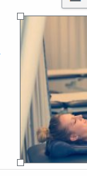
- To add you own images, just click where you want your image in the page/post editor and click on ‘Add Media’ > Upload Files > Select Files
Important note: If you need to find copyright and attribution free images, you can do so by visiting either of the following websites: www.pixabay.com – www.pexels.com (a word of caution, please don’t just search on Google and use images from a Google search, you may be in breach of copyright)

Adding video
- You can add you own videos in the same way you would add an image. There is a maximum file size of 50mb for uploading video. (go through the same process as adding images)
- You can always opt for adding a YouTube video. If you visit YouTube and find a video that you want to embed into your blog, simply copy the website address of the YouTube video and paste it into your blog editor. The video should automatically be created.

Adding links
- Add a hyperlink by clicking and dragging the mouse over any text – with the text highlighted click on the link icon.
- Just type in www.google.co.uk and click on the blue arrow icon

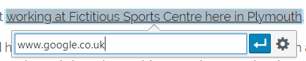
(Above is just an example)
- This will add the link to the text to Google and it’s how you can link to any other webpage.
- Click back on the link text and click on the pencil icon > then click on the cog icon.
- Check the box ‘Open link in a new tab’ and Update

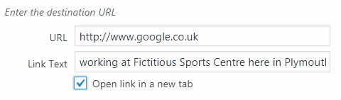
- This will mean that the link when clicked will open in a new tab, so the visitor to your blog site can still access your site easily.
- Experiment with the other formatting tools like bold and italic and start creating content for your blog.
Remember to save your work by ‘Save as Draft’ or if you’re ready to publish ‘Publish’

Hint: always publish any pages you create without content, this way the page will appear in the navigation menu. (You can then work in draft on the main body of content until you’re ready to publish)

How to upload a document
- Within the edit screen for either a post or a page, click on ‘Add Media’
- Go to ‘Upload Files’ > Select Files
- Find the document you want to upload and add it
- Change the title on the right-hand side to something more suitable and ‘Insert into Post’
- If you want the change the title of the text, just click on it > select the pencil icon > click on the cog icon > Update ‘Link Text’

How to change the template
If you wish, you can change the template to customise the look and feel of your blog.
- Navigate to ‘Appearance’ > ‘Themes’
- There are over 300 hundred templates to choose from – popular templates include ‘Bushwick, Aaron, Tracks’.
- Hover your mouse over ‘Aaron’ > Click on ‘Live preview’
- If you like the new template style click on ‘Save & Activate’ if you don’t like it, click on the cross top left-hand side of the screen to return to the templates.
Be aware that each template is different and the layout of the navigation and other aspects not covered in this session may be in a different place as well. Some of the templates setup during site creation are not recoverable once changed.

Customising your blog (optional)
You can customise the appearance of your blog if you wish.
- Head to ‘Appearance > Customise’ – (if you change the template, the available options will be different depending on the template used)

Configuring your blog (optional)
If you wish you can control how your blog is setup, this means that you can change the home page so that your blog posts don’t automatically appear on the home page. You can setup your own static home page, this could be an introduction to your blog. Then you can create a separate ‘blogs’ page, which you can assign as the space your blogs are posted to.
Go to ‘Settings’ > ‘Reading’ to change this.

Further Support
Head to our new starter guide, which has screencasts & more for any help related to Edublogs
If you are struggling with anything related to today’s session, you can also contact me directly via: mewens@marjon.ac.uk
Or call 01752 636700 ext 5673
If I am unavailable or away, you can also email digitalinnovation@marjon.ac.uk

.

