Setting up a live webcast through Panopto
This guide has been created to help you to create live webcasts for your modules. Note, automated captures will no longer be taking place, it is your responsibility to setup your own live lectures. A live webcast will enable remote students to access the live lecture from a located session.

How to create a webcast for your modules
- Visit the LearningSpace module page for the module that you want to have a live webcast and select ‘Course Settings’ from the Replay block.

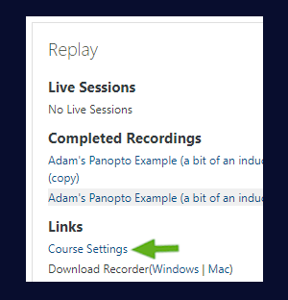
- You will be taken into Panopto (note ensure that you login) – close down the box that appears on screen.

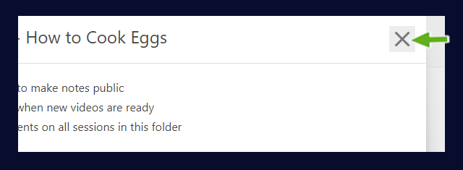
- Next select the ‘Create’ button and select ‘Webcast’.

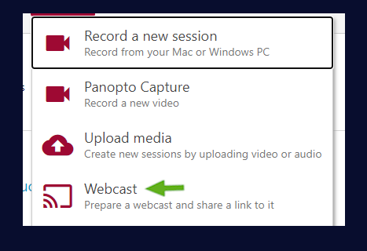
- Give your lecture a name (module code+name+date+time) > Then select ‘Create’.

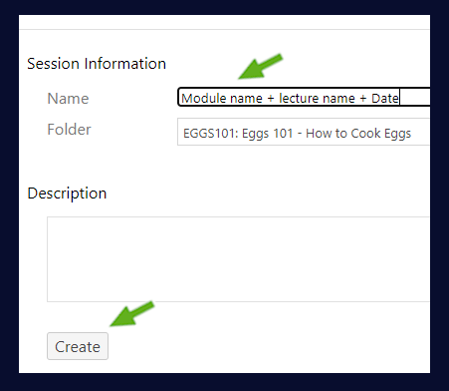
- A pop-up box will appear, close this down for now and you should see the ‘shell’ of the webcast created.

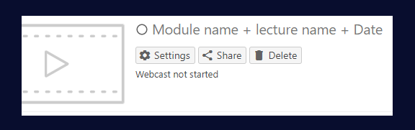
- If you wish, you can select the ‘Share’ button and copy the URL to the webcast. This can be used to add to an announcement for example.
- The webcast is now ready to be activated. (note you can setup as many as you need for other modules, then you’ll always have them ready to go, just repeat the above steps for your other modules).
- To activate and launch the webcast, select ‘Settings’.

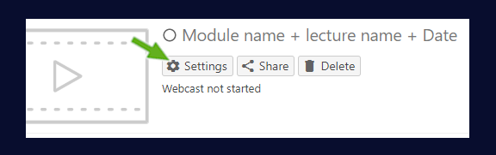
- Scroll down the pop-up page and click on ‘Record’.

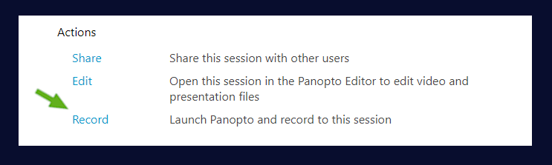
- Click on ‘Open Panopto Recorder’.

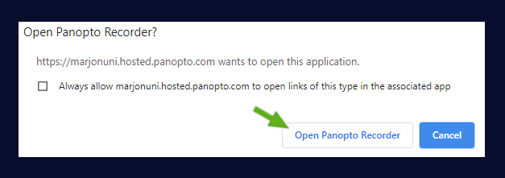
The Panopto desktop recorder will open. Please take time to view the key below to show the functions of the tool.

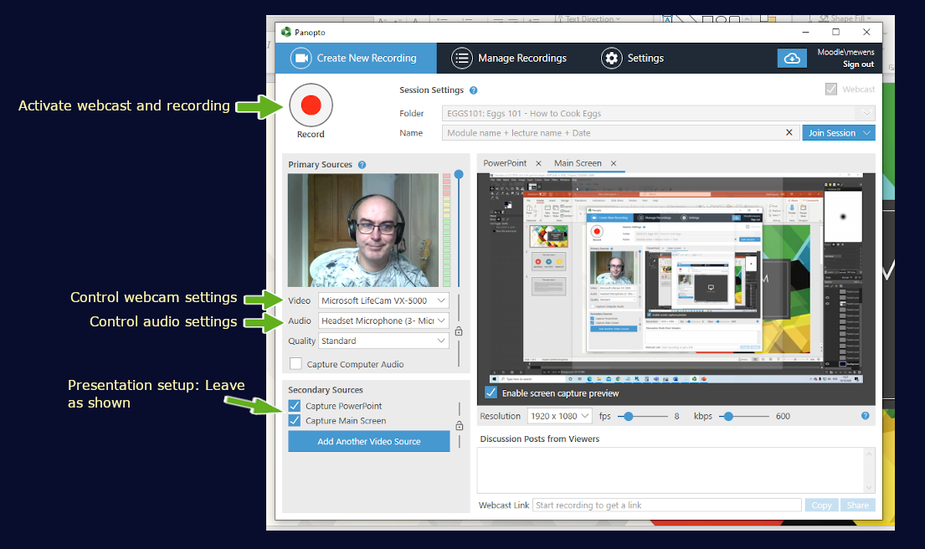
- To disable the web camera, select the video drop-down and select ‘none’.
- Leave the ‘Secondary Sources’ section as above.
- When you are ready to present your PowerPoint presentation, select the ‘PowerPoint’ tab.

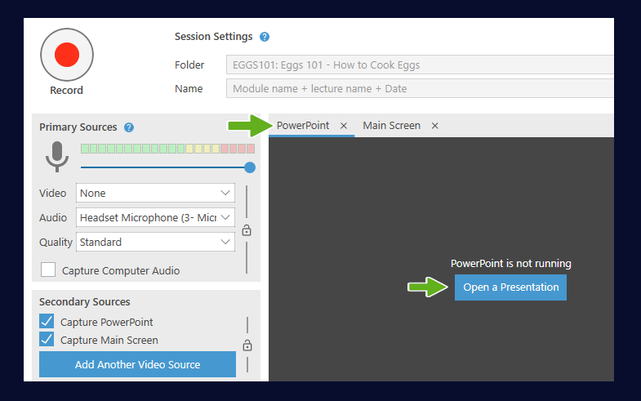
- Then select the blue ‘Open a Presentation’ button.
- Once you’ve opened your presentation, you’ll see a message. If you select ‘Yes’ the live webcast will start and the recording.

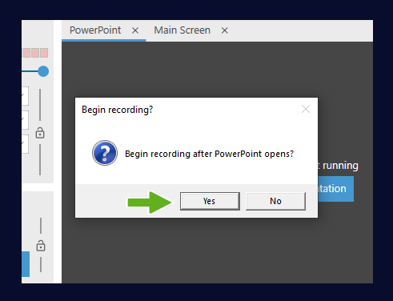
Note: If you select no, the Presentation will not open full screen mode and you’ll need to click the record button to activate the session.
- When you have completed your presentation navigate back to the desktop recorder (you can easily do this by exiting the PowerPoint and selecting the Panoto icon from your toolbar at the bottom of your screen).

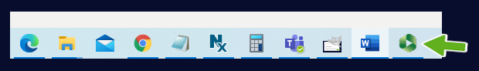
- Stop the recording.

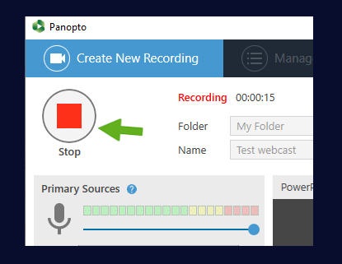
- Click ‘Done’ on the success message.

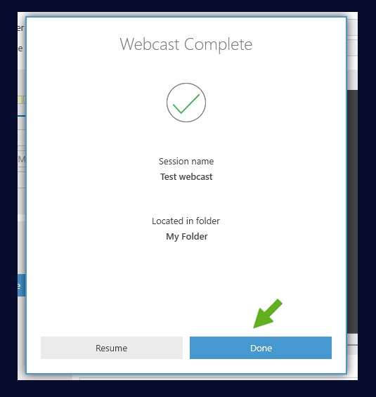

- You will then see the manage recordings area, to view your webcast click on the view link.
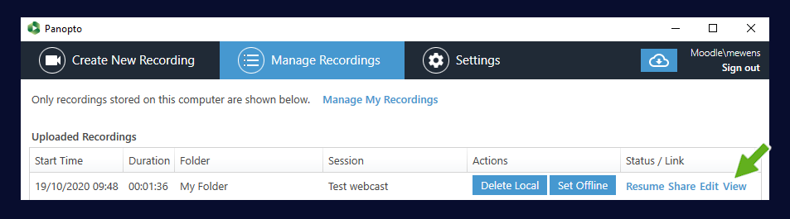
- To view your recordings in the module folder, simply click on the folder name (top left-hand corner).

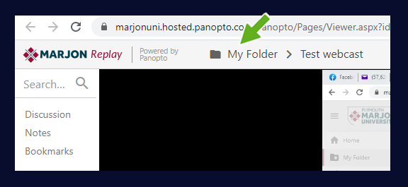

Student Perspective
Once you have started the recording, you may be concerned as to how your students watch the live lecture.
From the student perspective all they need to do is login to LearningSpace and visit the relevant module page and there should be a ‘Watch Live’ link in the Replay block as below:

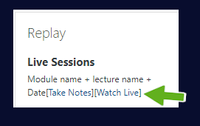
Note: Keep in mind that your remote students may experience a 10-15 second delay between the live broadcast. Although students can ask live questions in the discussion area, we would recommend holding discussions in Teams outside of the Panopto live webcast discussion feature.

When the live session has completed
After the session has been completed, it should appear in the ‘completed recordings area’ for the module – note if you need to edit the recording, but don’t want it to display immediately in the Replay block follow the below instructions:
- Go to the video in Panopto > Select ‘Settings’.

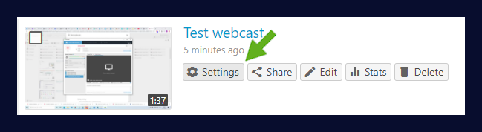
- Scroll down the page until you see the availability section and adjust the settings as required.
Watch the instructional video to learn more: https://web.microsoftstream.com/video/4d785b42-9ebe-4377-b9d1-469d7e3b9798

