Microsoft Teams: Meeting Recordings Update
Microsoft recently updated Microsoft Teams and made a significant change to the saved location of Teams recordings. This means that Teams recordings are no longer saved to Microsoft Stream, but OneDrive.
[Please note: Marjon classroom laptops may yet to have this update installed, please check with Computing Services if you have any concerns]
This guide has been created to help provide information about what this means and how best to provide access to the recordings for your students.
Important Tip: Once your recording is complete and you leave the meeting, it could be located within the conversation thread. Select the ‘replies’ link as below:

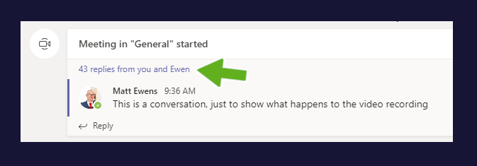
You may also need to select the ‘see previous replies’ link before you’ll be able to see the recording:

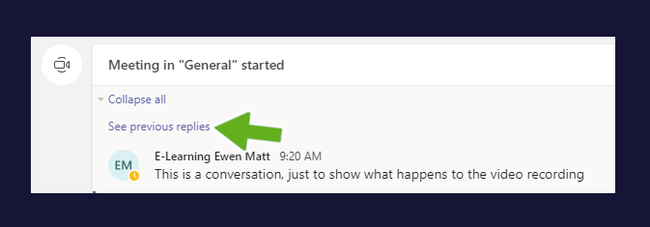
In addition, you may also need to scroll through the conversation before the video will become visible as in the below example:

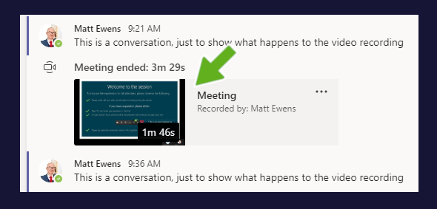

Making your recording available to students
In the above example the recording will be visible for all your students (those that are members in the module team) – they can simply click to view the recording (this will open the recording in a new browser window)
If you want to make the recording available on LearningSpace we would recommend copying a link to the recording as well as uploading it to the Panopto Replay block.

Copying a link
1. On the recording, select ‘more options’ (three dots) and select ‘Get link’

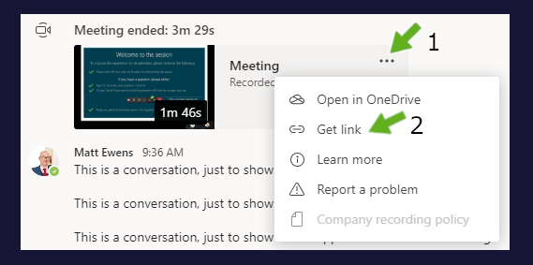

- Click on the link and select ‘Copy’ – You can now make this link available on the LS module page (it will only be visible to students who are logged in, not externally)

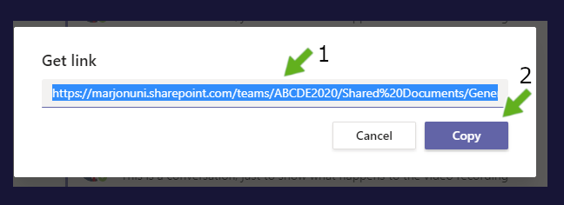

Making the recording available via Panopto
- Go to the LearningSpace module page replay block
- Click on ‘course settings’ in the replay block

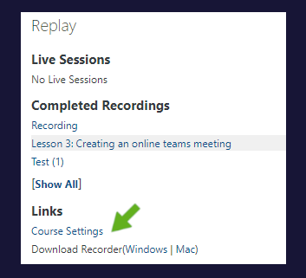
- This will take you into Panopto (you may need to login at this point) > Close the settings box on screen
- Now go back to the Teams recording and open up the recording (it should open in a new browser window)
- Select the ‘Download’ option to download the recording

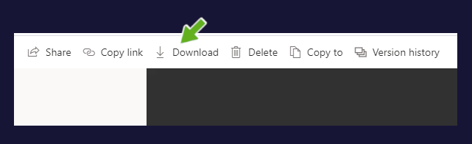
- Head back to the earlier opened Panopto page and click on ‘Create’
- Select ‘Upload media’ > Drag the downloaded video into the space or click to select it from your computer

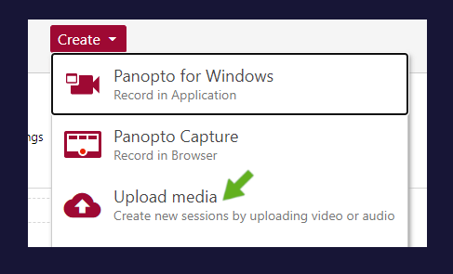
The recording should upload to the module Replay block, wait until the success message appears before closing the box

Watch a video tutorial to learn how
Link to recording

How to access all Teams recordings for any channel
Students may ask the question, ‘where are all the Teams recordings’ – if so, you can simply point them to view the ‘Files’ tab for the channel where the recordings are made.
- Visit the channel where you record your meetings (in this example we are assuming you use a separate channel for meetings)
- Click on the ‘Files’ tab at the top

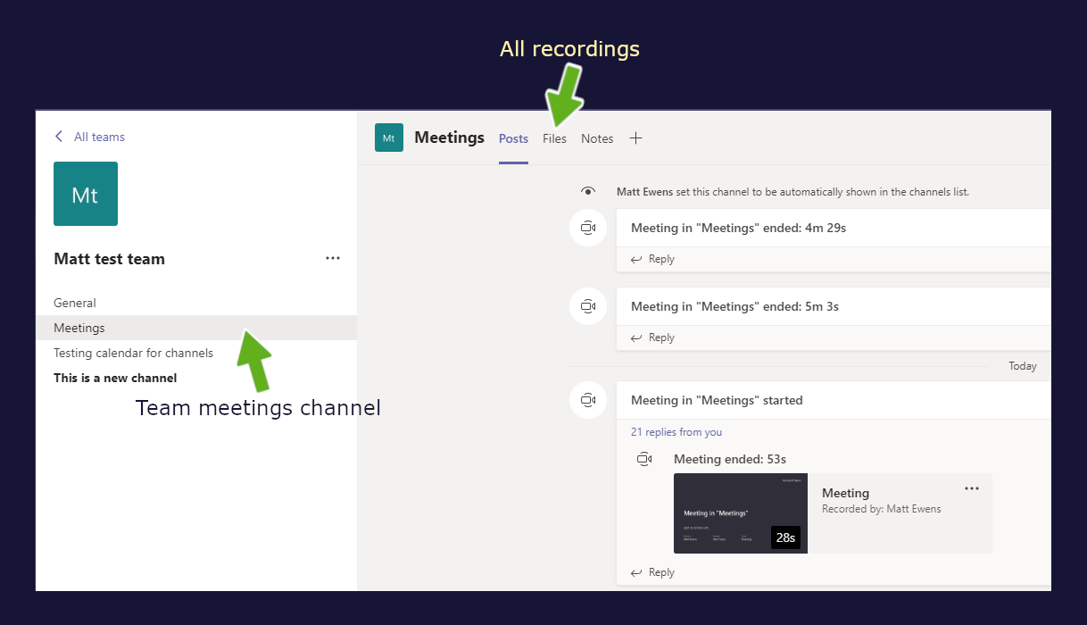
- Click on the folder called ‘Recordings’

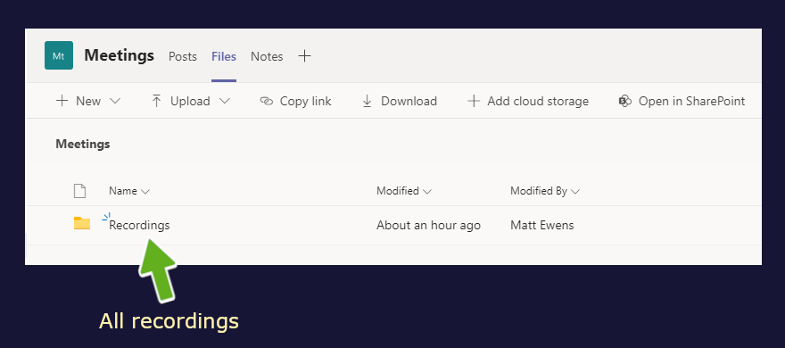

How to add a recordings tab at the top of your ‘General’ module team
- Click to visit the channel where you record your meetings > then select the three dots at the top right-hand side of the screen > Next click on the ‘Open in SharePoint’ link

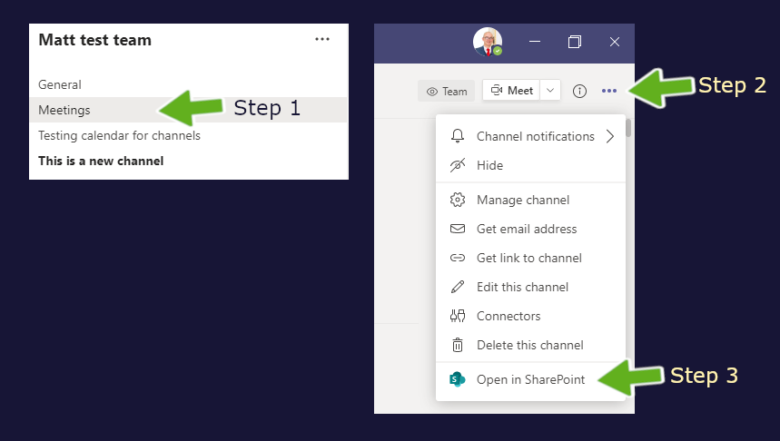
- This will open the folder location in SharePoint in a new browser window > Click into the folder marked ‘Recordings’

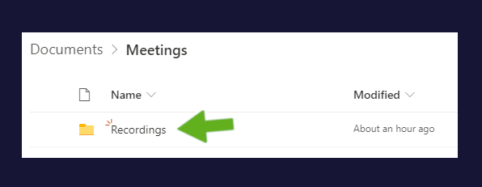
- Next click into the URL search box and copy the URL (do not click on the ‘share’ or ‘copy’ options)

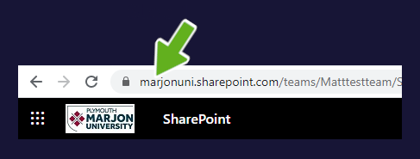
- Head back into your module Team and click on the ‘general’ channel (we are assuming you use a separate channel for your meetings)
- Click on the ‘+’ icon at the top

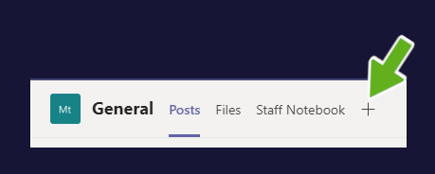
- Select the ‘Sharepoint’ app

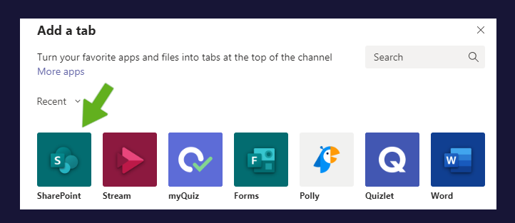
- Next click on the bullet to select ‘Any Sharepoint Site’

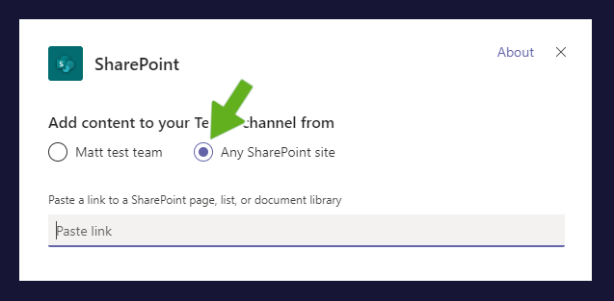
- Paste in the previously copied URL link and click on ‘Save’

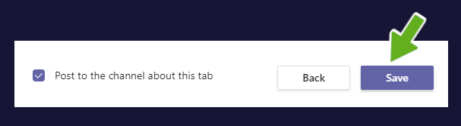
- Next, click on the downward facing arrow on your new tab title > Select ‘Rename’ > Enter a more appropriate name, such as ‘Recordings’ and Save

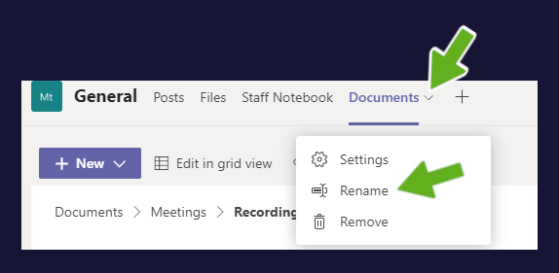

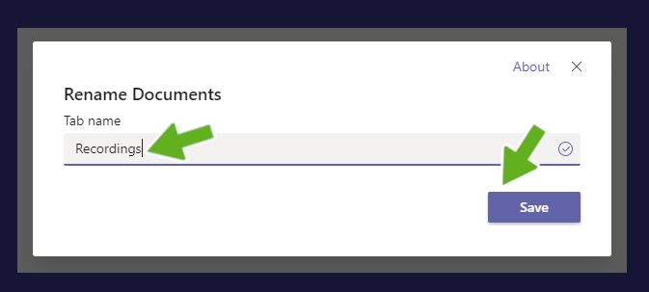

Watch a video tutorial to learn how
Link to recording

