Customising your Blog
You can customise how your blog looks by accessing the customiser.
1. Go to ‘Appearance’ > ‘Customize’
2. Depending on the template that you are using, you’ll have different options and customisations available
3. The Amadeus theme used in this example has more available options than some of the other templates
4. Most of these are quite self-explanatory – but here is a brief explanation of the tools in the Amadeus theme

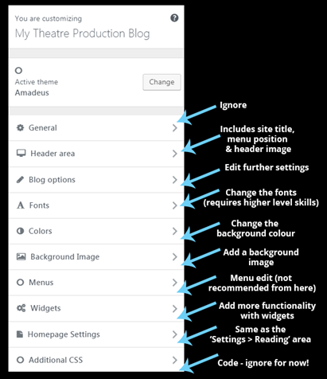
5. If you’re happy with any changes you make in the customiser, click on ‘Publish’

