Downloading the Teams app
- Login to your Microsoft Office account online via www.office.com (Marjon username & standard password)
- Visit the Teams space - if this is the first time you are visiting Teams the image may look like the below

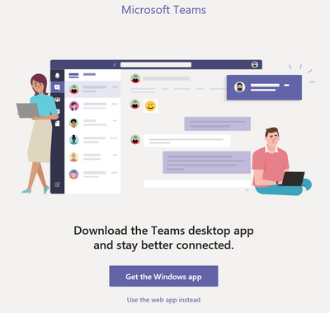
- Select the ‘Get the Windows app’ button and follow the prompts to download and install the software on your machine
- If you have logged into the Teams space online, then you can download the app by clicking on the three dots as below

