How to create a new blog site for your assessment

As part of your module assessment, your lecturer should send you a joining link to enable you to create your blog.
- Click on the joining link provided by your lecturer
- When you click on the invite link, it will take you to a page like the below screenshot (please login first as above to Edublogs using your Marjon credentials – you will need to visit: www.sites.marjon.ac.uk )
- Simply complete the below details (for site title enter a relevant title and include your name initials, for example: ‘Thematic Learning M.R.E’ – for site URL, please enter the module code and you name initials without any spaces and lower case, for example: abcdemre – check the box for ‘I’m not a robot’ and then click on ‘Create a Site’

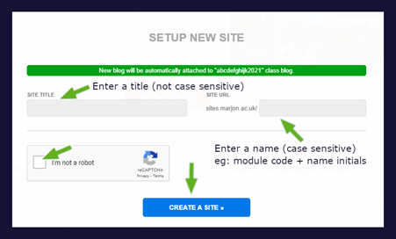
Your new site will process and you will be taken into your site dashboard in Edublogs.
Your site will automatically be added to your tutor’s class.

