Edublogs: How to work effectively
Once you have logged in to Edublogs and created your first blog, you should follow this guidance to help you to work more effectively.
- Hover your mouse cursor over the icon of a singular house
- On the ‘visit site’ option, right-click on the mouse and select ‘Open link in new tab’

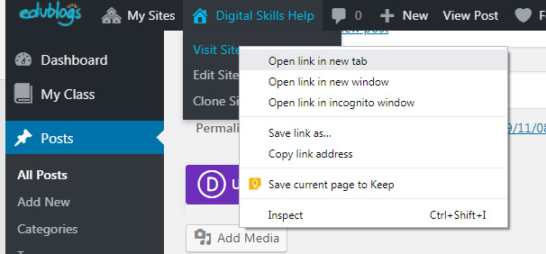
By doing this you can switch between the editor or the dashboard for your blog and the live site.
- Another useful tip:
If you are visiting the live site, you can return to the editor by clicking on the icon that looks like a speedometer.

