Guide on How to Setup Teams for the new Academic Year
Unlike previous academic years, automatic academic teams will not be created for all modules. This means that if you need to have academic teams for your modules you'll need to follow this guidance and set them up yourself.

All academic teams will now be created via Canvas.
- Login to Canvas via: https://marjon.instructure.com
- Head to the course where you want to add your Microsoft academic Team.

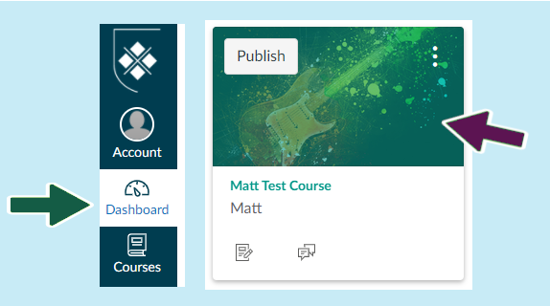
- You may notice x2 new items on your Canvas course - 'Microsoft Teams Meetings' and 'Microsoft Teams Classes'. These will not contain any content as yet as you will need to enable the Teams plugin. (read on to find out how)

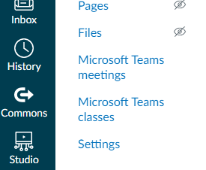
- Before you can use either of these you need to set up enrolment synchronisation between Canvas and Teams, so click on 'Settings' > Then select the 'Integrations' tab
- Select the slider button underneath 'State' to activate synchronisation then select the 'Sync Now' button. (click the > arrow on the left to open up the extra text) This should start synchronisation for the first time. Subsequently it will be automatic. Things should be ready within a few minutes but if you have more than one Canvas course then the synchronisation may take some time, in some cases we have had to wait for 24 hours for this to complete. We hope that this is not normal.

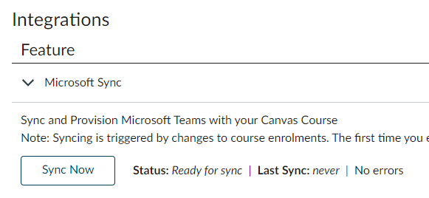

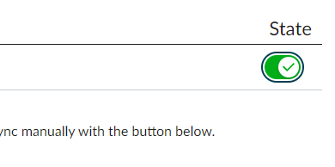
- You should have Microsoft Teams open at this point. When synchronisation is complete it will send you a notification and a new team will have appeared in Canvas. Click on 'Microsoft Teams Classes'

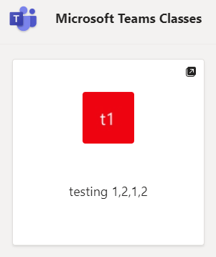
- If you click into the block it will send you to a new browser window where you can open in Teams. You should then see your new team.
Note: This will be unavailable to students until you click on the activate link at the top of the Team as below
Please note!
You may notice that the class team is visually different to the previous years' Teams. This is because it is the default Team layout that has been enabled with the Teams plugin and not something we can change. We would recommend that staff use the assessment tools within Canvas rather than those illustrated in the class Team.
The Team will otherwise operate in the same way as before, although each channel will display x2 boxes for 'uploading class materials & Setup class notebook.'
To activate the standard posts, simply click on the 'New conversation' button.

