Foodsavers Mechelen
Case study

Foodsavers (FS) Mechelen, an initiative of the City of Mechelen (Belgium) and Ecoso vzw (a social enterprise), started in January 2020 as one of the Flavour pilots to combat food waste. The team collects surplus food from vegetables, fruit, meat, dairy, canned and packet goods and NON-food, after which it is sorted and redistributed to local social organisations.
This activity creates meaningful employment for people who have been unemployed. FS Mechelen employs two volunteers as trainees and seven people who are unemployed as apprentices. The apprentices are given the opportunity to gain meaningful work experience and acquire Skills and competencies which will enable them to move on to regular employment in the food or logistics sector.

Self-managing teams
Within FS Mechelen, Ecoso vzw is responsible for the coaching and guidance of the employees. There is a strong focus on self-managing teams. This means that the employees are jointly responsible for the tasks, activities and product quality within the entire logistics process, from collection of the food surpluses to delivery. This bottom-up approach ensures that the employees are part of the process and it also creates a sense of ownership.
With the exception of preparatory administrative tasks, the employees perform all tasks independently. To facilitate this, the process is made as simple as possible. For example, they work with broad categories of fruit, vegetables, dairy and frozen foods. Customers cannot indicate which product they would like to receive, e.g. '30 kilos of tomatoes and 20 kilos of potatoes', they can only choose from the categories and the number of containers. However, customers can indicate what type of desserts they want to receive or if they want to receive specific vegetables, such as only soup vegetables for social restaurants. This way of working is also more feasible for larger distribution platforms and is a way to deal with the unpredictability of deliveries; after all, you do not always know what you will receive in advance.
On the work floor, two tasks and responsibilities can be distinguished, namely those of warehousemen and drivers. Because of the small team, employees are expected to be versatile. In practice, the most experienced employee is deployed as line manager to keep the entire process on track. Also, there are always coaches available for questions.

Learning on the work floor
Maria, the work floor supervisor, is closely involved in the onboarding of new employees. During an intensive guidance programme, new employees get to know the organisation and the work.
New employees first receive an explanation of the house rules, the do's and don'ts, and the most important agreements regarding food safety. To get a feel for the organisations and the end users of the products - people in food poverty - the warehouse workers accompany more experienced drivers during the first week. Marie also explains what each organisation stands for, e.g. whether it is a community group, a food distribution centre, people with a disability, young people, etc., so that the new warehouse workers also learn to assess for themselves what they are giving to which organisation. This experience not only helps them prepare the deliveries, but also increases their motivation because they know what and for whom they are working.
From the second week, the warehouse workers receive training on the logistics process. This takes place entirely on the work floor. They are intensively supervised by Maria. For about a week, she stands next to the new employee on the work floor. She shows everything and gives a detailed explanation of the different steps in the logistic process.
Once that is successful, the new employees are coached in a form of peer-learning, whereby they are paired with more experienced employees. For this to be successful, it is important that there is always a mixed profile in terms of experience. After about a month, the new employees can work independently.
In order to develop computer skills as well, warehouse workers make the delivery notes themselves. Using codes they enter into the computer, the categories come up automatically. They then only have to enter the number of kilos and click on the organisation. They print out the delivery notes themselves.
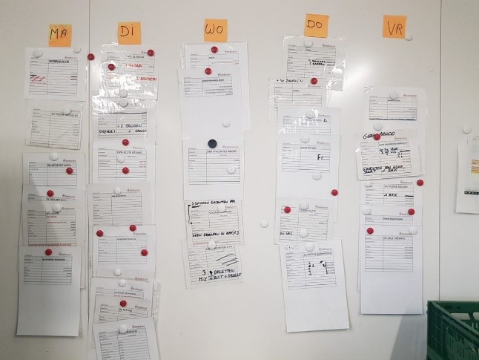
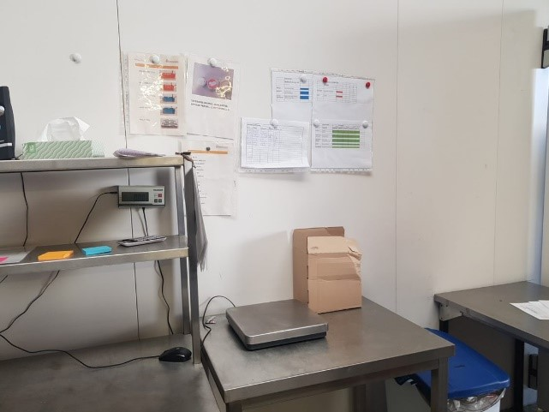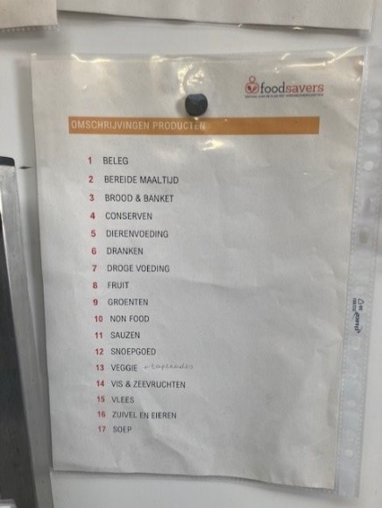
The drivers are trained to work independently as soon as possible. For the first two weeks, they ride along with an experienced driver until they have seen all the customers. They receive a route sheet with colour codes for collections (in orange) and deliveries (in green). In each container, a card is placed with the name of the customer so that the drivers know who will receive what. The drivers occasionally do warehouse work, but they never do this independently. They only follow orders from the warehouse workers.
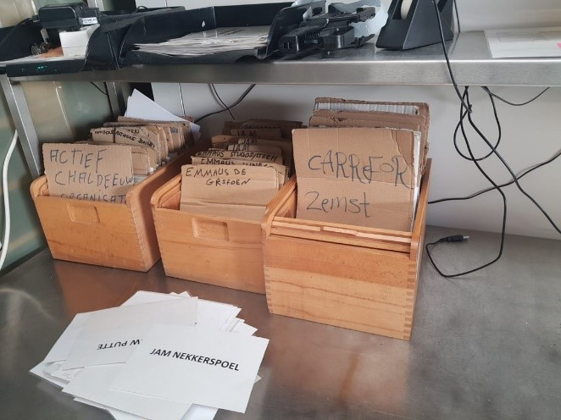
Training on the work floor is an added value for this target group. Instead of being taught classically in a separate room, they benefit more from 'hands on' learning. This also helps them learn the Dutch language. On the shop floor this goes faster than in a classroom. An exception is the explanation they get in Maria's office about food hygiene.

Additional offer of external training
In addition, and depending on the status of the employee, there is also a range of external training on offer. Thus, permanent employees of Ecoso can follow training offered by Ecoso itself, such as computer skills or assertiveness training. Article 60 employees get an exemption to follow Dutch lessons through the Centre for Adult Education or Centres for Basic Education. Other employees must follow these after working hours. A language coach literally stands next to the employee, encourages him to speak Dutch all the time and corrects if mistakes are made.
Maria tries to stimulate the employees as much as possible to participate in the training courses so that they can move on to the regular labour market with as many skills as possible.
Employee participation
Ecoso's flat organisational structure is extended to the employees so that they can have their say. Every month, a team meeting is organised during which the employees are asked what is going well and what is not going well on the work floor and whether they have any suggestions for improvement. An example of this is the first in first out (FIFO) system for the freezer. Because there is no freezer yet, people work with separate fridges, which sometimes causes chaos. One of the employees suggested sticking a post-it on each freezer with the freezing date. It is often about small adjustments like this, but participation is a great added value for the employees; it stimulates their involvement and gives them the feeling that, instead of just being the performers, they also mean something in the functioning of the organisation.
Concerns and challenges
Not everything runs smoothly. On Wednesdays, Maria is not present and the team is on its own. Maria notes that, given the state of the warehouse, work doesn't always go as smoothly the following day.
It is also important for the work floor supervisor to constantly repeat what has been agreed. This may, for example, concern agreements about food hygiene, but also about other matters on the work floor, such as closing the refrigeration unit so that it does not consume too much, or procedures concerning empties. The latter concerns the registration of incoming and delivered bins. Some of the bins come from the auction and must be returned in order to avoid having to pay for them. The bins that were not returned are invoiced to the client. The manual registration of these is therefore a precise job.
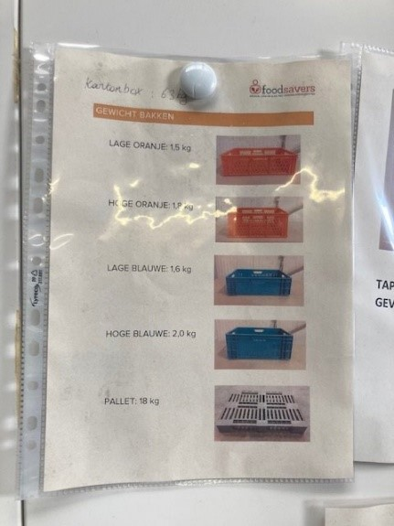
Employees also have difficulty with expiry dates and the FIFO principle. To avoid having to throw away a lot of food at the end of the week because it was not given out in time, this is always checked by Maria.
Tips for good work floor supervisors
- The work floor supervisor's background is important. Has he/she been trained to develop coaching competencies or at least the theory of certain problems and how best to deal with them?
- Provide a back-up for the work floor supervisor, a team that you can fall back on as a coach, ventilate and give the feeling that you do not stand alone.
- Be accessible as a coach. Have respect for your employees and create a safe working environment. Make sure employees know they can come to you for everything.
- Be flexible and try, where possible, to move with the needs and requirements of the employees.
- Stimulate a positive work environment by complimenting employees and thanking them for their efforts and flexibility.

