Case study: Panier de la mer.

Social employment through creating and sharing meals from fish surplus

Panier de la mer (PDLM), is a food distribution organisation in Boulogne-Sur-Me. It buys excess fish stock from the local fish market and redistributes it via food aid, which stops the fish ending up in the garbage. Panier De La Mer cuts the whole fish into easy to cook portions and also makes fish soup.
PDLM offers employment and training for people who have been out of work for a long time. They are trained on how to prepare fish and food processing - two key sectors in the Boulogne-sur-Mer region.
The training of the employees is based on two pillars: the "know-how" or technical skills and the "savoir-être" or personal and social skills. Trust and proximity
While the technical skills of how to cut fish are important, PDLM also focuses on personal and social skills as a way to reduce or remove the many personal barriers which may make it difficult for people to return to work, such as: childcare hours that do not correspond to work hours, lack of good health care, limited mobility, poor housing conditions, or financial problems.
Together with a network of partners, Charlotte at PDLM tries to remove these barriers to employment. They try to direct people to the appropriate services and provide ongoing support - like an anchor figure.
Touching people's personal lives requires trust. Working in close proximity and at people's pace is crucial. Charlotte's office door is always open and she’s often present at the work floor. This physical and mental proximity is beneficial for the accompaniment of the workers

Re-establishing the desire to work
PDLM emphasizes a good "atmosphere" in the workshop. The work pace is slower and they try to avoid stress. The working day is also relatively short. PDLM wants to "awaken the desire to work" in people.
Doing useful and meaningful work attributes to that. Delivering a beautiful product for consumption (whether for people living in poverty or for clients with more means) reinforces the self-esteem of the employees on the course.

Personal skills or ‘savoir-être’
The development of adequate social and professional skills, the ‘savoir-être’, is at the heart of the support for all employees. The topics covered are: punctuality, attendance, compliance with health and safety rules, communication (accepting orders and working in a team), appearance, interest and understanding. Charlotte tracks all of this in an evaluation document.
Charlotte also organizes training for job interviews: how to behave, what to say, what not to say?

technical training or ‘savoir-faire’
The technical training, or "savoir-faire", takes place largely in the food distribution centre. The skills are not taught as part of a one day course, instead they are taught during the work day. The technical instructors work side by side with the employees, explain, demonstrate the different work processes and make adjustments on a continuous basis. This way, the employees learn step by step and at their own pace.
Freezing and labelling
In order to freeze and package the fish, the employees first learn what a label is, why it used, what is mentioned on it, , etc. Learning this way is motivating and has a better retention effect.
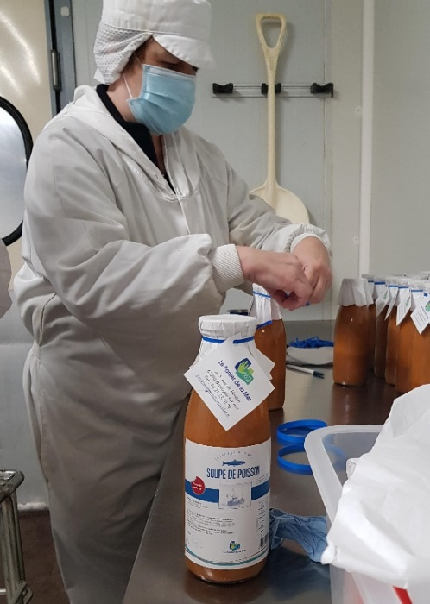
Packaging and labelling fish soup bottles

cutting fish
The instructor demonstrates the cutting techniques and lets the employee practice. Once the technique is more or less mastered, the employee can work independently, but with the support of more experienced colleagues present. Peer learning is an important workplace strategy that benefits both new and experienced colleagues. Giving employees confidence is important for their motivation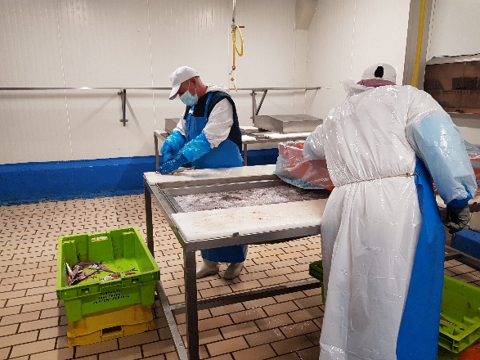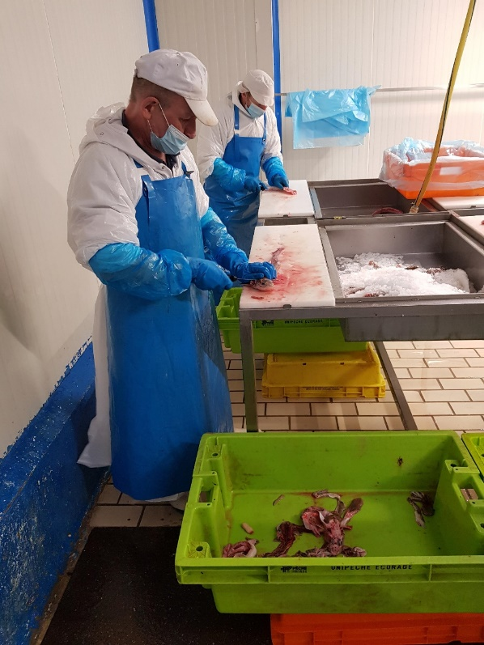
The only "classroom" training courses are "HACCP: food safety and hygiene" and a theoretical course on fish species, their origin, processing, etc. These courses have recently been outsourced to an external organization so that employees can obtain a certificate.
For each employee, there is an evaluation sheet in which technical skills are checked.
- Fish Processing Evaluation Sheet
- Catering Evaluation Sheet
What is the golden key to good coaching on the work floor?
Tailor your advice to the (prior) knowledge of the employees and always listen. Does the employee seem upset today? What's up? Technical instructors are often the first to detect signals of problems in the personal context. Then, it's important to pass it on to Charlotte, to avoid people give up. It is precisely the harmonious interaction between social and technical coaching that makes PDLM unique.
Visual tools are designed to support the work on the work floor
Fish filleting is a craft. PDLM developed visual cards showing the different handlings: beheading, cleaning the fish, cutting the bones, filleting, etc. There are also sheets for different types of fish, with the name, origin, fishing technique, filleting and preparation.

Internships in companies
Employees also do internships in different companies in the neighbourhood to gain work experience and to become familiar with different contexts and work rules. During the internships, the employees remain employees of PDLM. Charlotte closely monitors the internship to prevent companies from using them as "free workers" without offering the necessary support. After every internship, there is a follow-up: what went well and what will we work on?
A first internship is scheduled within the first 6 months of the contract. Taking up on internship is mandatory to continue at PDLM. Through the internships, PDLM creates a network in the region.
Transition to regular employment
In 2021, 10 employees left PDLM and 8 of them found a new job. We’ve discovered that companies hiring place more importance on people skills than technical skills. This is precisely where the added value of PDLM lies
What to know more
Le Panier de la mer : moins de gaspillage, plus d'emploi / Initiatives Alimentation Durable / Alimentation durable / Parcours thématiques - Centre Ressource du Développement Durable (cerdd.org)

