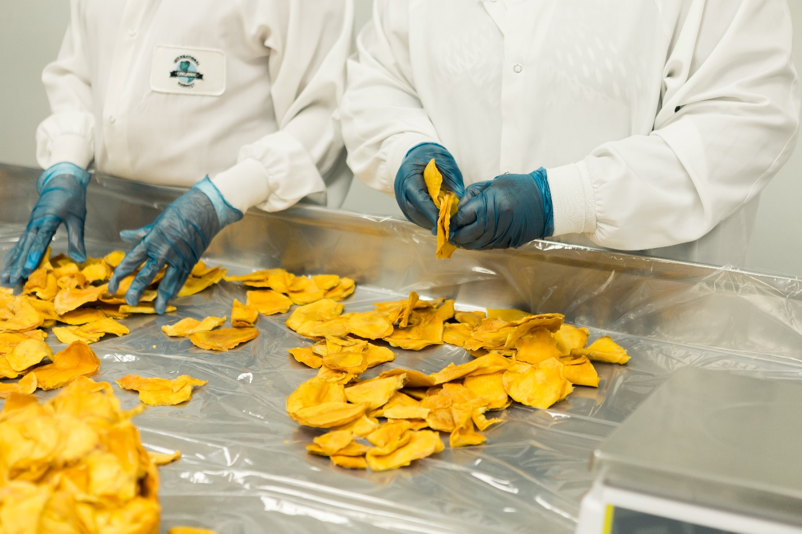

COMPANY NAME

Roles and Responsibilities

2021

TABLE OF CONTENTS
Table of Contents 2
Introduction 4
Employees & Volunteers 6
Food Safety and Hygiene 6
Personal Hygiene 6
Equipment & Infrastructure 6
Cleaning & Disinfection 6
Water 6
Waste & Rubbish 6
Pest Control 6
Training 6
Fridge & Freezer Temperatures 7
Visitors 7
Food Coming In 7
Traceability 7
Labelling 7
Fridges & Freezers 7
Food Going Out 7
Preparing for Food to be Delivered 7
Deliveries 7
Supervisors & Managers 10
Food Safety and Hygiene 10
Personal Hygiene 10
Equipment & Infrastructure 10
Cleaning & Disinfection 10
Water 10
Waste & Rubbish 10
Pest Control 10
Training 10
Fridge & Freezer Temperatures 11
Visitors 11
Food Coming In 11
Traceability 11
Labelling 11
Fridges & Freezers 11
Food Going Out 11
Preparing for Food to be Delivered 11
Deliveries 12
The Organisation 14
Food Safety and Hygiene 14
Personal Hygiene 14
Equipment & Infrastructure 14
Cleaning & Disinfection 14
Water 14
Waste & Rubbish 14
Pest Control 14
Training 15
Fridge & Freezer Temperatures 15
Visitors 15
Food Coming In 15
Traceability 15
Labelling 15
Fridges & Freezers 15
Food Going Out 16
Preparing for Food to be Delivered 16
Deliveries 16
Further Details 18
Template Copyright 19

INTRODUCTION
Food distribution centres and warehouses are busy places. Often there is lots going on and staff and volunteers will be doing different jobs each day. This organisation/company policy template shows these roles and responsibilities. As every organisation will run slightly differently, this is a template designed so that you can delete information that isn’t relevant to you and add in details which are.

The content within this template has been created as a broad overview of key procedures that should be followed in a distribution centre or warehouse. However, section titles and bullet points can be edited, deleted, and added, as required. Once the template has been filled to suit your organisation’s needs, you can simply update the Table of Contents on page 2 to reflect the structure within the template.

In addition to the content within, you will find the front and back covers are fully editable, with space for you to place your own image, company/organisation logo, and contact details and address. Again, the title on the front cover is editable.

Please do not remove, add to, or edit the Template Copyright page. Where applicable, Interreg 2 Seas Project, Flavour, must be credited.

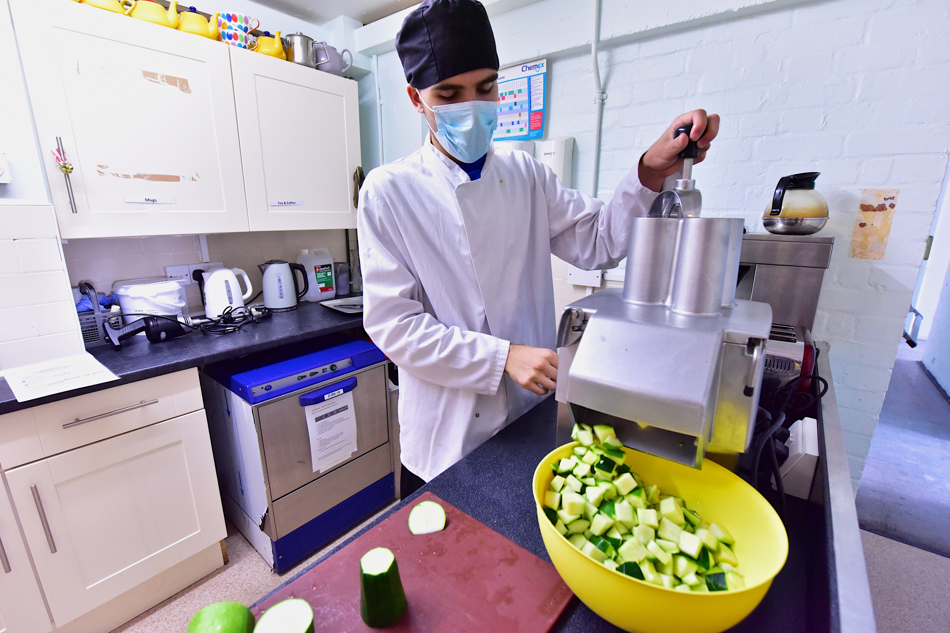

EMPLOYEES & VOLUNTEERS

FOOD SAFETY AND HYGIENE

Personal Hygiene
- Employees must ensure that their hair is tied back.
- Employees must not wear nail polish.
- Employees must not wear jewellery.
- Employees must keep beards short, and well groomed.
- Employees must keep wounds covered with a blue bandage.
- Employees must wash and sanitise hands before and after touching food.
- Employees must wash and sanitise hands after coughing or sneezing.
- Employees must wash and sanitise hands after using the bathroom.
- Employees must wash and sanitise hands after taking a break.
- Employees must wash and sanitise hands after having a cigarette / e-cigarette.
- Employees must wear clean clothes for work every day.

Equipment & Infrastructure
- If any equipment is needed, add in your own guidance and training.

Cleaning & Disinfection
- Complete any cleaning tasks your supervisor/manager asks you to do.

Water
- Please add in your own guidelines.

Waste & Rubbish
- Employees must use waste bins and make sure they put the lid back on
- Employees must ensure that they separate waste and recycling into separate bins if available.

Pest Control
- If employees see any pests, they must let their supervisor know.

Training
- Employees must take part in training requested by their supervisor.

Fridge & Freezer Temperatures
- Employees must check and write down the fridge/freezer temperatures regularly, your organisation will have a schedule for checks.
- Employees must ensure that they know the temperature that the fridges and freezers should be kept at.
- If the temperature is different to what it should be, employees must let their supervisor know.

Visitors
- Employees must inform their supervisor of any visitors.
- Employees must show them to the sign-in desk or book.

FOOD COMING IN

Traceability
- Where (name of shop, auction, farmer, etc) the food is coming from.

Labelling
- Employees must make sure that all items delivered are clearly labelled and logged on to the organisation’s system, stating the expiration date, and a description of the product.
- Allergens should be clearly labelled.

Fridges & Freezers
- Employees must check and record fridge and freezer temperatures 3 times a day.
- Employees must label the food and place in a fridge or freezer.
- Employees must check that the food is in date and suitable for freezing by looking at the storage instructions on the packaging.

FOOD GOING OUT

Preparing for Food to be Delivered
- Please add in your own guidelines.

Deliveries
- Employees must collect food for delivery.
- Employees must stick labels on deliveries.
- Employees must place the deliveries in vans.

SUPERVISORS & MANAGERS

FOOD SAFETY AND HYGIENE

Personal Hygiene
- Supervisors must check there is soap and hand sanitiser at the sinks, and they must refill them when needed.

Equipment & Infrastructure
- Please add in your own guidelines.

Cleaning & Disinfection
- Supervisors must prepare a cleaning schedule – showing what needs to be cleaned, when and the cleaning products to be used.
- Supervisors must include a way to show when it has been done (e.g., a column where staff can add their initials and time when done).
- Supervisors must store cleaning products in a lockable cabinet or a separate room.

Water
- Please add in your own guidelines.

Waste & Rubbish
- Supervisors must keep bins clean and ensure they are emptied daily.

Pest Control
- Supervisors must report any pest control issues to the appropriate authorities
- Supervisors must carry out regular checks for the presence of pests.

Training
- Supervisors must inform staff which training courses they need to do and keep a record of who attends.
- Supervisors must ensure that everyone has up to date certifications in areas which are needed, e.g., manual handling, food safety etc.

Fridge & Freezer Temperatures
- Supervisors must create a schedule for checking the temperature of fridges/freezers
- Supervisors must ensure that the fridge/freezer temperatures are checked and recorded every day.
- Supervisors must ensure that random temperature checks are made upon receipt of food in the store and note it on the delivery note.
- If temperatures are not compliant, supervisors must inform their manager and either move or dispose of the food.

Visitors
- Supervisors must ensure that all visitors have signed in and are aware of guidance.

FOOD COMING IN

Traceability
- Supervisors must keep an up-to-date list of companies which give food.

Labelling
- Supervisors must check that staff and volunteers are labelling ang logging food correctly
- Writing today’s date on a whiteboard helps people to accurately and quickly date check.

Fridges & Freezers
- Supervisors must check that the cold chain is never interrupted during collection and transport.
- Supervisors must set up a system for employees to check and record fridge and freezer temperatures at least 3 times a day
- Supervisors must ensure that the foodstuffs have been frozen for at least 48 hours before they are distributed to the consumer.

FOOD GOING OUT

Preparing for Food to be Delivered
- Supervisors must keep an up-to-date list of organisations that we give food to.
- If a supervisor finds out that a product we have received may be harmful to human health, animals or plants: they must notify organizations that have received the product - and recall all products immediately.

Deliveries
- Supervisors must create and print labels for delivery. They must include the contact’s name for delivery, the address with any special deliver instructions, the contents, and the allergens.
- If we are transporting chilled goods, there needs to be a space to record the temperature of the delivery vehicle on arrival on the dispatch (delivery) note.

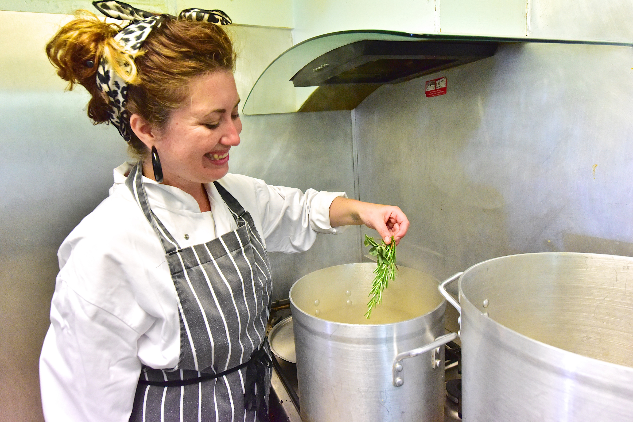

THE ORGANISATION

FOOD SAFETY AND HYGIENE

Personal Hygiene
- The organisation must provide a sink with running water, soap and a hand sanitiser.
- The organisation must display instructions on how to wash hands.
- The organisation must provide training to employees and volunteers on good personal hygiene and food safety.

Equipment & Infrastructure
- The organisation must ensure the warehouse/kitchen is clean and in good repair.
- The organisation must fix any damage as quickly as possible.
- The organisation must provide staff with toilets, somewhere to store personal belongings, and somewhere to eat.

Cleaning & Disinfection
- The organisation must provide necessary cleaning products
- The organisation must safely store the data and safety sheets for the cleaning products used.
- The organisation must ensure that all staff and volunteers are given regular training on cleaning.

Water
- The organisation must label all sinks and water sources as:
  - Handwashing.
  - Cleaning use only.
  - Drinking water.

Waste & Rubbish
- The organisation must provide necessary waste bins.
- The organisation must replace them when needed.

Pest Control
- The organisation must make a preventive pest control plan stating what should be done if pests are detected.
- The organisation must record on a business plan where the baits and/or other control systems (e.g., insect lamps, mouse traps, etc) are.
- The organisation must ensure they are stored in a lockable cupboard.

Training
- The Organisation must provide training on food safety and hygiene, manual handling, health and safety for chemicals, use of any lifting aids, and racking training.

Fridge & Freezer Temperatures
- The organisation must check measuring instruments weekly for correct functioning (calibrating the thermometer freezer/cold room/refrigerated truck).
- The organisation must ensure that all records are kept for the right amount of time and can be accessed for audit.

Visitors
- The organisation must make sure there is a place for all visitors to sign in.
- The organisation must make sure that there is clear instructions as to what to do in the event of an emergency.

FOOD COMING IN

Traceability
- If you believe a product to be harmful, the organisation must follow the country’s regulations on who to notify.

Labelling
- The organisation must ensure that there is a clear list of allergens which is easily accessible to all those who work in the warehouse.

Fridges & Freezers
- The organisation must keep accurate compliance records daily.
- The organisation must ensure a solution for automated temperature checking over weekends and public holidays.

FOOD GOING OUT

Preparing for Food to be Delivered
- If you believe a product to be harmful, the organisation must follow the country’s regulations on who to notify.

Deliveries
- Please add in your own guidelines.

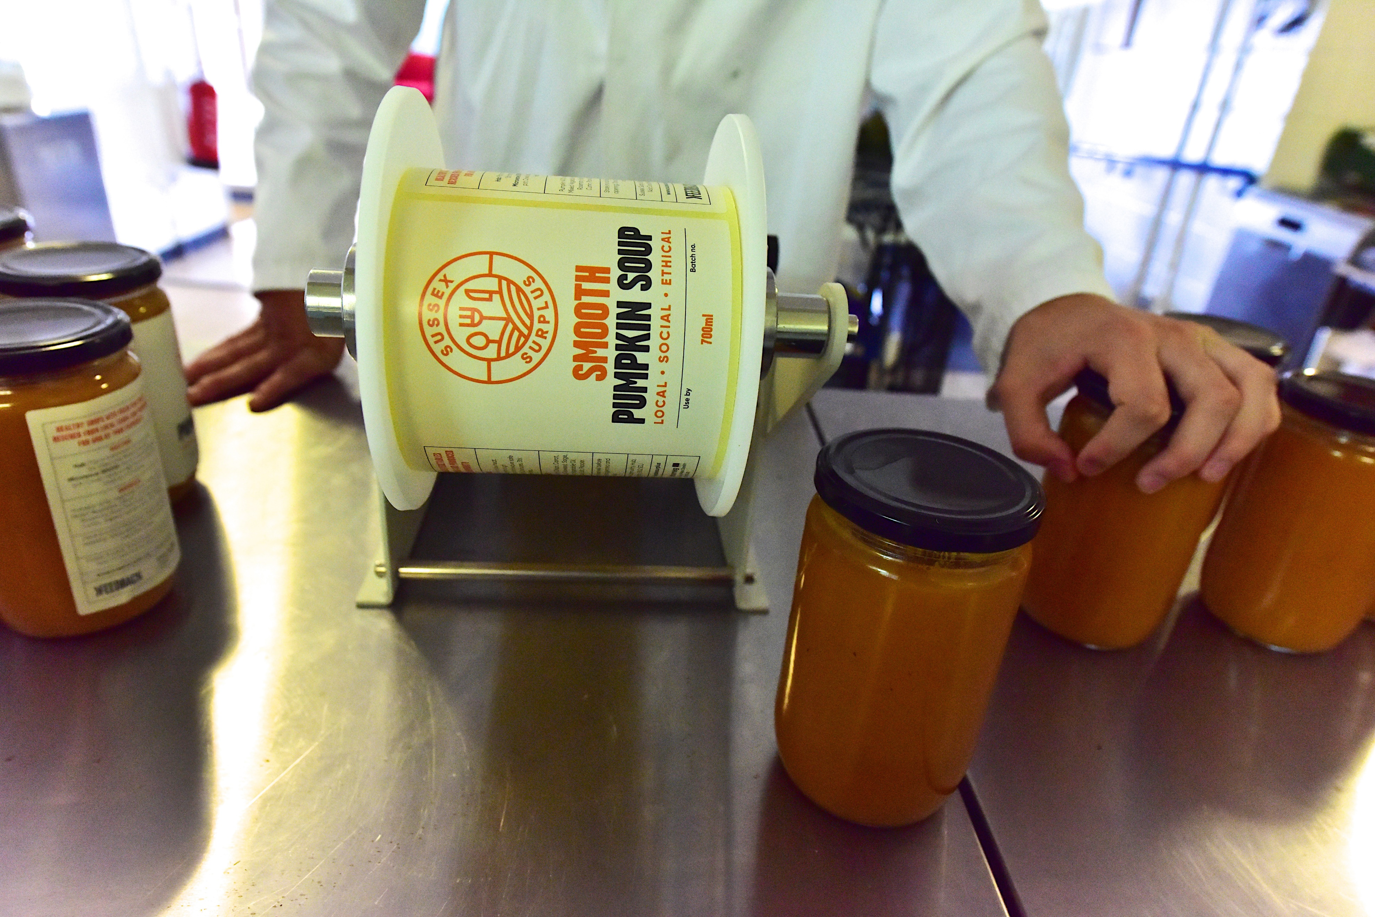

FURTHER DETAILS
Please direct any questions, suggestions, and concerns surrounding the roles and responsibilities in this guide to your supervisor, or the organisation via the following.

Supervisor/Manager Name
E-mail: email@email.com
Tel: 0800 000000

Company/Organisation Name
E-mail: email@email.com
Tel: 0800 000000

Further resources can be found on the following websites:
UK Government Guidelines
https://www.gov.uk/food-safety-your-responsibilities

Food Standards Agency
https://www.food.gov.uk/food-safety

TEMPLATE COPYRIGHT

This template was created in partnership with:
HERW!N vzw
Panier de la Mer
Milieu & Werk vzw
Stad Brugge
Stad Mechelen
VIVES Hogeschool
Brighton & Hove Food Partnership
Plymouth Marjon University Business School
FEEDBACK Global
FareShare Sussex

Photography taken by
Alexis Maryon from FEEDBACK Global

© 2021, Plymouth Marjon University.
This template can be adapted, printed and reproduced for your own use.
Please credit Interreg 2 Seas Programme, FLAVOUR Project.

THIS PAGE MUST NOT BE EDITED OR REMOVED
FROM THE TEMPLATE DOCUMENT.

Template © 2021, Plymouth Marjon University.

