Food safety in distribution
3 basic principles
A sample package for the teacher

Purpose of this package
- The employees can list the 3 most important aspects of food safety:
- Washing hands and personal hygiene
- 3 checks (temperature, date and smell/appearance)
- Cleaning
- For each of the aspects of food safety, the employees can give examples of how they can apply thin in their own workplace

The target group
This moment is meant for minimum 1 and maximum 6 employees from the distribution centres who have already worked at least 2 days.
It is important that they have already been on the work floor, because then they make connections more easily and learn better.
The session is suitiable for people with low language skills (Dutch).

Approach
- Motivational start (max. 3 min.)
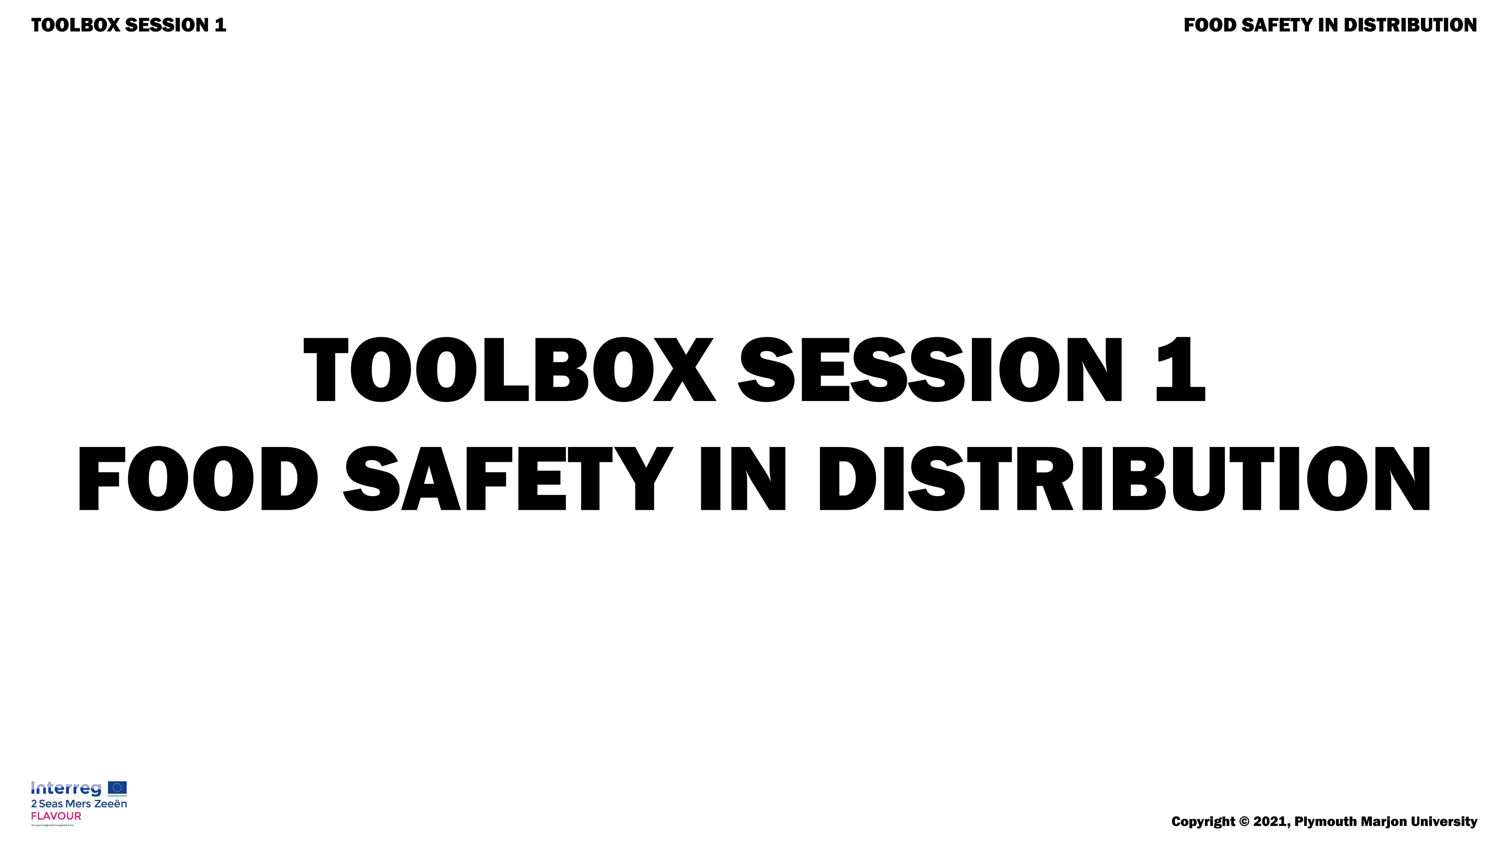

Welcome everyone.

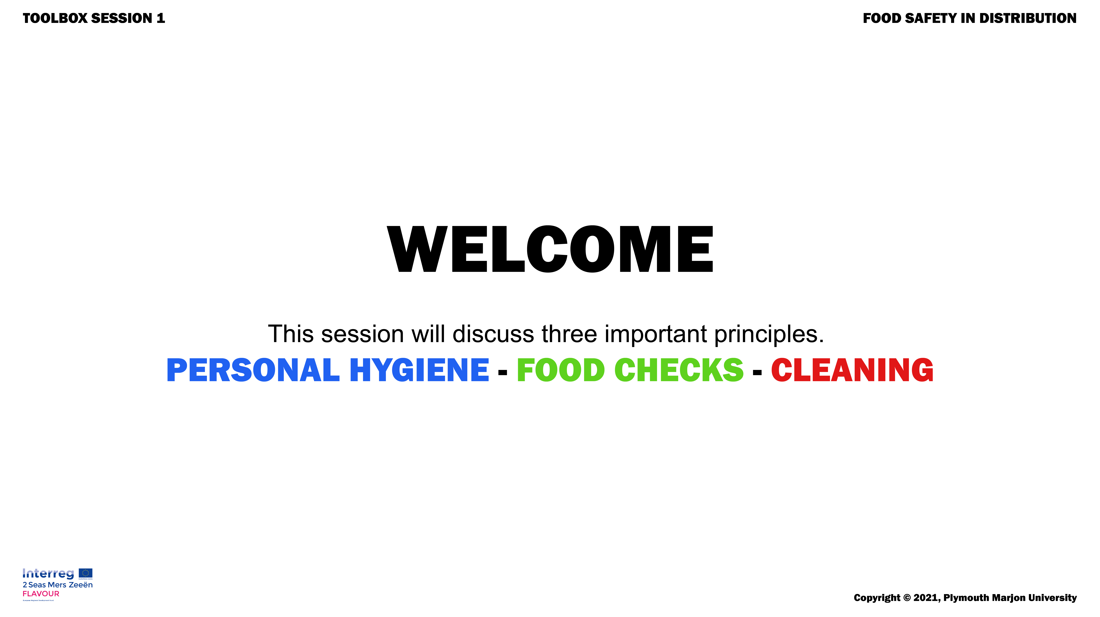

Show a picture of someone collecting a food parcel.

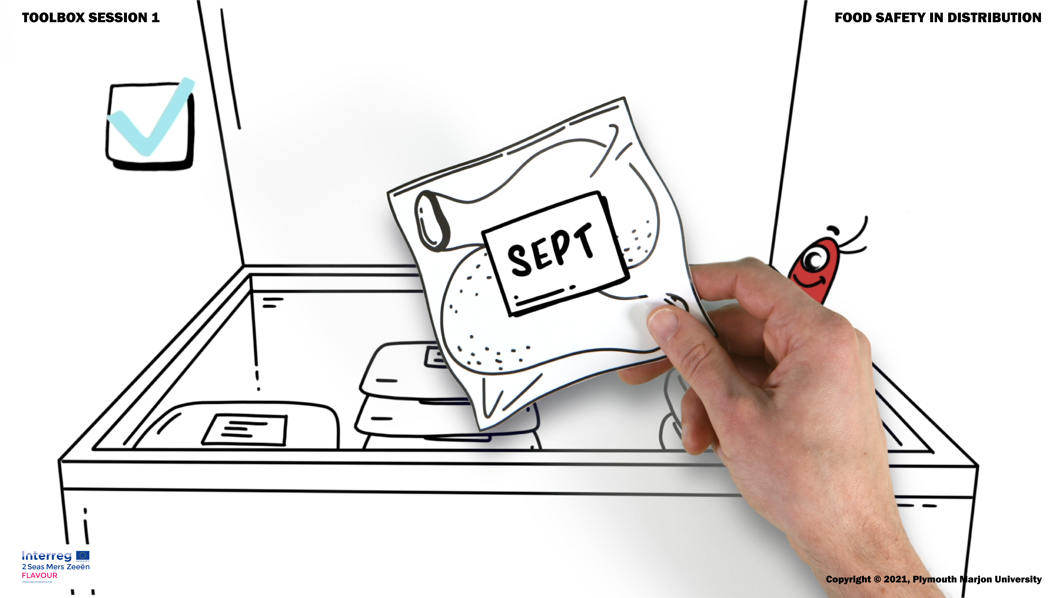

Tell that if the person can get a healthy package of food, we too are happy.
Show a picture of a sick person.

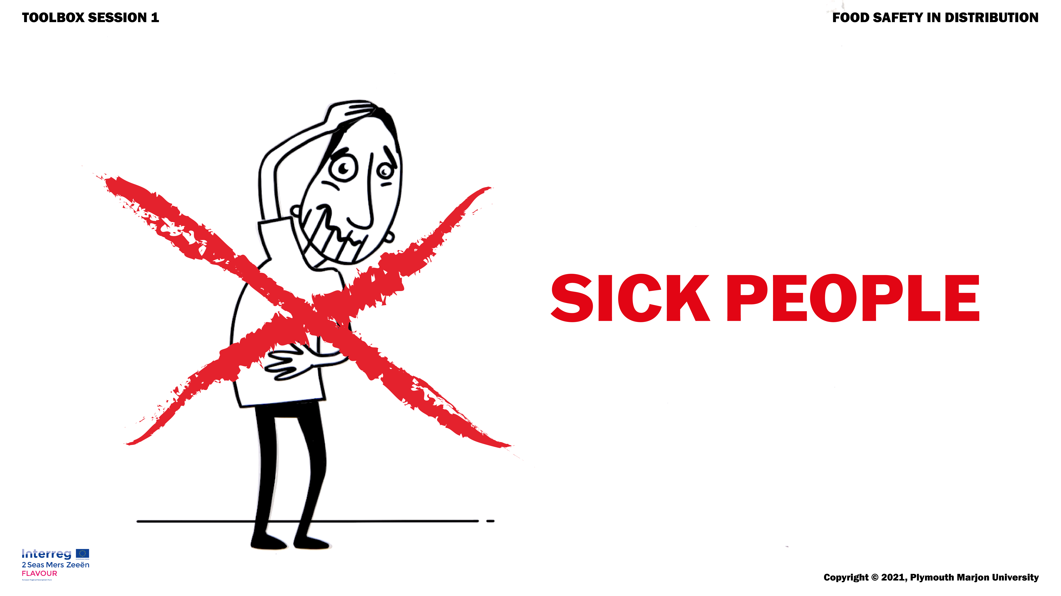

Say: We have to avoid that things are going wrong, that people getting sick.
Show: photo FAVV/UK

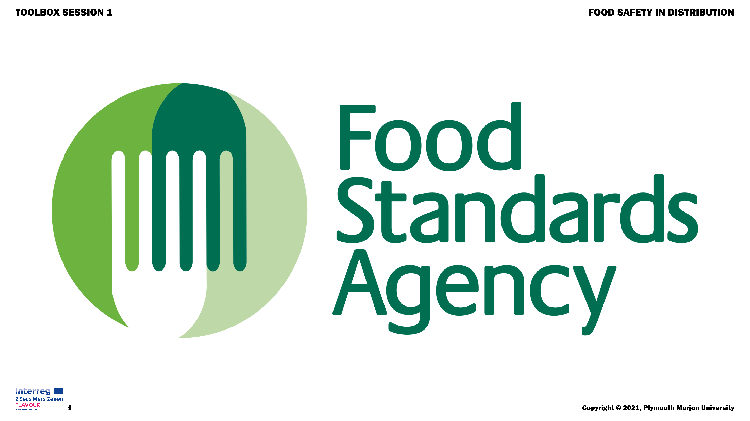
Say: we are being closely monitored for this.
Say: we will soon see what can be done to keep the food packages healthy and to avoid problems.
- Teaching moment (max 10 min.)
Introducing the content
Question: What are you doing already to work safely? Let the participants give some examples of their own working practice.
Say: There are many things we can pay attention to, but the following 3 things are the most important:
- washing hands & personal hygiene
- 3 Checks (temperature, date, smell/look)
- Cleaning
Say: I am going to show you a video that shows what it takes to work safely. You are going to see these three things and recognise things from your workplace.
Show Slide 6: the film - DISTRIBUTION
Repeat the content
Question: What things have you recognised that you also do? (leave enough time to answer)
Question: What have you seen that you did not know or did not think of? (allow sufficient time to answer)
Question: What are you going to do concretely on the work floor what you have seen on the video? (allow enough time to answer)
- Control moment (2 minutes)

Show slide 7

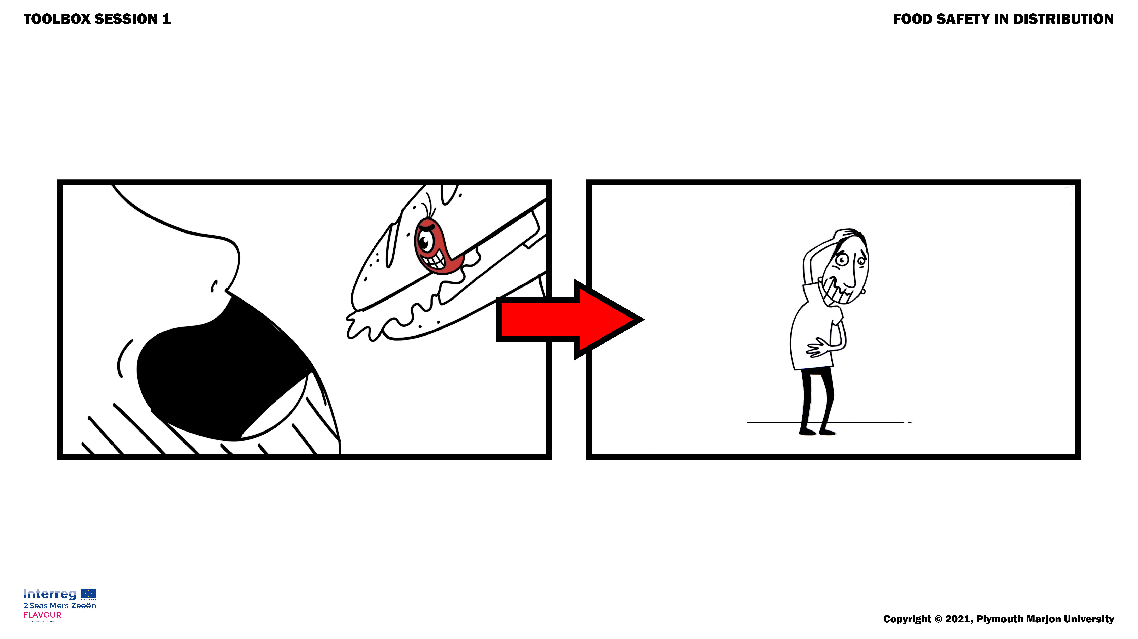

Say: We want to avoid this.
Say: We want safe food distribution (again, picture of the person collecting a food parcel)

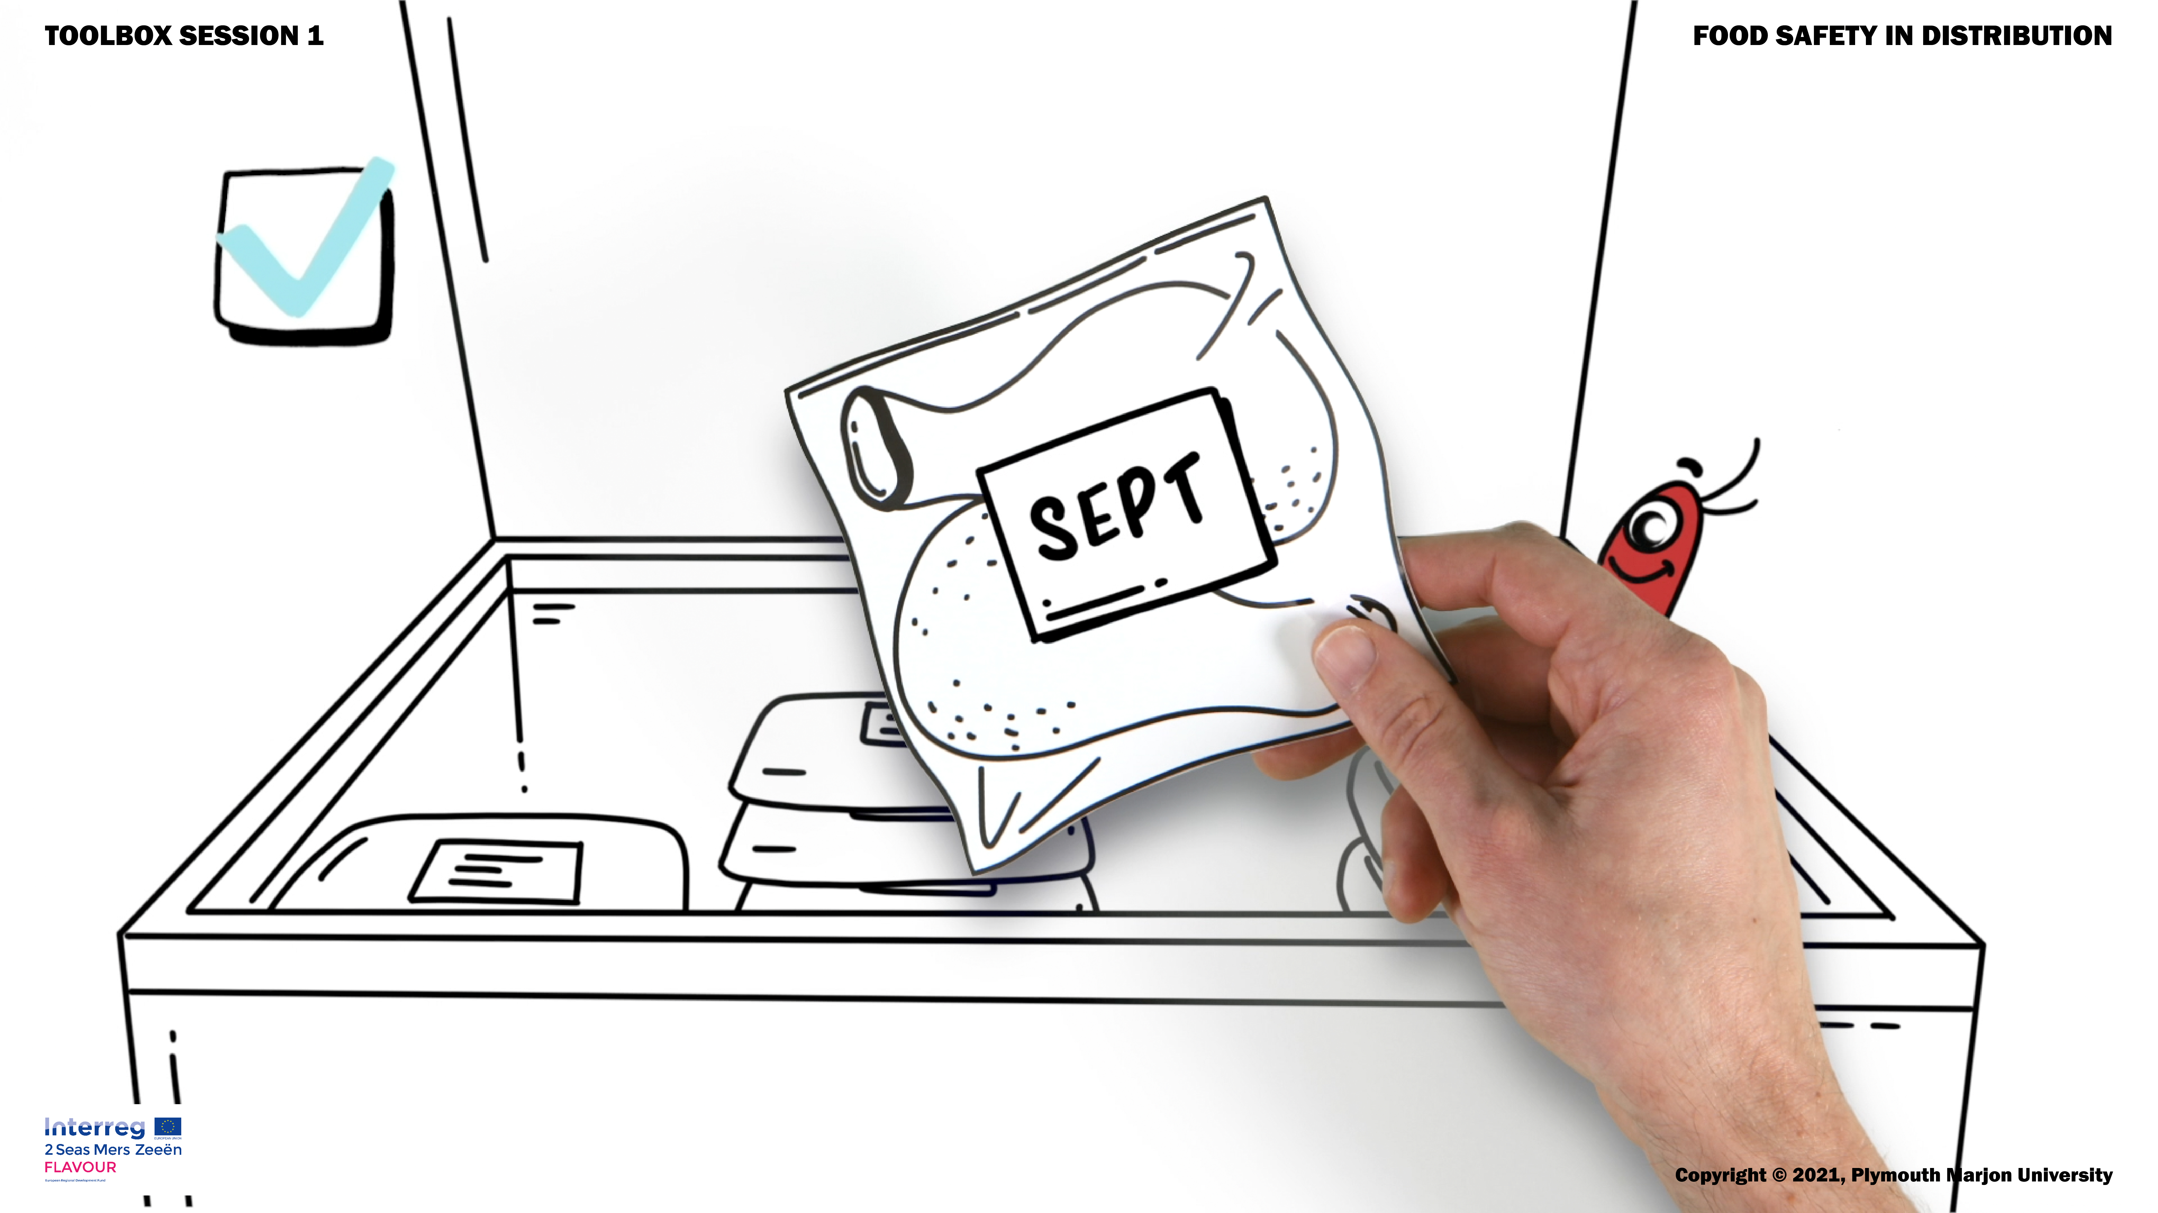
Question: How do we get safe food distribution? What three things are necessary to achieve this?

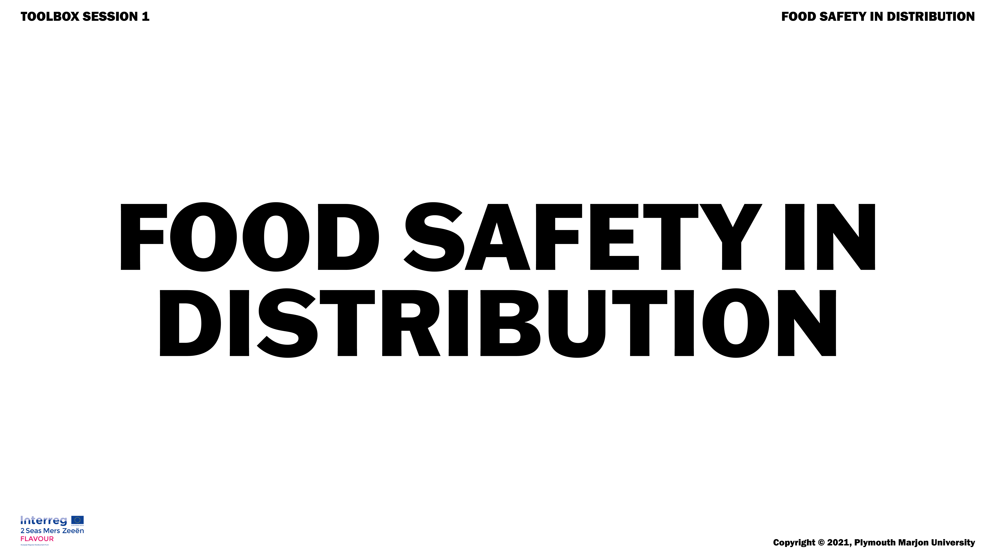

Slides 10 and 11 can be shown or hang out in the workplace to remind everyone of the most important aspects of food safety

