Temperature and food safety

A sample package for the teacher

Purpose of this package
- The participants can explain in their own words why food needs to be stored at temperatures above 60 degrees or below 10 degrees.
- The participants can indicate that freezing temperatures do not kill bacteria.
- The participant can indicate that temperatures above 60 degrees kill bacteria.
- The participants can indicate what they themselves can do on the work floor to keep food at the right temperature.
Target group
Minimum 1 and maximum 6 participants with at least 2 days of experience on the workfloor.
This learning moment is suitable for less language-savvy participants.

Approach
- Motivational start (max 3 minutes)
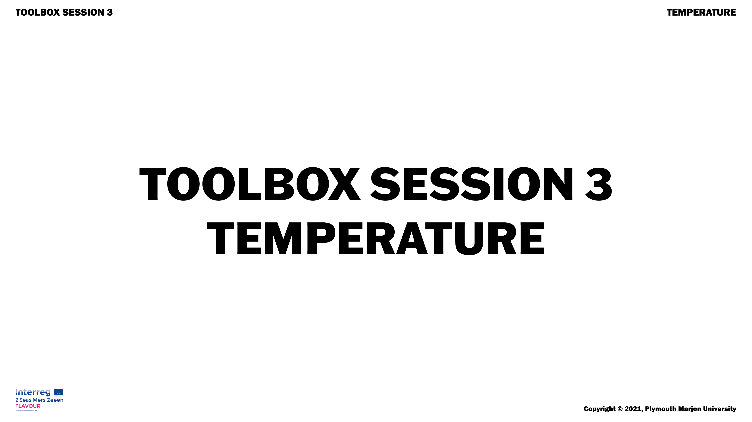

Welcome everyone.

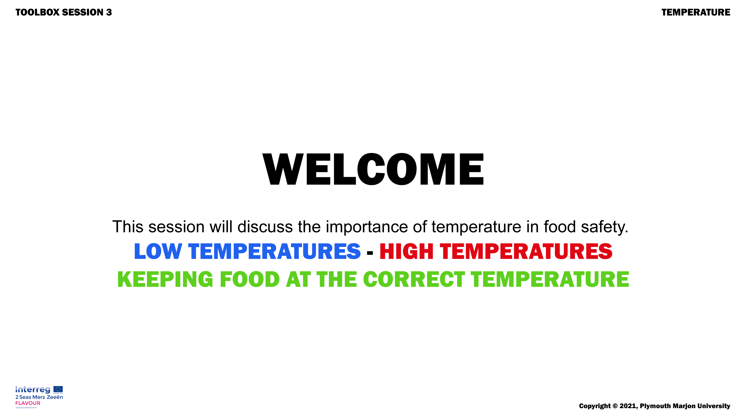

Show slide 3 of the bacteria
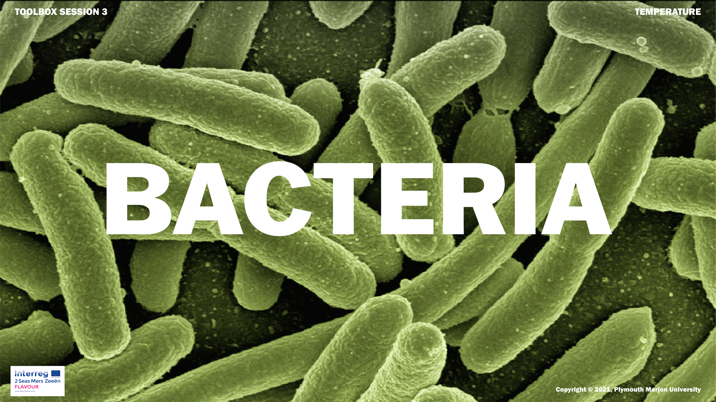
Ask: Does anybody know what this is? Answer: bacteria
Say: Bacteria are everywhere and they exist in different forms. There are 150 different species on our hands alone. Bacteria are also present in our food.
Show slide 4
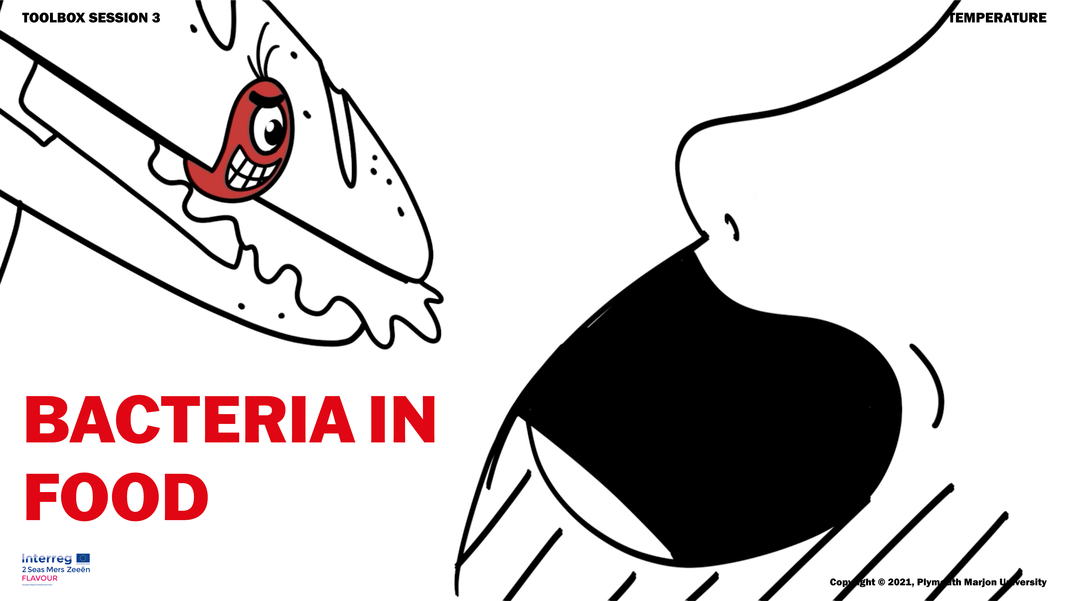
Some bacteria can make you sick.
Say: Today, we are going to see how temperature can be used to fight bacteria.
- Teaching moment (max 10 minutes)
Introducing the content
Test: Take a glass of cold water (best from the fridge), a glass of hot water and 2 sugar cubes.
Question: What do you think happens if I put a sugar cube in a glass of cold water? What happens if I do this in a glass of hot water?
Expected answer: It dissolves faster in the warm water.
Show: for the experiment.
Say: The sugar will move faster in warm water than in cold water.
This is also the case with bacteria, they not only move faster they also grow faster. The group of bacteria gets bigger faster in a warmer environment than in a cold one.
Show next picture of thermometer
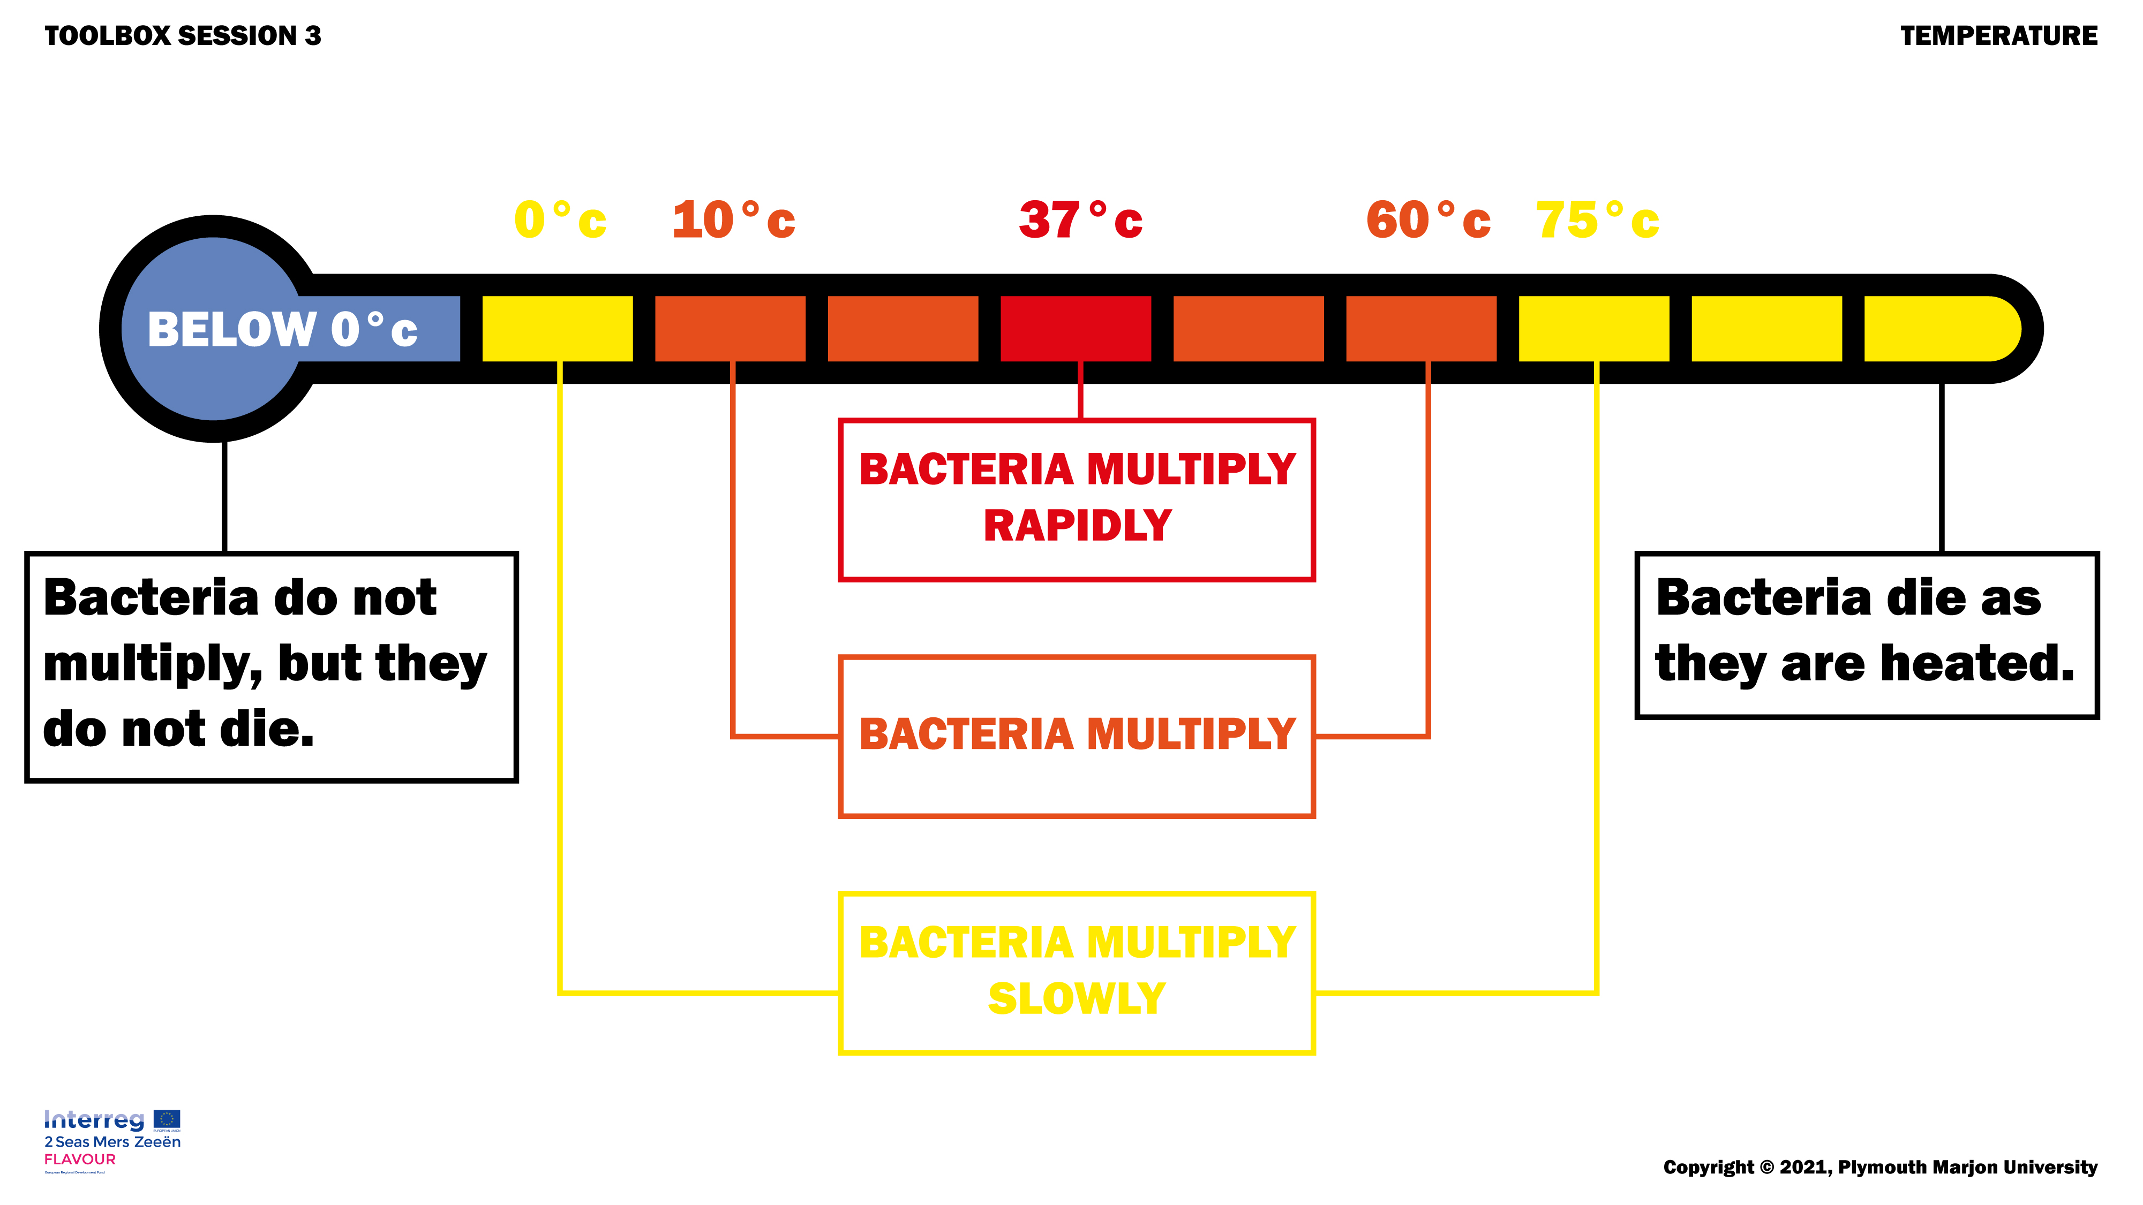
Ask: Which temperature do bacteria like most when you look at this picture?
Expected answer: 37 degrees.
Ask: What temperature is our body? (answer: 37 degrees)
Say: so once bacteria enter our body they can quickly become a lot.
Ask: what temperature do bacteria like least?
Expected answer: less than 10 degrees, more than 60 degrees.
Say: you can indeed see bacteria multiply only slowly at temperatures above 60 degrees and below 10 degrees. Bacteria die at temperatures above 70 degrees and stop multiplying at temperatures below 0 degrees.
Ask: how many degrees are the fridges in our house?
Expected answer: 4 degrees
Say: This is very important and strictly controlled. At 4 degrees, the bacteria have little chance to grow.
Ask: At how many degrees is food kept warm?
Expected answer: 60 degrees.
Say: This too is strictly controlled; we are instructed to keep a close eye on the temperatures.
Show slide 6 – temperature fridge and oven
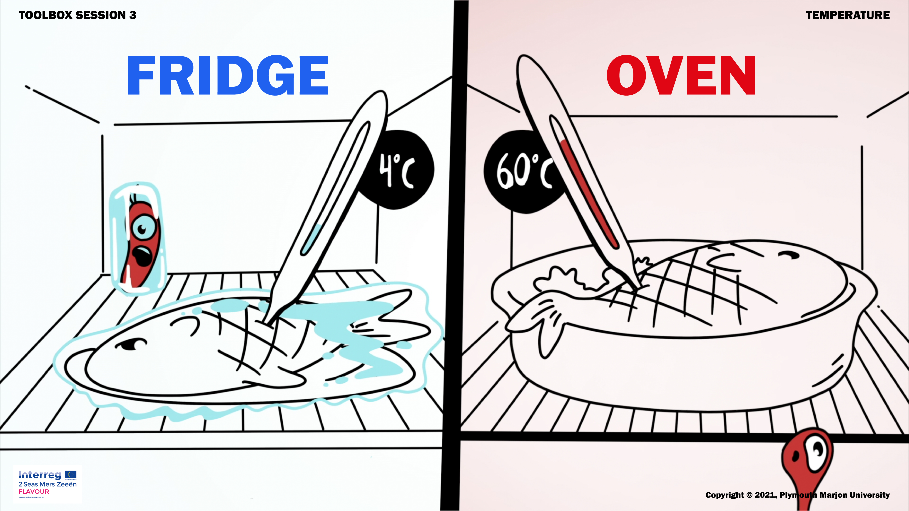
Say: We can control the temperature in the refrigerator and in the oven, but not in our workspace.
So we have to make sure that food is in the working area as little as possible.
Ask: when is food in the work area?
Expected answer: for example during deliveries.
Say: Indeed, so when a delivery is made it must go immediately to the refrigerator or freezer.

Repeat the content
Ask: why must food be kept in the fridge?
Ask: how can you kill bacteria?
Ask: what is the first thing to do when food is delivered?
- Control moment
Say: just a short check-up.
Show: 4 pictures of thermometers of fridges (2 degrees, 4 degrees, 6 degrees, 8 degrees)
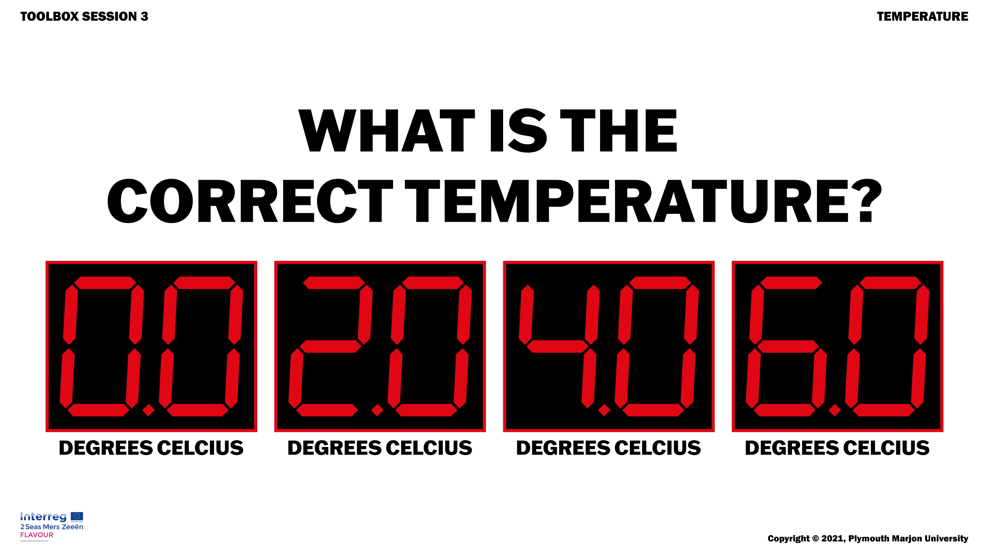
Ask: Which picture shows the right temperature?
Show the correct answer
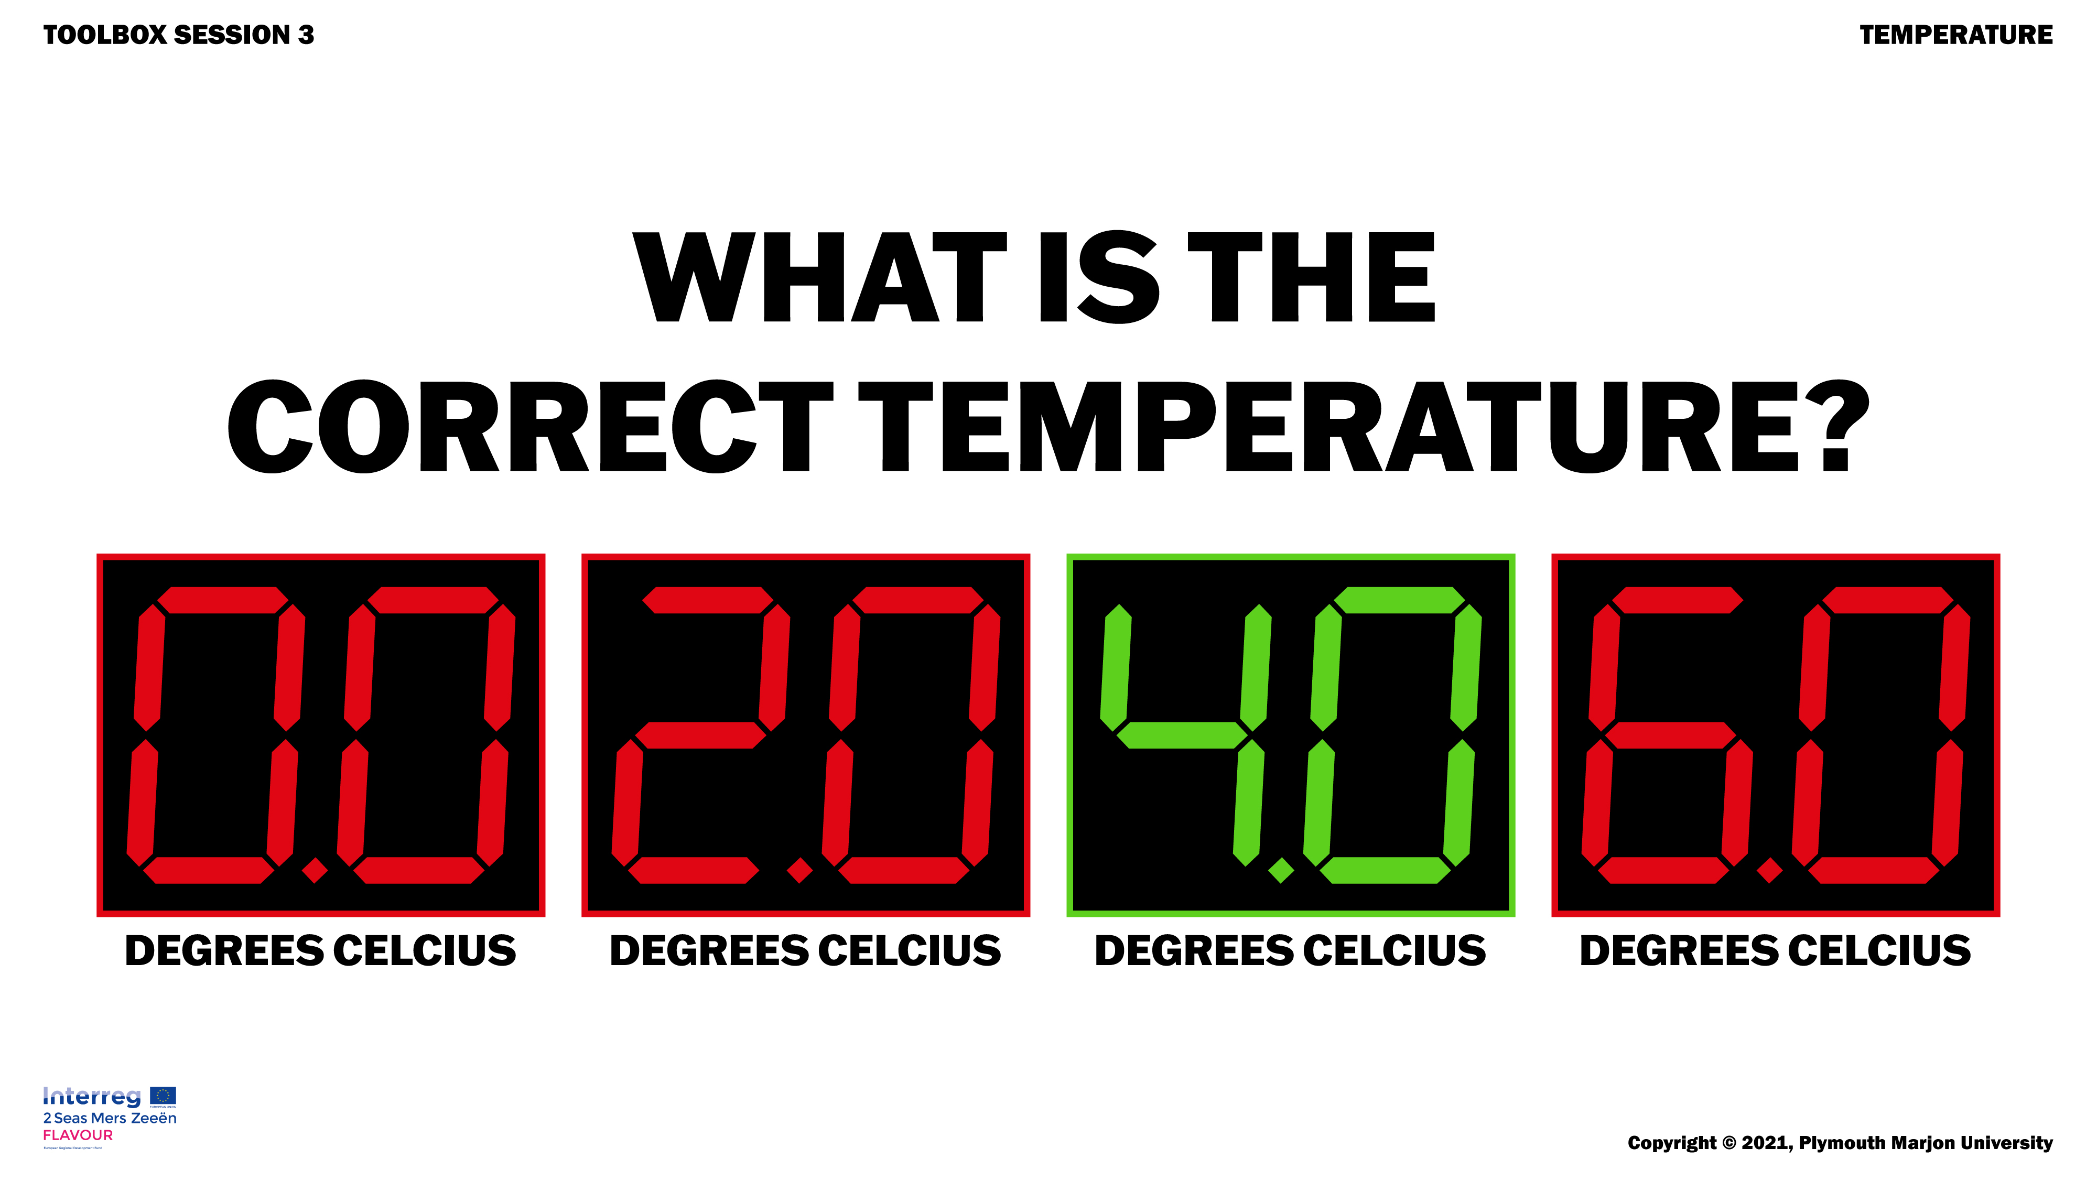
Ask: at what temperature do bacteria die? A: 70 degrees, B 60 degrees, C bacteria never die
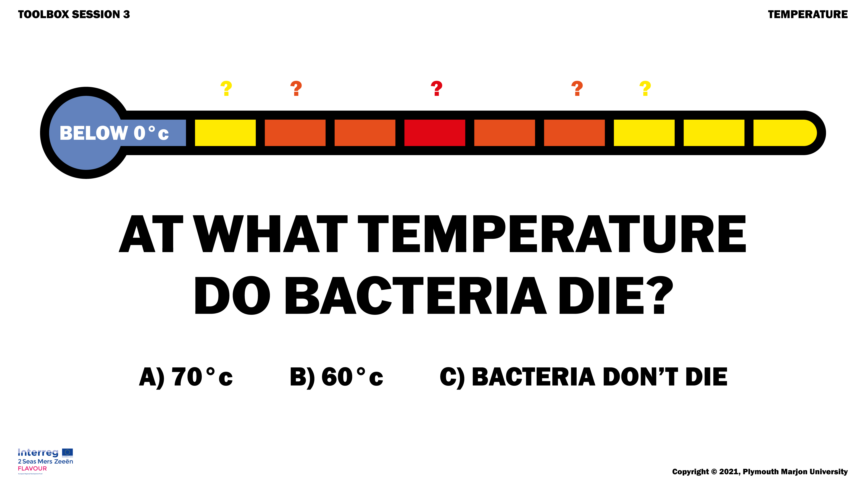
Ask: How do you ensure in your workplace that bacteria can multiply as little as possible? Give each an example.

