Year Three Summer Sessions

Calendar Overview

Date | Content | Delivery Team
June
10.06.20 | England Rugby 7s S&C  - Background of rugby 7s  - Structure of the healthcare team  - Load monitoring tools with reference to injuries | Ben Logan  Lead S&C Coach England Women Rugby 7s
17.06.20 | Subjective Assessment  - Using the systematic approach  Discussion:  - The power of language  Task:  Watch UPNL video | Clinic Team
22.06.20 | U.M.N Special  - Upper & lower motor neurons  - Motor neuron disorders  - Clinical tests | Clinic Team
24.06.20 | Subjective: further considerations  - Medications  Discussion:  - The biopsychosocial contribution towards pain production  - Place for imaging  Task:  - Subjective case studies | Clinic Team
July
01.07.20 | Objective Assessment  - Using the systematic approach  - Considerations for each joint: upper limb  - Adaptations for an online service  - Outcome measures  Task:  Complete lower limb Ax | Clinic Team
08.07.20 | Common Lower Limb Pathologies | Nick Perrim
13.07.20 | Objective Assessment Continued  - Considerations for each joint: Lower limb  Discussion:  - Diagnosis or clinical impression?  - Treating the symptomsDifferential diagnosis  - When and how to refer | Clinic Team
15.07.20 | Special Guest | Gareth Bait
20.07.20 | Military Series: Part 1 | Clinic Team
22.07.20 | Chronic Pain | Nick Perrim
29.07.20 | Military Series Part 2 | Pete Scott
August
05.08.20 | Objective Continued  - Considerations for each joint  Task: Post Covid Considerations | Clinic Team
September
02.09.20 | Considerations Post-Covid | Marjon Health & Wellbeing Team
09.02.20
16.09.20

Session 1 - The Subjective Assessment (17/06/20)

Subjective: the aims

- Building a thorough picture of the patients presenting condition: this is the time to gain all the information needed about a patient and their present condition in order to form the most appropriate treatment plan.

- What does the patient want out of this? It’s important to establish what the patient what’s to achieve in the sessions (occupational, functional or sport specific fitness).

- What are their concerns? Understanding what barriers (motivation, time etc.) the patient may face in their recovery is key.

With the aims of the subjective in mind, the following format can be used to take a thorough subjective:
- General Health & Contraindications
- History of Present Condition (HPC) - OLDCARTS
- Previous Medical History (PMH)
- Medications
- Social & Family History
- Aggravating & Easing Factors (AF/EF)
You’ll notice this is the same format as our clinic notes, so becoming familiar with the layout is a good idea.

1.General Health & Contraindications

i) General Health:
- Any recent illness? (Cancer, osteoporosis, arthritis), Do you feel yourself?
- Scans: How many (if any) X-rays or CT Scans has the Pt had in the last year?
- Any pins or plates?

ii)Special Questions/Red Flags

Unexplained weight loss: Any more than 10lbs could be a sign of cancer. If suspected, immediately refer to GP.

Anticoagulants: Blood thinners i.e. warfarin, will reduce the blood's ability to clot, thus a slower healing rate. Things to avoid: Contact sports, alcohol, NSAID’s, grapefruit juice.

Cauda Equina: Bladder and bowel dysfunction? Saddle numbness? Lower limb weakness? If yes and unexplained, immediately refer to ED as the Cauda Equina Syndrome may be a surgical emergency.

How to ask about Cauda Equina Syndrome

Cauda Equina Syndrome refers to the collection of neuromuscular and urogenital (urinary and genital organs) symptoms:

- Bowel/Bladder Dysfunction
- Lower Back Pain
- Saddle Anesthesia
- Unilateral/ Bilateral Leg Pain

Simply asking someone if they have CE, is likely to be misleading, as it is unlikely the patient will have heard of the condition.

By asking the right questions, we are able to identify whether a patient presents with symptoms of CE, so that we are able to make the correct referral were appropriate.

Example: a patient present with LBP and referred leg pain, so it is important to establish whether any other CES symptoms are present.

Does the radiating occur in both legs?

Have you experienced any bowel or bladder dysfunction? Such as the inability to control your bladder or bowel.

Have you experienced any numbness in the saddle region? ( the buttocks, between your legs and thighs?)

Vertebrobasilar insufficiency (VBI): Loss or altered vision? Nausea and vomiting? Loss of balance and/or coordination?

Vertebral Basilar Insufficiency

VBI refers to the inadequate supply of oxygen to the posterior circulation of the brain by the two vertebral (subclavian) arteries that merge to form the basilar artery at the base of the cranium.

The most significant symptom is the onset of sudden neck pain that is unfamiliar to the patient and/or the following S/s and S/x of ischemia:

“The five Ds”
- Dizziness
- Diplopia (double vision)
- Dysarthria (difficulty with speech)
- Dysphagia (difficulty swallowing)
- Drop attacks (loss of consciousness)

“The three Ns”
- Nausea
- Numbness in the face
- Nystagmus (repetitive uncontrolled eye movement)

Testing for VBI
Extension Rotation Test: patient lies supine, examiner passively moves head into extension with rotation and held for 30 seconds. The patient is then return to resting position in supine and watched for a further 30 seconds.
+ve test = the reproduction of signs of ischemia

Clinical Value = Weak (Hutting et al., 2013)

However, it is arguable that given the weak clinical value of this test its use as a diagnostic tool is unlikely to outweigh the risk of reproducing ischemia by performing it.

Night Pain: can be an indication of severe pathology or disease (such as cancer, infection or fracture)

Night Pain

Whilst this is a widely accepted red flag, make sure you are considering it on a case by case basis.

Night pain in regards to back pain, for example, is a widely accepted red flag, however, may be present in up to 44% of cases, of which serious pathology is present in <1%

When it may be relevant?
- Night pain which may be out of proportion of the injury.
- Insidious onset

iii) THREADS & Specialist Considerations/Health Conditions

If the patient has any of the following, consider adding a “medical alert” to their file where appropriate. For example, if a patient has a nut allergy, to alert future therapists an alert such as “Sever Nut Allergy - use hypoallergenic lotion”

T =Thyroid: Thyroid problems are associated with increased neuromuscular issues such as frozen shoulder (Huang et al., 2014), dupuytren's contracture and carpal tunnel. You’ll also want to know if this is controlled – do they take medication?

H = Heart: Heart problems may give you an indication of how good the circulatory system is so may flag up vascular issues that could contribute to the pain plus if a pacemaker is fitted this will limit some treatments that you can do as it is a contraindication so is important info to obtain.

R = Rheumatoid Arthritis (most prevalent in the hands/feet): Rheumatoid or inflammatory joint disease may be a causative factor in the pain but may not be. Avoid accessory motions to the C-spine and care with other joints is indicated in these patients as this can flare up symptoms.

E = Epilepsy: Epilepsy is something you want to be aware of in case of a fit and find out if it is controlled plus what type of epilepsy so you know if there is a likeliness of a fit or not – medication? How frequent are there attacks?

A = Asthma: It is important to know the severity and if it is controlled (inhaler), take into consideration when prescribing rehabilitation programs.

D= Diabetes: What type? Is it controlled? Diabetes is associated with poor healing rate and peripheral neuropathies, it is unadvised to use treatments such as cryotherapy or electrotherapy if the Px cannot differentiate between hot and cold.

S= Steroids: Long term oral steroid use (skin conditions, muscle atrophy, present in inhalers) has been associated with osteoporosis, skin quality is often reduced so taping is inadvisable and handling needs to be done with care.

2. History of Present Condition (HPC) = OLDCARTS (Onset, Location, Duration, Characteristics, Aggravating & Relieving Factors, Radiating, Timing, Symptoms)

Whilst there is a lot of information to cover during the HPC, the following acronyms OLD CARTS (relating to the present condition) and THREADS (relating to any health conditions) are super helpful to make sure a thorough subjective is taken.
O = Onset
Example = Neck pain, gradual onset over the past month since Pt started new office job.
Over what time frame did the pain come on?
- Sudden or gradual
- Insidious
L = Location
Example = R Ant Shoulder Px (Pt pinpoints the greater tuberosity)
Ask if the pain is:
- Centralised (local) or Peripheralised?
- Specific area or generalised Px?
- More than one area or several?
  - By gaining an understanding of the patient on a whole, your understanding of the condition will be more comprehensive than focusing on the area in isolation
D = Duration
Example = Patient C/O Lbp 3/12 (patient complains of lower back pain - started 3 months ago)

Time frames:
1/7 – one day
1/52 – one week
1/12 – one month
5/7 five days
4/52 – 4 weeks
6/12 – 6 months

24-hour pattern/behaviour
Worse in the...
Morning? Morning stiffness can indicate a tendinopathy, facet joint dysfunction
Middle of the day?
Evening?
Constant throughout the day?
Time frame since any relevant intervention (such as surgery)
C = Characteristics
Example = Effusion present inferior to med malleolus to the base of 5th. No visible contusion. Described as a dull ache at rest and sharp Px when weight-bearing.

Acute:
- Effusion (swelling)
- Contusion (Bruising)
- Discolouration
- Deformity/Abnormality
- Heat/Temperature change
- Pain Type – sharp, dull ache, throbbing, stabbing pain

Chronic:
- Swelling/Effusion – collagen thickening/ossification
- Scarring
- Deformity/Abnormality – posturally (head protraction) or nonlinear clavicle fracture healing
- Pain Type – sharp, dull ache, throbbing, stabbing pain
- Classically – dull ache/tooth ache, aching/discomfort
A = Aggravating & Relieving Factors (previous treatment)
Example = AF: sitting for long periods & EF: lying on back with a pillow under hips
You may need to prompt them, ask about:
- Movement
- Rest
- Sitting v standing
- Medication
- Ice
- Heat etc.
Previous Treatments

It’s important we know what previous manual therapy they have had and whether it’s had any effect, i.e. if someone's had a massage/ultrasound and think it really helped, it may be worth including as part of your treatment.

This is also an opportunity to see if they’ve tried any form of exercise-based rehab, you may find they are opposed to rehab - this is an opportunity to find out why. E.g. “I’ve tried but they didn’t do anything” - find out why this was.

Common reasons for not engaging:
- Poor rapport with the medical professional
- Too many exercises prescribed
- Found the exercises too difficult
- Did not understand the relevance of the HBE
R = Radiation
Example = LBP which radiates into L Glute (Lower back pain radiating into left glute)
Is it:
- Peripheralised
- Centralised
- Radiating
T = Timing
Is there a 24-hour pattern?
Example = A common symptom of Plantar Fasciopathy is morning pain which eases throughout the day with movement.
S = Symptoms
Internal: crepitus, heat etc
Severity and Irritability
To complete your HPC, identify whether the condition is:
- Improving
- Static
- Worsening

3.Previous Medical History (PMH)

Example = R THR replacement 2012 (OA) (Right total hip replacement in 2012 for Osteoarthritis)
This is your time to identify any previous injuries or conditions:
- Hereditary conditions within the family
- Individuals health
- Previous injury

4.Medication(s)
See:
- Task B (medications)
- Session 2: Medications

5.Social & Family History

Example = sedentary smoker or active student
- Consider the patient’s psychosocial profile + lifestyle factors
- Do They want to be here or are they here through the GP or a concerned relative?
- Any other burdens/stress that may influence their wellbeing/pain levels

Consider the complex interaction of biopsychosocial factors which contribute towards a pain response. It is unlikely to be necessary to address all the points below, consider which are relevant for the case and whether it is appropriate to ask directly. Personal Circumstances, for example, are important to consider but will depend on whether the client feels comfortable sharing/confiding in you.

6.Aggravating and Easing Factors (AF/EF)
This should be answered at this stage (if using OLDCARTS)

Task A

Case Study

Have a look at the case study "case study LBP" and think about:
- Any further questions/thoughts on the Subjective?
- what might the patient want out of this?
- what may be her barriers to achieving these goals?

Task A

1.Any further questions/thoughts on the Subjective?
- The patient could circle the body chart in order to pin point where the pain is
- Location = Is the LBP worse on a particular side? Point to where the pain is
- Why could the pain be worse on certain days?
- What ADLs does she struggle with?
- Is she a single mum? Less financial support
- Any other aggravating/easing factors – medication, rest (decrease/increase the pain), heat, ice, certain movements (disc = flexion) have they had any previous treatment (possibly for the disc herniation) – what treatment? Did it help? Any HBE?
- Have they had surgery (discectomy) for the disc herniation? Where was the disc herniation present? Lateral or central, cervical or lumbar
- What side was the sciatica on? Was it the right side? When the pain is worse they have pain in right glute

2. What might the patient want out of this?
- To be able to run again pain free
- Decrease their pain
- Lose weight through exercising
- Have no pain with ADLs
- Increase ROM – able to get up and down from playing with their child while being pain free
- Increase strength in order to life child safely

3.What may be her barriers to achieving these goals?
- Decreased motivation
- Weight gain since pregnancy (more pressure through disc) – not as confident with exercising
- Time – stay at home mum
- Money – for equipment (trainers), may be a single mum (no key income)
- Location – run route near her maybe too hard
- Weather – can affect motivation

Task B

These are the top three categories of medicines from the WHO list of essential medicines:
- Medicine for pain: Non-Opioid and Non-steroidal anti-inflammatory Medicines (NSAIMS
- Medicine for pain: Opioid Analgesics
- Anti-allergic and medicines used in anaphylactics

a) provide an example of a medication that falls into one of the above categories
b) give an example of its use
c) what is its recommended dosage/course of treatment?
d) watch this Video for an introduction to Opioids

Task B

Medicine for pain: Non-Opioid and Non-steroidal anti-inflammatory Medicines (NSAIMS)
Paracetamol
Use = Mild/moderate pain (headaches, toothaches, sprains), reduce fever (cold, flu)
Dosage (adult) = 1-2 tablets (500mg) every 4-6 hours

Ibuprofen
Use = Mild/moderate pain (toothaches, migraines, period pain), control fever, ease pain and inflammation (redness, swelling) that affects joints and muscles (RA and osteoarthritis) or caused by sprains/strains
Dosage (adult) = 1-2 tablets (200mg) every 4-6 hours
Course of treatment = The anti-inflammatory effect can take up to 3 weeks to get the best results

Acetylsalicylic acid (Aspirin)
Use = Painkiller for aches and pains (headache, toothache, period pain), treat cold/flu like symptoms
Dosage (adult) = 1-2 tablets (300mg) every 4-6 hours

Medicine for pain: Opioid Analgesics (very addictive)
Codeine
Use = Treat pain after an operation or injury, can be used if paracetamol, aspirin or ibuprofen haven’t worked, treat diarrhoea
Dosage = 15mg to 60mg up to 4 times a day
Course of treatment = It depends – may only need to take it for a few days but can be for longer (ideally you want the patient on it for as little time as possible)

Morphine
Use = Treat severe pain like an operation or serious injury, pain from cancer or heart attack, used when weaker pain killers no longer work
Dosage = Dose vary from person to person – depends how bad the pain is, how you have responded to previous painkillers ad if you get side effects
Course of treatment = Shorter period if you’re in pain after an operation or injury, longer period for LBP

Fentanyl
Use = Management of cancer pain, severe pain like during or after an operation or a serious injury, used when weaker pain killers no longer work
Dosage = Depends on the type: patch = every 3 days. Tablet, nasal spray etc = when you need it

Methadone
Use = Management of cancer pain, used when weaker pain killers no longer work
Dosage (starting dose) = 2.5mg every 8 to 12 hours

Anti-allergic and medicines used in anaphylactics
Dexamethasone
Use = Relieve inflammation, treat or prevent allergic reactions, treatment for a variety of cancers, autoimmune diseases, skin conditions, asthma, other lung conditions
Dosage = daily dose usually less than 10mg

Hydrocortisone
Use = On the skin to treat itching and irritation
Dosage = Amount of cream is measured in fingertip units – fingertip of cream should be enough to treat an area of skin that is double the size of the flat of your hand
Course of treatment = For insect bites/stings, nappy rash = up to a week. Long term skin problems like eczema = longer

Epinephrine (adrenaline)
Use = Treat very serious allergic reactions to insect stings/bites, foods, drugs or other substances

Loratadine (antihistamine medicine)
Use = Relieves the symptoms of allergies such as hay fever, conjunctivitis, hives, eczema
Dosage (adult) = 10mg once a day
Course of treatment = Take it on the day you have symptoms or regularly to prevent symptoms

Prednisolone (steroid)
Use = Allergies, blood disorders, skin diseases, infections, certain cancers and to prevent organ rejection after transplant (helps by reducing inflammation)
Dosage = Will depend on illness (5-60mg) and if you are taking it as a short or long course, calculated using height and weight so a child’s dose would be lower

Session 2 - Medications & Pathology Pain Relationship (24/06/20)
Biopsychosocial model = To understand a person’s medical condition it is not just the biological factors to consider, but also the psychological and social factors
- It helps to explain why people get pain even though the tissue has healed (chronic pain)
Psychological factors = Thoughts, emotions and behaviours such as psychological distress, fear/avoidance beliefs, current coping methods and attribution
- Self-esteem
- Depression
- Beliefs
- Thoughts and feelings
- Anxiety
- Coping skills
- Social skills
- Fear avoidance behaviours – example = fear of movement so there is an association of pain with a particular movement
Biological factors = Physiological pathology
- Hereditary
- Physical health
- Nociception
- Load = training load, bodyweight
Social factors = Socioeconomical, socioenvironmental and cultural factors such as work issues, family circumstances and benefits/economics
- Peers
- Family circumstances/relationships
- School
- Isolation – lack of social support
- Stress – work related or socioeconomic (money)
- Socioeconomic – if you have a lower income you may be at a higher risk of MSK disorders so need to emphasis prevention of injury, however they may have more barriers to exercise as they may not be able to afford equipment, gym membership, are less educated so do not understand the importance of exercise etc.

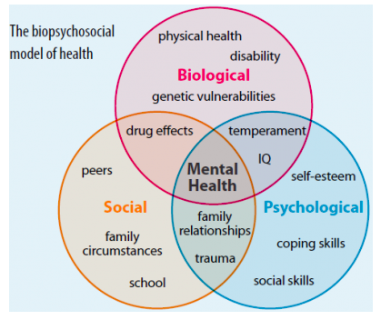

Medications
- Some medications have dual dosage = they can help with 2 different things (pain and epilepsy etc)

Pain killers
- Some you can access from over the counter, some you will need a prescription
- Varying strengths
Amitriptyline = neuropathic pain relief and an antidepressant
Aspirin
Calpol
Co-codamol
Codeine
Gabapentin = neuropathic pain relief and epilepsy control
Oromorph
Paracetamol
Pregabalin
Tramadol

Epilepsy
Gabapentin
Pregabalin
Carbamazepine
Lamotrigine
Oxcarbazepine
Topiramate
Keppra

Muscle Relaxants/Amtispastics
Baclofen
Diazepam

Antidepressants
Citalopram
Diazepam
Lorazepam
Mirtazapine
Sertraline
Escitalopram

Blood Thinners/Anticoagulants
Heparin
Rivaroxaban
Warfarin

Supplements
Alendronate - Bone Density (Osteoporosis)
Calcichew - Bone Density (Osteoporosis)
Risedronate - Bone Density (Osteoporosis)
Zoledronic acid - Bone Density (Osteoporosis)
Protein - Casein, Whey
Vitamins - B6, B12, C, D3

Diabetes
Esomeprazole
Omeprazole
Metformin

Blood Pressure Regulators
Indapamide
Acebutolol
Atenolol
Propranolol
Rampiril
Lisinopril
bisoprolol
Losartan
Candesartan
Amlodipine

Below is a list of the groups that different blood pressure tablets come up… feel free to do further reading into these but it is absolutely not necessary to. The above medications are to give you a brief overview of the more common ones we see clinically.
https://www.nhs.uk/conditions/high-blood-pressure-hypertension/treatment/
https://www.healthline.com/health/high-blood-pressure-hypertension-medication#qa

Beta Blockers
Diuretics
ACE Inhibitors
Calcium Channel Blockers
Alpha blockers
Alpha-2 Receptor Agonists
Combined alpha and beta-blockers
Central agonists
Peripheral adrenergic inhibitors
Vasodilators

Statins
Atorvastatin
Lovastatin
Simvastatin
fluvastatin
pitavastatin
pravastatin
rosuvastatin

Antibiotics - Common Antibiotics
Amoxicillin
Azithromycin.
Cephalexin.
Ciprofloxacin.
Clindamycin.
Doxycycline
Levofloxacin
Lymecycline
Metronidazole.
Sulfamethoxazole
Trimethoprim

Please see the groups below
Penicillins -
Cephalosporins -
Tetracyclines -
Aminoglycosides -

Anti-Inflammatory
Aspirin
Baclofen
Celecoxib
Diclafenic
Ibuprofen
Indomethacin
Meloxicam
Naproxen

Antihistamine
Cetirizine
Chlorphenamine
Fexofenadine
Hydroxyzine
Loratadine
Promethazine

HRT (Hormone Replacement Therapy)

Miscellaneous
Levothyroxine - Thyroid (Underactive)
Thyroxine - Thyroid (Overactive)
Tamsulosin - Prostate

Extra Session – Motor Neuron Special (22/06/20)

Task

Watch this video.

The role and location of:
- Upper motor neuron
- Lower motor neuron

Give a brief overview of the UMNL pathology:
- Lou Gehrig's disease (amyotrophic lateral sclerosis, or ALS)
- Primary lateral sclerosis (PLS)
- Traumatic brain injury
- Spinal cord injury
- Multiple sclerosis
- Stroke
- Huntington's disease

The role and location of:
- Upper motor neuron
- Lower motor neuron
The spinal cord is where the communication between the upper and lower motor neuron occurs

Upper motor neuron
= Transmits info from the brain to the spinal cord/brain stem
Causes of UMNL
Any damage to the brain = stroke, infection, tumor
Injury to the white matter of the spinal cord as the upper motor neurons travel through here
Clinical presentation:
Minimal muscle atrophy
Weakness
Hyperactive deep tendon reflexes (patella reflex)
Diminished or absent superficial reflex
Babinski sign is positive – dorsiflexion and fanning of the toes

Lower motor neuron
= Transmits info from the spinal cord/brain stem to the skeletal muscles
Causes of LMNL
Injury to the axons leaving the spinal cord
Injury to the ventral grey matter of the spinal cord as the lower motor neurons start here. Clinical examination
Muscle atrophy
Absent deep tendon reflexes
Fasciculation = single muscle fibers are still stimulated
Babinski sign is negative – no plantar response

Give a brief overview of the UMNL pathology:
Lou Gehrig’s disease (amyotrophic lateral sclerosis, or ALS)
= Motor neurons in the brain and spinal cord breakdown and die so the muscles no longer receive signals from the brain and become weak. As the muscles become weaker it gets harder to talk, walk, eat and breathe.
- Progressive disease = gets worse overtime
- After diagnosis people tend to die within 3-5 years
There are 3 types of ALS:
- Familial = hereditary
- Sporadic = not hereditary (no clear cause)
- Dementia = ALS that targets the brain
Symptoms:
- Difficulty chewing or swallowing
- Slurred speech
- Muscle weakness affecting an arm, a leg, neck or diaphragm
- Difficulty walking
- Behavioral changes

Primary lateral sclerosis (PLS)
= Similar to ALS but only affects upper motor neurons
- Not considered to shorten life expectancy
Symptoms:
- Weakness and stiffness in the arms and legs
- A slowed walk
- Poor coordination and balance
- Slurred speech

Traumatic brain injury
= A blow to the head or a penetrating injury that disrupts the normal function of the brain

Spinal cord injury
= Damage to any part of the spinal cord

Multiple Sclerosis (MS)
= A condition that affects the brain and spinal cord. The myelin sheath becomes damaged as the immune system attacks it. This damages and scars the sheath and potentially the underlying nerves so the messages travelling along these nerves are slowed/disrupted.
- It is an autoimmune condition = the immune system attacks a healthy part of the body (brain, spinal cord)
The main symptoms include:
- Fatigue
- Difficulty walking
- Vision problems, such as blurred vision
- Problems controlling the bladder
- Numbness or tingling in different parts of the body
- Muscle stiffness and spasms
- Problems with balance and co-ordination
- Problems with thinking, learning and planning

Stroke
= The blood supply to the brain is cut off. It is caused by a blocked blood vessel or bleeding in the brain.
Symptoms of a stroke:
F = Face
The face may have dropped on 1 side; the person may not be able to smile or their mouth/eye may have dropped
A = Arms
They may not be able to lift both arms and keep them there because of weakness or numbness in 1 arm
S = Speech
Speech may be slurred or the person may not be able to talk despite being awake, you may also have problems understanding what they are saying
T = Time
Call 999 immediately if you see any of these signs or symptoms

Huntington’s disease
= The progressive breakdown/degeneration of nerve cells in the brain.
- Its inherited from a person’s parent
- Full time nursing care is needed in the later stages and it is usually fatal about 15-20 years after the symptoms start
Symptoms:
- Difficulty concentrating and memory lapses
- Depression
- Stumbling and clumsiness
- Involuntary jerking or fidgety movements of the limbs and body
- Mood swings and personality changes
- Problems swallowing, speaking and breathing
- Difficulty moving

Task B
Objective Assessment:

- Fill in the empty objective form for a lower limb joint
- Consider how you would assess a hypothetical patient, covering all basis rather than looking for a specific pathology
- Clinical reasoning: think critically, you should be able to give rationale for choosing each Objective measure

- Palpations = They can cause an undesired response of pain so it is best to leave towards the end of the objective assessments
- Active movements = Don’t add overpressure (o/p) if they already get pain
Special tests:
- SN = Sensitivity (%): Ability of the test to correctly identify those who are positive
- SP = Specificity (%): Ability of the test to correctly identify those who are negative
Neurological = Helps us to distinguish between muscular and neurological
- Only use slump test when SLR is negative as it is more sensitive and specific
U.M.N.L:
Babinski = superficial tendon reflex test
- Draw an L or C shape on the bottom of the foot
- Abnormal response = fanning of toes
Clonus = Deep tendon reflex test
- Abnormal response = Tremor/beating of the gastrocnemius

Knee
Observations | Active
Static:  - Posture = Q-angle  - Spasms/symmetry/muscle bulk  - Deformity, bruising, swelling  - Observe knee levels= look at height of crease or patella, Varus or Valgus stress  Is there any:  Swelling = ligaments  Locking = cartilage, meniscus  Clicking  Giving away = ligaments, tendons  Dynamic:  - Knee angle  - Hip position = pelvic stability and rotation  - Gait = stride length, uncomfortable when walking?  - Foot position = slapping of feet could mean poor anterior tibialis control | Flexion  Extension (supine or prone)  Internal rotation (seated on edge of couch)  External rotation (seated on edge of couch)
Passive | Resisted
Flexion (supine or prone)  Extension (supine or prone)  Internal rotation (seated)  External rotation (seated) | Flexion (supine, prone or seated)  Extension (supine, prone or seated)  Internal rotation (seated)  External rotation (seated)
Functional movements | Special Tests or Provocation Tests?
Single leg stance  Squat (tracking of patella = does the patella stay in the groove)  Sit to stand  Lunge  Stair-climbing  Changing directions  Jump  Hop/single leg hop test = used in ACL rehab  Gait | PCL laxity:  - Posterior sag sign (SN =79, SP = 100)  - Posterior draw test (SN = 90, SP = 99)  ACL laxity:  - Anterior draw test (SN =9-95.24, SP =86)  - Lachmans test (SN = 63, SP =90)  - Lellis lever sign (SN = 94-98)  Valgus stress test (SN = 86-96) = MCL laxity  Varus stress test (SN = 25) = LCL laxity  Meniscal damage:  - Apley’s test (SN = 16, SP =80)  - Thessaly’s (SN = 66-92, SP =91-97)  - McMurray’s (SN = 10-66, SP =57-98)  - Joint line tenderness (SN = 79, SP =5-95)  Other structures:  Patella sweep test = Effusion/swelling of the knee  Nobles compression test = IT band syndrome  Ballottement test  Clarkes sign = Problem with patellofemoral
Palpation Neurological | Accessory movements
Straight leg raise (SLR) = Sciatic nerve  Prone knee bend (PKB) = Femoral nerve | N/A
Palpation | U.M.N.L
Feel for: Tenderness/pain, swelling, muscle spasm/wastage/tone, trigger points, deformity, temperature (use back of hand)  Palpate:  Bones/bony points = Medial and lateral border of patella, look at base and apex, tibial tuberosity, head of fibula  Muscles = Head of gastrocnemius, gracilis (medial knee stabilizer), quadriceps, hamstrings, soleus  Ligaments = MCL and LCL  Bursas = Prepatellar, pes anserinus, suprapatellar (can’t palpate)  Tendons = Patella tendon, tendon behind knee= 2 medial (semimembranosus, semitendinosus), 1 lateral (rectus femoris) | Babinski  Clonus

Ankle
Observations | Active
Static:  Posture = Q angle  Spasms/Symmetry/ Muscle bulk  Deformity, bruising (not usually where the problem is), swelling (tends to be on the lateral side)  “Too Many Toes” = sign for Tibilalis Posterior dysfunction  Knees= Crease height, Valgus/Varus  Achilles position and thickness  Arch height of foot= should be able to slide finger underneath  Dynamic:  Gait = stride length, uncomfortable when walking?  Foot position = slapping of feet could mean poor anterior tibialis control  Balance = instability differences | In seated:  Plantarflexion  Dorsiflexion  Inversion  Eversion
Passive | Resisted
In seated:  Plantarflexion  Dorsiflexion  Inversion  Eversion | In seated:  Plantarflexion  Dorsiflexion  Inversion  Eversion
Functional movements | Special Tests or Provocation Tests?
Single leg stance  Squat  Lunge  Stair climbing  Standing on tip toes  Gait  Changing direction | Anterior draw test = ATFL laxity (SN = 86, SP = 74)  Posterior draw test = PTFL laxity  Talar tilt test = CFL (inversion) and deltoid ligament (eversion) laxity (SN = 67, SP = 75)  Syndesmosis squeeze = High ankle sprain (SN = 30, SP = 93)  Distal/inferior tibiofibular ligament laxity:  - External rotation (Kleigers) (SN = 71, SP = 63)  - Cotton squeeze/lateral stress test (SN = 35)  - Fibular translation (SN = 75, SP = 88)  Tendon tests:  - Thompson squeeze test = Achilles tendinopathy (SN = 96, SP = 93)  - Windlass test = Plantar fasciitis
Neurological | Accessory movements
Straight leg raise (SLR) = Sciatic nerve  Prone knee bend (PKB) = Femoral nerve  Tinel’s sign = Tarsal tunnel syndrome | N/A
Palpation | U.M.N.L
Feel for: Tenderness/pain, swelling, muscle spasm/wastage/tone, trigger points, deformity, temperature (use back of hand)  Palpate:  Bones/bony points = Distal tip of medial malleous and distal tip of lateral malleous (if pain posteriorly refer on), navicular (attachment site for tibilalis posterior), tuberosity, metatarsals (including 5th), Sustentacular tali (tibiocalcaneal attaches to it)  Joint line= Head of talus and calcaneus  Muscles = Soleus, gastrocnemius, tibialis anterior (TOM), flexor digitorum longus, (DICK), flexor hallucis longus (HARRY)  Ligaments:  Lateral = ATFL, CFL, PTFL (over the site)  Medial = Posterior tibiotalar, Anterior tibiotalar, , Tibiocalcaneal, Tibionavicular | Babinski  Clonus

Hip
Observations | Active
Static:  Posture= hip, Q angle  Deformity, swelling, bruising/redness= generally seen around the iliac crest  Muscle bulk/ wasting/spasm/ symmetry  Dynamic:  Weight transference  Hip position  Knee angle  Gait = stride length  Spinal position = kyphosis, lordosis, scoliosis  Foot position | Flexion (supine)  Extension (prone)  Internal rotation (if it’s painful when the knee is in 90 degrees of flexion put the leg straight)  External rotation (if it’s painful when the knee is in 90 degrees of flexion put the leg straight)  Abduction (supine)  Adduction (supine)
Passive | Resisted
Flexion (supine)  Extension (prone)  Internal rotation (if it’s painful when the knee is in 90 degrees of flexion put the leg straight)  External rotation (if it’s painful when the knee is in 90 degrees of flexion put the leg straight)  Abduction (supine)  Adduction (supine) | Flexion (supine)  Extension (prone)  Internal rotation (if it’s painful when the knee is in 90 degrees of flexion put the leg straight)  External rotation (if it’s painful when the knee is in 90 degrees of flexion put the leg straight)  Abduction (supine)  Adduction (supine)
Functional movements | Special Tests or Provocation Tests?
Single leg stance  Squat  Lunge  Stair climbing  Gait | Thomas test = Tightness/length of rectus femoris and hip flexors  Trendelenburg = Integrity and strength of the gluteus Medius (weakness) + test is when the hip drops on contralateral side when standing on affected leg (weak glute medius) (SN = 23-73, SP = 77-94)  FABERs = Hip impingement and SIJ (SN = 89)  FADIRs = Femoroacetabular impingement (SN = 60, SP = 52)  Hip quadrant = Anything related to the hip  Elys test =Tightness/length of rectus femoris (SN = 56-59, SP = 64-85)  Obers test = Tightness/length of TFL and IT band  Glute firing = Should be glute hamstring then back  Active knee extension (AKE) = Tightness/length of hamstrings (removes sciatic nerve)  Piriformis test = Piriformis tightness  SIJ tests:  = If 2/4 tests are positive so cause pain or discomfort it indicates there is a problem with the SIJ  - Compression test  - Distraction test  - Sacral thrust  - Thigh thrust
Neurological | Accessory movements
Straight leg raise (SLR) = Sciatic nerve  Prone knee bend (PKB) = Femoral nerve  Slump test | N/A
Palpation | U.M.N.L
Feel for: Tenderness/pain, swelling, muscle spasm/wastage/tone, trigger points, deformity, temperature (use back of hand)  Palpate:  Bones/bony points= iliac crest/ASIS (look at height when in standing), greater trochanter, PSIS, ischial tuberosity  Muscles= gluteus maximus, gluteus Medius, hamstrings, quadriceps  Joints= SIJ, pubic symphysis | Babinski  Clonus

Session 3 – Objective assessment for the spine (1/07/20)

Spine
Observations:
- Lordotic curve = Lordosis (flat back), normal lordosis (fit one hand where the arch is), hyperlordosis (arched back due to an increase in anterior pelvic tilt).
- Scoliosis = if the shoulders, scapula, iliac crest or PSIS are not level this can indicate scoliosis
- Leg length discrepancy = Difference is over 2cm of true leg length (ASIS to medial malleolus)
- Posterior pelvic tilt (PPT) = ASIS is higher than PSIS (increased flexion, decreased lordosis)
- Anterior pelvic tilt (APT) = PSIS is higher than ASIS (increased extension, increased lordosis) – examples = pregnant women, imbalance between hamstring and quads (dominant), rugby (forward/scrummages)
Accessory movements = Movement that the patient cannot perform themselves
Palpations:
- They can cause an undesired response of pain so it is best to leave towards the end of the objective assessment
- REMEMBER – PA is not a palpation

Lumbar
Observations | Active (+ o/p)
Static (sitting and standing):  - Posture = protruding head, rounded shoulders (tight pectorals)  - Spasms/symmetry/muscle bulk  - Deformity, bruising, swelling  - Spine alignment = scoliosis, lordosis, kyphosis  - Look at ASIS and PSIS (PPT and APT)  - Leg length discrepancy  Dynamic:  Gait  Foot position  Transference of weight | Flexion  Extension (blocked end feel = facet joint problem)  Side flexion  Rotation  Combined movements:  Extension and rotation  Extension and side flexion
Passive | Resisted
N/A | N/A
Functional movements | Special Tests or Provocation Tests?
Putting on a seatbelt  Sit to stand/squat - do they favor one side, quad strength  Bending over – putting shoes/socks on  Stork stand test - impairment in proprioception, weaknesses | SIJ special tests:  = If 2/4 tests are positive so cause pain or discomfort it indicates there is a problem with the SIJ  - Compression test  - Distraction test  - Sacral thrust  - Thigh thrust
Neurological | Accessory movements (PAIVM)
Straight leg raise (SLR) = Sciatic nerve  Slump test (use if SLR is negative)  Flossing on traction bed = central and peripheral slacking of the nerve  Myotomes and dermatomes | Central PA = On the middle of the joints in the spine  Unilateral PA = On the joints in-between the transverse processes
Palpation | U.M.N.L
Feel for: Tenderness/pain, swelling, muscle spasm/wastage/tone, trigger points, deformity, temperature (use back of hand)  Palpate:  Bones/bony points= spinous processes (should be even spacing between vertebrae), L1 (in line with bottom of the ribs), L4 (in line with iliac crest), S2 (in line with PSIS), transverse process (posterior to erector spinae)  Length of L1-PSIS = length of hand  Muscles= erector spinae, external obliques, latissimus dorsi, quadratus lumborum, piriformis, thoraco-lumbar fascia, psoas major | Babinski  Clonus

Thoracic
Observations | Active (+ o/p)
Static (sitting and standing):  - Posture = protruding head, round shoulders (tight pectorals)  - Spasms/symmetry/muscle bulk  - Deformity, bruising, swelling  - Spine alignment = scoliosis, lordosis, kyphosis  - Scapula winging/position  - Look at ASIS and PSIS (PPT and APT)  Dynamic:  Gait  Transference of weight | In sitting NOT on a stool:  Flexion  Extension  Side flexion  Rotation
Passive | Resisted
N/A | N/A
Functional movements | Special Tests or Provocation Tests?
Sit to stand  Putting on a seatbelt/reaching to the back seat in a car  Reaching overhead  Drying/brushing hair  Putting on/taking off a bra | Adson’s test = Thoracic outlet syndrome  Muscle length testing = Anterior and middle scalenes
Neurological | Accessory movements (PAIVM)
Myotomes and dermatomes | Central PA = On the middle of the joints in the spine  Unilateral PA = On the joints in-between the transverse processes  PA = Costotransverse joint, costovertebral joint
Palpation | U.M.N.L
Feel for: Tenderness/pain, swelling, muscle spasm/wastage/tone, trigger points, deformity, temperature (use back of hand)  Palpate:  Bones/bony points= spinous processes (should be even spacing between vertebrae), transverse process (posterior to erector spinae)  Muscles = scalenes, UFT, erector spinae, pectorals | Babinski  Clonus

Cervical
Observations | Active (+ o/p)
Static (sitting and standing):  - Posture = protruding head, round shoulders (tight pectorals)  - Spasms/symmetry/muscle bulk  - Deformity, bruising, swelling  - Spine alignment = scoliosis, lordosis, kyphosis  - Scapula winging/position  - Look at ASIS and PSIS (PPT and APT)  Dynamic:  Gait  Transference of weight | Flexion  Extension  Side flexion  Rotation
Passive | Resisted
N/A | N/A
Functional movements | Special Tests or Provocation Tests?
Brushing hair  Driving (looking over shoulder) | Spurling’s compression test = Cervical radiculopathy  Muscle length testing = levator scapulae, UFT, scalene muscles (anterior, middle and posterior), sternocleidomastoid
Neurological | Accessory movements (PAIVM)
Upper limb tension test (ULTT)  Myotomes and dermatomes | Central PA = On the middle of the joints in the spine  Unilateral PA = On the joints in-between the transverse processes
Palpation | U.M.N.L
Feel for: Tenderness/pain, swelling, muscle spasm/wastage/tone, trigger points, deformity, temperature (use back of hand)  Palpate:  Bones/ bony points= occiput, spinous processes – C6 spinous process disappears during cervical extension where as C7 spinous process does not  Muscles = sternocleidomastoid, scalenes (middle, anterior), UFT, levator scapulae, pectorals | Babinski  Clonus

Upper Limb
Shoulder
Observations | Active
Passive | Resisted
Functional movements | Special Tests or Provocation Tests?
Neurological | Accessory movements
Palpation | U.M.N.L

Elbow
Observations | Active
Passive | Resisted
Functional movements | Special Tests or Provocation Tests?
Neurological | Accessory movements
Palpation | U.M.N.L

Wrist
Observations | Active
Passive | Resisted
Functional movements | Special Tests or Provocation Tests?
Neurological | Accessory movements
Palpation | U.M.N.L

Hand
Observations | Active
Passive | Resisted
Functional movements | Special Tests or Provocation Tests?
Neurological | Accessory movements
Palpation | U.M.N.L

Extra session – Common Lower Limb Pathologies (8/07/20)

Tables are adapted from a book called Clinical Sports Medicine

Causes of Hip Pain
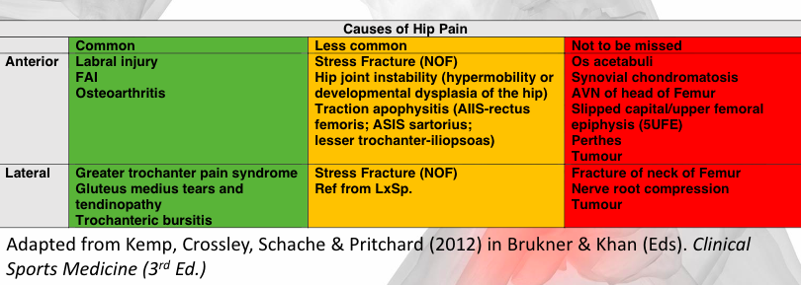
Common:

Labral injury
= Derangement of the labral (cartilage) inside the hip joint
- The type of labral injury and classification can be confirmed using imaging such as an MRA or CT scan
Presentation:
- History of trauma
- Loss of stability around the joint (function of the labrum is stability)
- Is the hip locking, crepitus/clicking – if it is painful REFER, if not may not need to refer

Femoroacetabular impingement (FAI)
= Extra bone grows along femur or acetabulum (or both) therefore structures will pinch on one another
- FAI can cause injury to the labrum
- If we scan an asymptomatic person who plays multidirectional team sports there was evidence of a high prevalence of cam and pincer deformity therefore FAI is likely to develop from load
Presentation:
- No trauma
- C/o hip pain
- Reduction in ROM (rotational movements)
- May or may not have crepitus

Special tests use to diagnosis a labral injury or FAI
- Hip quadrant = With the patient on their back get them to bring their knee to flexion, apply axial compression and work around a clock face
- FADIRs = after each movement see if the patient gets symptoms
- Thomas test = if o/p is applied it can help us to understand if there is an interior capsular injury to the hip

Hip Osteoarthritis
= A whole joint disease
- The hip is the third most common site where OA is present (1st = hands, 2nd = knee)
- Lower limb OA is more damaging as movement in these limbs are decreased therefore it has a larger impact on health
Presentation:
- Generally seen in over 55s
- Gradual onset of symptoms
- Reduced ROM (therefore assess passive ROM of the hip)
- Pain – may or may not have crepitus
- May want to refer for imaging (X-Ray)

Less common:

Neck of femur (NOF) stress fracture
- Population specific = runners, endurance athletes
- Can be hard to diagnose as the pain presents differently
May suspect if they have:
- Insufficient nutrition
- Accelerated rehab programme
REFER for an MRI

Hip joint instability
- Population specific = more common in children

Causes of Groin Pain
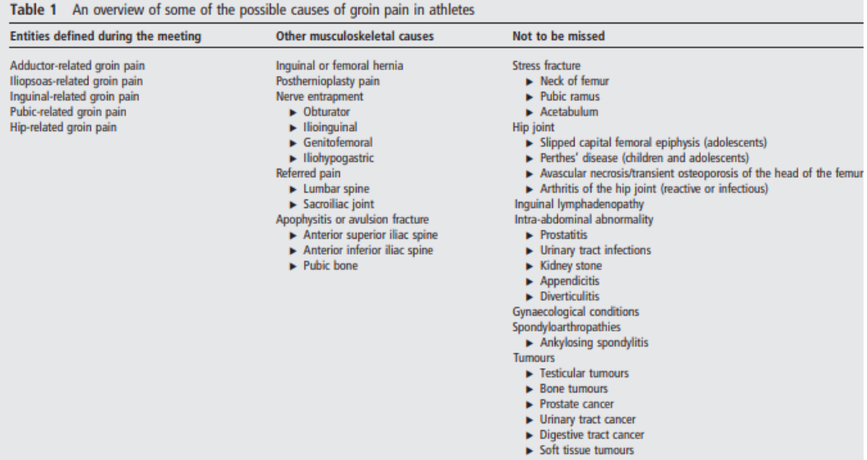

Doha Consensus Statement = The researchers came to an agreement on terminology and definition for groin pain that was based on history and physical examination
Groin pain is divided into three main categories
- Defined clinical entities for groin pain:
- Could be adductor related, iliopsoas/hip flexor related, inguinal/lower abdominal related, pubic related
- Hip related groin pain
- Other causes of groin pain

Assessment of groin pain:
1.Rule out if it is hip related groin pain by using special tests etc
2.Use palpations and resisted muscle testing to identify where the pain coming from (adductors, iliopsoas, inguinal, pubic)

Clinical Entities = how we identify what it is:
Adductor related | - Adductor tenderness  - Pain on resisted adduction testing
Iliopsoas related | Pain on resisted hip flexion add/or pain on stretching the hip flexors
Inguinal related (REFER) | - Pain location in the inguinal canal region  - Tenderness of the inguinal canal  - Aggravated by resistance testing of the abdominal muscles or on cough/sneeze
Pubic related | Local tenderness of pubic symphysis and the immediately adjacent bone
Hip related | - Passive ROM and hip special tests – FADIR and FABER  - Good subjective history required
Other conditions causing pain | High level of suspicion when not falling into one of the above categories

Causes of knee pain
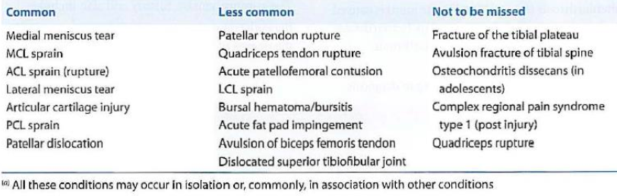
When to REFER knee injuries
REFER if = the knee is mechanically unstable or locking/clicking/catching/giving away
- If none of these signs are present try 6 weeks of conservative management first

There are 2 types of broad mechanisms for traumatic knee injuries:
- Decelerating (landing) = More likely a ligament injury
- Accelerating (planted then move off in another direction) = More likely a cartilage or meniscus injury

Common:

Meniscal tears
- Medial meniscus larger than lateral (more force on MM) so more common
- Function of meniscus = shock absorber and a passive stabilizer (it cups around the femur and sits on top of the tibia)
Presentation:
- Instability
- Restricted ROM particularly in flexion
- May or may not see swelling
- Pain that is focal around the joint line on palpation
- Crepitus (may or may not be painful)
Special tests:
- Mcmurrays
- Apleys
A meniscus injury is suspected if = The client has lost ROM in flexion (passive) and symptoms are provoked when you add passive rotation and overpressure in flexion (Mcmurrays and Apleys)
- Thessalys (perform this test last as it can produce a false positive)

Ligament injuries
- Very important to understand history
- In 10% of ligament injuries, fractures are also present so if you suspect ligament damage an X-Ray may be necessary as well
Presentation:
- Affusion (swelling) – test using patella sweep test
- Painful
- Loss of ROM
Clinical tests should only be performed once the swelling has decreased else there may be false positives

Less common:

Fracture of tibial plateau
- Usually occurs due to some type of trauma (high or low velocity)
- If suspect REFER for X-Ray

Causes of Anterior Knee Pain
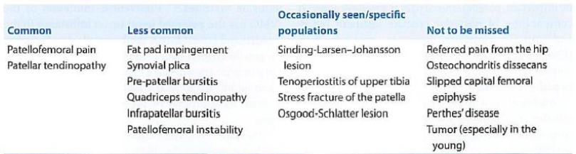

Common:

Patellofemoral pain syndrome (PFPS)
= Pain that comes from around or behind the patella
- PFPS is aggravated by activities that load the patellofemoral joint during weight bearing on a flexed knee like squatting/running/jumping etc
- Always rule out ligament, meniscus and bone injuries first
- No definitive clinical test to diagnose PFP
Mechanism = Extreme and/or repetitive loading of patellofemoral joint, could be a problem with VMO or joint morphology (may be a symptom of joint disease)
Considerations that may allow us to start to diagnose PFPS (HARD TO DIAGNOSE):
- Crepitus or grinding coming from the patellofemoral joint during knee flexion movements
- Tenderness on patellar facet palpation (palpate underneath)
- Small effusion
- Pain on sitting, rising on sitting, straightening the knee following sitting
Synovial plica = massively over diagnosed
Causes of Leg Pain (between the knee and ankle)
- During a clinical assessment for any leg pain assess neurological and vascular involvement

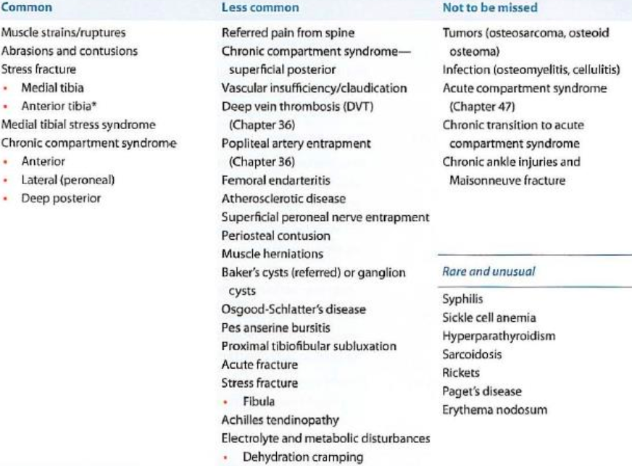
Common:
Medial tibial stress syndrome = not specific as only tells you they have pain on the medial side
Stress fractures
Causes of Calf Pain

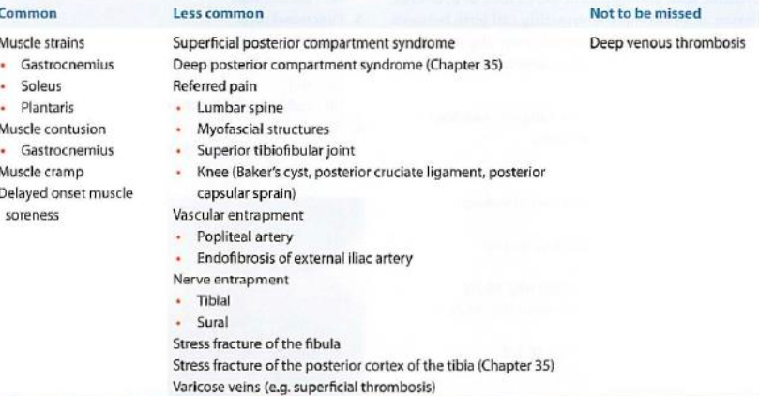
Common:
Achilles tendinopathy (pain from the tendon)
- This injury can occur at 2 different sites: mid portion or insertional
- The cause and treatment differ depending on the site and load can affect the structures in different ways
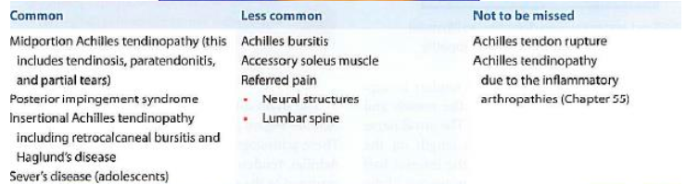
Acute Ankle Injuries

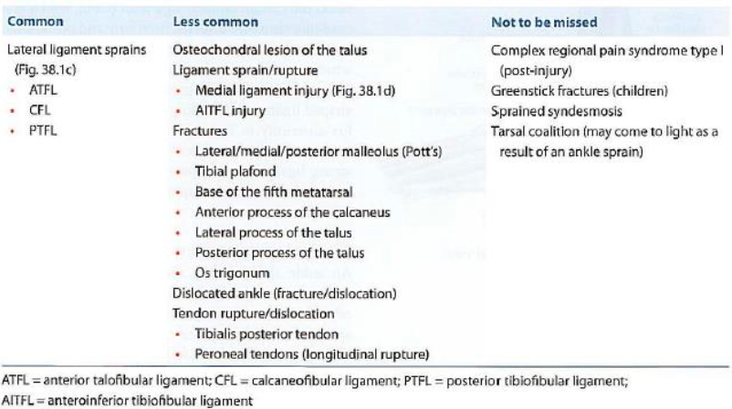
Causes of Rear Foot and Inferior Heel Pain
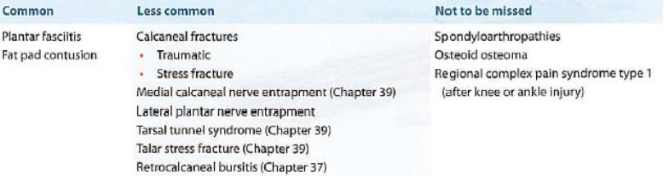
Extra session – Gareth Bate (15/07/20)
Extra session – Military Series Part 1 (20/07/20)
Case study = A Royal Marine Assaulter who is at the end stage of an ankle inversion injury. Design a programme for the end stage of rehab (pain free).

A Royal Marine Assaulter:
- Climbs ladders
- Changes directions at speed
- Moves short and fast distances
- Will carry limited body weight

Consider:
- How will we test them to ensure they are safe to return to work?
- Include exercises that are specific to what they have to do within their job

Extra session – Pain (22/07/20)
Key definitions associated with pain:
- Allodynia (A) = Pain due to a stimulus which does not normally provoke pain
- Hyperalgesia (H) = An increased response to a stimulus which is normally painful
- Primary hyperalgesia = Hyperalgesia present in the zone of tissue damage (localised)
- Secondary hyperalgesia (S) =Hyperalgesia present in a region in which there is no evidence of tissue damage (widespread)
- Sensitisation = An increased responsiveness to stimuli
- Peripheral sensitisation = increased sensitivity to an afferent nerve stimuli. It occurs after there has been an injury or cell damage to the area and produces a flare response due to nociceptors producing lots of neuropeptides
- Central sensitisation = condition of the nervous system that is associated with the development and maintenance of chronic pain
Pain = “an unpleasant sensation and emotional experience associated with actual or potential tissue damage, or described in terms of such damage” (Merskey and Bogduk, 1994 cited in Strong et al., 2002).
- Pain is associated with the body feeling vulnerable
- It is a subjective experience
- Pain does not necessarily mean there is tissue damage as it may be psychological
- Pain is not a stimulus, it is a response to stimulus that the brain receives from different parts of the body
- Pain is a protective mechanism (you want to protect yourself and prevent injury) however it can become maladaptive (persistent pain) = protective mechanism of pain has gone wrong so you are now having a protective experience that is not associated with actual or potential tissue damage within the body

3 key features to the experience of pain:
- Sensory discrimination/something they can feel – pain may feel localised, hot, cold, tingling etc
- Emotional
- Cognitive
Theories of pain
Descartes Model = Pain is a response to an external stimulus
Neuromatrix theory = The CNS (brain and spinal cord) is where pain is produced and multiple parts of the brain and spinal cord work together in response to a stimulus from the body and/or environment to create the experience of pain.
Mature organism model = Inputs from the tissues and the environment travel up the spinal cord to the brain. The brain processes these inputs and samples information from itself to generate a corresponding output.
Specificity theory = Specific pain receptors transmit signals to a pain centre in that brain that produces the perception of pain
- It assumes that the free nerve ending are pain receptors
- Pain impulses are carried by A-delta and C fibres to the pain centre in the thalamus
- Innocuous (non-harmful) go to higher mechanoreceptive areas in the brain
- Noxious (harmful) go through a pain fibre to a higher pain centre
Intensity theory = Emotion that occurs when a stimulus is stronger than usual rather than a sensory experience
- Some form of summation must occur for a subthreshold (too weak to produce a response) stimuli to become unbearably painful
Pattern theory = All fibre nerve endings are alike and pain is produced by intense stimulation of nonspecific receptors
- Ignores physiological specialisation

Gate control theory of pain = non-painful input (myelinated nerves) interrupts the signal so closes the nerve gate to a painful input (unmyelinated nerves) which prevents pain sensation from travelling to the CNS
- Describes the process of nociception

Nociception vs pain
Nociception = Physiological process whereby nerve fibres respond to a stimulus which may indicate tissue damage or the potential for tissue damage (it’s the process that will trigger us to have pain)
Pain = A subjective lived experience
- You may have pain without nociception

3 predominant pain mechanisms:
Nociceptive pain
- Stimulus response relationship therefore predictable
- Pain is generally confined to an area or structure that was injured –> if you twist your ankle your ankle will hurt (primary hyperalgesia)
- Generally, a predictable response to treatment
Localised tissue damage -> peripheral sensitisation -> CNS decides to have a pain response to protect the injured limb

Peripheral neurogenic pain = Pain is due to a response directly from the nerve itself
Example = sciatica -> the nerve is irritated so gives the person a pain response that can be widespread but a recognisable distribution
- The reason for pain is not because of local tissue damage
- Sharp/shooting/lancinating/burning/paraesthesia
- Patches/clumps
- Recognisable distribution
- Ongoing/difficult to relieve
- Allodynia
- Secondary hyperalgesia (increased pain sensation distant from the site of injury)
- Variable response to treatment
The main causes of PNP:
- Trauma
- Excessive repeated compression or tension -> disc bulge, tight piriformis
Could also be immune-mediated response, chemical stimuli, metabolic issue, hereditary, ischaemic change
Management of PNP:
- Neurodynamics
- Treat MSK structure if we believe this is causing compression to see if it alleviates pain

Central sensitisation = Pain that is experienced for a long period of time (persistent)
- Pain persists after the tissue has healed
- Strange behaviour to the pain
- Widespread and non-adhering distribution of pain
- Decreased fitness
- Allodynia/hyperalgesia
- Psychological dysfunction
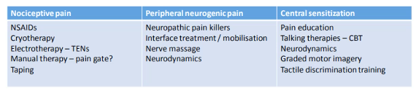

Management of pain:
- NSAIDS (reduce amount of localised inflammation therefore calm down the nervous system in that area) -> aspirin, ibuprofen etc
- Cryotherapy -> still unsure whether it reduces local inflammation
- Electrotherapy -> TENs as it stimulates local nerves
- Neuropathic pain killer -> amitriptyline etc
- Neurodynamics/nerve gliders -> nerves need to be able to move else they may become sensitised
- Pain education
- Massage
- Exercise
- Taping and strapping
- Stretching
- Talking/listening

MAY WANT TO AVOID THE TERM CHRONIC AND USE PERSISTANT PAIN INSTEAD!
Extra session – Military Series Part 2 (27/07/20)
- REMEMBER the principles of rehab -> what are the risk factors to the specific injury? Use this to help prevent and rehab the injury
- Predictors of injury -> physical fitness (the fitter you are, the less likely you are to get injured), previous injury, smoking
- Defensive rehab is different as it is needed for occupational fitness -> we need to find the problem, rehab them and get them back to work (get better or get out)
- The military population differ from the general population with regards to clothing including footwear, body armour and helmets which means they have a lot of functional differences

Stages of rehabilitation (same for every individual):
Reduce pain levels
Protect -> taping, bracing, crutches
Active rest
Ice
Rest
Compress
Elevate
Move
Regain ROM
Regain strength
Regain function
Role specific rehab
- Use outcome measures at each stage (VAS pain scale, ROM) -> this is important as it helps both you and your client to see progress

Early management -> aggressive intervention
Pain management -> TENs, acupuncture
Exercise therapy
Hydrotherapy pool
Example = simple ankle inversion -> PRICEM (protect, rest, ice, compress, elevate, move), game ready

Late rehabilitation
Strength based
Plyometrics
Functional training

Return to combat -> functional specific assessment testing
FOB test can help determine if they are fit to return to frontline role
6 tasks are performed:
- Fireman’s drag
- Step up/jump
- 3.5km patrol
- Ditch crossing
- Ditch jump
- Fire positions
Measured the effective of the FOB test by seeing how many people became injured again
Extra Session – Case Studies (05/08/20)
Case studies
A male (40-50 years old) who is a labourer experiences LBP
- Single parent
- Overweight
- Borderline diabetic
- Moderate –high alcohol consumption, poor diet, smoker, poor & irregular sleep pattern
- Doesn’t exercise as job is physical so doesn’t see the point + tired from longer physical days at work.
- Medicates pain –high dosage of non-opiate based medication only to allow him to work but doesn’t really do much

A female (early 40-50s) who is a care worker has posterior lower limb/heel pain (bilateral) and a meniscus tear in right knee
- Netballer -> use to play to a high standard and always been active but recently realised “age is catching up with her”
- Type 1 diabetic
- Spends 10+ hours a day on her feet working
- Shift patterns that vary
- Has a disabled child
- Good healthy diet, non-smoker and doesn’t drink alcohol

A female (mid-late 20s) who is a HR worker in the police
- Active –walking only
- Moderate–high alcohol consumption (goes on nights out a lot)
- Smoker, poor sleeper, poor diet
- High stress due to job and parents currently going through divorce
- Got a lot on her plate at work currently, is unable to leave the desk very much at work
- Currently taking citalopram (anxiety)

A male (30s) who is a ski Instructor, manager of complex and studying at open university has chronic ankle pain (joint –Osteochondral Lesion)
- Active but limited by injury to what he can do and limited at work
- Gaining weight through inactivity
- Concerned about his job as he can’t instruct so just desk bound currently doing managerial duties
- Finding it difficult with his mental health due to lack of exercise
- Moderate alcohol consumption, non-smoker, moderate diet quality, good sleeper but not recently

A professional cricketer who has torn two of the rotator cuff muscles
- Bowler and fielder
- Mid – late stage rehab

A royal marine commando (multi terrain, high intensity movement, short and sharp movements) who had ruptured there ACL
- Conservative management/no surgery
- Late Stage Rehab

A professional NFL player who has a syndesmosis tear (ligament between the tibia and fibula AKA high ankle sprain) and ankle dislocation
- Quarter back
Late stage rehab:
- Agility/multidirectional movements -> use ladders to replicate avoiding tackles
- Plyometrics -> jumps, bunny hops, hurdles
- Running backwards, parachute runs
- Landing mechanics and proprioception
- Sled pulls
- Power bands

An Ultra-Endurance Runner who does Ironman events and triple triathlons has sustained a stress fracture to the neck of femur
- Early stage rehab

A jockey who has a shoulder dislocation, Bankart lesion and scaphoid fracture
- Horse rider – events every couple of weeks (essentially self-employed -> if they don’t race they won’t get paid)
- Consider calorie deficit and building strength
Late stage rehab:
- Strength -> sumo squats, adductor strength, core stabilisation (bear crawl, Nordic, make use of paddleboard), latissimus dorsi strength, rotator cuff strength, neck strength (use bands and pulleys), trapezius strength (dumbbell snaps, lateral raises)
- Battle ropes
- Plyometrics -> step off a box (one leg/two leg)

An elderly individual who is unsteady on their feet is having rehab for a hip fracture and consequently needs a full hip replacement
- Doesn’t exercise or get out much

A hairdresser is experiencing carpal tunnel syndrome
- Scissor work/detailed small muscle recruitment
- Early stage rehab

A bin man had sustained a meniscus tear
- 12 –14,000 steps per day, on feet nearly all day
- Drives the truck
Late stage rehab:
- Occupational fitness -> walking football carrying weight (replicate job) , side lunges, step ups and seated to standing with weight (getting out of lorry)
- Plyometrics -> use hurdles
- Strength -> glute/heel bridges with band or barbells

An accountant who is a recreational runner has Plantar Fasciopathy & Achilles Tendinopathy
- Mid stage rehab

