How to create accessible documents for the website
This guide outlines how to create an accessible document in Microsoft Word and how to save it as an accessible PDF to upload to the website.

Fonts
- Use a single sans serif font such as Arial or Calibri.
- Use font size 12 for body text and 14.5+ for headings
- Use bold for emphasis (not italics or underline)
- Line spacing of at least 1.5 times the font size
- Left justify your text
Tip: Use the Text Styling tool on the Home tab of Word to help.
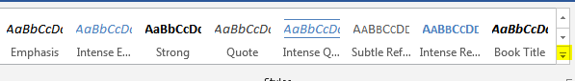

Images and colour
- Right click any image to add alt text and select ‘Edit Alt Text’
- If alt text is not needed do as above but check the ‘mark as decorative’ box
- Stick to a single colour background and a contrasting text colour, like black or navy blue on white. Don’t use greens, pinks and reds
- Don’t put images or watermarks behind text
- If embedding a video it needs to have captions and a text transcript too
- Words should to be text; don’t turn them into images. If unavoidable then add that text in full as alt text for the image
- Don’t express meaning through colours or colour coding

Writing style
- Write in short and simple sentences
- Consider using bullet points or lists in place of long paragraphs
- Avoid tables (because they may not flow well when read out by screen readers)
- If using a table is unavoidable keep it simple; don’t merge cells, don’t have horizontal columns next to vertical rows, check it on ‘Read Aloud’ in MS Word
- Avoid abbreviations where possible, always use the expanded form the first time
- Don’t use characters as a visual device e.g. ‘x’ is no, a square is not a check box, a line of full stops is not a dividing line (do you even need a line?)

How to check and save your accessible document
Tip: Use the Check Accessibility tool on the Review tab in Powerpoint or Word and correct anything it finds.
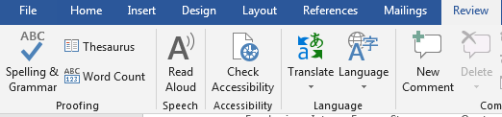
You are done when you get the message that reads “No accessibility issues found”.
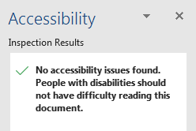
To save your document in an accessible format, click save and then select PDF. Then click on the options button and check the box for ‘Check document structure tabs for accessibility’.
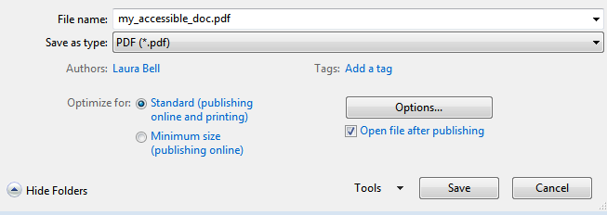

Finally, add your document to the website by selecting the content type ‘File upload (accessible)’. Thank you.

