STYD01 Clinical Reflections
Date | Location | Total Amount of Hours | Overview of Session
25.11.19 – 6.00-6.30 & 20.00-22.00 | Marjon Sports Therapy & Rehab Clinic & Pool | 2.5 hours | Supporting Swimmers & Water Polo with massage & taping before training and poolside during training
Reflective Summary |  |  | Areas for further Improvement plus action plan
I booked a couch in the Sports Therapy & Rehab clinic for an hour so that the members of the swimming and water polo teams could come and see me for a massage, check out any muscle tension or niggles that could potentially lead to injury and for taping if required.  I am trying to develop a culture amongst the teams of injury prevention rather than cure. To encourage athletes to seek therapy for muscle tension that reduces their ROM and something that doesn’t feel quite right. I can deal with it before it becomes an injury 3-4 weeks later. I am also keen to educate them about their training loads.  I had a follow-up visit from a male swimmer that I had previously treated with biceps tendinopathy and tight upper fibres of the trapezius. He has been doing the strength exercises prescribed for the trapezius and has said that his shoulder is so much better and the exercises are really helping. He asked me to apply k-tape to his left bicep muscles and to the upper fibres of the trapezius. It was good opportunity for me to get some more practice taping. I enjoyed it.  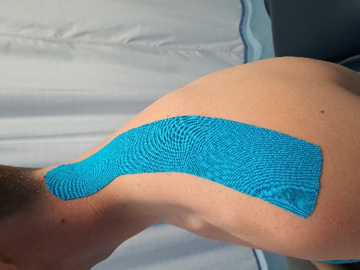  Figure 1 - K-taping of the upper fibres of the trapezius  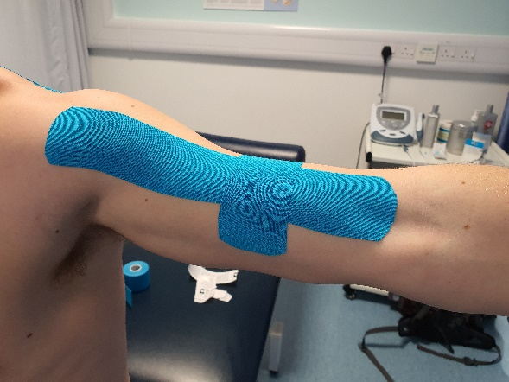  Figure 2 – K-taping of the biceps brachii  No other swimmers visited me during that hour.  During the training sessions there were no issues but five members of the swimming and water polo teams did come and talk to me about various issues that they were having. One male had trigger points in the Rhomboids, another male swimmer mentioned tension in his upper back. I am scheduling an appointment with both of them. One female had sprained her ankle a few weeks ago on the lateral side of the left ankle (possibly the ATFL) and had been prescribed rehab exercises but said that she was experiencing discomfort in the foot. The exercises prescribed only focussed on plantar flexion, so I sent her a programme of exercises for rehab and asked her to come and see me for assessment. She also wanted the ankle taped. Another female talked to me about her lower back and said she felt stiff during lumbar flexion and lateral flexion… which leads me to believe that she may have tightness in the QL. I am in the process of scheduling an appointment for them both. Another female also wanted to see me but it was nothing major so we agreed that I would see her at 6 p.m. on Monday 2nd December.  I think I am going to be busy during the next couple of weeks. |  |  | Revise ankle anatomy & pathologies  Revise Anatomy and muscle actions for upper body
 |  |  | Returning to reflections at a later date
For office use only:

