 | DAILY RECORD OF VISIT TO THE PLACEMENT  REFLECTIVE PLACEMENT LEARNING  JOURNAL TEMPLATE 2019/20

You will need to keep a regular, detailed record of your time on placement. This process is an important part of experiential learning and will also help with the assessment task. This template is designed to help you reflect on your experiences. Reflection should take place before, during and after your placement. It is also important to return to your reflections after a period of time.

You should decide with your University Placement Tutor (UPT) how you will record your reflections. One way you may wish to do this is by setting up an Edublog. The Marjon eLearning Team have produced comprehensive guidance on how to set up and determine who sees your Edublog accessible via: http://sites.marjon.ac.uk/elearninghelp/category/help-for-students/edublogs-help-for-students/.

 | Please remember confidentiality must be maintained at all times when reflecting on your placement experiences.
Date: | 11.12.19
Group or individual with whom I worked: | Mick Smirthwaite

BEFORE my placement …
What am I aiming to achieve from my placement today? What do I need to be mindful of? What issues/questions need to be addressed to ensure I achieve my aim? Do I need to be aware of particular theories, or have particular skills? Have I thought about all of the ‘what ifs’?
To gain understanding of each client’s specific injury or musculoskeletal issues by observation and an opportunity to practice STM techniques.

DURING my placement …
What did I notice happening around me today? What was I thinking and feeling? How was I involved? Did I do anything to intervene and change the situation that I found myself in e.g. how I conveyed a point or whether I decided not to do something I had planned to do? Did my reflections at the time change the session I had planned or my actions?
Today I wanted to discuss my progress with Mick, mid-way through the placement and to remind him to complete and return the Formative Assessment form to my University Placement Supervisor. I was expecting to have a busy afternoon with clients.
AFTER my placement … (based on the Gibbs (1988) Reflective Cycle)
Describe the activities you undertook whilst on placement today. Set the context, what you did and what happened.
On arrival Mick informed me that his 1 p.m. appointment had cancelled and that he only had one client coming in this afternoon at 2 p.m. I was a little disappointed but we are fast approaching the Christmas holiday period and people are busy at work. Also during winter people are more susceptible colds and viruses. It gave us an opportunity to discuss my progress mid-way through the placement. Mick was happy with my progress. He said that I was quite knowledgeable about anatomy. He felt that I needed to develop my confidence in my palpation skills and some of the soft tissue techniques. Confidence will improve with more practice.

He mentioned also that he will be busy next Wednesday 18.12.19 because he has to visit his accountant, so will not have any appointments that day. We will pick up the second half of my placement on 08.01.2020.

Client 1 – this client is a regular visitor to Mick’s practice. He is a middle-aged business man with ongoing lower back and hip issues as a result of a car accident 5 years ago.

During the SA the client said that he was feeling more mobile and positive. He purchased the Transcutaneous Electrical Nerve Stimulation Device (TENS) that Mick had recommended to him the previous week and has been using it. He reported that the TENS device had helped to reduce muscle tension and improve ROM. He hasn’t overdone it during his exercise sessions this week. His personal trainer however, noticed that the client had difficulty holding a single-leg balance on his left leg.

I observed Mick palpate the client’s left and right glute muscles. During the examination the client did not have full ROM in lateral rotation of hip on both the left and right side of the body. He asked the client to extend the left hip and laterally extend the left leg. The client had difficulty with both movements. The glute muscles were not firing. The QL and hamstrings were doing all the work. There was tension in the TFL, Glute Medius and Glute Maximus. In order to re-educate the Glute muscles to fire during hip extension and lateral extension and improve proprioception, the client performed hip extension and lateral extension of the leg with resistance using a theraband, which was placed around his ankles. This has been an ongoing issue. It is possible that the signals from the nerves to the muscles are being blocked because of sensory damage as a result of the car accident. The glute muscles began to fire after the resistance band exercises. Mick also applied trigger point acupuncture to facilitate relaxation in the Gluteus Medius and TFL muscles (Figure 1). A needle was inserted into the TFL and another was inserted into the Gluteus Medius. Mick observed both muscles and tested the needles to check whether the treatment had effectively relaxed the muscles. The needles were removed when muscle relaxation was achieved.

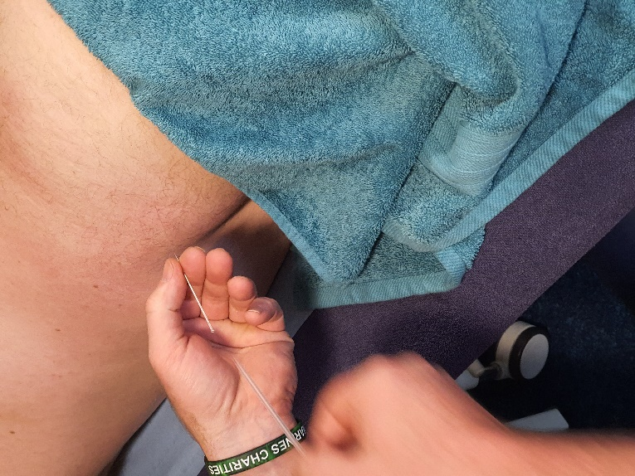

Figure 1. Insertion of acupuncture needle into the Gluteus Medius

After the acupuncture treatment Mick applied mobilisations to the lumbar spine and hip. I was invited to apply soft tissue massage to the left upper back to ease out trigger points and tension in the Rhomboids.

Document how you felt through-out your placement today. Were you anxious, confident, pleased or disappointed?
I felt comfortable and relaxed during my placement today. There was a little bit of disappointment that there was only one client this afternoon, but this is what happens in private practice. Individuals are busy and have things going on in their own lives that sometimes prevent them from attending an appointment.

Evaluate today’s placement activity. What went well, what went badly, what would you have done differently?
I enjoyed applying soft tissue massage to the client’s left upper back. It is always good to have an opportunity to practice. I enjoy performing STM, reducing tension in the muscles and helping the client to feel good.

It was also good to have an opportunity to discuss my progress throughout the placement and areas for development.

Take a deeper, analytical and critical approach to today’s experiences. Can you make connections or apply academic theory or current policy to understand why today’s activities went well or went badly.
I am not familiar with the effects of acupuncture. I assume that it has a similar impact as TENS. Although we do not cover acupuncture in our degree programme, I will take some time to research the benefits of acupuncture, when I have an opportunity.

Draw conclusions. What have you learnt from today’s activities and your reflections?
I am beginning to understand how getting clients to move the tight or strained muscles during the application of particular massage techniques helps you to understand muscle movements and identify what the problem actually is.

Action plan. How will you apply what you have learnt from today’s activities to the rest of your placement and your future professional and personal development? Do you need to undertake further research or reading? Are there courses that you need to undertake to fill a skills gap?
Read up on the benefits of acupuncture to gain a better understanding of how treatment affects the muscle tissue.

Have any questions arisen today that I need to discuss with my Placement Supervisor or University Placement Tutor (UPT)?
At the end of the placement we discussed the treatments applied to improve the activation of the glutes in the left hip to consolidate my understanding of the reasons why they were applied.

RETURNING to my reflections …
It is often useful to return to your reflections after a period of time. Revisit the experiences you had; think about how you felt (positive and negative feelings) and re-evaluate your experiences. Do you feel differently about the experience now time has passed have your feelings changed in light of the experience or do you now view the experience in a different light?

Am I able to complete any actions in my Personal & Professional Development Plan?
Are there any actions I need to add to my Personal & Professional Development Plan?

SAKE - Skills, Attributes/Attitudes, Knowledge and Experience
Want to secure a graduate level job when you finish your degree?
Employers agree that placements are a great way to develop the vital skills, attributes/attitudes, knowledge and experience (SAKE) they are seeking. As a result of your experience can you include any of the following on your CV, an application form or discuss at interview?

- Imagination/creativity |  |  | - Adaptability/flexibility | - Willingness to learn
- Working autonomously |  |  | - Working in a team | - Planning/self-management
- Working under pressure |  |  | - Oral/written communication | - Numeracy
- Attention to detail |  |  | - Time management | - Coordination/organisation
- Sector/business awareness |  |  | - Ethical/sustainable practice | - Problem solving/initiative
- Self-awareness |  |  | - Technical ability | - Resilience
 | Use the STAR technique to demonstrate your competencies on your CV, in a job application or at interview.
Situation |  | Describe the situation with which you were confronted, set the context.
Task/Target |  | Explain the task or target you were set (be concise!).
Action |  | This is the most important part and demonstrates your competencies:  - Explain what you did, your role and what part you played;  - Explain how and why you did what you did.
Result |  | Explain what happened, the outcome. Ideally quantify the positive impact you made. You can also demonstrate your reflection skills by reviewing your decisions and making suggestions about how you would do an even better job in the future.

Reference:
Gibbs, G. (1988) Learning by doing. A guide to teaching and learning methods. Oxford Brookes University: FEU.

