Rehabilitation Exercise programme for lower back and upper limbs
Mobilisations to improve range of movement - can be performed on a bed or on the floor. If performing exercises on the floor use a chair for support when getting down onto the floor, and getting back up again. Please repeat the exercise once every day.
1. Lying flat on the floor – bring one knee up to the chest, and keep other leg straight on the floor. Hold stretch for 30 seconds. Repeat on the opposite leg.

2. Bring knees to chest- place hands on knees and move knees around in a circle to the right 10 times and move knees around in a circle to the left 10 times.
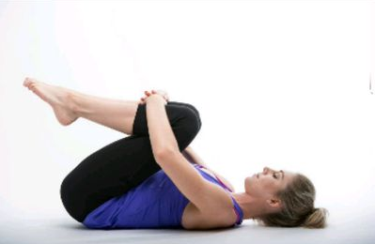

3. Trunk rotations
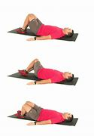
Repeat 10 times on each side
4. Prone hamstring curl
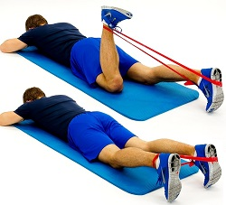

Repeat 10 times on each leg

6. Seated Knee extension with resistance band
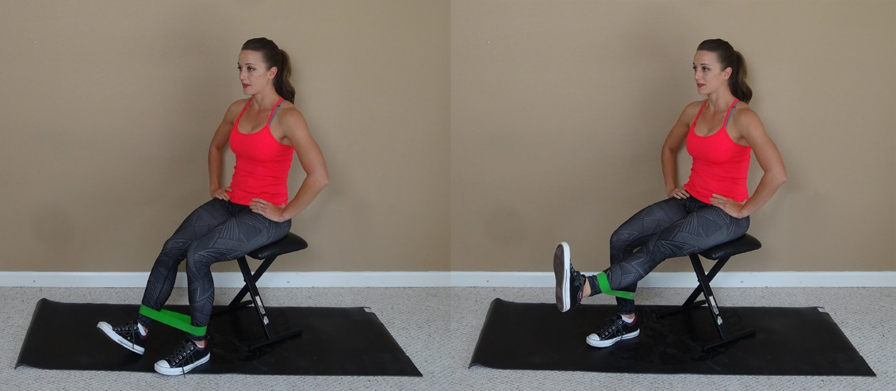
Repeat 10 times on each leg.

7. Supine hamstring stretch
Hold stretch for 30 seconds. Repeat on the opposite leg.

