Osteochondral Lesion-
An injury to the Talus that involves bone and overlying cartilage.
Anatomy-
Talus is the bottom bone in the ankle joint and much of it is covered by cartilage. The tibia and fibular.
The main movements that the talus provides are plantar and dorsi flexion.
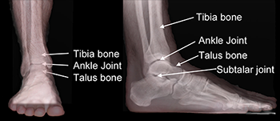
Blood supply to the talus is weak and therefore can take longer than normal to recover.

Onset-
85% caused by traumatic injury to the ankle joint. Ankle sprains often lead to OLT’s.

Signs and symptoms-
- P on FWB activities
- Swelling with reduces with rest and elevation
- Instability of the joint
- Locking/ catching
- PoP
- Decrease in ROM.

Treatment-
Phase 1- decrease P, Maintain/ improve ROM, Maintain strength.
Immobilize and restrict weight bearing.
Phase 2- improve/ maintain ROM, increase strength, increase proprioception.
Introduce PWB- FWB with movements on patient tolerance
Phase 3- sport related/ functional movements.
Towel scrunches, calf raises, alphabet

https://www.footcaremd.org/conditions-treatments/ankle/osteochondral-lesion#:~:text=What%20Are%20Osteochondral%20Lesions%3F%20Osteochondral%20lesions%20are%20injuries,also%20be%20called%20osteochondritis%20dessicans%20or%20osteochondral%20fractures.

