Shoulder Rehabilitation Programme

Isometric loading
- Internal rotation- placing hand and forearm against a wall and pushing inwards against the wall.
- External rotation- placing back of hand and forearm on the wall and pushing outwards against the wall.
- Press-up position- placing both hands on the wall, stepping back two steps, bend elbows as if you were to do a press-up and hold.
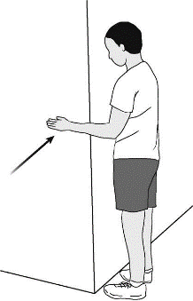
- Pendulum swings- standing up, other arm resting on a table or counter, leaning forwards, and letting your other arm hang down to the floor, sing arm forwards and backwards, side to side, then circular motions.
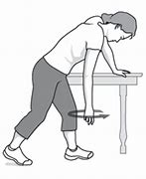
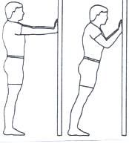
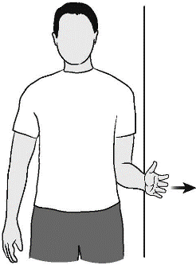
Figure 1 Pendulum swings
Figure 2 Press up isometric.
Figure 3 External Rotation

Figure 4 Internal Rotation

Exercise | Reps x Sets | Days per week
Internal rotation | Hold for 30 seconds x 2 | 1 per day x 5 days per week
External rotation | Hold for 30 seconds x 2 | 1 per day x 5 days per week
Press up Isometric | Hold for 30 seconds x 3 | 1 per day x 5 days per week
Pendulum swings | 10 times each movement x 3 | 2 per day x 5 days per week

Perform these exercises for the first week to help activate the muscles. Please let me know if you require any assistance with these exercises. By the each of the week please report back if you felt any pain whilst doing these exercises and we can change them. Record a daily log of how you feel whilst doing these exercises, does it hurt? Is it easy? Etc.

Shoulder Strengthening
Please only use a dumbbell that is less than 5kg.
- Bicep Curls- having your palms facing out, grasp hold of weights and bring the weight to your shoulder by bending your elbow. Alternate arms rather than doing them one at a time.
- Triceps extensions- holding onto the weight, bring your elbow up as far as you can and drop your hand behind your ear. Extend your arm up to the ceiling and then bend again. Make sure your elbow is staying in line and not sticking out to the side.
- Scapular retraction- lying on a raised surface, drop one arm down to the floor and lift that shoulder up. This will bring your whole arm up but only slightly. This will activate your deep shoulder muscles and back muscles.
- Bent over row- placing one knee on a chair/bench and the other leg on the floor. Same hand as the resting leg on the same surface with other hand holding the weight. Weight hand straight to the floor, pull the weight up to your side driving your elbow as far as it can go behind you.
- Bent over Flyes- similar to bent over row. In the same position you need to have a slight bend in the weighted arm and bring the weight away from your body and inline with your shoulder. Make sure that bend in the arm stays.
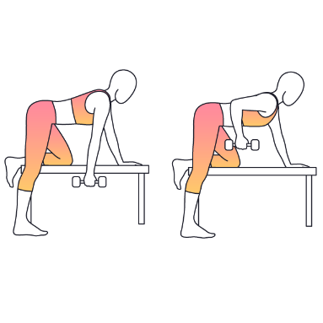
Figure 8 Bent over row
Figure 7 Scapular retraction
Figure 5 Triceps Extensions
Figure 5 Bicep Curl

Figure 6 Bent over Flyes- ignore the persons position, just look at what the arm is doing.

Exercise | Reps x Sets | Days per week
Bicep Curl | 10 x 3 | 4 days per week
Triceps Extension | 10 x 3 | 4 days per week
Scapular retraction | 10 x 2 | 4 days per week
Bent over row | 10 x 2 | 4 days per week
Bent over Flyes | 10 x 2 | 4 days per week

Please keep a daily log of how you feel whilst doing these exercises. Were they harder one day compared to the next? Only do these exercises once you have done the isometrics for the first week and pain free! If any of these exercises being to cause the pain to occur please do not do them and let me know.

